1. 3 + 2 Axis Machining

Introduction
On a 3 + 2 Axis Machine it is possible to index the head and\or bed to realign the tool prior to performing standard X Y Z transitions. This is achieved either by manual adjustment or as part of the cnc control.
It is possible for customers who do not possess a PowerMILL Multi-Axis licence to create 3+2 strategies by using individual Workplanes to control Tool Alignment and output ncdata via the NC Preferences form with the Automatic Tool Alignment set to Off.
It is however both faster and easier to create 3 + 2 toolpaths if the Multi-Axis licence is available as it provides access to a larger range of options with minimal dependency on individual Workplanes. Either way PowerMILL enables components normally requiring a series of separate 3-Axis operations to be machined in one set-up. This could include direct machining of undercut features or sidewalls deeper than the maximum tool length.
It is essential to apply suitable Toolpath - Leads, Links, and Extensions to eliminate any potential gouges.

3 + 2 Axis - Machining Example

- Import the Read-only, protected Project:- D:\users\training\PowerMILL_Data\five_axis\3plus2_as_5axis\3Plus2-ex1-Start.
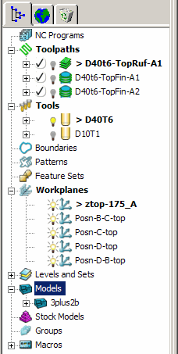
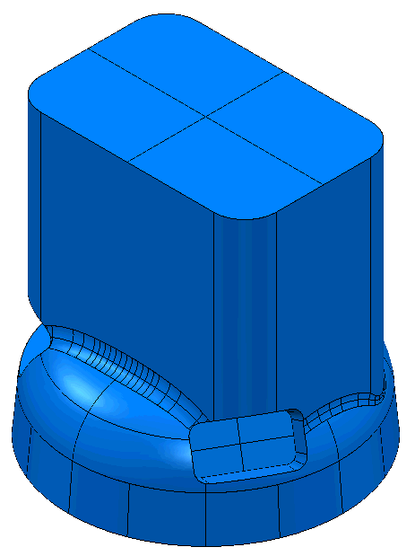
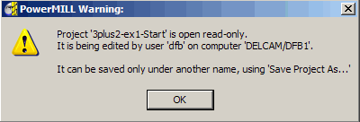

- Save the Project as:-
D:\users\training\COURSEWORK\PowerMILL-Projects\3Plus2-ex1

Note; A 3-Axis Roughing and two Finishing strategies already exist in the imported Project.
Also, a series of workplanes are already included in the Project with one just above the top of the model at Z175 above the Transform. This workplane will be used as the main machining datum. The other 4 workplanes will be used later to control positional movements between multi-axis machining strategies.
- Select an ISO 1 view and consider the machining options.

Note the relatively high sides of the component and the orientation of the three recesses making it impossible to machine as 3 Axis (with the tooling aligned to the Z-Axis).
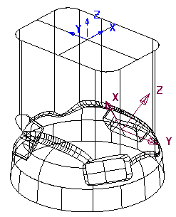

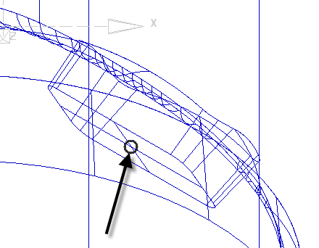

The pocket located along the X direction will be the first to be assigned with a new Workplane to control one of the 3 Plus 2 - Tool Axis alignments.

- From the PowerMILL explorer select Workplane - Create and Orientate Workplane - Workplane Aligned to Geometry.
- Using the left mouse key - snap or box the wireframe crossover at the base of the first pocket (located along X from workplane ztop-175_A).
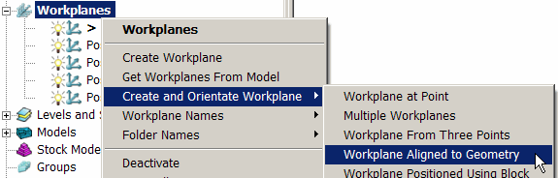

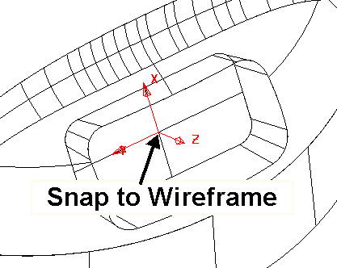

- Activate the new Workplane - 1.
The Workplane is automatically aligned to the wireframe with the Z Axis normal to the surface. It still requires further editing as it is required that the X-Axis points Anticlockwise around the component in reference to the global coordinates.

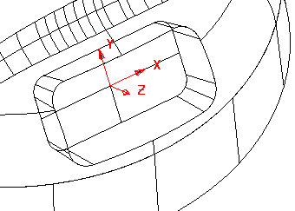
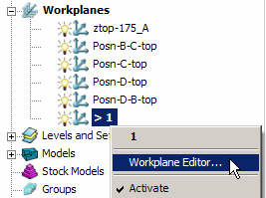

- From the PowerMILL explorer, right mouse click on Workplane 1 and from the local menu select the Workplane Editor option to open the following toolbar.

- Select Twist about Z and in the form input an Angle of -90 (normal to the base of the recess).
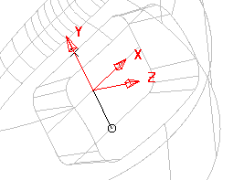
The X-Axis of the workplane should be pointing anticlockwise relative to the Transform (Global Datum) as viewed from the top of the component (If not already the case).

- Select the Green tick to save the changes and exit the Workplane Editor toolbar.
- Rename the Workplane 1 as Align_B.
- Activate the Workplane ztop-175_A
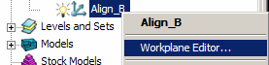
- Right mouse Click on Workplane - Align_B and from the local menu select the Workplane Editor.

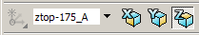
- Select the operational axis as Z (bottom left of graphics area).

- In the Workplane Editor toolbar select Keep Original and then Rotate workplane about point.

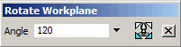
- In the form input the angle 120 to create a new Workplane (Positioned normal to the base of the next pocket in an anticlockwise direction as viewed from the top).

- Select the small black cross to exit the form.
- Select the Green tick at the end of the Workplane Editor toolbar to accept the new Workplane (Align_B_1).
- Select the new Workplane (Align_B_1) and repeat the above operation to create another Workplane (Align_B_1_1)
Note:- Do not forget to select keep original before applying Rotate workplane about point (120 degrees)

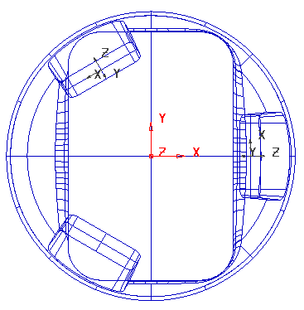
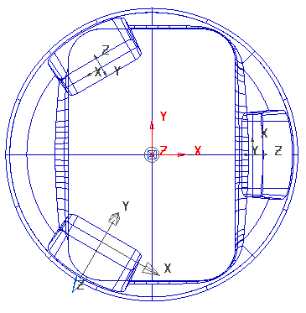

- Rename the 2 new Workplanes as Align_C and Align_D respectively.

The component is now ready to have the 3 Plus 2 machining strategies created, relative to the three new Workplane alignments. ( Align_B, Align_C, and Align_D).
For each of the 3 Pockets a rectangular material Block will be created locally, relative to the aligned 3+2 Workplane. A Model Boundary will also be created around each pocket to be included in the machining strategies (Machine Inside Boundary).

- Activate the Workplane Align_B.
- Select both Surfaces that define the pocket around Workplane Align_B.
- Create a Block Defined by Box to Type Model (selected surfaces).
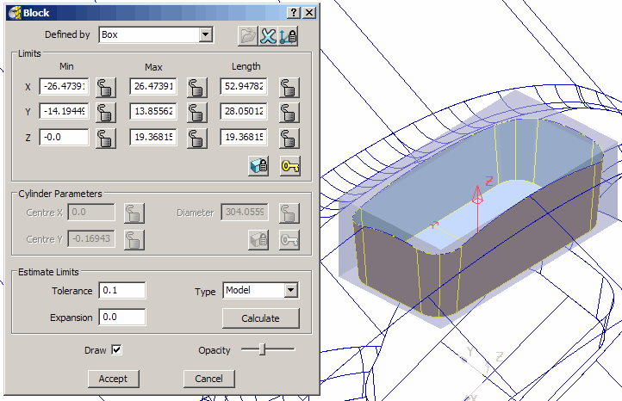

- In Rapid Move Heights input the operational Workplane as Align_B and select Calculate to create appropriate values for Safe Z and Start Z.
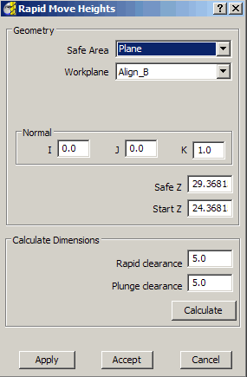

Input Workplane (Align_B) to achieve the correct Rapid Move Heights alignment.

- In Start and End Point select First Point - First Point Safe Z, Last Point - Last Point Safe Z and Accept the form.
- Create a User Defined - Model - Boundary named Pkt-B1 on the top edge of the recess containing the Workplane Align_B.
- Activate the existing Tiprad tool D10t1.
- In the Strategy Selector form in 3D Area Clearance select Model Area Clearance and fill in the options in the pages, exactly as shown below.
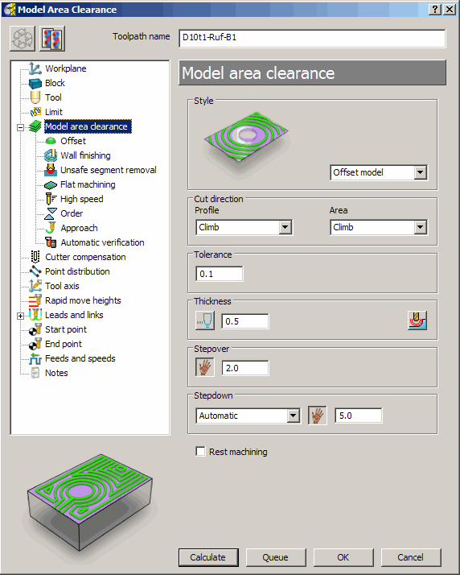
Toolpath name:-
D10t1-Ruf-B1

Use Style:- Offset model.

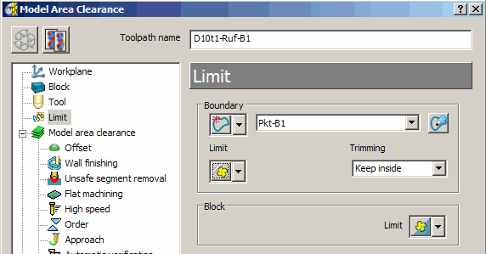

In the Limit page input the:-
Boundary Pk1-B1 with Trimming Keep inside.

- Select Calculate to create the toolpath and then Cancel the form.
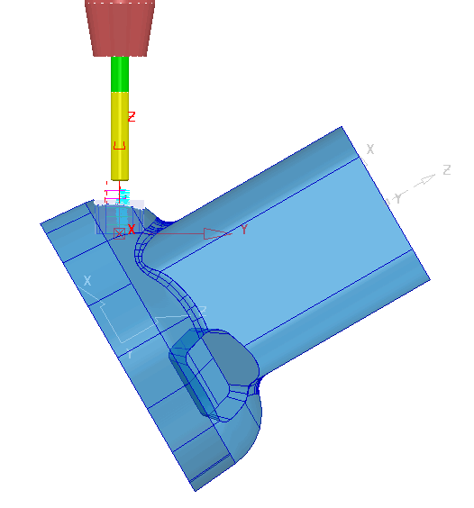

The toolpath plunge moves are aligned to the Active workplane’s Z Axis.

- Repeat the above strategy (Use Copy) on the other two recesses and adjust the values and settings as required, to create Toolpaths (D10t1-Ruf-C1 and D10t1-Ruf-D1).
- Don’t forget to create and use the necessary User defined - Model - Boundaries Pkt-C1 and Pkt-D1.

Note the Block and Rapid Move Heights values will differ due to the increased Z height of other two recesses resulting from them being in the corners of the main model.
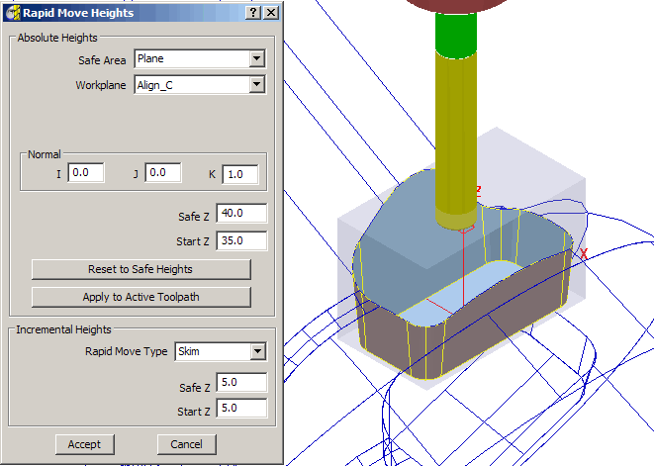

Both Recesses C and D have the same (increased) wall height, and after the new, local Block is created, suitable revised values for Safe Z and Start Z are around 40 and 35 respectively. Additional User Defined - Model - Boundaries (Align_C and Align_D) will be required for recesses C and D.
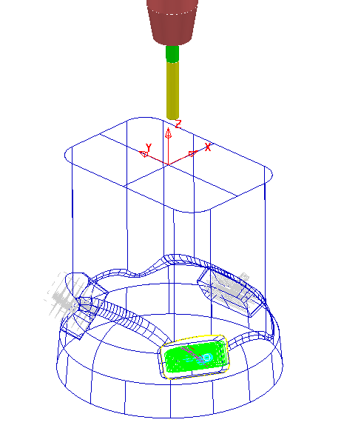

After the creation of toolpaths for 3 + 2 Axis valid ncdata can only be output using a compatible, post-processor. For programs containing multi-alignment toolpaths the NC Programs output options create the ncdata from one datum (In this case the Workplane - ztop175_A). This option is selected in the NC Preferences or NC Program Settings form.

- In the explorer, right mouse click on NC Programs and select Preferences.
- From the Machine Option File select r2e3.opt as the controller.
- For the Output Workplane select ztop-175_A.

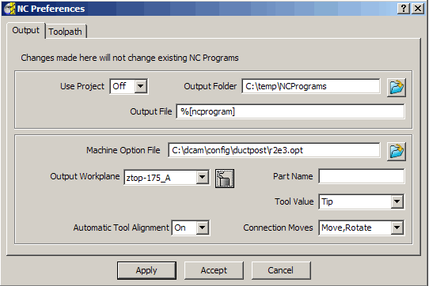

- Apply the settings and Accept the form.
- In the explorer, create an NC Program and add to it the three ‘3 Plus 2’ toolpaths, (D10t1-Ruf-B1, D10t1-Ruf-C1, and D10t1-Ruf-D1).
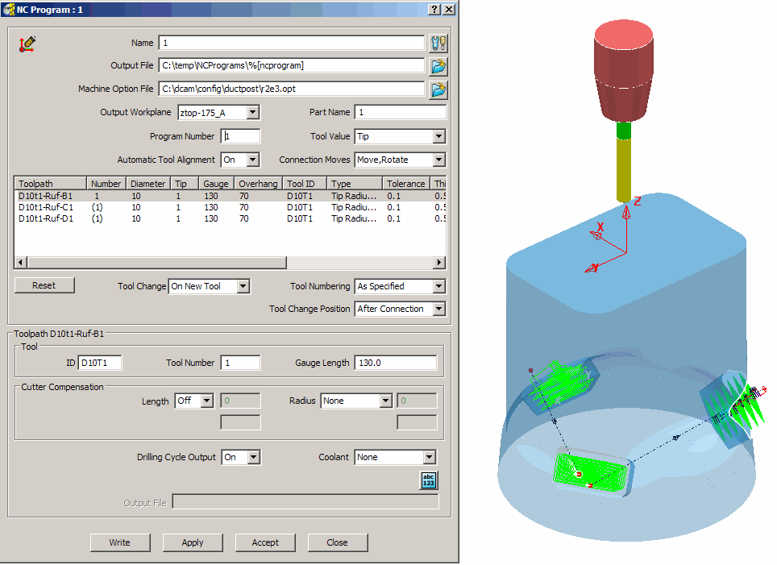

Note: The link moves between the three individual ‘3 Plus 2’ toolpaths are displayed in the NC Program and in this case are passing straight through the component!
In addition to creating the ‘3 Plus 2’ toolpaths it is essential to control the Positional Moves between them to eliminate any collisions with the component and fixtures.
The original Project contains a selection of pre-defined Workplanes to be inserted as required into the NC Program to provide safe positioning and alignment of the tool during link moves.

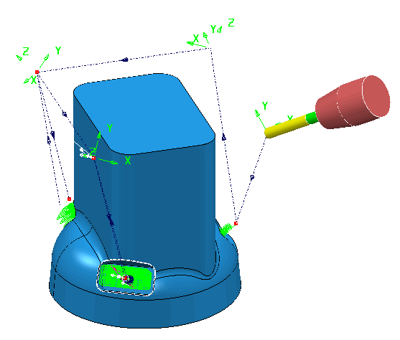
- From within the explorer ‘Drag and Drop’ copies of the workplanes into the NC Program (as shown below left).
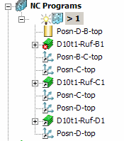

The link moves will now pass via the workplane coordinates and the tool will align to the workplane Z Axis at these positions.

Note: Multi Axis - Positional Moves are covered in more detail in Chapter 2.

- Select File - Save to update the contents of the previously stored Project.

3+2 Axis – Stock Model Application

The Stock Model represents the un-machined material at any point in the machining process. An empty Stock Model is created, followed by applying the material Block and\or any number toolpaths to be considered in the process. The Stock Model is then updated by selecting Calculate, to display the current ‘un-machined’ material remaining.

- Delete all and Reset forms.
- Import the Model:-
D:\users\training\PowerMILL_Data\five_axis\AnglePad\StockModelRest

- Save the Project as:-
D\:users\training\COURSEWORK\PowerMILL_Projects\StockModel-3plus2
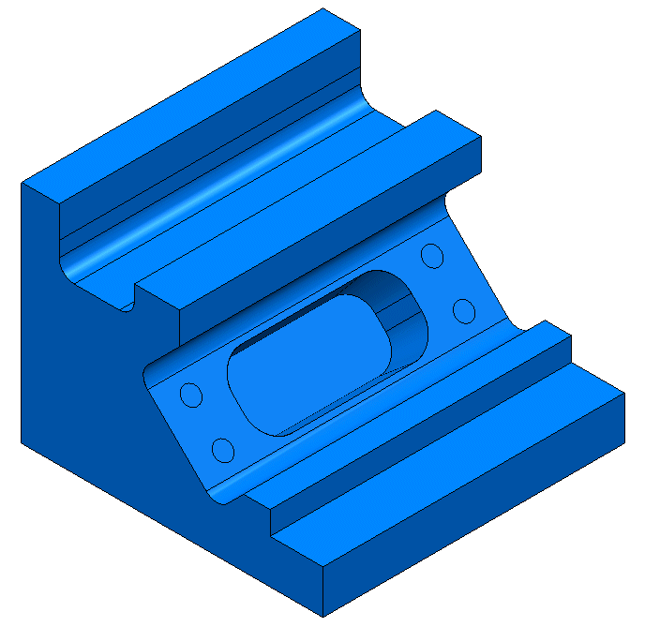

The model contains undercut pockets, which for a normal 3-Axis application, would require the component to be machined in two separate set ups. However, by applying 3+2 with separate Workplanes controlling the Tool Alignments, the whole project can be completed in one setup. During an initial 3-Axis operation, the undercut pockets will be partially machined which provides an application for using Stock Model to enable the user to optimise the local 3+2 machining within each pocket.
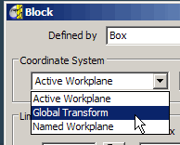
- Open the Block form and Calculate a Box to Min\Max Model limits, with the Coordinate System set to the Global Transform.

- Accept the form.

By creating and locking the material Block to the Transform (global co-ordinate system), the orientation and position will remain unchanged if a Workplane is Active.
- Create a Dia 16 - tip radius 3 tool and Rename D16T3.
- Create a Dia 12 - tip radius 1 tool and Rename D12T1.
- In the Rapid Move Heights form select Calculate.
- Set both Start Point and End Point as Block Centre Safe.
- Activate the tool D16T3.
- Select the Strategy Selector and from 3D Area Clearance select Model Area Clearance filling in the options in the pages, exactly as shown below.
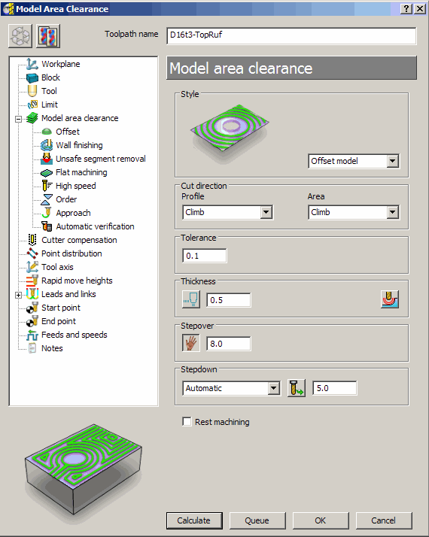

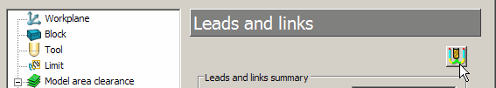

- In the local explorer select the Leads and Links option and in the new page select .
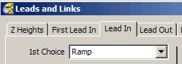
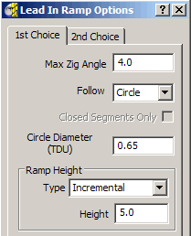

- Select the First Lead In select 1st Choice Ramp.

- Select

- Input Max Zig Angle 4 using a Circle with Dia 0.65 (TDU).

- Accept and Cancel both the Ramp Options and Leads and Links forms.

- Back in the main form, select Calculate to create the toolpath and then Cancel.

- Select an Iso1 view.
- In the PowerMILL explorer, right mouse click on Create Stockmodel.
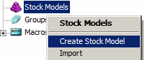
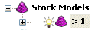

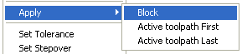
- Right mouse click over the new (empty) Stock Model and from the local menu select Apply - Block.

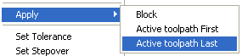
- With the local Stock Model menu still open select Apply - Active toolpath Last.

- With the local Stock Model menu still open, select Show Rest Material, followed by Drawing Options - Shaded, and finally Calculate.

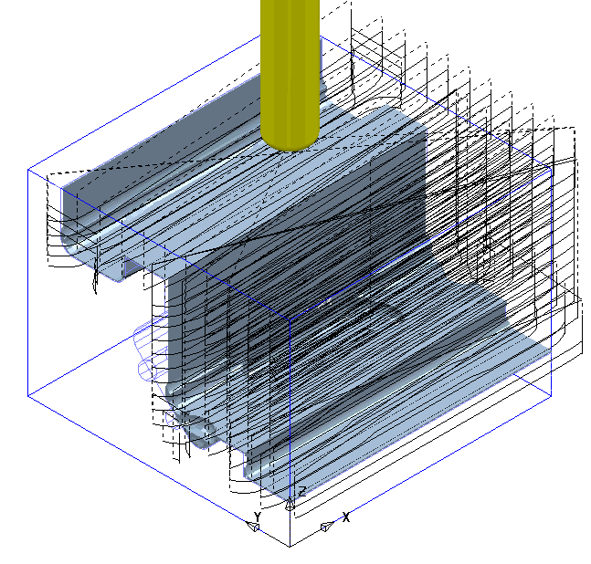
The 3-Axis Roughing operation has removed all accessible material leaving a 0.5 thickness on the component form. This is clearly visible on the displayed Stock Model.

- Right mouse click on the Active toolpath TopRuf and select Settings to reopen the Offset Area Clearance form.
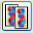
- Select the Copy Toolpath icon ready to input some new parameters and settings for the 3+2 roughing strategy (keep the form open).
- Activate - Workplane 2 to change the set up to a 3+2 orientation.
- Activate the tool D12T1.
- From the main toolbar select Rapid Move Heights and input the correct Workplane (2) in the form before selecting Calculate.
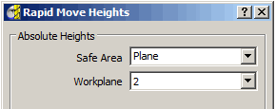

- Enter the Name - D12t1-AngRuf along with the remaining values and settings exactly as shown below.

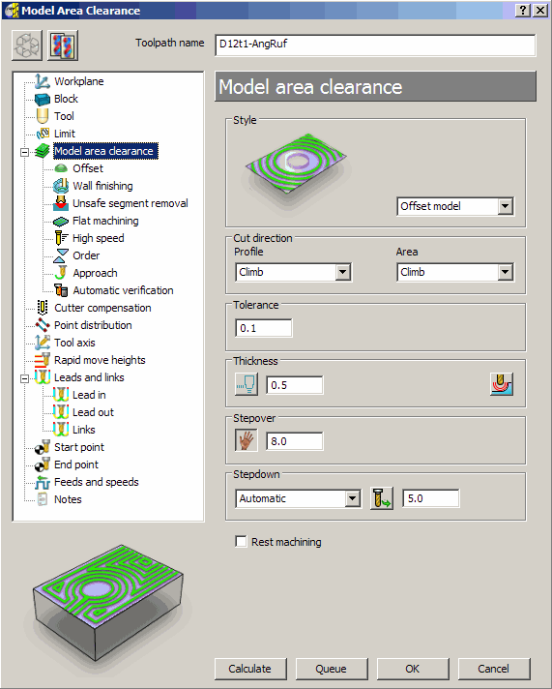

- Select Calculate to create the toolpath and then Cancel.
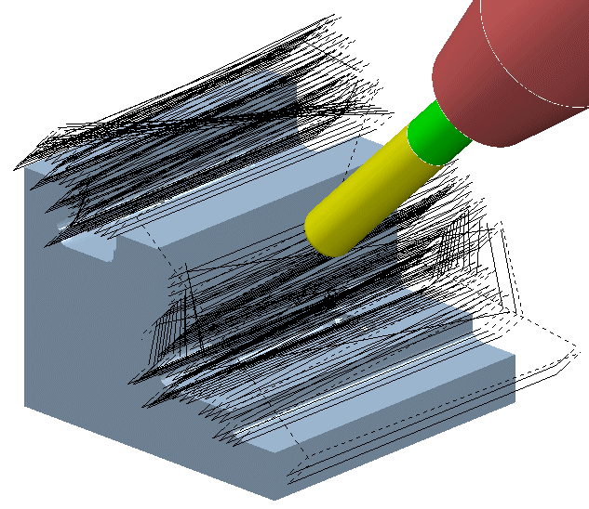

The 3+2 Axis Roughing operation has removed all the remaining material but at the expense of a lot of wasted time cutting fresh air. Most of the material has already been removed by the previous strategy. This is clearly visible on the illustration.

- Recycle the latest Area Clearance strategy (D12t1-AngRuf) using Rest Machining to Toolpath applied as shown in the illustration, below.

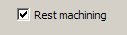
- Tick the Rest machining box in the main Model area clearance page (Changes the page to Model rest area clearance)

- In the local explorer select the Rest page and input Rest Machining - Toolpath - D16t3-TopRuf.
- Select Calculate to request the toolpath to be created.
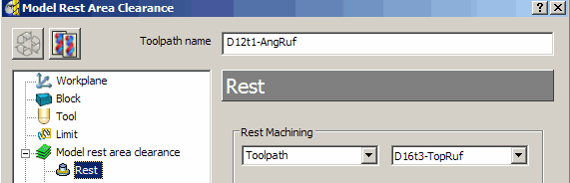

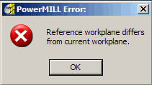

The strategy fails to calculate and the above PowerMILL Error message box appears!

Note; It is not possible to apply Rest Roughing to an Area Clearance strategy if the reference toolpath has been generated relative to a different Workplane alignment.
This is overcome by using the Stock Model to limit the Rest Roughing instead as shown in the next section.

- Select OK to close the PowerMILL Error form to return to the strategy that is still in Recycle mode.

- Tick the box labelled Rest Machining and in the Rest page set to Stock Model and 1 as shown below.
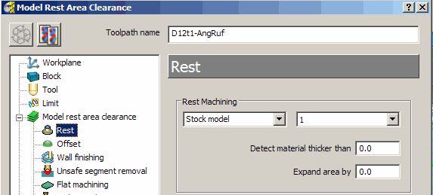

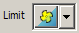
- In the local explorer select the Limit option and in the new page select limit tool centre to block edge.
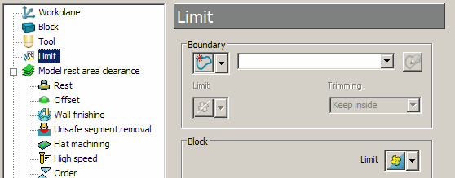

- Select Calculate to create the toolpath and then Cancel.

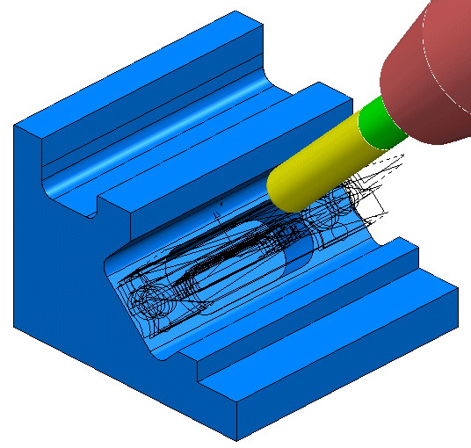
The modified Rest Roughing toolpath now successfully operates within the Stock Model limits (as shown left).
Note:- The material removed by the toolpath, although registered, is not included as part of the actual Stock Model at this stage.
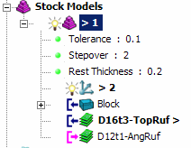

- In the explorer right mouse click on the Stock Model and in the local menu select Apply - Active toolpath Last, followed by Calculate.
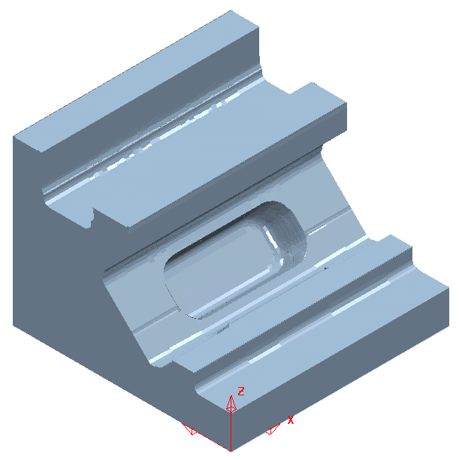
The Stock Model now displays the remaining material after both the 3-Axis Roughing and 3+2 Roughing operations.
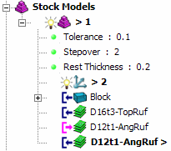

Unlike Area Clearance, Finishing strategies cannot be directly rest machined to a Stock Model. However it is possible to create and apply Stock Model Rest Boundaries where required, providing suitable rest limits for subsequent finishing operations.

- Activate the Toolpath D16t3-TopRuf to reinstate the settings used.
- Create a Dia 6 Ball Nosed tool named BN6.
- Select the Surfaces (shown shaded below) required for initial finish machining relative to Workplane 1.
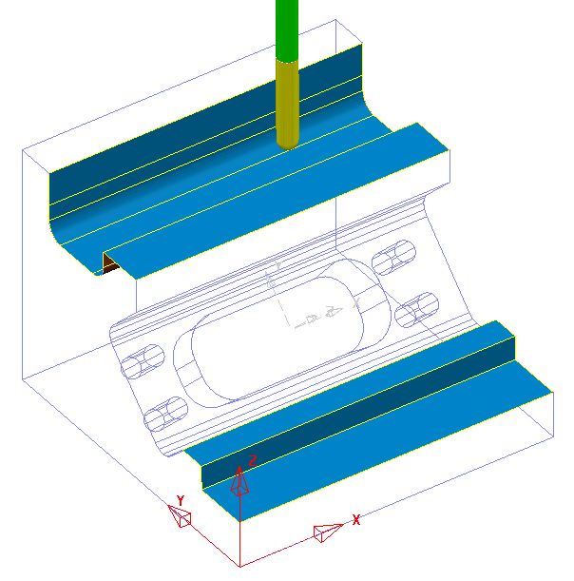

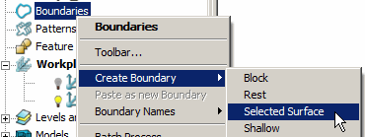
- In the explorer Right click over Boundaries and select Create Boundary followed by Selected Surface to open the following form.
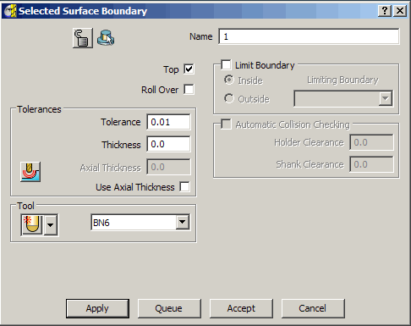

- Input data in the Selected Surface Boundary form exactly as shown with a tick in the box named Top and make sure that the Boundary has the Name 1.
- Apply and when processed Cancel.
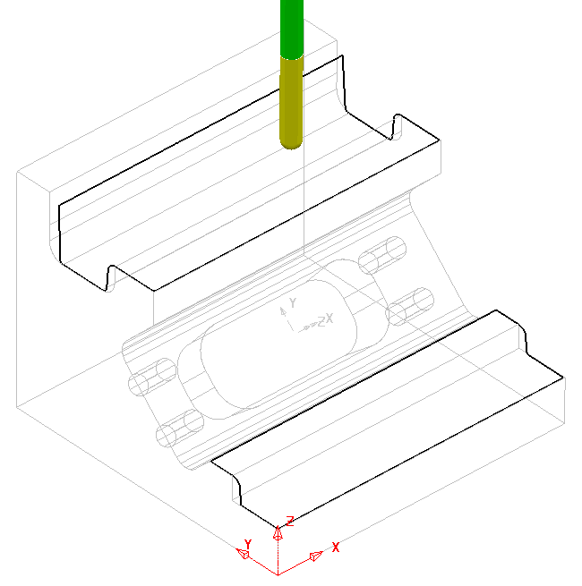
The Boundary will be Active which in turn will cause it to be automatically included as the limits (keep Inside) in the following finishing strategy.

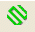
- Select the Strategy Selector and from the Finishing form select the Steep and Shallow finishing option.
- Enter the Name BN6-TopFin along with the remaining values and settings exactly as shown below before selecting Apply.
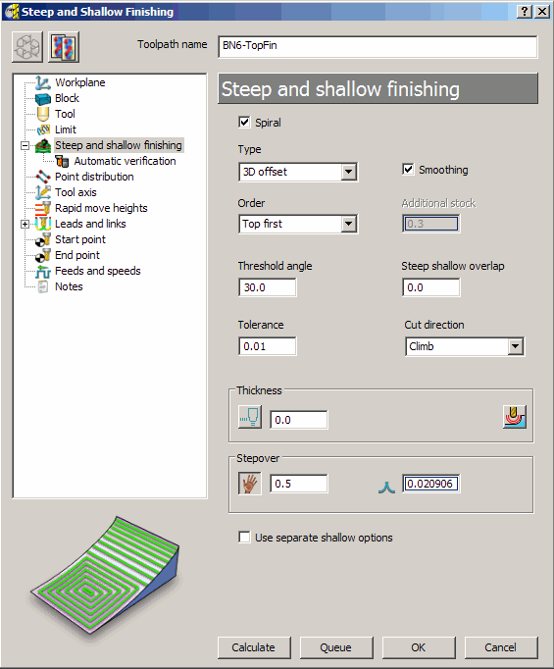

- Select Calculate to create the toolpath and then Cancel.
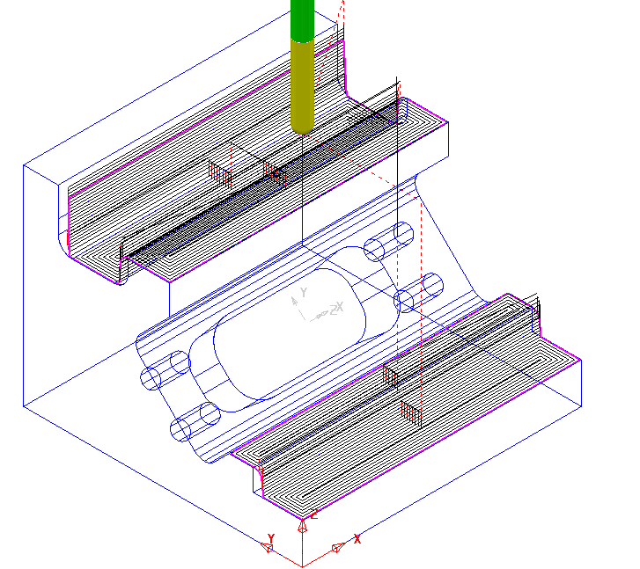

The features accessible from the top have now been finish machined. This finishing strategy will be added to the Stock Model ready for a Stock Model Rest Boundary to be created and applied to a 3+2 finishing strategy along Workplane 2.

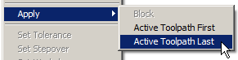
- With the local Stock Model menu still open select Apply - Active toolpath last

- With the local Stock Model menu still open, select Show Rest Material, followed by Drawing Options - Shaded, and finally Calculate.
- Activate Workplane 2.
- Select an ISO 1 view to display the component relative to the Workplane 2 orientation.
- From the main toolbar select Rapid Move Heights and input the correct Workplane (2) in the form before selecting Calculate.
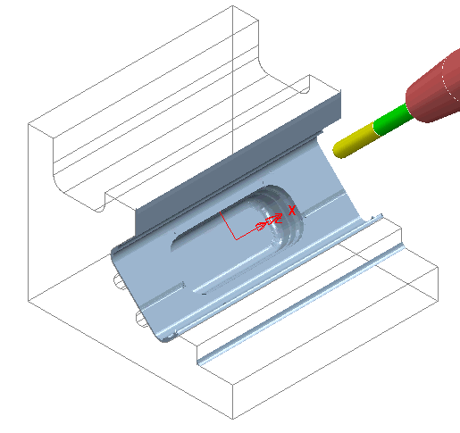

- In the explorer Right click over Boundaries and select Create Boundary followed by Stock Model Rest to open the following form.

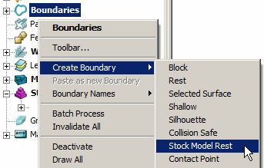
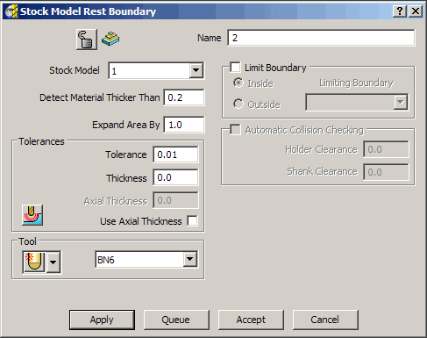

- Input data in the Stock Model Rest Boundary form exactly as shown and ensure that the Boundary has the Name 2.
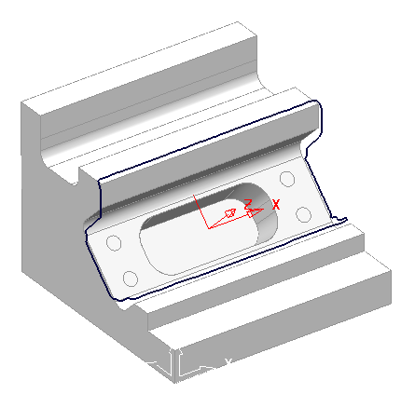

Note:- The base of the lower wall has not been recognised as part of the Stock Model Rest - Boundary. That is due to the Stock Model in this area being inaccessible to the BN6 tool.

- Apply and when processed Cancel.
- Select the Strategy Selector and from the Finishing form select the Steep and Shallow finishing option.
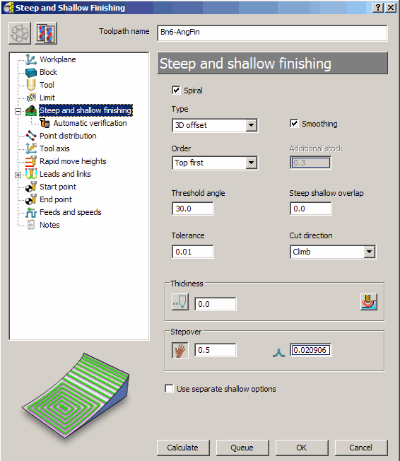
- Enter the Name BN6-AngFin along with the remaining values and settings exactly as shown below before selecting Apply.

- Select Calculate to create the toolpath and then Cancel.
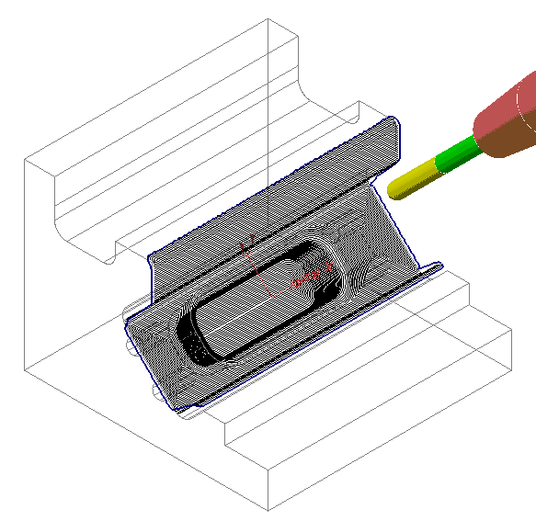

The features accessible within the Stock Model Rest Boundary down Workplane 2 have now been finish machined. This finishing strategy will be added to the Stock Model to confirm whether machining is now complete.

- With the local Stock Model menu still open select Apply - Active toolpath Last.

- With the local Stock Model menu still open, select Show Rest Material, followed by Drawing Options - Shaded, and finally Calculate.
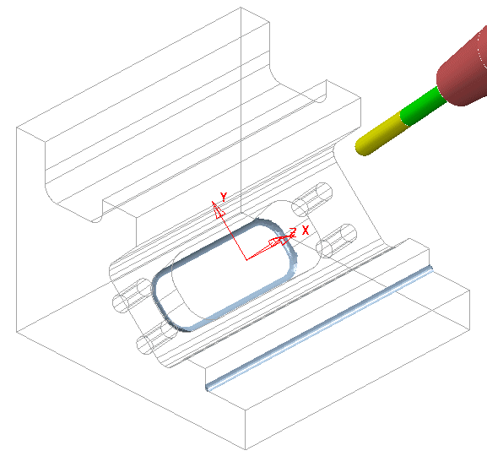

There are now 2 areas remaining as part of the Stock Model. As both include sharp internal corners they will need to be finished off using an End Mill.

- Create a Dia 12 End Mill named EM12.
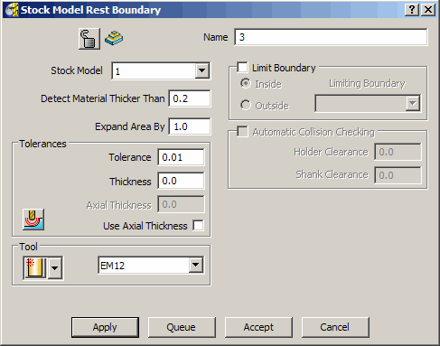
- In the explorer Right click over Boundaries and select Create Boundary followed by Stock Model Rest to open the following form.
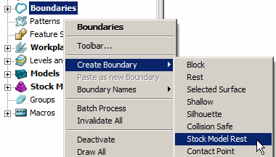

- Input data in the Stock Model Rest Boundary form exactly as shown above and make sure that the Boundary has the Name 3.
- Apply and when processed Cancel.

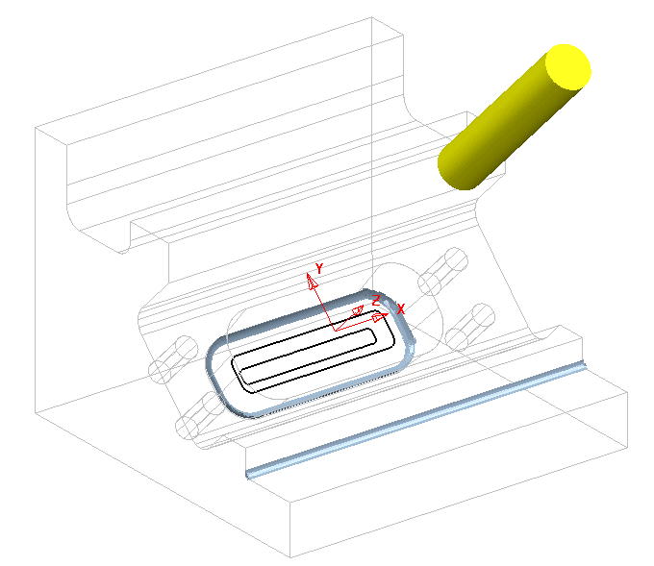

A new Stock Model Rest Boundary has appeared where the remaining material is accessible to the EM12 tool.

This area is not accessible to the EM12 tool, and as a result Boundary segments will not be created.

- Select the Toolpath Strategies icon and from the Finishing form select the Constant Z option.
- Enter the Name EM12-AngFin1 along with the remaining values and settings exactly as shown on the following page before selecting Apply.
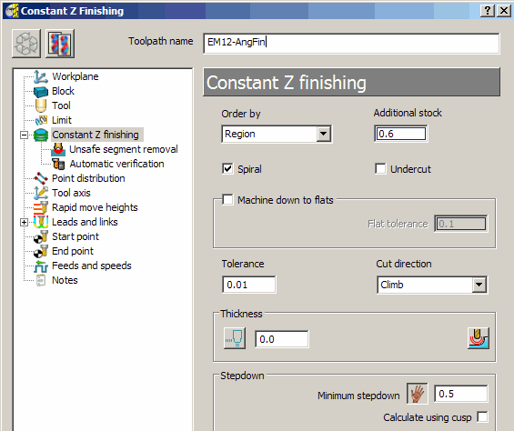

- Select Calculate to create the toolpath and then Cancel.
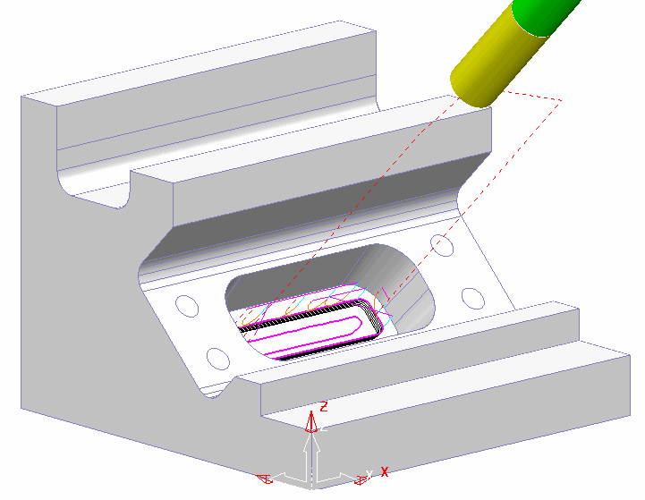

The Angled pocket is now fully machined and the latest toolpath will now be added to the Stock Model.

- With the local Stock Model menu still open select Apply - Active toolpath Last.

- With the local Stock Model menu still open, select Show Rest Material, followed by Drawing Options - Shaded, and finally Calculate.
- Activate the Toolpath D16t3-TopRuf to reinstate the settings used.
- De-activate the Toolpath D16t3-TopRuf and Activate the EM12 tool.
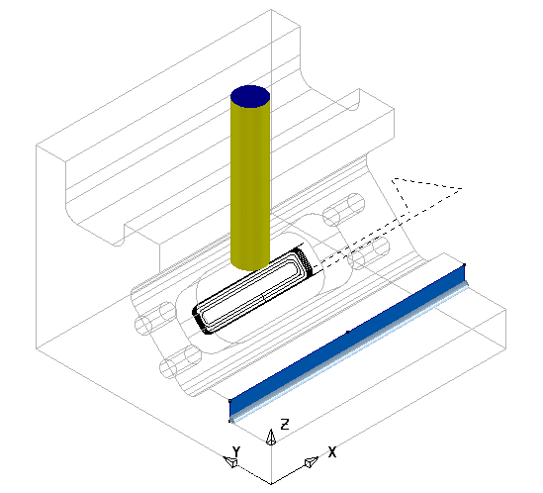

- Create a Swarf Finishing strategy named EM12-TopFin1 on the vertical surface as shown shaded above (Do not include the Boundary in the form).
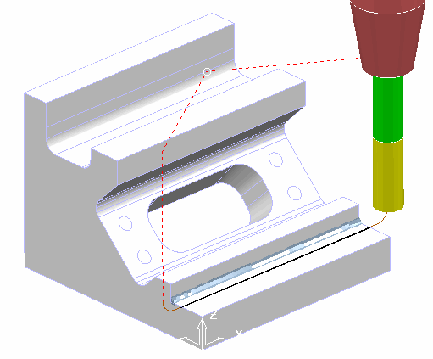

- Add the new toolpath EM12-TopFin1 to the Stock Model and Calculate to confirm that all excess material has now been removed.
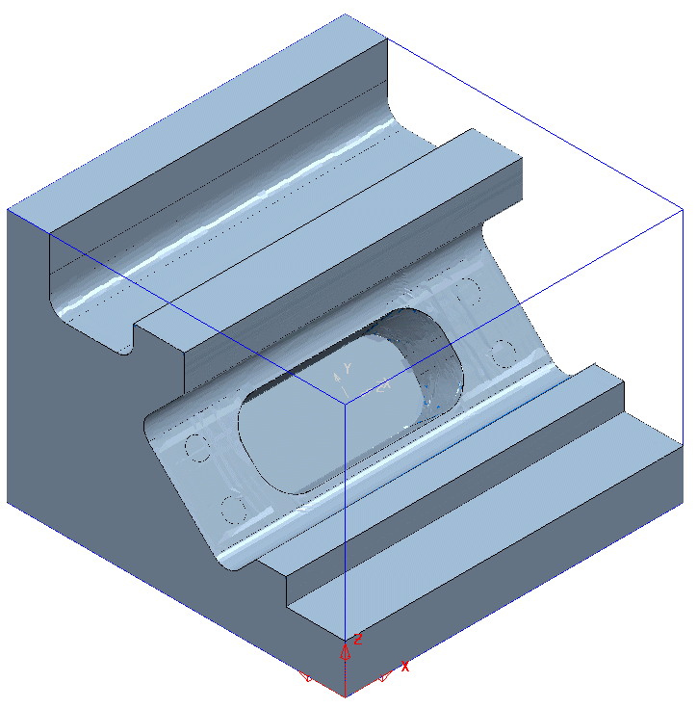

The Stock Model is only visible when the Show Rest Material option is un-ticked.

- Select File - Save to update the contents of the previously stored Project.

3+2 Axis - Drilling Example (For users with MultiAxis licence)

The PowerMILL - Drilling options operate on Hole Features and not directly on the Model. This enables drilling to take place without the need to modify or trim back the existing surface data. When the Multi-Axis option is ticked the Hole Features at different alignments will be created to a common workplane.

- Delete All entities and Import the model:- D:\users\training\PowerMILL_Data\five_axis\drill_5axis\drill5ax_ex1
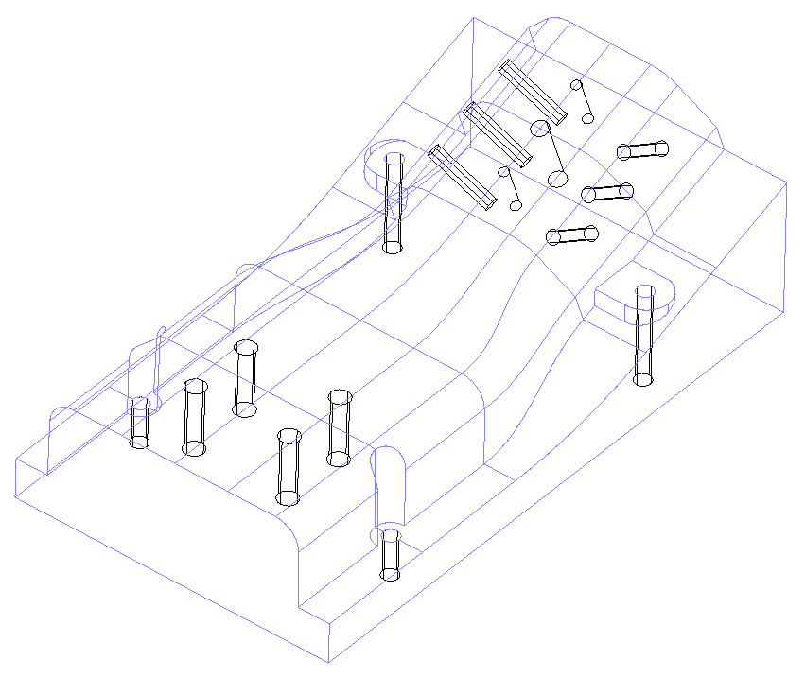

- Save the Project As:-
D:\users\training\COURSEWORK\PowerMILL-Projects\MultiAxisDrill-ex1

- Do Not define a material Block and if one already exists, delete it (Blue Cross at top right corner of form).

Any cylindrical surfaces within the selection will automatically be recognised as a Hole Feature. In this example, with no Block defined, the Hole Features will be arranged with the top at the end of maximum Z height.
If however, a Block is pre-defined, the orientation of an individual Hole Feature occurs with the top of the hole being nearest to the upper Z or lower Z, face of the material Block.
Note: It is possible, if required, to Reverse the Holes in a Feature Set using the local Edit options combined with dynamically selecting the affected Hole Features.
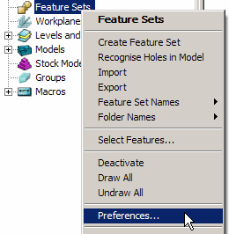
- Select the option Preferences.

This will open the Feature Form.

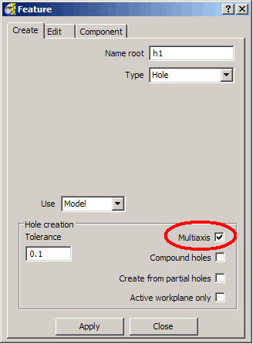
- Select all Surfaces displayed in the graphics area and select Create Feature Set entering the values into the form Exactly as shown.

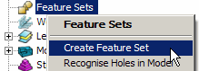

Once the option Type Hole has been selected the Multiaxis option must be ticked for a Multi Axis Hole - Feature Set to be created (All selected holes including those at different orientations will be input into the same Feature Set to a common Workplane).

- Apply and Close the form.

All cylindrical surfaces within the selection will automatically be recognised as Multiaxis Hole Features.

- Undraw the model to view the newly created Features.
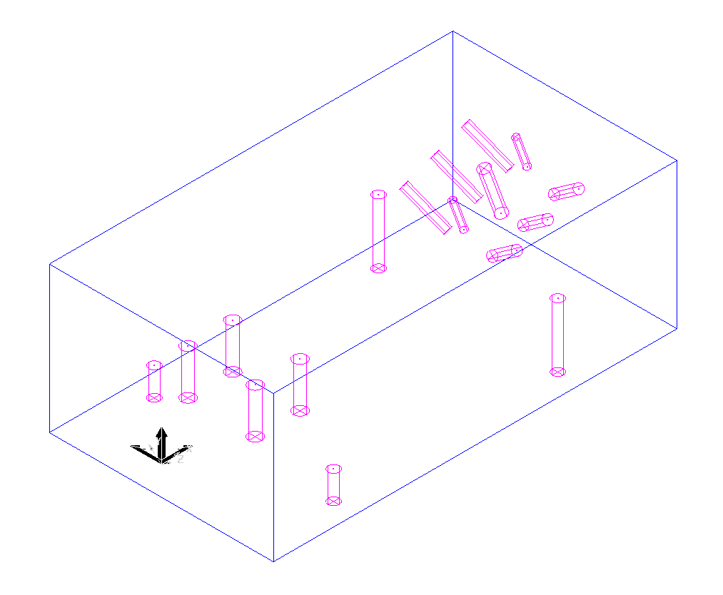

All 17 Holes in the Feature Set are correctly aligned, with the cross at the base representing the bottom of the hole.

- Create a material Block - Defined by - Box using Type Model.
- In the Rapid Move Heights (Safe Z, Start Z) form select Calculate.
- Set both the Start\End Points to Use - Block Centre Safe.
- Create a 5mm Drill (Named Drill5) of Length 60.
- Add a Shank component Upper\Lower dia 5 Length 30.
- Add a holder component Upper Dia 50 Lower Dia 30 Length 30 overhang 75.
- Add a holder component Upper Dia 50 Lower Dia 50 Length 30.

- SelectToolpath Strategies and in the Strategy Selector form select Drilling.
- In the Drilling form select the option Drilling.
- Rename the toolpath DRILL5.
- In the Drilling form click the Select tab to open the Feature Selection form.
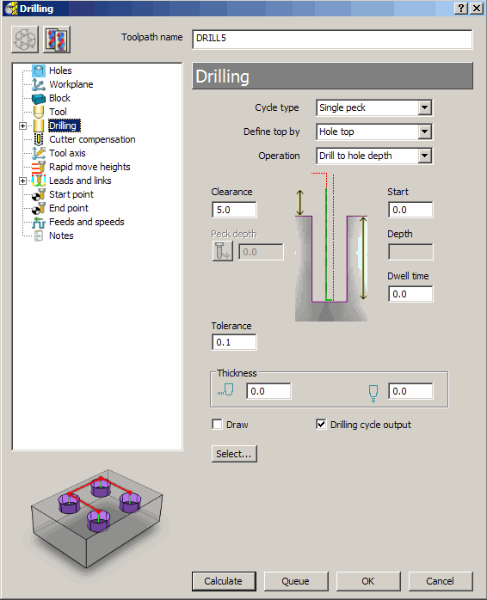

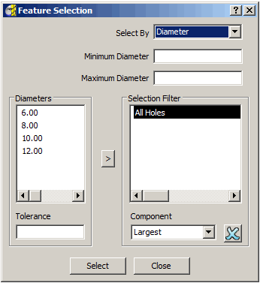

- Left mouse Click on the Select tab in the Feature Selection for all Hole Features will be selected in the Active - Feature Set.
- Close the Feature Selection form.
- Select Calculate to create the drilling toolpath, then Cancel the form.
- Simulate the Toolpath.
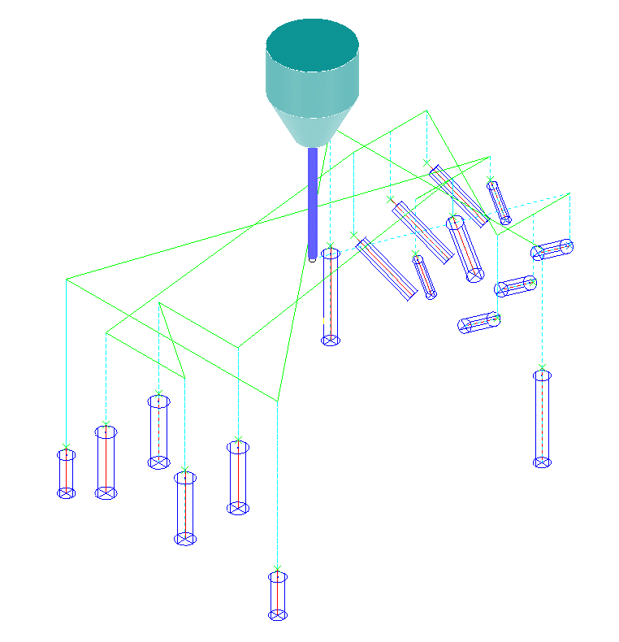

The Multiaxis options are automatically recognised enabling the user to create a single Feature Set from components that exist at different tool alignments and machine them in one go. Without the licence the Recognise Holes in Model option can be applied from the Feature Set menu to create separate 3+2 - Hole Features. This command segregates the Features into separate Feature Sets each with it’s own Workplane, to provide the necessary 3+2 - Z Axis alignment.

The two 6mm Hole Features are to be Tapped. The point angle of the 5mm Drill has left a conical shape at the bottom of the holes. When the holes are Tapped it will be necessary to stop short within the full diameter range by applying a suitable Axial Thickness value.

- Create a Dia 6mm Tapping Tool (Named TAP6) of Length 25.
- Add a Shank, Upper Dia 4, Lower Dia 4, Length 30
- Add a Holder, Upper Dia 30, Lower Dia 30, Length 30, Overhang 60.
- Select the two 6mm Hole Features in the Graphics Window.
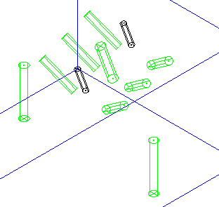

- SelectToolpath Strategies and in the Strategy Selector form select Drilling.
- In the Drilling form select the option Drilling.
- Rename toolpath TAP6.
- Set Cycle Type - Tapping, Operation - Drill to Hole Depth, and Pitch - 1mm.
- Input an Axial Thickness value of 5mm.
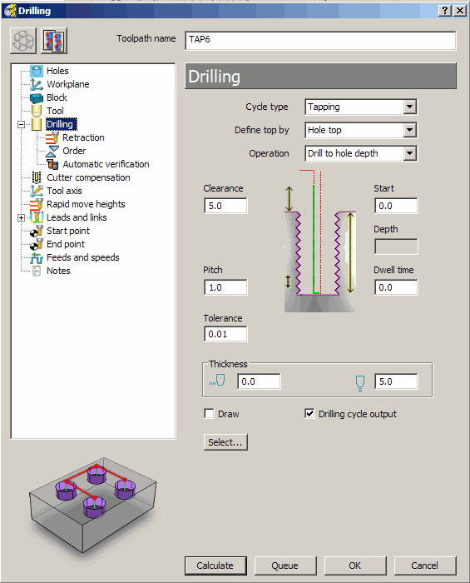

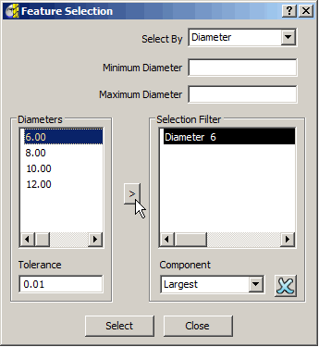

- Select the two Dia 6 Hole Features.
- Apply and Close the form to create the toolpath.
- View the model along the -Y axis.
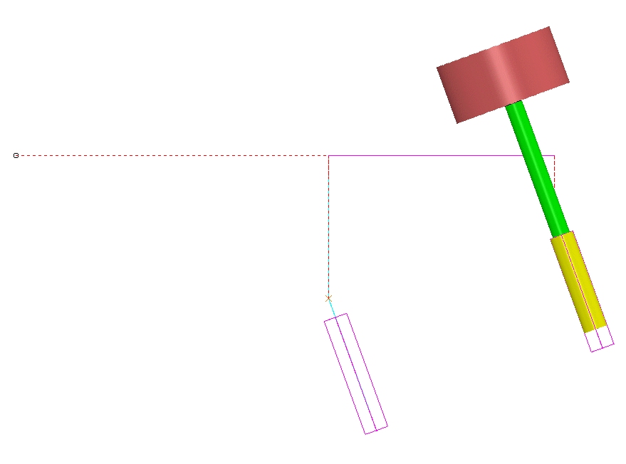

The selected holes have been Tapped to a distance 5mm short of the full depth.

- Select File - Save to update the contents of the previously stored Project.

