Apalachicola Maritime Museum

Guest Services
Procedures Training Guide

Strive for perfection. Find satisfaction in a job well done.

Table of Contents

Introduction 4
Overview 4
SGI Visitors Center Mission Statement 4
SGI Visitors Center Policies 5
Employee Information Worksheet 7
Employee Lesson completion Worksheet 8
Administrative Web Pages 12
Staff Admin Web Page 12
On The Clock 12
New Hire Paperwork to be completed 13
List of Web Browser Startup Windows 13
Grid of production links for trip selection 14
Web Store Trips Processing and Sales - Introduction 17
Background 17
Narrated Screen Shot of Nine Step booking / sales process 17
Trip Booking Policies 26
Quick links from web site and map 28
Getting Started with Training and Testing 28
Web Store Trips Processing and Sales - Lessons 29
Overview of types of transactions that will be utilized 29
Lesson One – On the water trips: Multiple trip bookings for one trip with credit card 33
Lesson Two – On the water trips (continued): Cash booking and Refunds 38
Lesson Three – On the water trips (continued) Transfer of passengers to other trips 41
Lesson Four – Zero cost “trips” used for Gift Shop, Consignments, Donations, Event receipts and other sales recorded as “Upgrades” in Step #5 43
Lesson Five – “Trips” used for Memberships, Museum Entry Fees, WBS classes & Raffle Tickets 50
Lesson Six - Discounts via Promotional Codes, Groups and Group discounts (Not Yet Complete) 56
Lesson Seven - Manual transactions when web is down 65
Lesson Eight - Visitor Center information gathering only, ie, no payments of any type 65
Lesson Nine – Open for Future use 65
Web Store Maintenance – Advanced training 66
Introduction 66
The hierarchy from Outfitters to Locations to Trips to Schedules 66
Reservations 66
Customers 66
Items 66
Promotions 66
Bundles 67
Transportation and Equipment 67
Users 67
Configuration 67
CSV exports into Excel analysis worksheets 67
Excel analysis with pivot tables 67
Document Image Workflow 67
Introduction- How to Scan and Save 68
Lesson One – Scanning of a TLW batch for Manifest Document Control 69
Lesson Two – Scans file routing via email 69
Lesson Three – Scanning DPR, OTH, INV, INS and other batches 70
Lesson Four – Scanning CCR batches for credit card expenditures 71
Lesson Five – Printing documents to a scan file 71
Lesson Six – Picture and Video Files 71
Cash Accounting 72
Introduction 72
Lesson One – Shift accounting 72
Lesson Two – Daily summary (DPR) 73
Lesson Three –Event Accounting (to be completed after Sat. night event) 74
Lesson Four – Complete Three Shift DPR 75
Lesson Five – Checks and other payments received via mail 75
Procedural Checklist 76
Introduction 76
Lesson One– Completing Procedural Checklist 76
Lesson Two – Advancements 77
Lesson Three – TBD 77
Lesson Four - TBD 77
Lesson Five - TBD 77
Log Sheets 79
Introduction 79
Lesson One – Web based log sheet 79
Artifact Accession Record Form 80
Introduction 80
Lesson One – Web based log sheet 80
Inventory Processes 81
Introduction 81
Lesson One – Daily transactions accounting 81
Lesson Two – Physical Counts 81

Introduction

Overview

Welcome to the Apalachicola Maritime Museum staff and team. The following training manual is intended to educate and train all new employees on the mandatory procedures and documents used at the Apalachicola Maritime Museum and St. George Island Visitor Center. The training manual is organized in a structured and hands on approach. Lessons and Exercises should be completed and submitted to the manager for review. The training manual can also be utilized for practice and review for current museum and visitor center employees.

SGI Visitors Center Mission Statement

The mission of the St. George Island Visitors Center is to provide a welcoming and educational environment for visitors to learn about the unique characteristics of Franklin County and St. George Island, to increase tourism and tourist spending, and to provide quality service to our visitors.
Goals:
- To positively impact the economic well-being of Franklin County through destination marketing and the promotion of local businesses.
- To promote Franklin County as a top leisure tourism destination through a broad program of advertising, public relations, social media, Internet marketing, promotions, research, and other marketing strategies.
- To encourage visitors to discover the historic, cultural and recreational opportunities available and the factors that make us an outstanding destination.
- To invite people to be our guests, encourage them to stay, and to return again.
- To further our image as a great place to visit, to attract increased numbers of travelers, and to increase tourist spending.
- To increase year-round tourism through awareness of our commercial and natural resources, and our entertainment, recreational, cultural and historical opportunities.
- To assist visitors in creating the perfect getaway based on their interests and preferences.

SGI Visitors Center Policies

The function of the SGI VC is to promote tourism to SGI and Franklin County in a friendly and professional atmosphere.

- Any business is allowed to display brochures, flyers, or posters. The only exception has been real estate sales info, since most tourists are not looking to buy and space is limited.
- Brochures should be continually restocked as they get low. If we run out, call the business and let them know.
- Staff should learn the answers to frequently asked questions and be knowledgeable of Franklin County and its attractions, restaurants, etc.
- Staff should be familiar with the locations of brochures and how to find information on request.
- The Franklin County Visitors Guide (blue booklet) and accompanying map should be pointed out to all visitors and a few of each left in the plastic box by the front door. These are the official publications of the Franklin County Tourist Development Council, which contracts with us to run the center.
- We must not say anything negative about any business.
- When asked for recommendations of restaurants, etc., try to find out what type the person is interested in and point out the variety. Avoid referring to personal favorites exclusively. Refer to the guide book in #5.
- Focus on Franklin County businesses.
- Ask each visitor to sign the guest log. Point out that by giving their email address, they will receive a newsletter with lodging specials, events, festivals, deals, activities, etc.
- Be sure to use the counter to record the number of visitors.

Employee Information Worksheet

You should record the following information to be used in your training as you come up to speed on what it takes to work in Operations at AMM and SGI.
- Web based time clock
  - Employee # _______
  - Email: __________________________________
  - Password: AMMFL
- Store.riverecologic.com for simulated customer activity
  - User email: _________________________________
  - Password: _________________________________
- Store.riverecologic.com/admin for staff administrative processes
  - Admin login: _________________________________
  - Password: _________________________________

Employee Lesson completion Worksheet

You should record the completion of the lessons in this guide in the grid below and review the results with your manager. Note that this worksheet can be printed from the Procedures worksheet using the VCPTG tab.
Visitor Center Procedure Training Guide Training Track
Use with the VCPTG manual | Staff |  | Date
Contents description | Date Complete | Staff initials | Manager Review | Score
Introduction
Overview
SGI Visitors Center Mission Statement
SGI Visitors Center Policies
Employee Information Worksheet
Employee Lesson completion Worksheet
Administrative Web Pages
Staff Admin Web Page
On The Clock
New Hire Paperwork to be completed
List of Web Browser Startup Windows
Grid of production links for trip selection
Web Store Trips Processing and Sales - Introduction
Background
Narrated Screen Shot of Nine Step booking / sales process
Trip Booking Policies
Quick links from web site and map
Getting Started with Training and Testing
Web Store Trips Processing and Sales - Lessons
Overview of types of transactions that will be utilized
Lesson One - TRIPS : Multiple trip bookings for one trip with credit card
Exercise one: Trip Booking using a credit card
Exercise two: Trip Booking with a product add on at Step 5
Exercise Three: Trip Manifest- Required Documentation and Paperwork
Final Exercise: Self Evaluation and manager Review
Lesson Two - TRIPS : Cash booking and Refunds
Exercise One: Cash transaction booking via the web store admin page
Exercise Two: Perform a refund on the second transaction created in Exercise one of Lesson One
Final Exercise: Self Evaluation and manager Review
Lesson Three - TRIPS : Transfer of passengers to other trips
Exercise One: Transfer a passenger to the same trip on a second date
Final Exercise - Self review of results and submittal for manager review
Lesson Four - Gift Shop, Consignments, Donations, Event receipts and other sales recorded as Upgrades to a $0 cost trip (start using a new Trip Date at this point)
Exercise one: Gift Shop sales
Exercise Two: Consignment sales
Exercise Three: Event Tally
Exercise Four: Donations
Exercise Five: End of Shift Coffee/Tea fund
Final Exercise – Self review of results and submittal for manager review
Lesson Five - Memberships, Entry Fees, WBS classes & Raffle Tickets recorded as Trips
Exercise One: Museum Entry Fees paid via Credit Card
Exercise Two: Museum Entry Fees paid via Cash
Exercise Three: Museum Entry Fee
Exercise Four: Event Entry Fee
Exercise Five: Wooden Boat School classes
Exercise Six: Raffle Tickets
Lesson Six - Discounts via Promotional Codes, Groups and Group discounts
Lesson Seven - Manual transactions when web is down
Lesson Eight - Visitor Center information gathering only, ie, no payments of any type
Lesson Nine - Open for future use
Web Store Maintenance – Advanced training
Introduction
The hierarchy from Outfitters to Locations to Trips to Schedules
Reservations
Customers
Items
Promotions
Groups
Transportation and Equipment
Users
Configuration
CSV exports into Excel analysis worksheets
Excel analysis with pivot tables 49
Document Image Workflow
Introduction- How to Scan and Save
Lesson One - Scanning of a TLW batch for Manifest Document Control
Lesson Two - Scans file routing via email
Lesson Three - Scanning DPR, OTH, INV, INS and other batches
Lesson Four - Scanning CCR batches for credit card expenditures
Lesson Five - Printing documents to a scan file
Lesson Six – Picture and Video Files
Cash Accounting
Introduction
Lesson One - Shift accounting
Lesson Two - Daily summary (DPR)
Lesson Three -Event Accounting (to be completed after Sat. night event)
Lesson Four - Complete Three Shift DPR
Lesson Five - Checks and other payments received via mail
Procedural Checklist
Introduction
Lesson One- Completing Procedural Checklist
Lesson Two - Advancements
Log Sheets
Introduction
Lesson One - Web based log sheet
Artifact Accession Record Form
Introduction
Lesson One - Web based log sheet
Inventory Processes
Introduction
Lesson One - Daily transactions accounting
Lesson Two - Physical Counts

Administrative Web Pages

Staff Admin Web Page

The web page at staff.Ammfl.org/admin.htm website contains mandatory and useful information for the everyday operations of the Apalachicola Maritime Museum. This website is continuously updated with important links and information. It is essential for all new hire to become familiar with this website.
New hire should complete the following from this website:
- Employee and Contractor Applications:
- Print and fill out form AMM New Hire Packet and submit to manager
- Read and sign the Employee Manual and submit to manager
- Go over safety manual, activity hazards analysis and safety documents
- Open and learn the format for the Staff Schedule, explore the legends tab and read all of the scheduling policies and procedures
- Open and understand all links under the Procedural Checklist, Policies, and Forms section

On The Clock

The website www.ontheclock.com is an online payroll system used to keep track of all employee hours.
There are two ways used to clock in using ontheclock.com
- Login on the designated “group punch in” computer using your employee number. Here you type in your employee number then select the punch in button. Be sure to scroll down in the Exercise bar to select your job detail. Ex. Guest Services_AMM
- Login from any computer using your email address. The password will always be AMMFL. Select job description from Exercise bar before selecting the punch in button.

Note the area to add additional pertinent information job description, add if needed

New Hire Paperwork to be completed

All new hires must complete the necessary paperwork which can be accessed from the Staff Admin Web Page and have these documents scanned in as a NHP. Other required elements of a New Hire Package include

- George Floyd is the only one who will be assigning OTC numbers for all new hires. It needs to be this way to keep payroll process working correctly.
- BEFORE any new hire starts work a correctly completed New Hire Package must be prepared. This should be selected from staff.ammfl.org/admin.htm option 1.c for the Contractor application
- This MUST have a voided bank document provided that clearly shows bank routing number and bank account number. Handwritten bank information IS NOT acceptable.
- The form MUST be completed in the entirety with all information legible and a valid email address.
- It is best to get this information to me at least a week before the person is to start work to give me time to review and set it up.

NO ONE SHOULD START WORK UNTIL AN EMPLOYEE NUMBER IS SET UP AND ASSIGNED ON OTC !!!!!

List of Web Browser Startup Windows

In the web browser, the following should be the windows opened on start of the browser window
- staff.AMMFL.org/admin.htm – Administrative page used for schedules, procedures and many other commonly used documents
- store.RiverEcoLogic.org – The public web store. Used for Charge Card transactions
- store.RiverEcoLogic.org/admin – Used for AMM staff processes such as booking cash transactions and generating reports for trip manifests, etc.
- Trips link page and map <GKF to provide>
- staff.AMMFL.org /Procedural.xls
- staff.AMMFL.org /Schedule.xls
- www.AMMFL.org – The AMM public page
- www.saltyflorida.com/ - TDC web page
- www.seestgeorgeisland.com – St. George Island Visitor Center web site maintained by AMM staff

Grid of production links for trip selection

Following is a grid that lists trips by category in the same order that they are listed on the web store. Clicking on the link will take you to step 3 of the trip booking process. This is similar to the grid on the public web site.
Tour description / Vessel | Trip Title | Cash  walk-in | Web store
Visitor Center | Gift Shop sales | 0.00 | 0.00
Visitor Center | Consignment Sales - Caty Green | 0.00 | 0.00
Visitor Center | Museum entry fee | 5.00 | 4.00
Visitor Center | Lecture event entry fee | 5.00 | 4.00
Visitor Center | Membership - Mate (Individual) | 25.00 | 20.00
Visitor Center | Membership - Crew (Family) | 50.00 | 40.00
Visitor Center | Membership - Captain (Sponsor) | 100.00 | 80.00
Visitor Center | Donations | 1.00 | 0.80
Visitor Center | Raffle tickets | 5.00 | 4.00
Motor Vessel Tours | Working Waterfront Heritage | 15.00 | 12.00
Motor Vessel Tours | Sunset Dinner | 25.00 | 20.00
Motor Vessel Tours | Estuary Educational | 40.00 | 32.00
Motor Vessel Tours | Estuary - Little St. Marks afternoon gator tour | 40.00 | 32.00
Motor Vessel Tours | Estuary - Jackson River to Lake Wimico waterway exploration | 40.00 | 32.00
Motor Vessel Tours | Ships Channel to Little St. George Island | 50.00 | 40.00
Motor Vessel Tours | Two Mile Channel to St. Vincent Island | 50.00 | 40.00
Motor Vessel Tours | Full Moon | 25.00 | 20.00
Kayak and Canoe | Kayak/Canoe from Museum Dock, 1/2 day | 10.00 | 8.00
Kayak and Canoe | Kayak/Canoe from Museum Dock, Full day | 20.00 | 16.00
Kayak and Canoe | Kayak/Canoe from Museum Dock, Scipio creek to Museum Docks | 25.00 | 20.00
Kayak and Canoe | Kayak/Canoe from Museum Dock, Breakaway Lodge to Museum Docks | 35.00 | 28.00
Sail Trips | Heritage booking for four to six, Half day | 250.00 | 200.00
Sail Trips | Heritage booking for four to six, Full day | 500.00 | 400.00
Sail Trips | Heritage booking for four to 24 hours or more | 1000.00 | 800.00
Sail Trips | Ron's sail boat, Half Day | 50.00 | 40.00
Sail Trips | Ron's sail boat, Full Day | 50.00 | 40.00
Sail Trips | Sailing instruction | 50.00 | 40.00
Chattahoochee Trips | Paddle trip from Chattahoochee to Apalachicola | 250.00 | 200.00
Chattahoochee Trips | Power boat trip from Chattahoochee to Apalachicola | 500.00 | 400.00
Chattahoochee Trips | Eight Day Trip in the Fall | 1000.00 | 800.00
Wooden Boat School | Build a Plywood Canoe | 20.00 | 16.00
Wooden Boat School | Build a Gunter Sloop Rigged Passagemaker
Wooden Boat School | Build a 14' Wood Duck Kayak | 10.00 | 8.00
Wooden Boat School | Build a Stand Up Paddle Board | 25.00 | 20.00
Wooden Boat School | Build an Annapolis Wherry Rowing Shell | 35.00 | 28.00
ZZZ Test Trips | ZZZ - Test Trip #1 | 0.10 | 0.08
ZZZ Test Trips | ZZZ Gift Shop sales | 0.00 | 0.00
ZZZ Test Trips | ZZZ Gift Shop Sales on Consignment for XXX vendor | 0.00 | 0.00
ZZZ Test Trips | ZZZ Museum Entry | 0.05 | 0.04
ZZZ Test Trips | ZZZ Membership - Mate (Individual) | 0.25 | 0.20
ZZZ Test Trips | ZZZ Donations | 0.00 | 0.00
ZZZ Test Trips | ZZZ Raffle tickets | 0.20 | 0.16

Web Store Trips Processing and Sales - Introduction

Background

The Web Store at Store.Riverecologic.com is used on a daily basis to check trip bookings at the Apalachicola Maritime Museum. It is designed as an online booking system where clients can book trips, donate to the museum, or buy items from their home computers. Additionally it allows staff to enter and book trips for clients in person or over the phone when logged in on the admin site at store.riverecologic.com/admin. This site keeps track of all trip bookings, credit card and cash transactions to be used for accounting processes as well.

Narrated Screen Shot of Nine Step booking / sales process

The flow of the web store goes through the following distinct steps when started directly from Store.Riverecologic.com. When a trip is accessed from a map or table link that lists the trip name, the web flow begins at Step 3. The steps in the booking process are described below. Use this when you are going through the web booking process as a guide to learn how the process flows. Use this whenever you need a refresher.
Step 1: Select an Outfitter – When you access Store.Riverecologic.com this is the home page you are taken to. The web store supports multiple outfitters that are all listed in alphabetical order on this first page.. When you are working with this training guide you will be using the ZZZ - Test Outfitter. When you are working production trips for the AMM, you will be using the Apalachicola Maritime Museum link. Select the outfitter you want by clicking on the name link or the select button below the narrative which describes the outfitter. This will take you to the Step 2 web page. Following is an example of the Step 1 Outfitter selection page.
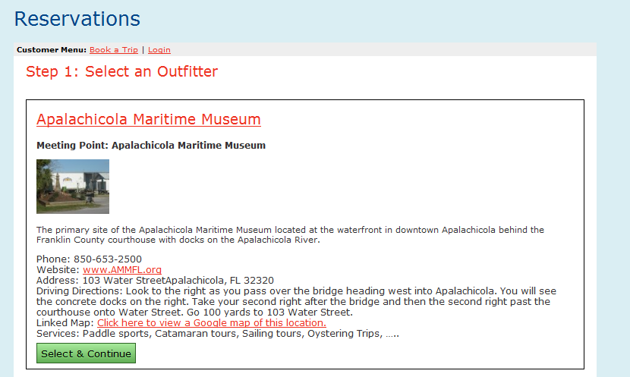

Step 2: Select a Trip – This page lists all of the products and services that are available for this outfitter. This includes trips, memberships, donations, museum access fees and raffle tickets. Any and everything that is bought by visitors such as gifts, products, food and beverages, is recorded under a Museum Store Visit “trip” on the list of items shown here (and on the Step 5 Upgrades screen below). The order is set up by the web store administrator where the most commonly accessed items are at the top. Find the trip or other products you are looking for by scrolling down the page or using the search option (Control-F) and typing in the unique characters that would be found in the name of what you are looking for like “Sunset” for Sunset Cruise to find the listing of the trip. If there are multiple listings for the search term you used, you may need to scroll through the matches by using the next or previous arrows. Select the trip or product you want by clicking on the name link or the select button below the narrative which describes the trip or product. This will take you to the Step 3 web page. Following is an example of the Step 2 Trip selection page showing the first trip, Working Waterfront Heritage, listed below the Outfitter description repeated at the top of the screen.
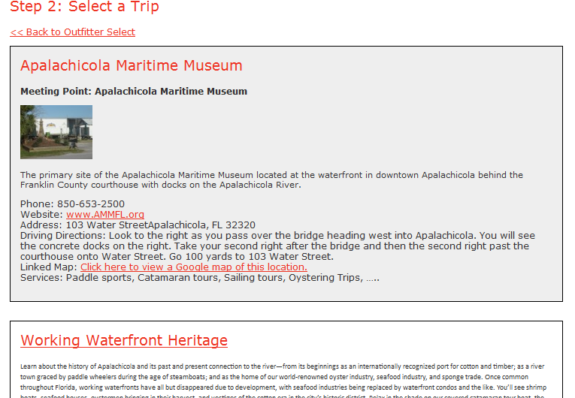

Step 3: Select passenger count– This page prompts for the number of passengers that will be included within this reservation. The drop box allows for selection of a quantity up to the maximum number of persons allowed on the trip that are still available. For instance if the maximum quantity for the trip is 24, and 8 seats have already been reserved, then the maximum that the drop box will show is 16. The information below the green Select button lists the same trip information as shown on Step 2. After you select the number of passengers click the green Select button to proceed to the next page. Following is an example of the Step 3 Select Passenger Count, page showing the selection of 3 passengers.
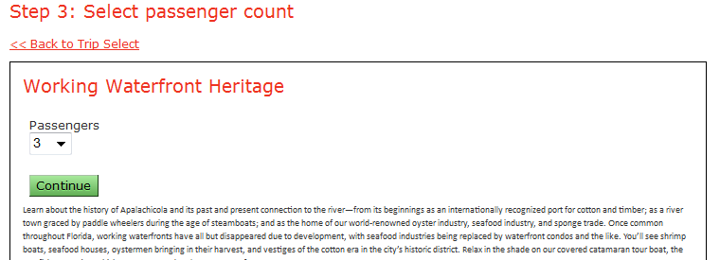

Step 4: Please select a date/time from the available trips - This presents a calendar showing the dates available for booking as dark shaded dates with a time and green number indicating the number of spaces still available on the trip. For instance, in the February 7th date shown below the date is available and departs at 11 AM and has 24 seats available. Note that the trip time is determined by the computer system based on scheduling decisions that optimize trip efficiency, avoid schedule conflicts with equipment, captain and crew as determined by the web store administrator and cannot be changed. New trip times may open up after the initial trip is filled.
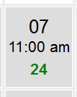
Click on the date desired the green Select button to proceed to the next page. Following is an example of the Step 4 Date/Time selection with February 7th highlighted.
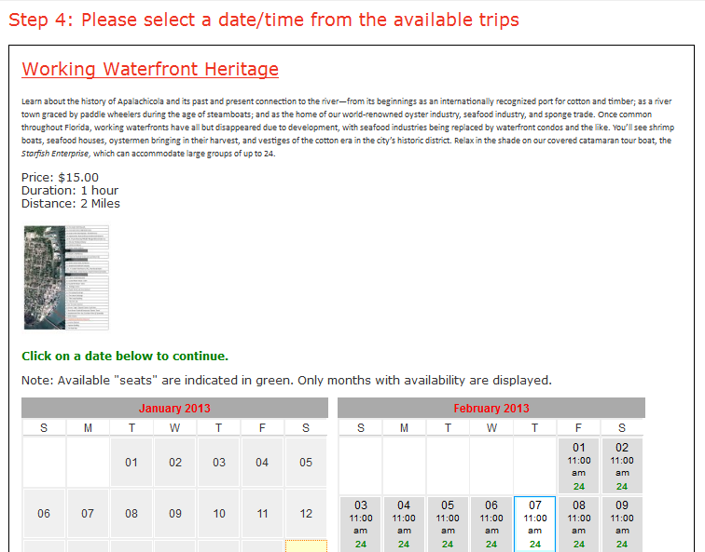

Step 4a: User Login / Account Creation - This presents the opportunity for a customer user to either sign in to their existing account if they have one or to create a new account. If the user is already logged in, this screen will be bypassed. If not already logged in, the user will be taken to the next step of the booking process before continuing with the booking. If it is a first time user, the user will be required to use the create a new account link which will take them to the next step below. Following is an example of the Login web page.
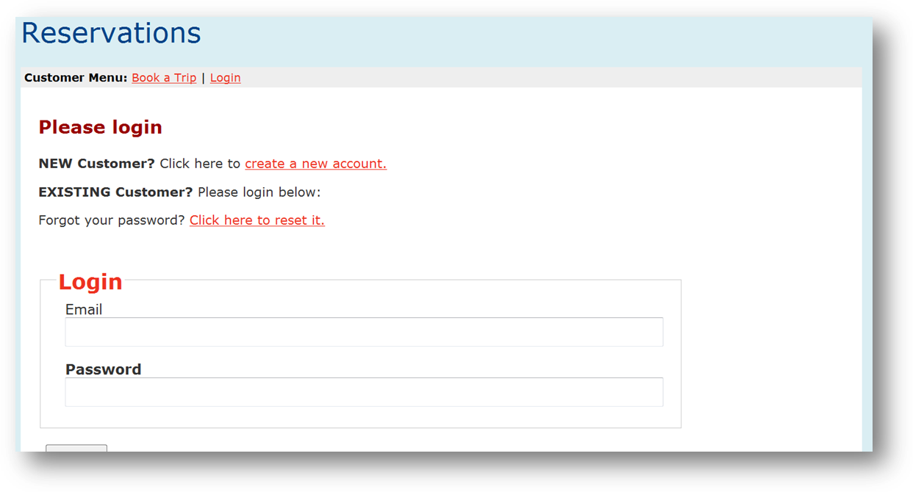

Step 4b: Create New Customer Account – From this page the new customer will fill in all of the spaces below the Add Customer label and then click the Submit button at the bottom of the page. Alternatively the Customer can return to login or click the link to reset the password. If the password reset link is clicked, an email with a new password is sent to the customer which will allow them to login after receiving the email. If you are booking the trip though the staff admin page, there will be no prompt for the creation of customer information. Following is an example of the Account Creation web page.
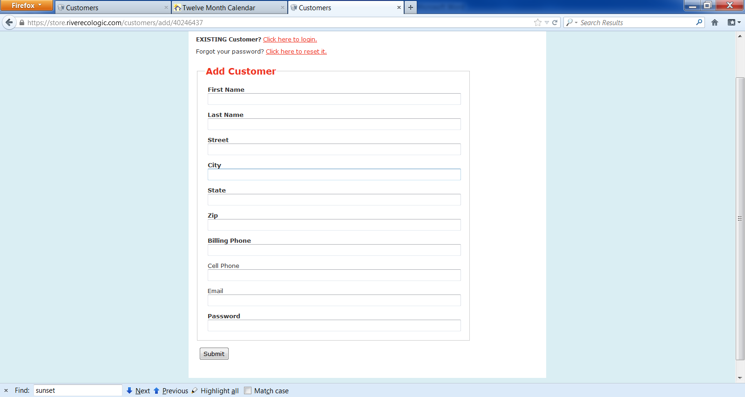
Step 5: Select Upgrades - This presents a list of items that can be purchased in conjunction with the trip or other purchase. Items are added by selecting the quantity listed under each item using the drop box. If no items are to be added, then leave all Quantities at zero. When you have completed the Upgrade selections, proceed to the bottom of the page and click the green Select button to proceed to the next page. Following is an example of the Upgrades web page.
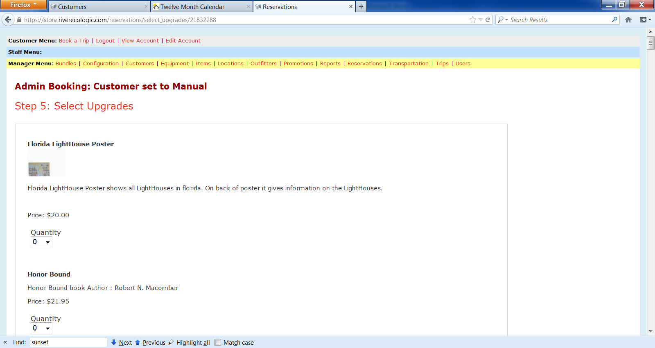
Step 7: Confirmations – This page contains four elements that must be reviewed and completed. The four sections are contained in box outlines on the page with a light green descriptive label shown in each one. They are described below
- Details - Provides an accounting recap of the purchases and has a link that allows the addition / Removal of upgrades. Verify this information is correct and complete before proceeding. If wrong, use the back arrow to go back and correct. A sample screen is shown below
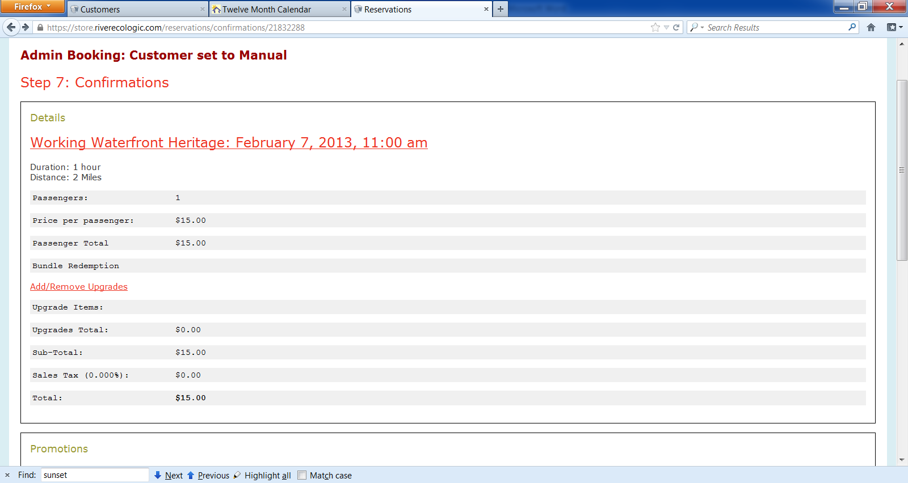
- Promotions – Provides for entry of a Promotional code that provides a discount on the trip (not applied to Upgrades). If you have a Promo code enter it here and then click . You will note that the pricing in the Details section above is changed when this is done to show the amount of the discounted net price. See the sample screen below showing the discounted price after entering the WebStore code which resulted in a 30% discount.
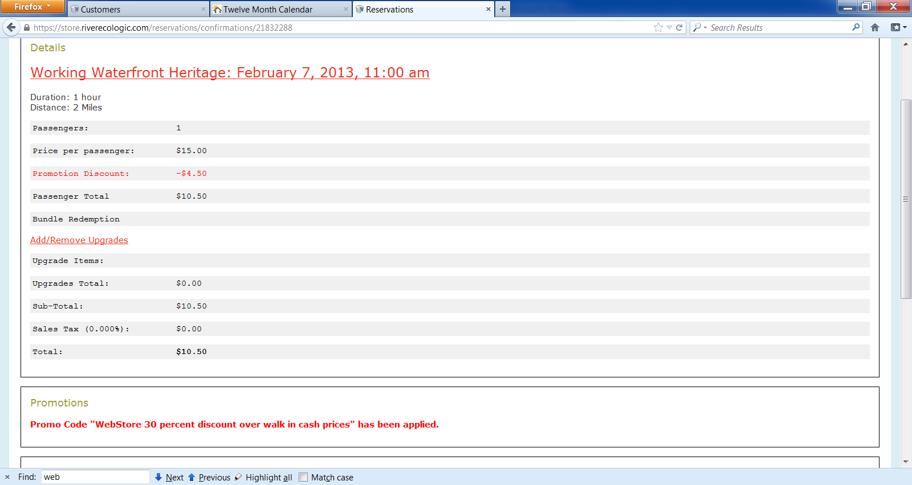
- Passengers – Provides for selection of adult/minor status and entry of the name for each passenger. See the sample screen below showing the entry of the name John Doe as the passenger for this trip.
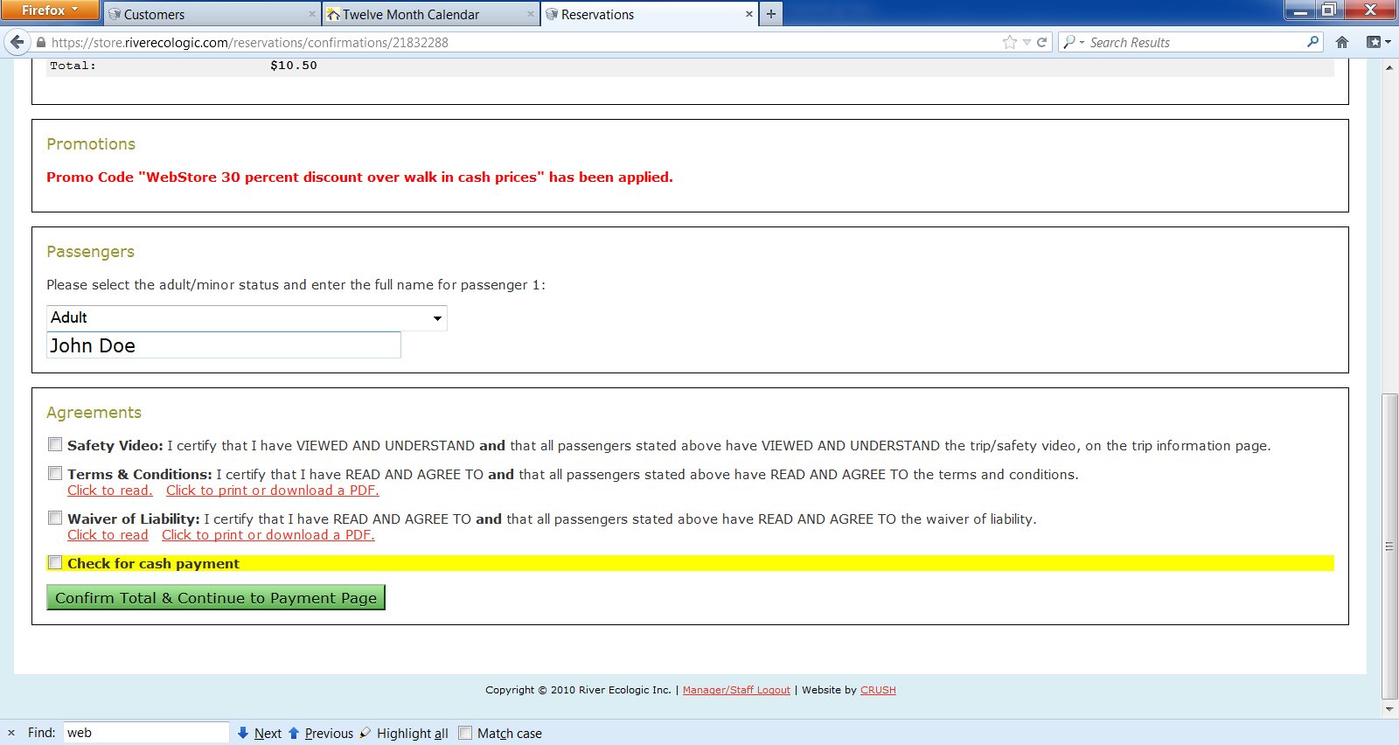
- Agreement – Provides for viewing of the following to establish the legal relationship with the passenger a) Safety Video, b) Contract Terms & Conditions and c) Waiver of Liability. These can be viewed within the web store by clicking the Click to read or print or download options. The passengers will be required to sign a printed copy of these documents prior to departure in addition to these web signoffs. All boxes must be clicked prior to continuing. If you are working in the Staff portion of the web store, there is a in yellow to be clicked if this is a Cash transaction. Once all of the selection boxes have been completed, click 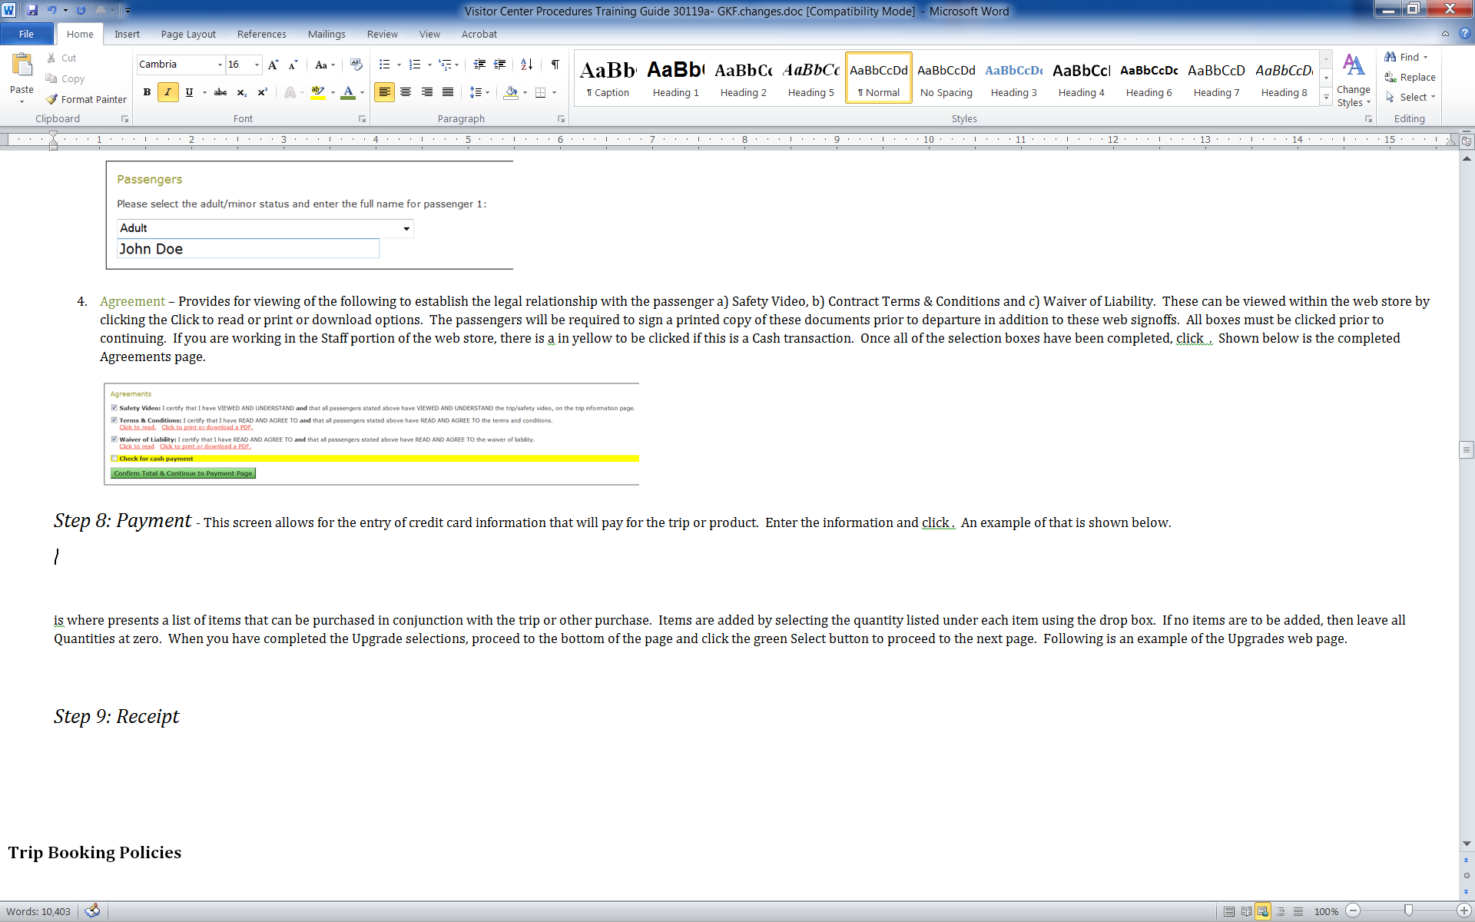. Shown below is the completed Agreements page.
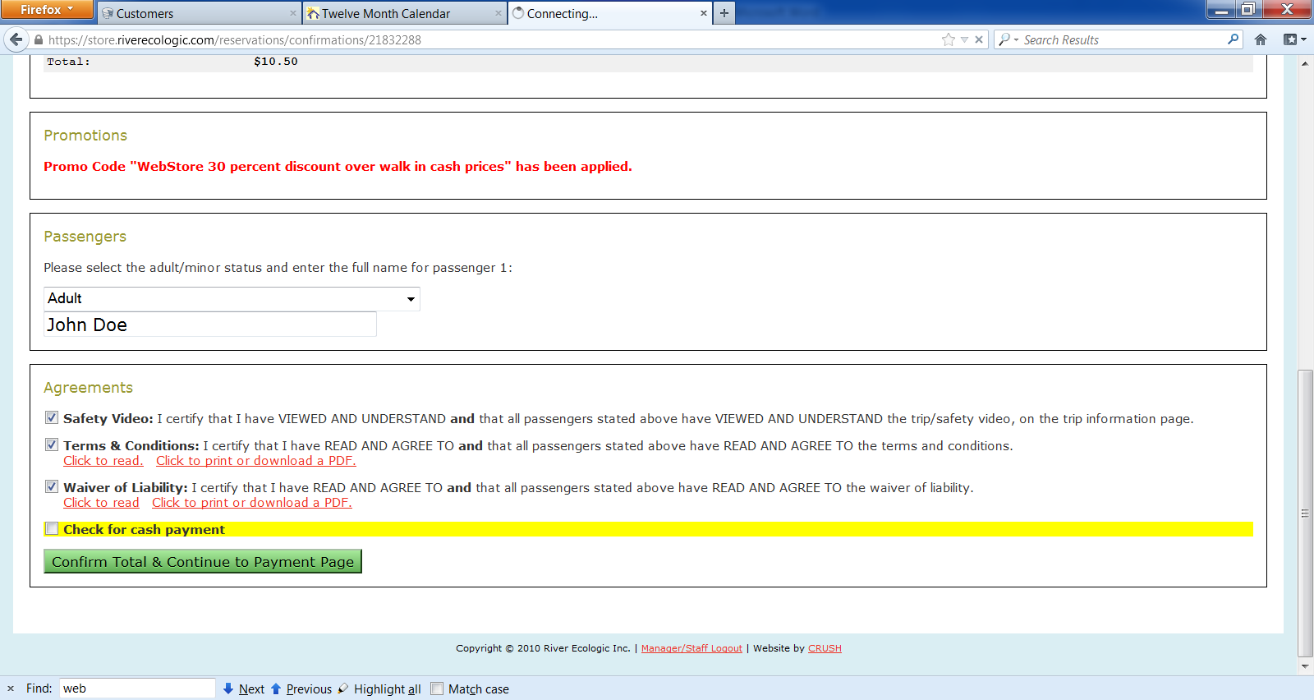

Step 8: Payment - This screen allows for the entry of credit card information that will pay for the trip or product. Enter the information and click 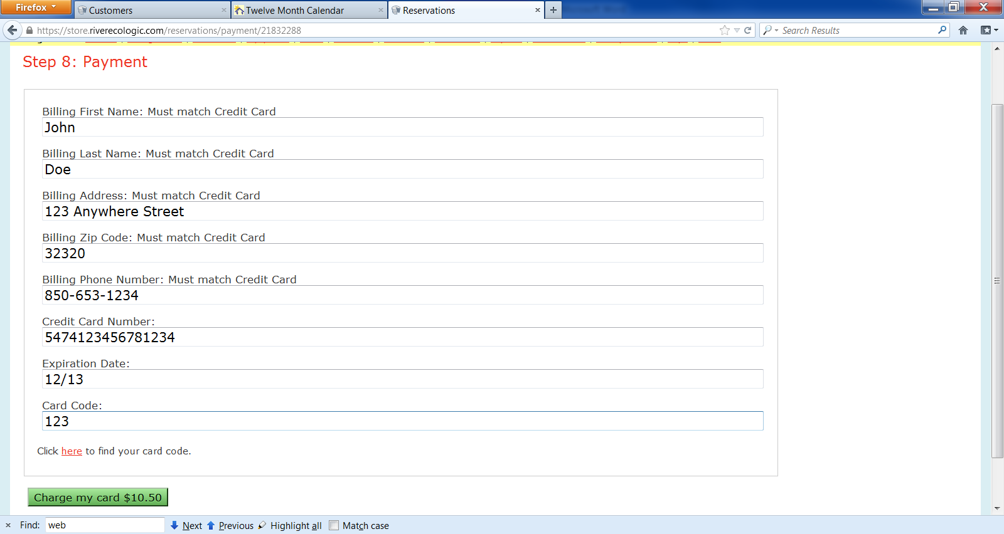. An example of that is shown below.
If the transaction was created from the Staff admin page, and selected to be a Cash Transaction, this screen is skipped and goes directly to the next page.

Step 9: Receipt - This screen shows the receipt for the transaction which can be printed for the customer if a cash transaction. If done via a customer account using a credit card, the receipt is emailed to the customer. Below is an example of the receipt screen. Note that the bottom of the screen provides an ability to Cancel the trip or purchase.
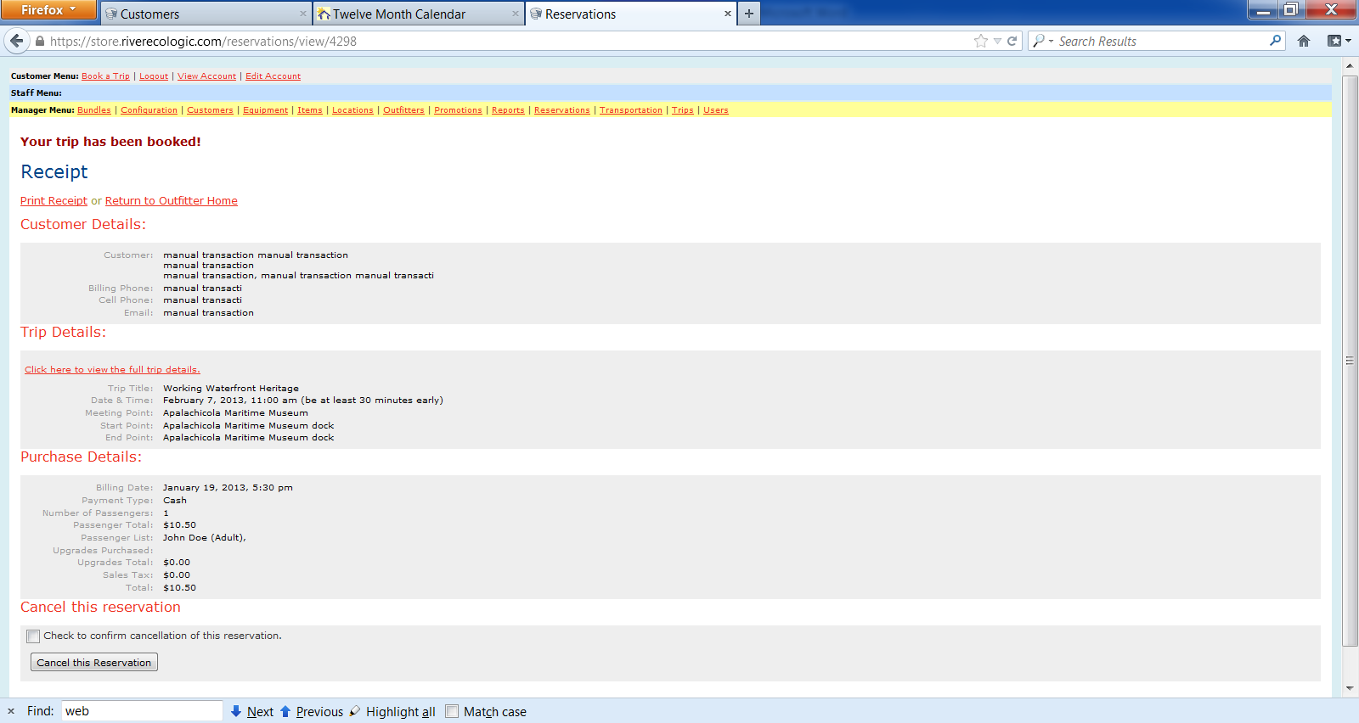

Trip Booking Policies

Always be familiar with upcoming trips that are already have passengers booked anytime on the current date or in the upcoming 7 days out. Do this by using the web store admin page Report option and select the End Date for the current date plus 7. Passengers can be added to an existing trip with no planning of availability of the captain and crew. Booking for the initial passengers on a trip that is not already established requires coordinating with captain and crew to ensure they are available or able to find backup. Generally new trips require overnight notice so that the trip takes place the following day or beyond. This is so captains and crew can check weather, etc and confirm the trip is good to go.. Call the primary captain on the web schedule, preferably by noon the day before, or as soon as possible after booking. The exceptions to this rule are:
- If you have a large group of 10 or more people, we will try to accommodate a same-day booking by contacting available captains and mates (if more than 6).
- There is a previously scheduled trip and you are adding new customers to it.
Our captains are listed on the Schedule and contact information is located there as well.
A mate is required if there are more than 6 passengers. Give as much notice as possible. The mates and their contact information is also located on the Schedule.
All reservations must be prepaid. Payment in advance reduces the odds of cancellation and cuts down on everyone’s time during pre-departure procedures. We will accept payment in-store or credit cards over the phone. Make sure to complete the booking process while the customer is present or on the phone to ensure you have all information. Get a phone number to call the customer in case of weather delay, etc.
Cancellations by the customer may be made for a full refund if 24 hours advance notice is given. Otherwise, no refunds will be given. If we cancel a trip due to weather or other circumstances, a full refund will be given.
Customers should arrive a minimum of 30 minutes prior to departure time. If you have many customers on a trip, you may wish to stagger their arrival times to avoid having too many people lined up to sign paperwork at one time (for example, tell one family to arrive 25 minutes early and another to arrive 30 minutes early). Trips with only a few passengers need less time.
Communication among Visitor Center staff will make things easier for everyone. We should try to consolidate people when we can. If one of us books a trip, the others should be notified as soon as possible via email or phone call so that we can all try to direct new customers to existing trips.
Everyone booking trips needs to go on trips so that they know the product they are selling. Employees and volunteers can go on unlimited trips in their off time free of charge. You may bring guests as long as there is space available. Guests must be booked using the “freetrip” promo code, be part of the manifest, and sign waivers. In other words, they must follow the same procedures as paying customers.
Credit card transactions should always be booked from the Customer menu so that we capture the visitor email address and other information.

If the yellow menu bar is present at the top of the screen, be sure to go to the bottom and click the logout button before starting the booking for a credit card transaction.

Quick links from web site and map

Many trips can be opened directly from the quick links or web site map <GKF to insert>

Getting Started with Training and Testing

This training and testing process will allow you to learn how our web store, Store.Riverecologic.com, will be used in conjunction with our document scanning process to account for all kinds of transactions from educational trips to gift shop sales to lecture events and beyond. You will be doing the initial training as if you were a customer using the web store from their home or when you are booking for a customer at the visitor center. You will then learn how to use the administrative menus of the web store to produce documentation and check in processes.
You will use the information provided by your manager in the Employee Information Worksheet in all of the testing processes that you do. You will use the dates from the EIS to book the transaction tests noted below. You will scan files in the names provided by your manager as well to support review and learning.

Web Store Trips Processing and Sales - Lessons

Overview of types of transactions that will be utilized

You will use the information provided by your manager in the Employee Information Worksheet in all of the testing processes that you do. You will use the dates from the EIS to book the transaction tests noted below. You will scan files in the names provided by your manager as well to support review and learning.

Following is a grid of the transaction types which you will use for the web store transactions test. Clicking the links below will save you time by going directly to the Step #3 in the booking process for the trip thereby skipping the Outfitter and Trip selection screens.
Tour description / Vessel | Trip Title | Cash  walk-in | Web store
ZZZ Test Trips | ZZZ - Test Trip #1 | 0.10 | 0.08
ZZZ Test Trips | ZZZ Gift Shop sales | 0.00 | 0.00
ZZZ Test Trips | ZZZ Gift Shop Sales on Consignment for XXX vendor | 0.00 | 0.00
ZZZ Test Trips | ZZZ Museum Entry | 0.05 | 0.04
ZZZ Test Trips | ZZZ Membership - Mate (Individual) | 0.25 | 0.20
ZZZ Test Trips | ZZZ Donations | 0.00 | 0.00
ZZZ Test Trips | ZZZ Raffle tickets | 0.20 | 0.16

Following is the outline of all lessons in the Web Store training

- Trips – These are the primary function of the web store to support our educational excursions. The following lessons will cover these transaction types
  - Lesson One – Multiple trip bookings for one trip with credit card. Same process that is performed by a person booking from home or credit cards from the museum Store.
    - Task one: Trip Booking using a credit card
    - Task two: Trip Booking with a product add on
    - Task Three: Trip Manifest- Required Documentation and Paperwork
    - Final Task: Self Evaluation and manager Review
  - Lesson Two – Cash booking and Refunds.
    - Task One: Cash transaction booking via the web store admin page
    - Task Two: Perform a refund on the second transaction created in Task one of Lesson One
    - Final Task: Self Evaluation and manager Review
  - Lesson Three – Transfer of passengers to other trips.
    - Task One: Transfer a passenger to the same trip on a second date.
    - Final Task – Self review of results and submittal for manager review
- Lesson Four – Gift Shop sales recorded as Upgrades to a trip or “Museum Store Visit” trip – These are items that can be added to Trips or to the Museum Store Visit as add on Upgrade items. In Step 5 The following lessons will cover these transaction types
    - Exercise 1 - Gift Shop sales. The gift shop “trip” charge is $0.00 and the items to be purchased are selected from the list of Upgrades at step #5 as was done on Exercise 2 of Lesson 1
    - Exercise 2 – Consignment Sales as a Trip. This is the same as a Gift Shop sale, except that the “trip” is the name of the vendor and only vendor supplied consignment items are displayed for selection on the Step #5 screen.
    - Exercise 3 – Event Tally. Sales of items in the event receptions are manually tallied during the event on AMM Inventory Count worksheet from the Inventory tab of the Procedures worksheet. At the end of the reception event the manager will complete this document to reflect the sales for the event reception and use that tally sheet to enter all sales in one transaction from the Event “trip”.
    - Exercise 4 - Donations and checks received via mail. The Donations “trip” charge is $0.00 and at the Step #5 screen there are four items ($1,000, $100, $10 and $1 items) where the quantity is selected to allow incrementing of the amount to equal the amount of the donation.
    - Exercise 5 – End of Shift Coffee/Tea sales. Coffee sales are not recorded on the web store for each cup of coffee or tea. This is because these items do not have a direct one to one relationship with the variety of ingredients used to make these beverages. Instead, all of the money received for the sale of these items will be placed in the clear plastic box on the counter by the customer. Each day, the administrative manager will open the box with another Visitor Center Staff present and count the amount of money in the box.
- Lesson Five –Entry Fees, Event Fees, Memberships, WBS classes, Raffle Tickets recorded as Trips. Set up each membership level as a different trip
    - Exercise 1 – Membership booked with a Credit Card. This also works the same as an Entry Fee by using a Membership “trip” to record the joining of an individual to the Museum. This exercise reviews how to inquire on the web store Account and Customer screens to find a Membership booking.
    - Exercise 2 - Membership booked with Cash. This exercise reviews how to create a Credit Card account using the AMM store card and then book a cash donation to equal the amount of the Membership fee. This satisfies the need to book all memberships with a Credit Card so the membership is stored on a user Web Store Account.
    - Exercise 3 – Museum Entry Fees entered as trip. Have check box on Log sheet to show entered from Web Store.
    - Exercise 4 – Event Entry. Works the same as a Museum Entry Fee, except this is used for events and at the end of the event, the total from collected for food and beverages is entered as a Donation (as described above)
    - Exercise 5 – WBS class. Booked as a trip consistent with Exercise 3 and 4.
    - Exercise 5 – Raffle tickets – Same as Museum Entry. These also work the same as an Entry Fee by booking a “trip” for the Raffle Ticket. The transaction created on the web store is used in a random number selection to identify the winners.
- Lesson Six – Promo Codes, Groups, discounts
  - Overview
    - Commonly used codes at time of booking
    - Promotional coupons and tickets

  - Promotional Codes
    - Exercise 1 – Self booking with Web Store
    - Exercise 2 – Free Trips
    - Exercise 3 –
  - Groups
    - Exercise 1 -
  - Discounts
    - Exercise 1 -
- Lesson Seven – Manual transactions when web is down
    - Exercise 1 –
- Lesson Eight – Visitor Center information gathering only, ie, no payments of any type
    - Exercise 1 – With sign in from visitor for name, email, etc – Enter to Email list daily
    - Exercise 2 – With no sign in, show as a “no information provided” click box on the log, noting time.
- Lesson Nine – Demonstration of trip queue controls to optimize passenger loading on day and week priorities
    - Exercise 1 –
- Lesson Nine – Kayak / Canoe trips with special sign off forms and trip video
    - Exercise 1 – Booking the trip has video sign off
    - Exercise 2 – Accounting for lost or damaged gear

- Lesson Ten –Other ??
    - Exercise 1 –

Lesson One – On the water trips: Multiple trip bookings for one trip with credit card

Objectives: Become familiar with web store and learn how to book trips online with a credit card as f you were booking the trip reservation from home. Learn the flow of the web store process that is very similar to a web travel site like Orbitz or Travelocity. Learn the Steps of booking a trip and fill out the web pages correctly. Learn how to use the web store admin page and AMMFL admin page to print the manifest for trips and to print the trip Document Control sheet. Learn how to compare your results to a correctly completed document set published on the web to ensure your trip booking Exercises were completed correctly and to get an idea of what your documents will look like when they are scanned into digital image archives on the computer.
When booking your first trip you will be prompted to create a log in using your email and a password. Be sure to write this down on your Important Employee Information Worksheet.
Exercise one: Trip Booking using a credit card
In this exercise you will:
- Use the training outfitter (ZZZ Outfitter) and test trip (Test Trip #1) to make web store trip reservation transactions.
- Book your tests on the same date. Select a date 10 days out from the date of the test
- Book transactions as follows.
  - First trip with one person,
  - Second trip with two persons,
- Access the Admin portion of the web store to print the manifest for the trip they booked (should have 3 persons)
- Prepare the Prepare the Manifest Control Sheet with the manifest, sign offs, ships log, etc
- Scan the complete document package using the Manifest Control Sheet as the first sheet in the TLW batch

Following are the detailed steps you should follow

- How to book a trip
- Go to web store at Store.Riverecologic.com
- Step 1: Select ZZZ- Test Outfitter
- Step 2: Select ZZZ Test Trip #1
- Step 3: Select one passenger and continue
- Step 4: View calendar and select a date 10 days in advance to book your trip
- When prompted to login screen select create new account
- Create email account and password
- Step 5: View upgrades page, select 0 upgrades then continue
- Step 7: View confirmation page and type in your name under passengers
- Check to agree to safety video, terms& conditions, liability
- Select confirm and continue
- Enter your credit card information complete transaction
- Print the receipt then close window
B. Book another trip for two persons (using fictitious names) on same date as first booking in the same way that you booked the first trip above.
Exercise two: Trip Booking with a product add on at Step 5
In this exercise you will:
- Learn how to add product sales with a trip booking for items commonly purchased by passengers that are going on trips. Some common things are sun screen and insect repellant. Hats, t-shirts and any other product may be appealing as a trip memento.
- Learn how the booking process is just like the two that you did in Exercise One, except that at Step 5 you will select an “Upgrades” that are the products added to the trip purchase.
- Add ZZ - Test Item #1, Small waterproof bag to the booking of a third trip for the same trip code and trip date as was done in Exercise One.
- Access the Admin portion of the web store to print the manifest for the trip which should be 6 persons
- Prepare the Prepare the Manifest Control Sheet with the manifest, sign offs, ships log, etc
- Scan the complete document package using the Manifest Control Sheet as TLW batch

Following are the detailed steps you should follow
- Review the Exercises learned in booking the two reservations in Exercise One above.
- Use the web store to begin booking a third trip to be paid via credit card with three persons (using fictitious names) on same date as first two bookings. Stop when you get to the Step 5 screen
- At Step 5 in the booking process locate the Upgrade for ZZ - Test Item #1, Small waterproof bag using the text search (CTRL-F) to search for that literal “ZZ - Test Item #1”. You will see a picture of sample waterproof bag. Below the photo you will find the Price at $0.05 and a Quantity selection box.
- Use the Quantity selection box by selecting the down arrow drop box and select 1.
- Proceed to the bottom of the web page and click Continue
- Continue through print to the Receipt page as done in the trip booking transactions of Exercise One above.
- Use the Report option of the Admin Page select the date ranges corresponding to the trip dates used in the above transaction bookings. Do this by selecting the Start Date and End Date on the report menu, clicking the check box by the Apalachicola Maritime Museum. See the illustration below
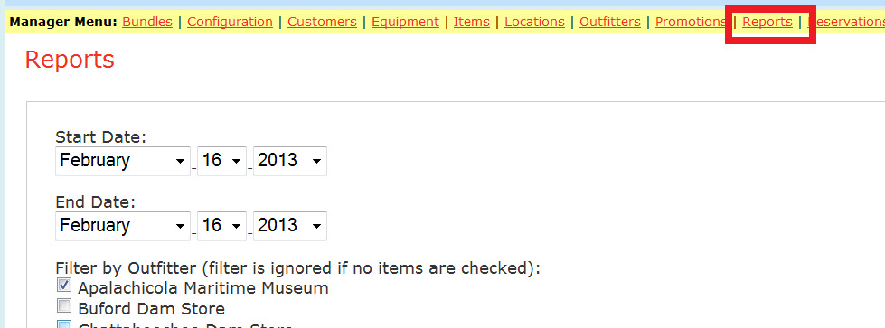
- Next go to the bottom of the page and click the 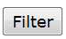 button and then locate the Test Trip #1 for the transactions you made in the above exercises and click the Manifest link for that trip. These are highlighted in red in the screen shot below
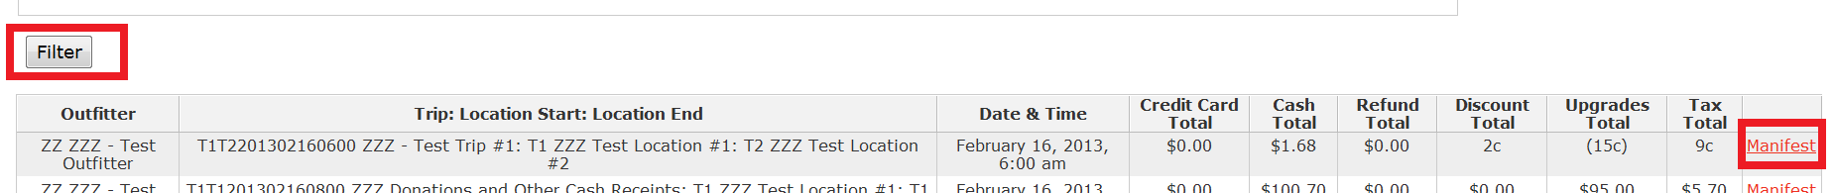
- Print the manifest for the selected trip code and date.
Exercise Three: Trip Manifest- Required Documentation and Paperwork

Following are the detailed steps you should follow

- Locate Manifest Control Sheet
- Go to staff.Ammfl.org/admin.htm
- Locate the caption “Procedural Checklists, Policies, and Forms for Visitor Center operations ”
- Select the link Procedures and forms for daily use
- Click to access the Manifest Control Sheet
- Print Manifest Controls Sheet
- This will be the first page of your competed manifest
- Read through all of the Exercises listed there. These will need to be completed for each trip.
- In the column enter your initials under every block that shows “GS” (for Guest Services) to indicate when you have completed each step. Each step must be completed to include actually performing the Exercises describe as if the trip is preparing to depart within the next hour. Contact your manager with any questions on how these steps are to be completed.
- The remainder of this exercise will take you through all elements associated with a trip departure and return and the completion of the Manifest Control Sheet.
- Print the Ships Log form from Exercise 2f of the Manifest Control Sheet
  - From the Legend tab click to access the Ships Log Tracking Page - Starfish & Greenie.
  - Print the Ships Log form. Normally this would be given to the captain to complete and return to Guest Services after the trip. But for now, simply fill out the sheet as if you were the captain and attach to the Manifest Control Sheet
- Print Manifest as instructed on Step 3 of the Manifest Control Sheet
- Open new browser tab and go to store.riverecologic.com/admin
- Sign in under your Admin Login, name and password
- Select Reports
- Enter date of trip as both beginning and ending date for the date that you created the trips for in the earlier step.
- Locate and select the filter for ZZZ-Outfitter
- Click the button to show the ZZZ Test trip for the selected date.
- Scroll down to find the ZZZ Test trip produced from the above step
- Click the Manifest link to the right of the Trip listing to display the list of passengers for the trip. This is called the Trip Manifest.
- Print the manifest
  - Right click to print preview
  - Shrink to fit page and print manifest
  - Locate and number passengers on manifest
  - Attach this as your second page of the Manifest Control Sheet documentation package
- Contract and Liability Waiver forms on Step 4 of the Manifest Control Sheet
- Go to staff.Ammfl.org/admin.htm
- Locate the caption “Trip, class and event waiver and contract documents”
- Below that locate “www.riverecologic.com/BRS_Forms.htm - Manifest forms from RiverEcoLogic page.” And click on the link.
- Scroll to the bottom of the web page and select the link for Waiver forms that is equal to or more than the number of passengers on the trip. Then print.
- Do the same for the Contract document. Then print.
- Write manifest number on Manifest Controls Sheet (pg.1)
- Complete the documents with sample signatures as to simulate actual customers. Names need to be in same order as read on Manifest, locate passengers from top to bottom, left to right
- Attach the pages to the Manifest Control Sheet package and enter the values for and
- Take a photo of all six guests in same order as read on Manifest and signed on Terms and Liabilities.
- For this exercise draw out your six fictitious clients (stick figures are okay)
- Take a picture using AMM digital camera
- Print picture by inserting memory card into printer and following prompts on printer’s touch screen
- Write the passenger above their head on the printed picture
- Attach the pages to the Manifest Control Sheet package and enter the values for and
Final Exercise: Self Evaluation and manager Review
After all trip documents assembled behind the completed Manifest Control Sheet they are scanned and saved as a digital image that are routed to administration. The scanned file is named as what we call a “TLW” batch where TLW stands for Travel Liability Waiver. In future training materials you will learn how to scan documents and save them in the appropriate file name and route to administration.

For now, you will use link below to retrieve a copy of a scanned TLW batch that was prepared as a correctly prepared Manifest Control Sheet package that we provide for comparison to what you have prepared as of this point. Repeat the steps above until completed correctly and your results match those of the document retrieved from the web via link below. Submit your image batch via email to your manager for review and approval prior to going to next step.
Lesson 1 - Approved Solution Document - These need to be booked as credit card transactions

Lesson Two – On the water trips (continued): Cash booking and Refunds

Objectives: Expand your knowledge of additional types of transaction booking activity that will empower you to be more versatile with the web store transaction booking processes. You will be introduced to other commonly encountered activities in the web store.
You will learn how capture email address and cell phone in Passenger cells so these will show on the trip manifest in the event we need to call them regarding a trip cancelation. When the transaction is run up via credit card, this information is captured as the customer account is set up. In cash transactions, we do not set up customer accounts so we must capture these items in the Step 7 Passengers box by entering the name, email address and phone number separated by slashes (“/”). For instance Don Taft with email address of A.B@C.com and phone number of 850-653-2501 is entered as “Don Taft/A.B@C.com/850-653-2501” This is shown in the example below.
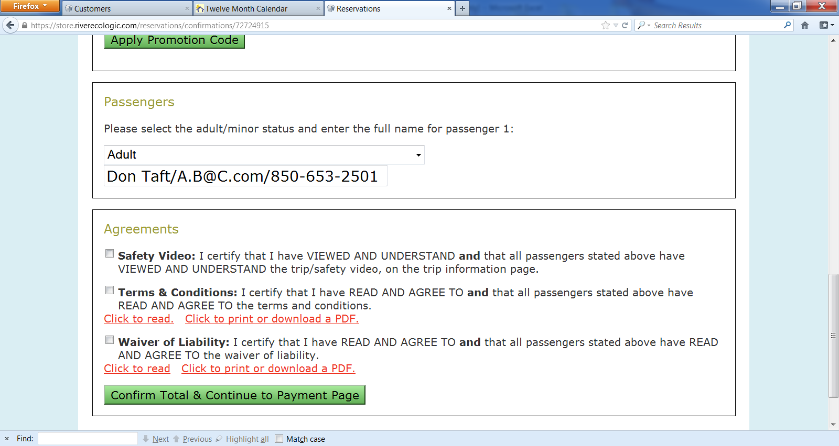

In this exercise you will learn how to
- Access the administrative web store page store.riverecologic.com/admin page and get introduced to some of the capabilities there
- Add clients to original manifest using cash booking transactions within the Admin page
- Book a fourth group of four persons for the same trip as a cash transaction
- Refund the second group for two to the credit card from the original bookings of Lesson One
- Print and scan the batch as an new TLW batch with the “b” sequence

Exercise One: Cash transaction booking via the web store admin page
Follow the steps below

- Book a fourth group to same trip for four persons paying cash as follows
- To do this you must sign onto the store.riverecologic.com/admin page before completing the booking process
- Select book a trip, ZZZ Outfitter and select the trip ZZZ Test Trip #1
- As Step 7, Enter names of passengers <name>/<email address>/<Phone>
- Agree to Safety, Terms, Liability as normal
- Select Check for Cash Payment highlighted in yellow (you are allowed to do this because you logged in under the admin page)
- Click the Confirm Total button at the bottom and note the Step 8 Payment Information screen is skipped and you go directly to the Receipt page.
- Review the example below which shows “Manual Transaction” in all of the Customer Details section below (see yellow box outline below). Also note that the passenger list has the name, email address and phone number all neatly entered for use should we need to contact the passenger. We also extract this email for later use in newsletter mailings, etc.

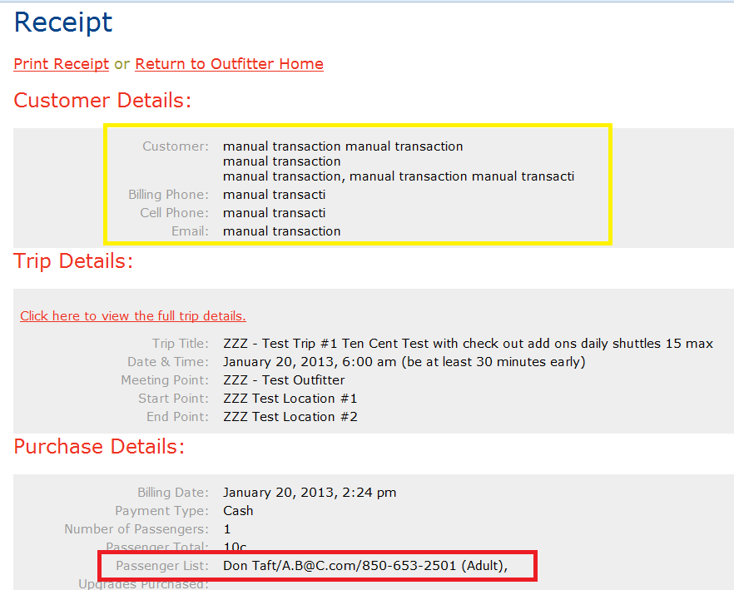

- Print the receipt page
- Print a report of the updated manifest
- Go to reports and filter to find the Manifest for your trip. Print that too. Note the presence of the passenger list has the name, email address and phone number listed for the cash transaction you just booked.
Exercise Two: Perform a refund on the second transaction created in Exercise one of Lesson One
Follow the steps below

- Note that a credit card cannot be refunded until 24 hours after the original transaction was made.
- Refund the second booking for two persons, Fake Name and Fake Name 2 by selecting view/void then cancel the reservation
- Use the store admin page Report option to locate the trip for reservation transactions booked in Lesson 1 Exercise 1.
- Select the Manifest for that trip locate the transaction first transaction that you booked in second transaction created in Exercise one of Lesson One
- Click on View/Void to the right of the reservation transaction located in the above step
- On the Receipt Page that comes up, go to the bottom of the web page and locate the click box with the label “Check to confirm cancellation of this reservation” afterit and then click the box so that a check mark appears in it
- Click the “Cancel this Reservation” button.
- Verify that the next page shows a “Cancel this Reservation”
- Use the Report option to show the updated trip and view the manifest.
- Note the refund transactions that have a minus (-) to offset the original reservation. Both the original transaction and the refund transactions are maintained by the web store to provide an easy means of identifying the original trip and the credit transaction created through the refund process.
- Complete, scan and save new Trip Manifest under the “b” sequence
- Ex. TLW AMM 30101b – ZZT1T2201301011230 ZZZ Test Trip
Final Exercise: Self Evaluation and manager Review
Use link below to retrieve the scanned prototype for comparison to what you have prepared as of this point. Repeat until completed correctly and your results match those of the document retrieved from the web via link below. Submit your image batch via email to your manager for review and approval prior to going to next step.
Lesson 2 Approved Solution Document – Needs to be redone after correction to Lesson 1 is corrected GKF

Lesson Three – On the water trips (continued) Transfer of passengers to other trips

Objectives: Move passengers who cannot make it on the current trip from one trip manifest to another trip using Manifest Controls Sheet. This may only be done for trips of equal or less value. This applies for visitors who cannot make it on a trip and notify the office a minimum of one day in advance. Visitors that do not call and do show up will not receive a refund or have the opportunity to be transferred since we have expended time and effort of Visitor Center staff, Captain and Crew to be ready for them and they did not show up.
Exercise One: Transfer a passenger to the same trip on a second date
Follow the steps below

- Make a copy of each page of completed manifest from lesson two
- We will simulate moving a person that is unable to make the trip and contacts us in advance to move to another trip. This may also be used when bad whether forces a trip to be moved to a different date.
- Locate the booking for one person that was done in Lesson One, Exercise One on the Manifest page and strike through and write note in margin “moved to future trip”
- Locate passenger count on Manifest Controls Sheet and correct modified passenger count and totals
- Locate trip picture and strike through last figure because You/Your Name was never on trip but moved to a future trip
- Add You/Your Name to a future trip
- Sign onto the web-store Admin page and locate manifest for day of trip and print
- Circle the future trip/no show client(s) and strike through remainders
- Add this manifest sheet to any other manifest packet right behind original manifest
- Modify and add manifest number to passenger count on the future manifest controls sheet
Final Exercise – Self review of results and submittal for manager review
Use link below to retrieve the scanned prototype for comparison to what you have prepared as of this point. Repeat until completed correctly and your results match those of the document retrieved from the web via link below. Submit your image batch via email to your manager for review and approval prior to going to next step.
Use link below to retrieve the scanned prototype for comparison to what you have prepared in the Exercises of this Lesson. Repeat the reading of this Lesson and repeat the Exercises until you have correctly completed all such that your results match those of the document retrieved from the web via links below. Submit your image batch via email to your manager for review and approval prior to going to next step.
Lesson 3 Approved Solution Document

Lesson Four – Zero cost “trips” used for Gift Shop, Consignments, Donations, Event receipts and other sales recorded as “Upgrades” in Step #5

Background: All products are purchased by using the Museum Store Visit trip on the Step 2: Select a Trip page. This trip is priced at $0.00 (has no charge). All store purchases are selected in the Step 5 Upgrades page and then you proceed to checkout in the normal fashion. Manifests for non trip sales do not need to be printed or scanned. In addition, we often sale goods on consignment which are handled in the same way except that at Step 2, you will select the Consignment vendor and then the Step 5 screen shows the products sold by that vendor. Donations are handled in the same way by selecting the Donations “trip” at Step 2. All of web store transactions in this Lesson Four group work the same way by starting with a “trip” that has no charge and then the items are added at Step #5 to prepare for the sale. Think of these transactions as trips where the trip is to a grocery store where the items from Step 5 are added to a the “Shopping Cart” and paid for at the register. The cart has no cost, but the items in it does.
Objectives: Expand your familiarity with how to add items on the Step 5 screen to zero cost trips for Museum Store Visits, Consignment Sales and Donations. Learn how the web store trip booking process is used for sales of non trip items such as gifts, products, food and beverages, and donations. Find the trip or other products you are looking for by using the search option (Control-F) and typing in the unique characters that would be found in the name of what you are looking These transactions do not require a scanned copy of the Trip Manifests or other documentation when used in normal operations, but you will need to print and scan the receipts for review with your manager. As you run reports, you will see how the transactions are grouped by the Trip to allow segregation of amounts for Gift Ship, Consignment and Donations.
All of the tests will be done with Cash transactions although they could be used for Credit card transactions in the same way.
Remember what we learned in Lesson 1 Exercise 2 regarding use of the Step 7 Passengers list to capture email address and cell phone in Passenger cells so these will show on the trip manifest in the event we need to call them regarding a trip cancelation. When the transaction is run up via credit card, this information is captured as the customer account is set up. In cash transactions, we do not set up customer accounts so we must capture these items in the Step 7 Passengers box by entering the name, email address and phone number separated by slashes (“/”). For instance Don Taft with email address of A.B@C.com and phone number of 850-653-2501 is entered as “Don Taft/A.B@C.com/850-653-2501” This is shown in the example below.

Exercise one: Gift Shop sales
In this exercise you will accept payment for a non trip Gift Shop using the ZZZ Gift Shop Sales item in the ZZZ - Test Outfitter. In this exercise you will:
- Learn how to add product sales toe the ZZZ Gift Shop Sales for items purchased in the Visitor Center Gift Shop.
- Learn how the booking process is just like the two that you did in Exercise One, except that at Step 5 you will select an “Upgrades” that are the products added to the trip purchase.
- Add ZZ - Test Item #1, Small waterproof bag for purchase.
- Access the Admin portion of the web store to print the manifest showing the gift shop purchase and provide a receipt to the customer.

Follow the steps below

- Start by reviewing the process from Web Store Trips Processing and Sales, Lesson One, Exercise Two.
- This only difference in this web store transaction is that the ZZZ Gift Shop Sales is selected instead of ZZZ Test Trip #1.
- Sign into the Admin page of the web store.
- Proceed through booking this for a new “trip” date that is later than your original (to keep it separate from the original Lesson One, Two and Three transactions data). This date should be assigned by your manager.
- Proceed through the booking process as one passenger (step 3) and with the new “trip” date (step 4) and then at Step 5 find the ZZ - Test Item #1, Small waterproof bag to add to the “trip” and proceed to checkout.
- Fill out the Step 7 Passenger list for Don Taft with email address of A.B@C.com and phone number of 850-653-2501.
- Complete the transaction as a Cash transaction and then print the receipt.
- Access the manifest for the Store Visit trip you just booked to see that the ZZ - Test Item #1, Small waterproof bag was added to the reservation. Print this as well for review.
- Scan and then review with your manager to ensure everything has been done correctly.

Exercise Two: Consignment sales
Consignment Sales are another area where transactions are entered as a “trip”. This is the same as a Gift Shop sale, except that the “trip” is the name of the consignment vendor (e.g. Katy Greene, jeweler) and only vendor supplied consignment items are displayed for selection on the Step #5 screen. In this exercise you will accept payment for an item placed on consignment with the Gift Shop item in the ZZZ - Test Outfitter. The items for a Consignment Vendor will generally be in price groups, so you will look for the price tag on the vendor item and locate the corresponding price group Item on the Step 5 Upgrades screen that matches the price of the Vendor Item. In the Exercise below, you will sell one of the $20 items by using the ZZZ consignment - $20 price group item on Step 5. This is different from the Exercise One example where we looked up items by their description. Here we select the price group corresponding to the tag on the consignment item.
Follow the steps below

- Start by reviewing the process from Lesson Four, Exercise One – Gift Shop Sales. You must have this done correctly before proceeding to this new Exercise.
- This only difference in this web store transaction is that the ZZZ Gift Shop Sales on Consignment for XXX vendor is selected instead of ZZZ Gift Shop Sales.
- Sign into the Admin page of the web store.
- Proceed through booking this for the new “trip” date that was used in Exercise One of this Lesson #4.
- Proceed through the booking process as one passenger (step 3) and with the new “trip” date (step 4) and then at Step 5 find the ZZZ consignment - $20 price group to add to the “trip” and proceed to checkout.
- Fill out the Step 7 Passenger list for Don Bob Roy with email address as BR1@x.com and phone number of 850-123-4567.
- Complete the transaction as a Cash transaction and then print the receipt.
- Access the manifest for the Store Visit trip you just booked to see that the ZZZ consignment - $20 price group was added to the reservation. Print this as well for review.
- Scan and then review with your manager to ensure everything has been done correctly.

Exercise Three: Event Tally
When we run events such as the lecture program we often host a reception with the sale of beverages and other items. Sales of items in the event receptions are manually tallied during the event on AMM Inventory Count worksheet from the Inventory tab of the Procedures worksheet. Open the Procedures worksheet from the Staff Admin Web Page at staff.Ammfl.org/admin.htm and go to the Legends tab and select Inventory from the list of worksheet links (shown in the yellow box below).
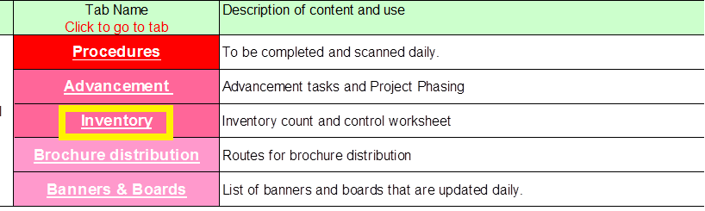
You should see the worksheet format below on the Inventory tab. Print this as if you were preparing for an event.
At the end of the reception event the manager will complete this document to reflect the sales for the event reception and use that tally sheet to enter all sales in one transaction from the Event “trip”.
In this exercise you will access and print the AMM Inventory Count worksheet. You will fill it out to show 5 cans of beer and 10 glasses of wine as if you were the event manager. You will then enter this information into a ZZZ Event summary accounting “trip” and enter the appropriate quantities at the Step 5 Upgrades screen.
Follow the steps below

- Start by reviewing the process from Lesson Four, Exercise One – Gift Shop Sales. You must have this done correctly before proceeding to this new Exercise.
- This only difference in this web store transaction is that the ZZZ Event summary accounting is selected instead of ZZZ Gift Shop Sales and the preparation of the AMM Inventory Count worksheet
- Locate and print the AMM Inventory Count worksheet. Fill it out to show 5 cans of beer and 10 glasses of wine as if you were the event manager.
- Sign into the Admin page of the web store.
- Proceed through booking this for the new “trip” date that was used in Exercise One of this Lesson #4.
- Proceed through the booking process as one passenger (step 3) and with the new “trip” date (step 4).
- At Step 5 find the ZZ1 - Event beer - Bud / Bush / etc and ZZ2 - Event wine by the glass to add to the “trip”.
- Select the appropriate quantities of each and proceed to checkout.
- Fill out the Step 7 Passenger list with your name, email and phone number as if you were the event reception manager.
- Complete the transaction as a Cash transaction and then print the receipt.
- Access the manifest for the Store Visit trip you just booked to see that the ZZ1 - Event beer - Bud / Bush / etc and ZZ2 - Event wine by the glass was added to the reservation. Print this as well for review.
- Scan the documents including the AMM Inventory Count worksheet and then review with your manager to ensure everything has been done correctly.

Exercise Four: Donations
In this exercise you will account for Cash Donations and Checks received via the mail at the Gift Shop in the ZZZ - Test Outfitter. The Donations “trip” charge is $0.00 and at the Step #5 screen there are four items ($1,000, $100, $10 and $1 items) where the quantity is selected to allow incrementing of the amount to equal the amount of the Donation or Check received through the mail. Prepare a separate transaction for each checks or donation received from a different person. In the Exercise below, we will enter a transaction to account for the receipt of a $95 check for a donation. This would be accomplished by selecting 9 of the Z10 Cash increment $10 and 5 of the ZZ1 Cash increment $1.
Follow the steps below

- Start by reviewing the process from Lesson Four, Exercises One and Two. You must have this done correctly before proceeding to this new Exercise.
- This only difference in this web store transaction is that the ZZZ Donations and Other Cash Receipts is selected instead of ZZZ Gift Shop Sales.
- Sign into the Admin page of the web store.
- Proceed through booking this for the new “trip” date that was used in Exercise One of this Lesson #4.
- Proceed through the booking process as one passenger (step 3) and with the new “trip” date (step 4).
- At Step 5 find the Z10 Cash increment $10 and select quantity of 9 and then the ZZ1 Cash increment $1 and select quantity of 5 to add to the “trip” and proceed to checkout. The quantity selected should get the correct total of $95.
- Fill out the Step 7 Passenger list for Don Ima Donor with email address as BID2@x.com and phone number of 850-111-2222.
- Complete the transaction as a Cash transaction and then print the receipt.
- Access the manifest for the Store Visit trip you just booked to see that the Z10 Cash increment $10 and ZZ1 Cash increment $1 that were combined to make a total of $95 to account for the transaction.
- Print this as well for review.
- Scan and then review with your manager to ensure everything has been done correctly.

Exercise Five: End of Shift Coffee/Tea sales
Coffee sales are not recorded on the web store for each cup of coffee or tea. This is because these items do not have a direct one to one relationship with the variety of ingredients used to make these beverages. Instead, all of the money received for the sale of these items will be placed in the clear plastic box on the counter by the customer. Each day, the administrative manager will open the box with another Visitor Center Staff present and count the amount of money in the box. This amount is entered in the same fashion as the Donation example in Exercise Three above. In this example, you should plan for the Coffee fund to be $27. The Z10 Cash increment $10 and ZZ1 Cash increment $1are utilized to enter the appropriate amount.
Follow the steps below

- Start by reviewing the process from Lesson Four, Exercises One and Two. You must have this done correctly before proceeding to this new Exercise.
- This only difference in this web store transaction is that the ZZZ Coffee/Tea Sales is selected instead of ZZZ Gift Shop Sales.
- Sign into the Admin page of the web store.
- Proceed through booking this for the new “trip” date that was used in Exercise One of this Lesson #4.
- At Step 5 find the Z10 Cash increment $10 and select quantity of 2 and then the ZZ1 Cash increment $1 and select quantity of 7 to add to the “trip” and proceed to checkout. The quantity selected should get the correct total of $27.
- Fill out the Step 7 Passenger list with your name, email and phone number as if you were the administrative manager.
- Complete the transaction as a Cash transaction and then print the receipt.
- Access the manifest for the Store Visit trip you just booked to see that the Z10 Cash increment $10 and ZZ1 Cash increment $1 that were combined to make a total of $95 to account for the transaction.
- Print this as well for review.
- Scan and then review with your manager to ensure everything has been done correctly.

Final Exercise – Self review of results and submittal for manager review
Use links below to retrieve the scanned prototype for comparison to what you have prepared in the Exercises of this Lesson. Repeat the reading of this Lesson and repeat the Exercises until you have correctly completed all such that your results match those of the document retrieved from the web via links below. Submit your image batch via email to your manager for review and approval prior to going to next step.
Exercise 1 - Gift Shop sales
Exercise 2 – Consignment Sales as a Trip
Exercise 3 – Event Tally – needs AMM Inventory Count worksheet
Exercise 4 - Donations and checks received via mail – needs be redone with new outfitter sales tax and Item descriptions corrected by GKF
Exercise 5 – End of Shift Coffee/Tea sales – needs be redone with new outfitter sales tax corrected by GKF

Lesson Five – “Trips” used for Memberships, Museum Entry Fees, WBS classes & Raffle Tickets

Background:
In these examples we use “Trips” set up to record Memberships, Museum Entry Fees, WBS classes & Raffle Ticket transactions. We utilize trips for these transactions since they are actually more of a “trip” than the product sales or donations that were the subject of Lesson Four. In addition recording these transactions as a trip provides more information for classifications of revenue which is important for statistical reporting and raffle administration.
Objectives: Become familiar with how to use the web store capture information on these transactions. None of these transactions require printing or scanning in production, although you will be asked to print your exercises for review with your manager.
Exercise One: Membership created via Credit Card
In this exercise you will learn how to create an AMM membership via the web store. All Memberships MUST be captured as a Credit Card transaction which requires the creation of an account on the Web Store. We do this because it simplifies our ability to inquire of a member status. Following are the
The different levels of Membership are listed below.
- Mate (Individual) $20 – One year membership which provides a 20% discount on any trip that occurs on the day of membership purchase and free entry to the museum.
- Crew (Family) $50 – Same as Mate membership with the benefits applying to all members.
- Skipper (Individual Sponsor) $100 – Same as Mate membership with the 20% discount applying to all trips during the membership period.
- Captain (Corporate Sponsor) $500 - Same as Skipper membership with the brick paver containing the company name and a specially hosted trip for all employees of the company.
- Commodore (Patron) $1,000 - Same as Skipper membership a pennant identifying the company or person name flown on the Museum flagship.
- Admiral (Lifetime) $5,000 – Same as Commodore with a brass placard placed in the entryway to the museum identifying the name of the member as a Lifetime member. All trips provided at no charge.

All membership levels can be purchased online by client or in Visitor Center Gift Shop. All memberships require that an account be setup with the complete entry of all address, email and phone number information and paid for with a credit card. This is done so that the membership status of an individual can be determined via an inquiry on the Customer history menu of the Admin page. Note that Promotional discounts may not applied to membership transactions.
In this example, you will create a ZZZ Membership - Mate (Individual) in the ZZZ - Test Outfitter for your account that you set up for yourself in Lesson One Exercise One.
Follow the steps below

- Start by reviewing the process from Lesson One, Exercises One. You must have this done correctly before proceeding to this new Exercise.
- This only difference in this web store transaction is that you will be purchasing a ZZZ Membership - Mate (Individual) is selected instead of ZZZ - Test Trip #1.
- Sign out of the Admin page of the web store. Do this by clicking the logout link at the bottom of the web page. Be sure that the yellow menu bar is no longer present and only the Customer Menu is shown.
- Start the trip booking process from the Customer Menu with Book a Trip. Select the ZZZ Outfitter at Step 1.
- At Step 2, select ZZZ Membership - Mate (Individual) and proceed through the remainder of the trip booking process. Sign in to your account after Step 4. Pay for your membership with a credit card at Step 8. Print the receipt page.
- Next click the View Account page from the Customer Menu. You will see the ZZZ Membership - Mate (Individual) under your customer information. See the example below showing the recent booking of a membership. Print the View Acco unt page.
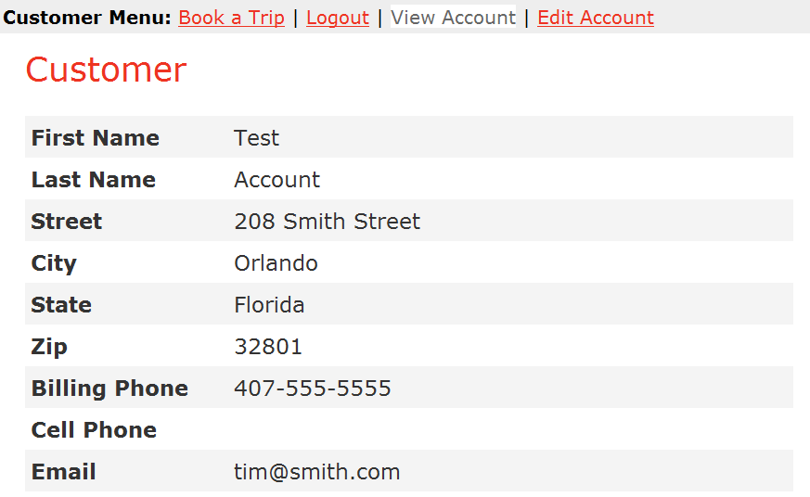
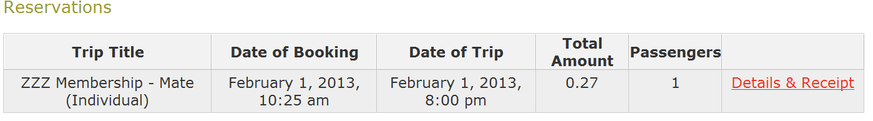
- Access the manifest for the Store Visit trip you just booked to see that the ZZZ Membership - Mate (Individual). Print the manifest page.
- Access Customers Link on the Admin page as shown below (outlined in red). Notice how this page lists all customers in alphabetical order by last name and provide the option to View or Edit a customers account.
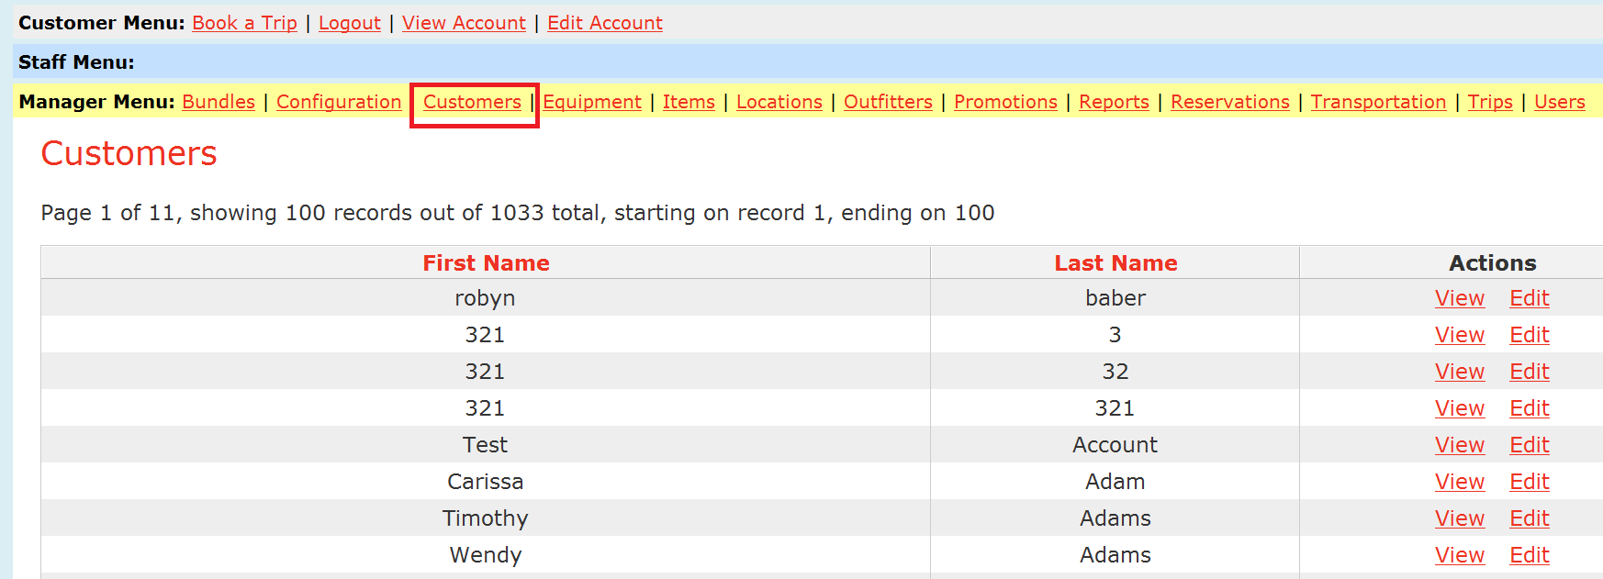
- Locate your account by looking for your name on the list. If you go to the bottom of the page and your name is not listed because your last name is alphabetically beyond those shone, use the pagination controls at the bottom of the page (shown below in red) to select subsequent pages until you find the page containing your name. For example if your last name is Smith, it is a much later page since the current page ends with Brien.
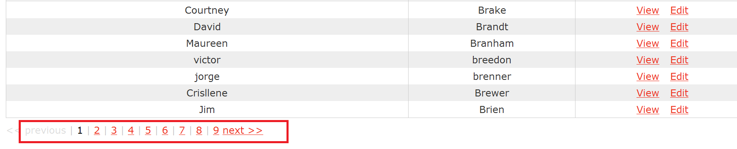

In the case of the last name Smith, we had to page all the way to page 9 to find the last names beginning with “S”. If the last name is later in the alphabetic order, you may want to jump ahead to a higher page to locate the alpha range that may contain your name.

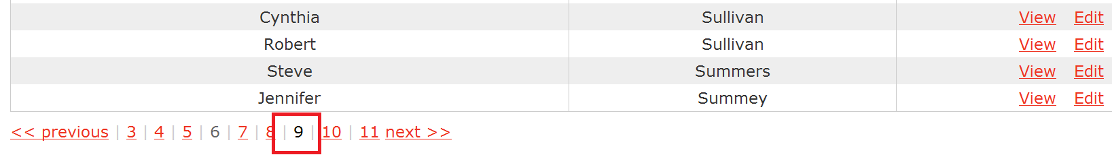
- Once you locate your name, click on the View link to the right to see the account information and transaction history showing the membership. This is the same view as shown in Step F above. Print this page again demonstrating that you were able to locate the account information in the Customer menu.
- Note that the Customer lookup process will be used to check for the membership status of anyone coming in to claim membership benefits such as free entry to the museum events or trip discounts.
- Scan and then review with your manager to ensure everything has been done correctly.

Exercise Two: Membership by Donation for Cash
For persons who want to be a member of the AMM but do not have a credit card, we have come up with a way to create the Membership with the AMM testing credit card and accepting a cash donation equal to the membership fee. This approach requires two separate transactions. When booking the Membership transaction you follow the process in Exercise One above with the only difference being the use of the Promotional Discount code MMCD (Museum Donation Equivalent for use with Cash Memberships) in Step 7 that discounts the membership by 99% to keep the amount of charge on the AMM testing credit card to a minimum. This is then followed with a second transaction which captures a cash donation equal to the amount of the membership level as documented in Lesson Four Exercise Four.
In this exercise you will learn how to utilize the web store to capture cash based memberships using the two step booking process described in the paragraph above..
Follow the steps below

- Repeat Steps A through E in Exercise One above except use the MMCD (Museum Donation Equivalent for use with Cash Memberships) promotional code to discount the membership for use with the AMM testing credit card. Print the Receipt Page.
- Follow steps of Lesson Four, Exercise Four to create a Cash Donation equal to the membership fee (in this case $2.00). Print the Receipt Page from this as well.
- Access the account that was setup and Print the Account View page.
- Scan and then review with your manager to ensure everything has been done correctly.

Exercise Three: Museum Entry Fees
In this exercise you will learn how to utilize the web store to capture Museum Entry Fees. This is similar to the Membership Exercise above since the Museum Entry Fee is a “Trip” transaction. Since the tracking of an Entry Fee is much less important than tracking of a Membership, the Entry Fees can be paid for via Credit Card (which is preferable) or Cash.
In this example, you will create a ZZZ Membership - Mate (Individual) in the ZZZ - Test Outfitter for your account that you set up for yourself in Lesson One Exercise One.
Follow the steps below

- Start by reviewing the process from Lesson One, Exercises One. You must have this done correctly before proceeding to this new Exercise.
- This only difference in this web store transaction is that you will be purchasing a ZZZ Museum Entry is selected instead of ZZZ - Test Trip #1.
- Sign in to the Admin Web Page and book this as a Cash transaction.
- Start the trip booking process from the Customer Menu with Book a Trip. Select the ZZZ Outfitter at Step 1.
- At Step 2, select ZZZ Museum Entry and proceed through the remainder of the trip booking process.
- Print the Receipt Page and scan for review with your manager.

Exercise Four: Events Entry Fees
We have set up a separate “trip” for Events Entry Fees so that they may be priced differently and to track entries for Lecture and other special events separately from normal Museum Entry Fees.
Perform the tasks in Exercise Three while substituting ZZZ Event Entry Fee for ZZZ Museum Entry. Print the Receipt Page and scan for review with your manager.

Exercise Five: Wooden Boat School classes
These “trips” are for boat building classes that occur based on scheduled dates throughout the year. The date of the various boat building class are staggered to prevent overlap and conflicts. The trip booking process works very similar to the other “trips” in this Lesson Five.
Perform the tasks in Exercise Three while substituting Wooden Boat School - Build an Ark for ZZZ Museum Entry and then selecting the first available date. For this sample trip, you will note that the classes are scheduled for the first day of every month. Print the Receipt Page and scan for review with your manager.

Exercise Six: Raffle Tickets
These “trips” are for raffle tickets that can be purchased to give a chance to win a trip or gift that is described within the trip description. Each Raffle item will be a separate Trip in the web store. Sometimes we will run a multiple day sail trip for which each day will be have a separate Raffle Trip in the web store. The winner(s) are selected by a computer process that selects the web store transaction randomly among all who have purchased raffle tickets.
Perform the tasks in Exercise Three while substituting ZZZ Raffle Tickets for Monthly Heritage Coastal Cruise - Day 1, AMM docks to SGI Lighthouse for ZZZ Museum Entry and then selecting the first available date. Print the Receipt Page and scan for review with your manager.

Final Exercise – Self review of results and submittal for manager review
Use links below to retrieve the scanned prototype for comparison to what you have prepared in the Exercises of this Lesson. Repeat the reading of this Lesson and repeat the Exercises until you have correctly completed all such that your results match those of the document retrieved from the web via links below. Submit your image batch via email to your manager for review and approval prior to going to next step.
Exercise 1 - Membership booked with a Credit Card – Needs to be redone to remove extraneous transactions
Exercise 2 – Membership booked with Cash – to be reviewed GKF
Exercise 3 – Museum Entry Fees – to be reviewed GKF
Exercise 4 - Event Entry – to be reviewed GKF
Exercise 5 – WBS class – to be reviewed GKF
Exercise 6 – Raffle tickets – Missing, to be reviewed GKF

Lesson Six - Discounts via Promotional Codes, Groups and Group discounts (Not Yet Complete)

The web store has several ways in which discounts can be applied to a purchase or trip transaction. These include
- Promo Codes - Use of a Promotional Code which is applied at Step #7 in the booking process to discount the cost of a trip. A Promo Code will discount any trip by the same amount. Only one Promotional Code can be used on any single trip. Promo codes can be set up as a percentage or dollar amount.
- Negative Trip Items for free child trip– Added to trips at Step 5, Upgrades, to remove the cost of children under age 8 going on a trip when accompanying a parent or legal guardian. This allows for the names to appear on the manifest, but have the trip costs removed.
- Group Discounts - Percentage discounts associated large groups that book a trip all at the same time in one transaction. These are set up on a trip specific basis.
None of the discounts are applied to items added to a trip (or Gift Shop visit, Consignment Sale, etc) in step 5, Upgrades, of the web store process.
Following is more detail on each of the three discount alternatives.
- Promotional codes are the most frequently used forms of discounts and are used in the following scenarios
- WebStore - A 20% discount for booking a reservation on your own using your computer of mobile device. This is for people who book the trip on their own prior to arriving at the museum.
- Member – A 20% discount applied for members. For Mate (individual) and Crew (family) memberships, this should only be used to the day that the membership was purchased. For Skipper, Captain and Commodore memberships, this discount code is applied for any trip during the time that their membership is active.
- LifeMember - For Admiral members, this provides a 99% discount on any trip.
- SameDayAdd – A 50% discount for visitors adding onto a trip occurring on the same day
- FreeTrip – Free trips are provided for one of the following reasons :
  - Locals go Free Saturdays – Those going on the trip must show a driver license with Franklin County residence
  - Promotional card signed and dated by a staff member of the Museum as part of a promotional program
  - Staff or Volunteer trips
Free trips are actually set up to ring up a one cent ($0.01) amount for a trip which is paid for with loose change from the cash drawer since trips are not allowed to be at zero cost by the web store software. Consequently, since the price of trips vary, a special FreeTrip code must be used for each trip as follows
- MMCD – A 95% discount for Museum Donation Equivalent for use with Cash Memberships (see Lesson Five, Exercise Two)
- Seniors – A 10% discount for Senior Citizens (over age 65)
- Custom – A discount arrangement that is changed for special events on an as needed basis. It must be used only on a short term basis.
- WeekTrip, FourDayTrip, WeekTripLow, WeekTripMid, FourDayTripLow, FourDayTripMid, DayTripLow, WeekTripMid – Used with guest rentals.
- NOTE : No new promo codes should be established without a management consensus.
- Negative Trip Items for free trips for children are added to trips at Step 5, Upgrades, to remove the cost of children under age 8 going on a trip when accompanying a parent or legal guardian. This allows for the names to appear on the manifest, but have the trip costs removed. Following is the table of credit items to be applied for children. Note that the item must be matched to the trip and the quantity selected to ensure the appropriate discount amount is applied to leave only those over age 8 paying for their trip.
- Group Discounts - Percentage discounts associated large groups that book a trip all at the same time in one transaction. These are set up on a trip specific basis. Following is a list of the Group discount applied for trips

A single table which documents all of the trip specific codes, items and Groups is shown below

Exercise One: Promotional Code for WebStore
In this exercise you simulate an unaffiliated individual booking a reservation to occur with their upcoming vacation a week in advance of arrival by using the WebStore promotional code. Follow the same steps as performed in Lesson One, Exercise One, using the ZZZ Test Trip #1 trip. The only difference being that you will apply the WebStore promotional code at Step 7 in the booking process as shown in the screen below.
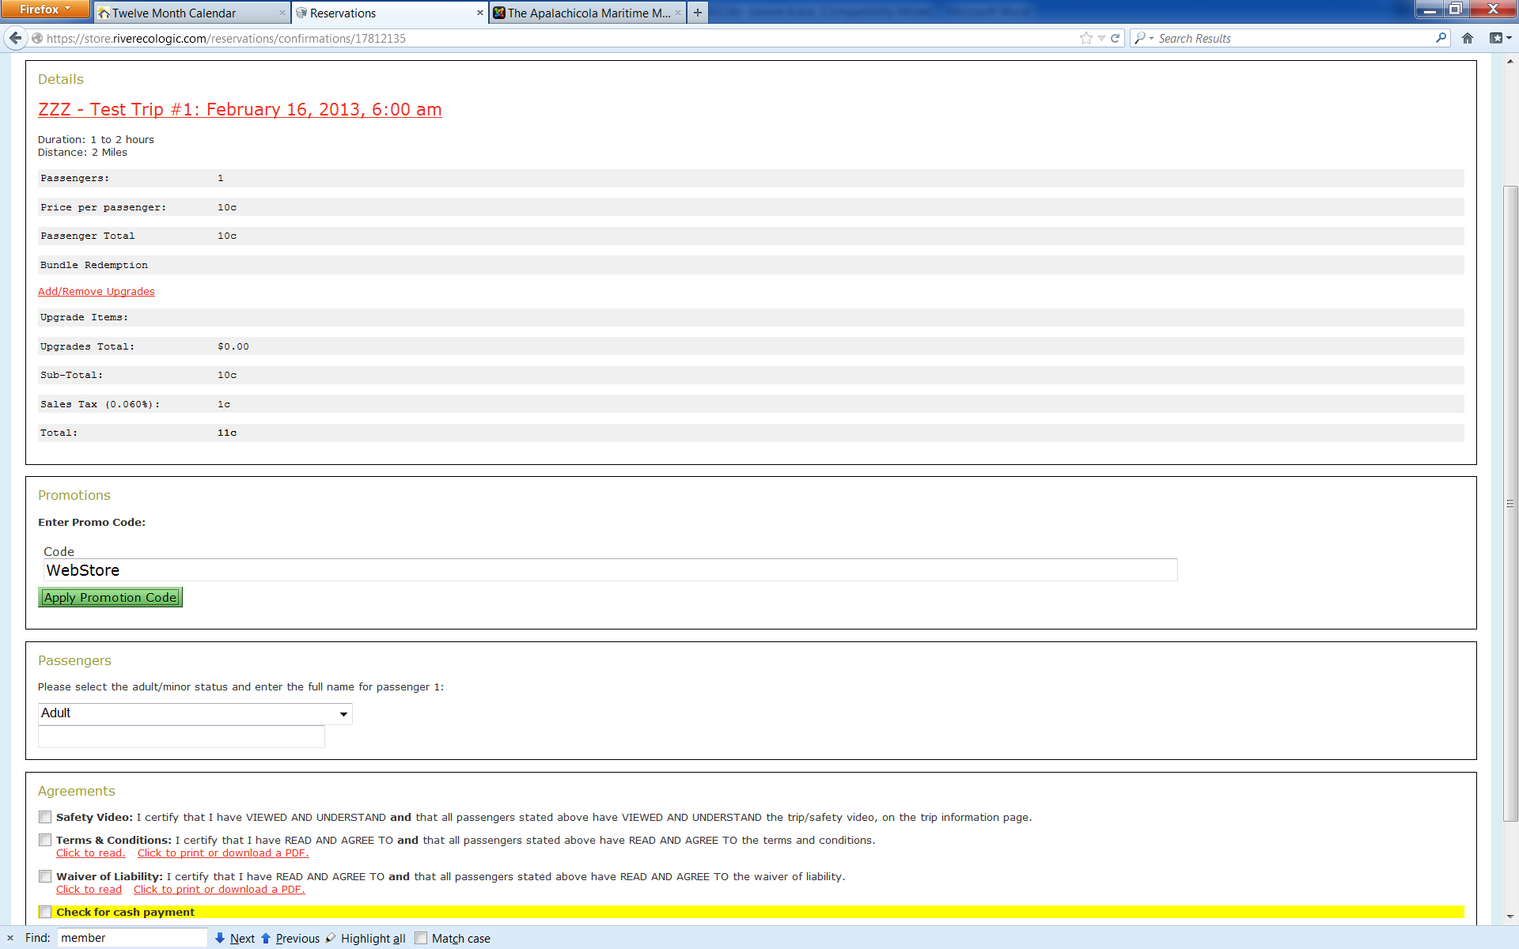
Once you have entered the promo code, cli on the “Apply Promotional Code” button and you will see how the discount is applied in the schedule above.
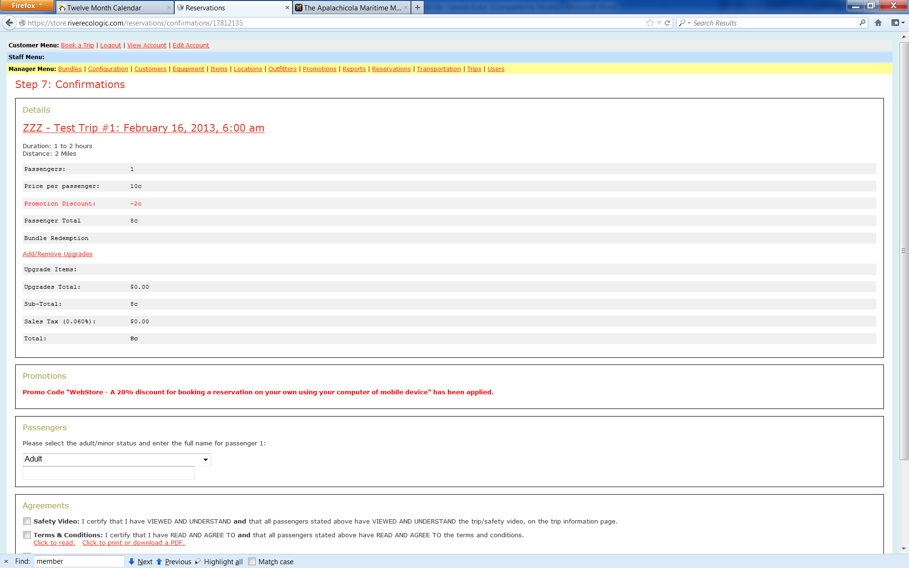

Verify that the 20% reduction in the ten cent trip cost resulted in the two cent Promotional Discount highlighted in red in the above trip screen.

Follow through to pay for the transaction with the credit card and then print a manifest. Scan and then review with your manager to ensure everything has been done correctly.

Exercise Two: Promotional Code for Member Discount including Membership status lookup
In this exercise you must first verify the membership status of the individual by inquiring on Customer screen of the web store admin page. Do this by looking up the membership you created in Lesson Five, Exercise One. Once you find the membership on the Customer View screen, print it. Then follow the steps of the Exercise One above to book a ZZZ Test Trip #1 trip using the Member promotional code. Follow through to pay for the transaction with the credit card and then print a manifest. Scan the printed Customer View screen and trip manifest and then review with your manager to ensure everything has been done correctly.

Exercise Three: Apply a Negative Trip Items for a free child trip
In this exercise you simulate booking of a family with two parents and a child under the age of 8. You will follow the same steps as performed in Lesson One, Exercise One, using the ZZZ Test Trip #1 trip. The only differences being that you will
- select 3 passengers at the Step 3 screen for the mother, father and child and
- Locate the Child Trip credit for ZZ test trip at the Step 5, Upgrades Screen and use the drop box below that to select a quantity of 1 which will apply a negative ten cent ($-0.10) adjustment to the reservation

Proceed to Step 7 of the booking process where you should see that the negative ten cent ($-0.10) adjustment to the reservation reduced the total cost from 30 cent to 20 cent as shown in the screen below.

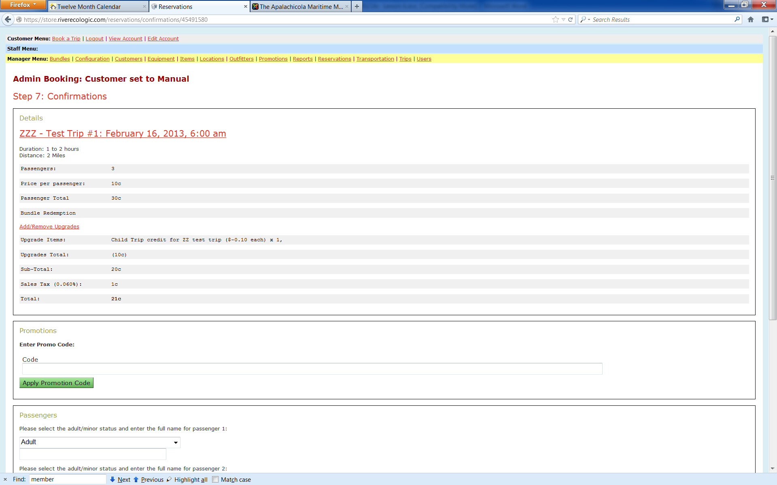

Verify that the reduction for the ten cent credit for the child cost as shown in the above trip screen.

Follow through to pay for the transaction with the credit card and then print a manifest. Scan and then review with your manager to ensure everything has been done correctly.

Exercise Four: Book a large group to obtain a Group discount
In this exercise you simulate booking of a group of twelve persons that will trigger the 20% discount to be applied at Step 7 in the booking process. You will follow the same steps as performed in Lesson One, Exercise One, using the ZZZ Test Trip #1 trip. The only differences being that you will
- select 12 passengers at the Step 3 screen

Proceed to Step 7 of the booking process where you should see that the normal cent ($0.10) cost per person has been reduced by 20% yielding a net adjusted price of eight cent ($0.08) cost per person which is then multiplied by the 12 passengers yielding a trip cost of ninety-six cent ($0.96)

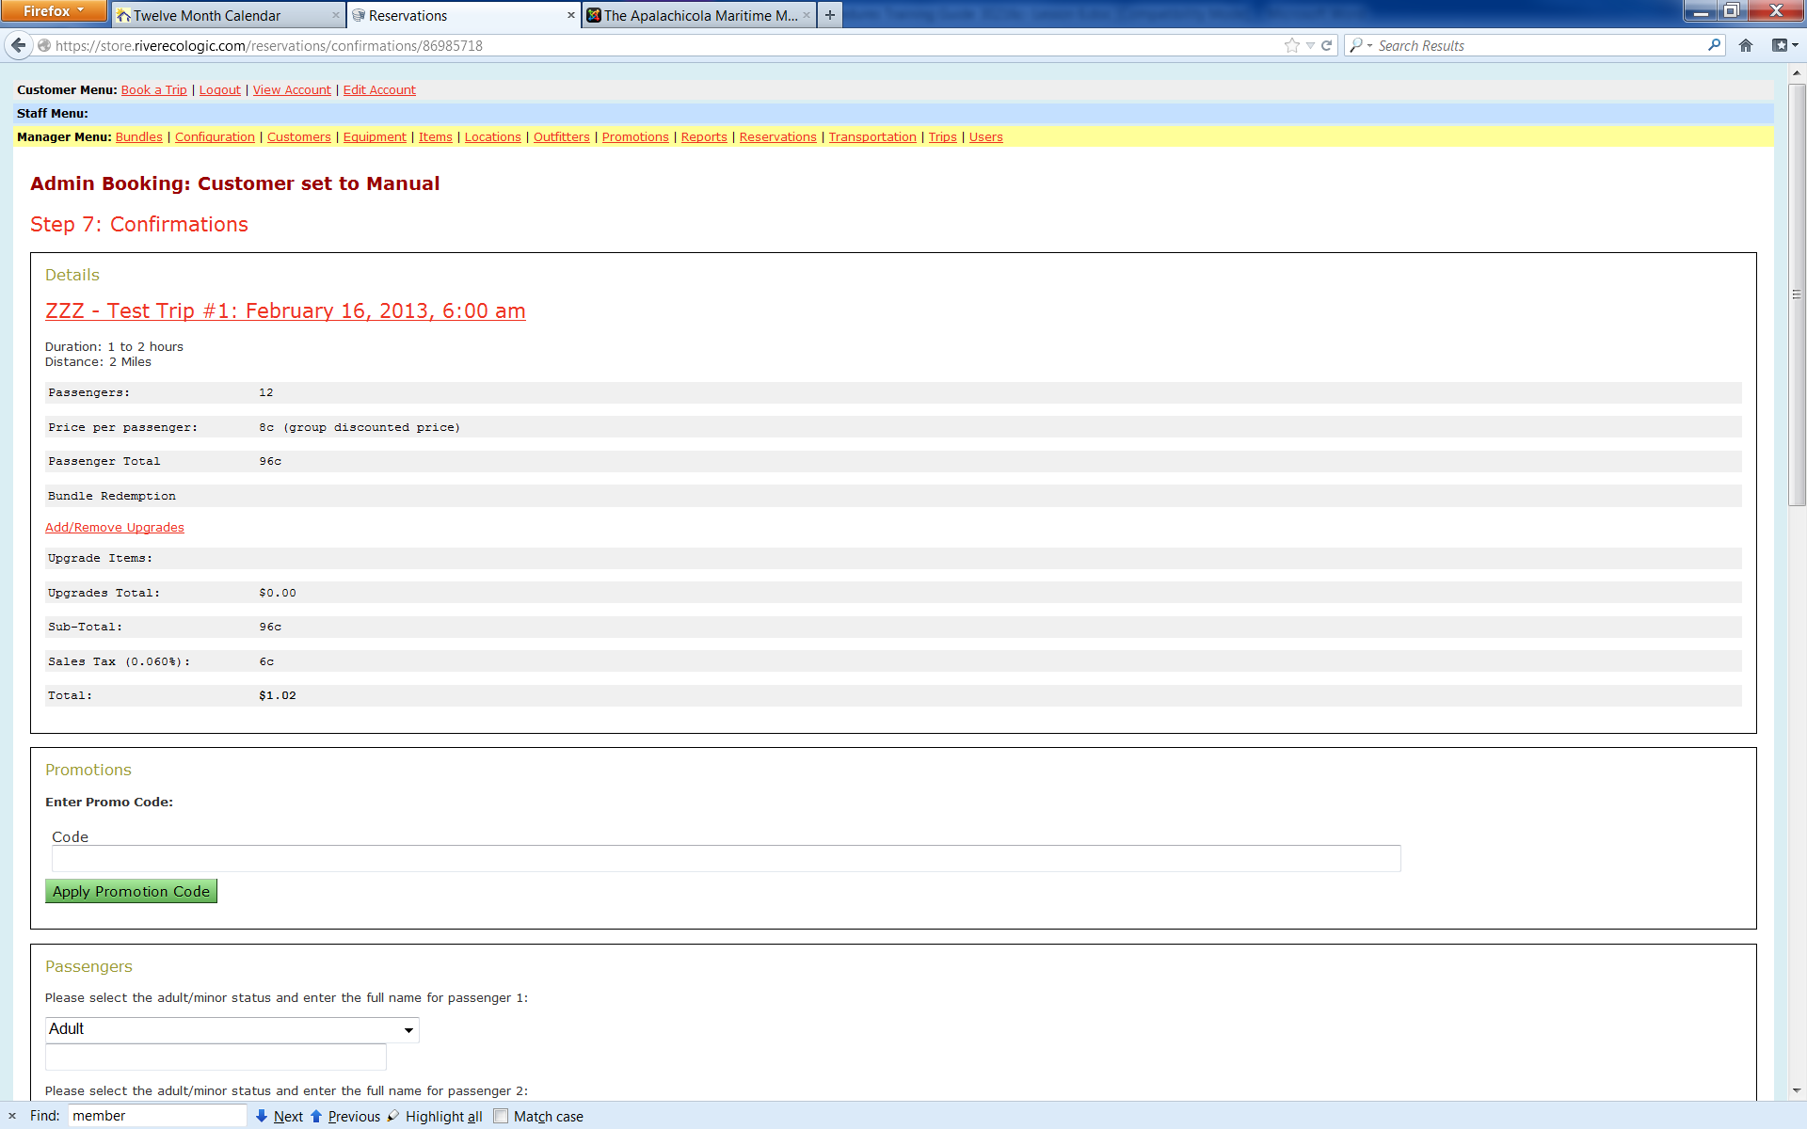

Verify that the 20% reduction due to Group Discount is applied as shown in the above trip screen.

Follow through to pay for the transaction with the credit card and then print a manifest. Scan and then review with your manager to ensure everything has been done correctly.

Lesson Seven - Manual transactions when web is down
In this lesson we will document how to utilize the manual card swipe and carbon forms to capture credit card transactions when the web site is not available. You will use the option from the Legend tab of the Procedures worksheet to access and print the Visitor Center Shift Accounting document and use that to track all transactions during the shift. After the web store has become available again, we will utilize this form to enter all the transactions (both cash and credit card) into the web store.
Develop narratives and examples based on the weekend of 1/12 where the web store was down. Ensure the charge card receipts are scanned and use the new Shift Accounting form to show all transactions captured.

Lesson Eight - Visitor Center information gathering only, ie, no payments of any type

In this lesson we will document how to utilize the manual card swipe and carbon forms to capture credit card transactions when the web site is not available. You will use the option from the Legend tab of the Procedures worksheet to access and print the Visitor Center Shift Accounting document and use that to track all transactions during the shift. After the web store has become available again, we will utilize this form to enter all the transactions (both cash and credit card) into the web store.
Develop narratives and examples based on the weekend of 1/12 where the web store was down. Ensure the charge card receipts are scanned and use the new Shift Accounting form to show all transactions captured.

Lesson Nine – Open for Future use

Open for future use on
- Refunds
- Donations of artifacts
- Separate the retail items into a separate outfitter or imply sales taxes to the cost to get whole dollar amounts. Integrate with EOM sales tax schedule

Web Store Maintenance – Advanced training

Introduction
Scan documents to be saved on the computer as a PDF image file. Do this by loading the documents to be scanned into the document feeder or by opening up the printer icon on computer desktop. Always be sure to rotate documents until they are upright. Save the documents under the following file name structure.

The hierarchy from Outfitters to Locations to Trips to Schedules
Scan documents to be saved on the computer as a PDF image file. Do this by loading the documents to be scanned into the document feeder or by opening up the printer icon on computer desktop. Always be sure to rotate documents until they are upright. Save the documents under the following file name structure.

Reservations
Scan documents to be saved on the computer as a PDF image file. Do this by loading the documents to be scanned into the document feeder or by opening up the printer icon on computer desktop. Always be sure to rotate documents until they are upright. Save the documents under the following file name structure.

Customers
Scan documents to be saved on the computer as a PDF image file. Do this by loading the documents to be scanned into the document feeder or by opening up the printer icon on computer desktop. Always be sure to rotate documents until they are upright. Save the documents under the following file name structure.

Items
Scan documents to be saved on the computer as a PDF image file. Do this by loading the documents to be scanned into the document feeder or by opening up the printer icon on computer desktop. Always be sure to rotate documents until they are upright. Save the documents under the following file name structure.

Promotions
Scan documents to be saved on the computer as a PDF image file. Do this by loading the documents to be scanned into the document feeder or by opening up the printer icon on computer desktop. Always be sure to rotate documents until they are upright. Save the documents under the following file name structure.

Bundles
Scan documents to be saved on the computer as a PDF image file. Do this by loading the documents to be scanned into the document feeder or by opening up the printer icon on computer desktop. Always be sure to rotate documents until they are upright. Save the documents under the following file name structure.

Transportation and Equipment
Scan documents to be saved on the computer as a PDF image file. Do this by loading the documents to be scanned into the document feeder or by opening up the printer icon on computer desktop. Always be sure to rotate documents until they are upright. Save the documents under the following file name structure.

Users
Scan documents to be saved on the computer as a PDF image file. Do this by loading the documents to be scanned into the document feeder or by opening up the printer icon on computer desktop. Always be sure to rotate documents until they are upright. Save the documents under the following file name structure.

Configuration
Scan documents to be saved on the computer as a PDF image file. Do this by loading the documents to be scanned into the document feeder or by opening up the printer icon on computer desktop. Always be sure to rotate documents until they are upright. Save the documents under the following file name structure.

CSV exports into Excel analysis worksheets
Scan documents to be saved on the computer as a PDF image file. Do this by loading the documents to be scanned into the document feeder or by opening up the printer icon on computer desktop. Always be sure to rotate documents until they are upright. Save the documents under the following file name structure.

Excel analysis with pivot tables
Scan documents to be saved on the computer as a PDF image file. Do this by loading the documents to be scanned into the document feeder or by opening up the printer icon on computer desktop. Always be sure to rotate documents until they are upright. Save the documents under the following file name structure.

Document Image Workflow

Introduction- How to Scan and Save

Scan documents to be saved on the computer as a PDF image file. Do this by loading the documents to be scanned into the document feeder or by opening up the printer icon on computer desktop. Always be sure to rotate documents until they are upright. Save the documents under the following file name structure.
Go to the of the Legend tab of the Procedures document for more information about the four elements of the file name that come together to uniquely identify all image documents. The elements of the scan file name are as follows
- Document Type File Name Prefix followed by a space
- Property Code Entity followed by a space
- Date incrementing file name suffix saved as “ymmdds followed by a space hyphen and another space
- Description of Content including invoice date, # and amount
Date incrementing structure: Last digit of year, month, day
Examples:
- 01-01-13 structured 30101
- 11-19-13 structured 31119
This is then followed by a lower case alphabetic character going from “a” to “b” to “c” for the first, second and third instance of a document of the same based file name for the dame day.
The format for saving a Manifest Control Sheet is defined as follows
TLW AMM ymmdds – MANIFEST NUMBER Description
Trips, museum donations, retail store sales will all contain a manifest page thus manifest number. These will all be saved as a TLW.
Examples:
ZZZ Test Trip: TLW AMM 30101a – ZZT1T2201301011230 ZZZ Test Trip
EE Trip: TLW AMM 20510a – ASAAAA20120510900 EE Trip
Retail Store Sale: TLW AMM 20510b – ASAAAA20120510900 Retail Sale for X amount
Donations: TLW AMM 20510c – ASAAAA201205101000 Museum Donations for X amount
Cash Deposits: DPR AMM 20510a – Daily Cash Documents for X amount

GKF note : Document how to capture file name from Web Report list of trips by copy and paste.

Lesson One – Scanning of a TLW batch for Manifest Document Control

Objectives: Scan the documents created in the Lessons of the Web Store Trips Processing and sales.
Need to document the means of scanning and saving to the appropriate folder. Include viewing the scan after creation to ensure all pages are present and legible.
Prepare detail instructions for scanning all of the Lessons of the Web Store Trips Processing and sales. Insert sample links to compare to the saved versions on web link. Instructions to review with manager..

Lesson Two – Scans file routing via email

Revise narratives to send all scan files via Hotmail.
Objectives: Access and log onto Apalachicola Maritime Museum email to send scanned documents to administration. Apalachicola Maritime Museum has two email addresses that can be used to send scans. Admin@ApalachicolaMaritimeMuseum.org password AMMFL and AMMVC@hotmail.com password AMMFL123 The same process applies with any scans of mail or documents received at the St. George Island Visitors Center at SGIVisitorCenter@hotmail.com password AMMFL123. A return email will be sent back within 48 hours confirming that all the scans were received. If no return email from administration was received in 48 hours go back and resend scans. Scans are to be sent to administration at George.Floyd@riverecologic.com
- Admin@ApalachicolaMaritimeMuseum.org Password: AMMFL should be checked daily by Visitor Center staff. Can be used to send individual scans as needed on an as needed basis
- Go to email.riverecologic.com
- Log in using username Admin@ApalachicolaMaritimeMuseum.org Password: AMMFL
- Compose email and attach scan and send document
- AMMVC@hotmail.com Password: AMMFL123 Is usually used once a week on Mondays for all weekly scans to be sent to administration. This includes TLW, DPR, OTH, NHP and anything else that has been scanned for that week.
- Go to hotmail.com
- Log in using username AMMVC@hotmail.com Password: AMMFL123
- Locate and enter Skydrive Tab at top of page
- Select Public Folder
- Create New Folder in Public Folder
- Label using date format
- ex. AMM VC 30101a - Scans
- Select Upload and select scanned items to upload to folder
- Select Sharing tab to send files as link to administration email
- For St. George Island Visitor Center Scans use the hotmail account SGIVisitorCenter password: AMMFL123

Lesson Three – Scanning DPR, OTH, INV, INS and other batches

Develop narratives for this section based on documents processed to date. x.
<all documents are captured into an image file early in process. Paper goes to chronological
<Insert a link to the scanned prototype for comparison> Repeat until completed correctly. Submit to manager for review prior to going to next step.

Lesson Four – Scanning CCR batches for credit card expenditures
Develop narratives for this section based on documents processed to date. Use examples from Ron
<all documents are captured into an image file early in process. Paper goes to chronological
<Insert a link to the scanned prototype for comparison> Repeat until completed correctly. Submit to manager for review prior to going to next step.

Lesson Five – Printing documents to a scan file
Develop narratives for this section based on printing from a web page to a PDF. x
<all documents are captured into an image file early in process. Paper goes to chronological
<Insert a link to the scanned prototype for comparison> Repeat until completed correctly. Submit to manager for review prior to going to next step.

Lesson Six – Picture and Video Files
Develop narratives for this section based on printing from a web page to a JPG or Movie. x
<all documents are captured into an image file early in process. Paper goes to chronological
<Insert a link to the scanned prototype for comparison> Repeat until completed correctly. Submit to manager for review prior to going to next step.

Cash Accounting

Introduction

The Cash Accounting at AMM and SGI follows two step processes to account for cash. First Shift Accounting worksheet to document cash transactions per shift and secondly a Daily Cash Accounting (DPR) worksheet to compile a complete summary across all shifts for each day. All cash is documented based on web store transactions. The two step process helps ensure everything is properly accounted for to eliminate confusion and lost money which is VERY BAD. Since all credit card transactions go direct from web store to bank, these are accounted for via administration, so Shift Accounting Worksheets and DPR worksheets account for daily cash only.

Lesson One – Shift accounting

Objectives: Learn how to locate, print, and complete Shift Accounting worksheet. Print manifest summary. Attach money and deposit into safe. This is to be done at the end of every shift by AMM and SGI staff. Shift Accounting envelope with be collected and a DPR completed by a manager.
In this exercise you will print a Visitor Center Shift Accounting worksheet and complete it for use with the daily cash accounting process.
- Prepare a worksheet for the results from the Lesson 2 of Web Store transactions training
- Follow thru to make deposit into envelope with safe

Following are the detailed steps you should follow:

- Print Daily Shift Accounting Worksheet
- Open the Master Procedures for all Departments on the staff.AMMFL.org/admin.htm site
- Open the Shift Accounting tab and print
- Log into the store.riverecologic.com/admin page
- Go to the Reports and filter for ZZZ and the date of your Lesson Two trip manifest
- Highlight and print the manifest summary, remember to print preview and shrink to fit page
- Complete Shift Accounting Worksheet
      - Fill in all information- date, shift, location etc.
      - Use printed manifest summary to fill in manifest number and totals
- Deposit to safe
            - Place completed Shift Accounting worksheet, printed manifest summary, and cash into envelope
            - Label envelope with your name, the date, and total of cash contained
            - Place completed envelope into deposit safe
Final Exercise – Self review of results and submittal for manager review
Use link below to retrieve the scanned prototype for comparison to what you have prepared as of this point. Repeat until completed correctly and your results match those of the document retrieved from the web via link below. Submit your image batch via email to your manager for review and approval prior to going to next step.
<Lesson 1 Approved Solution Document>
Need a Shift accounting solutions document

Lesson Two – Daily summary (DPR)

Objectives: Completed daily by manager. Learn how to locate, print, complete, deposit and scan the Daily Cash Documents (DPR) using the Trip Manifest from Web-store Transaction Training Lesson Two and the completed Shift Accounting worksheet. The cash accounting worksheets will correspond to daily trips, museum donations, and museum store visits and for a DPR packet to be completed daily by a manager.
In this exercise you will prepare the Daily Deposit Accounting (DPR) worksheet
- Prepare Daily Deposit Accounting (DPR) worksheet from the Visitor Center Shift Accounting worksheet done above
- Prepare the deposit ticket
- Assemble all documents and scan to create the DPR batch

Following are the detailed steps you should follow:

- Print Daily Cash Accounting Documents
- Open the Master Procedures for all Departments on the staff.AMMFL.org/admin.htm site
- Open the DPR- Daily Deposit Report tab and print
- Open Shift Accounting and print
- Log into the store.riverecologic.com/admin page
- Go to the Reports and filter for ZZZ and the date of your Lesson Two trip manifest
- Highlight and print the manifest summary, remember to print preview and shrink to fit page
- Locate cash total on summary to complete following forms
- Fill out forms
- Complete Daily Deposit Accounting sheet, will be first page of packet
- Complete Shift Accounting Sheet, will be last page of packet
- Write Deposit Slip for amount of cash total
- Make copy of deposit slip
- Make deposit to Centennial Bank and keep deposit receipt
- Compile DPR packet
- Place Daily Deposit Accounting sheet first
- Taped copy of deposit slip and taped copy of deposit receipt second
- Add printed web-store manifest summary third
- Place Shift Accounting form last
- Scan and save DPR using correct labeling
- Ex. DPR AMM 30101a – Daily Cash Documents for $0.53

Note that manager can skip steps including Shift Accounting if receiving Shift Accounting Envelope from safe. Steps including Shift Accounting would have been completed prior by staff.
Final Exercise – Self review of results and submittal for manager review
Use link below to retrieve the scanned prototype for comparison to what you have prepared as of this point. Repeat until completed correctly and your results match those of the document retrieved from the web via link below. Submit your image batch via email to your manager for review and approval prior to going to next step.
Lesson 2 Approved Solution Document

Lesson Three –Event Accounting (to be completed after Sat. night event)
Create documentation from event of 1/12/13 prepared by Mike Anderson
<all documents are captured into an image file early in process. Paper goes to chronological
<Insert a link to the scanned prototype for comparison> Repeat until completed correctly. Submit to manager for review prior to going to next step.

Lesson Four – Complete Three Shift DPR

needs to be done and scanned
<all documents are captured into an image file early in process. Paper goes to chronological
<Insert a link to the scanned prototype for comparison> Repeat until completed correctly. Submit to manager for review prior to going to next step.

Lesson Five – Checks and other payments received via mail

<all documents are captured into an image file early in process. Paper goes to chronological
<Insert a link to the scanned prototype for comparison> Repeat until completed correctly. Submit to manager for review prior to going to next step.

Procedural Checklist

Introduction

The Procedural Checklist is a list of the everyday responsibilities for Apalachicola Maritime Museum and St. George Island Guest Services staff members. The Procedural Checklist is to be printed and completed everyday and submitted to a manager.
- Complete and Initial all Exercises on checklist, submit to manager when completed
- View and understand Advancements tab for weekly assignments and projects to be completed during idle time
- Advancements will be discussed on a weekly basis at the Monday/Thursday morning staff meetings

Expand to include the use of filters on Exercises and completion of time spent and date accounting

Lesson One– Completing Procedural Checklist
- Access and print Procedural Checklist
- Go to staff.AMMFL.org/admin.htm and open Procedures and Forms link
- Select the Procedures tab
- Use auto filters to select required areas
- Print procedural checklist
- Complete Checklist
      - Fill out information
      - Daily items are to completed daily
      - Weekly items can be completed every Monday
      - Add actual time completed and initial
- At end of shift scan and save completed procedural checklist to be emailed to administration with weekly scans
Ex. PRC AMM 30101a – Procedural Checklist for Your Name

<Provide a scan for a sample of the PRC for Insert of a link to the scanned prototype for comparison> Repeat until completed correctly. Submit to manager for review prior to going to next step.

Lesson Two – Advancements
Advancements are projects and improvements assigned on a weekly basis. Advancement Exercises are to be completed during idle time to help improve or advance our operations at the Apalachicola Maritime Museum and St. George Island Visitor Center.
- To view advancements go to staff.ammfl.org/admin.htm
- Open Procedures and Forms link
- Locate and open Advancements tab
- Understand your weekly goals/advancements
- Contact manager for assistance if needed
- Attach link to advancements

Lesson Three – TBD
<all documents are captured into an image file early in process. Paper goes to chronological
<Insert a link to the scanned prototype for comparison> Repeat until completed correctly. Submit to manager for review prior to going to next step.

Lesson Four - TBD
<all documents are captured into an image file early in process. Paper goes to chronological
<Insert a link to the scanned prototype for comparison> Repeat until completed correctly. Submit to manager for review prior to going to next step.

Lesson Five - TBD
<all documents are captured into an image file early in process. Paper goes to chronological
<Insert a link to the scanned prototype for comparison> Repeat until completed correctly. Submit to manager for review prior to going to next step.

Sam
- Complete Event Accounting after Sat
- Separate Shift Accounting to be scanned
- Do complete example 3 shift DPR, scan
- Complete/scan example procedural checklist

George
- Pg. 13 format so clicks to Doc Image Workflow
- Pg. 15 link to scanned lesson 3 TLW AMM 30101c- ZZZ Test Trip
- Pg. 26 Attach link to advancements page
- Add Belinda/Jamie/ Augusta presentations
- Add shift accounting scan (once Sam completes)
- Add event accounting scan (once Sam completes)
- Add complete 3 shift dpr scan (once Sam completes)
- Add procedural checklist scan ( once Sam completes)

Log Sheets

Introduction

The Log Sheets ….

Lesson One – Web based log sheet

The Log Sheets ….

Artifact Accession Record Form

Introduction

The Log Sheets ….

Lesson One – Web based log sheet

The Log Sheets ….

Inventory Processes

Introduction

Inventory control is used to monitor the items that are sold at AMM. The following is the complete instructions on how to process your inventory paperwork for your shift. The process will include monitoring the Web Store to ascertain the items sold through the reports menu, manual count of inventory, and adding items to new inventory or existing inventory.

Lesson One – Daily transactions accounting
You have already sold items from the gift shop in Lesson Four. Now you will learn how to account for the items you sold.

Objective:
In this exercise you will do a complete inventory count to ascertain your total amount if items on hand.
- First you will print a copy of the Manual Inventory Count work sheet from the Admin web page.
- Second you will do a manual count of all inventory
- Third you will access and print the manifest for the sales from that day
- Fourth you will verify all inventory has been accounted for and scan in the files

Exercise one: Preparation
Follow the steps below
- Start by printing a copy of the Manual Inventory Count work sheet. Open the Procedures worksheet from the Staff Admin Web Page at staff.Ammfl.org/admin.htm and go to the Legends tab
- Select the Manual Inventory Count worksheet
- Print this work sheet.
- Complete the top portion of this form with the Inventory Sales Sheet for date, the staff initials, and the file name. Example of file name as follows: MIC AMM 30912a - Jenni
- Pull the prior shift worksheet that was completed by staff with the starting totals.

Exercise two: Manual Count of Inventory (Completed Weekly)
Follow the steps below
- Set up your paperwork:
- Place your paperwork in the following order:
Top page – Prior Day Manual Inventory Count Work Sheet
Next page – Carbon Paper
Bottom page – New Manual Inventory Count Work Sheet (for next shift to use)
- Line up the Top page and Carbon Paper to be even with each other.
- Line up the Bottom Page to where the hash mark at the top is touching the right margin of the Top page and carbon paper.

By lining up your paperwork in the above order, when you complete your new inventory count, your end amount will be the next shifts start amount and will be transferred to the new manual inventory count work sheet via the carbon paper.

*If any items were Comped, be sure to note the explanation of Comped on the bottom of the Manual Inventory Count Worksheet.

Exercise three: Printing Manifest
Follow the steps below
- Sign on to the Web Store Admin Page
- Click on the reports tab at top of page
- Select todays date for Start and End Date
- Use the filter to select AMM
- Scroll to Bottom of page and click filter.
- Scroll back to the bottom of page and review the list of manifest for the following:
- VMS - Visit, Museum Store: AV AMM Visitor Ctr: AV AMM Visitor Ctr
- Any Trip that shows an amount in the Upgrades Total Column
You will need to print each manifest for all items sold from the web store. They should be included in the above.
- Make sure the items that are listed in the Web Store manifests balance with the items difference on the Manual Inventory Count Worksheet.

Exercise three: Verification and Scanning
Follow the steps below
- Verify all Amounts on your Manual Inventory Count Worksheet balance with all totals in the Web Store.
- Scan the completed form and manifest.
- Name the scanned file using the following example: MIC AMM 30912a - Jenni
- Upload file to Sky Drive Daily
- Place new Manual Inventory County worksheet with your end of shift paperwork to be given to next shift staff.

