CONFIDENTIALITY CONCERN AND ON-LINE SHOPPING

dr. Vasja Vehovar (vasja@ris.org), Bojana Lobe (bojana.lobe@uni-lj.si), Matej Kovačič (matej.kovacic@uni-lj.si)

University of Ljubljana, Faculty of Social Sciences

Paper prepared for »Consumer WebWatch and Consumers International First International Workshop and Roundtable on Web Credibility: Building Trust on the Web, Ljubljana – 8-9 June 2003«

Abstract

The paper overviews the relationships between concern for security and on-line shopping. The issues of confidentiality, privacy and credibility are also briefly discussed.

Despite some recent turbulences, the on-line shopping is steadily growing, surpassing 1% of retail sales in some most developed countries. Of course, the indirect effect of on-line shopping information on off-line retail is much larger.

The data from SIBIS project for 25 European countries and US are presented with special attention to the relation between e-shopping, security, privacy and Internet developments. We can observe that in developed countries around two-thirds of Internet users express concern for security and also for privacy. In addition, one third of those being concerned also report that they have been often stopped from on-line buying because of these security concerns.

On a country level, the relation between the Internet developments and on-line shopping seems to be strongly linear. The same is true also for the relationship between the concern for security and concern for privacy. However, the security concern, and - in particular - its impact on on-line shopping, exhibits much more complex relation, which is strongly conditioned on specific (cultural) country characteristics. No simple linear correlation can be observed between this concern and the extent it prevents users from on-line purchase. Similarly, no simple relationship can be found between security concern and the general developments of on-line shopping or general level of Internet usage.

Of course, the relations observed on aggregated national data may not hold on individual level of consumers. More detailed individual data from Slovenia enabled the modeling of the causal relation between security concern and on-line shopping. It is shown, that at individual level the on-line purchase is basically determined by attitudes towards e-shopping and not so much with security concern and the intensity of Internet usage. There also exist some differences, if data are used from representative telephone survey, or, from the self-selected survey on the Web.

Some other specific data on Slovenia are also presented, showing a typical country with modest internet penetration (40% of the population 15+) and relatively slow development of on-line shopping (0.2% of retail in 2002). There, privacy and confidentiality concern have not yet developed to the extent that would present a serious obstacle. However, the consumer attitudes reveal some surprising issues. Thus, for example, the navigation of the on-line shop seems to be the most important characteristic of a good shopping Web site (before security and privacy assurance). Similarly, among the complaints related to the consumer rights, the most exposed one was the problem that the Web site was not enough user-friendly.

The final conclusion would be that security concerns is only one specific barrier against e-shopping. However, it already presents a serious barrier for certain segments, particularly in developed countries.

CONTENT

1 Introduction 3
1.1 On-line shopping 3
1.2 Security, confidentiality, privacy and credibility 6
2 The security and on-line shopping: The SIBIS data 8
2.1 On-line shopping 8
2.2 Security concern and privacy concern 9
2.3 Security concern and impact on on-line shopping 11
2.4 The socio-demographics of “concerned” users 14
3 Security issues and on-line shopping in Slovenia 17
3.1 The basic characteristics 17
3.2 Segmentation of on-line shoppers 19
3.3 Characteristics of on-line shops 20
3.4 Obstacles for non-shoppers 22
3.5 Consumer rights issues 24
3.6 Modeling security concern and on-line shopping 26
4 Bibilography 29

Introduction

Despite serious turbulences in recent years, the electronic commerce is steadily growing. Of course, the brave five-year forecasts of consulting agencies from mid 90’s did not come true. Similarly, many visions of digital society, from Being Digital (Negroponte, 1990), Third Wave (Toffler, 1980) to What Will Be (Dertousoz, 1995) become somehow more remote. However, there still exists an increasing trend of integration of the information and communication technologies (ICT) into the life of the citizens as well as into the business practice of the organisations.

In this paper we basically focus on security concern and on-line shopping, so we first overview these two notions (1). In second part we present the results of the SIBIS project (2). Next, Slovenian data are presented based on RIS project (3) and finally the model that links security and on-line shopping is elaborated (4).

On-line shopping

We focus here on specific aspect of electronic commerce, where we narrow the discussion to the on-line purchase, i.e. the purchase that is performed on-line. The on-line shopping is often a wider term, which also includes the search for shopping information and not only the mere act of purchase. An even broader notion is the term B2C (Business to Customer) e-commerce, which typically includes, besides on-line retail, also the e-banking and other business services to final customers. Here, the relations among the concepts (e.g. electronic commerce, electronic business, internet shopping, on-line shopping, on-line purchase, etc) often become very complex, overlapping and even contradicting. As we have a very specific focus, we will omit discussion of these concepts and will use these terms in a relatively vague manner.

Let us start with the latest release of the U. S. Census Bureau of the Department of Commerce for the first quarter of 2003. The on-line retail amounts $11.921 billion, an increase of 26 percent from the first quarter of 2002, what accounts 1.5 percent of total retail sales. An economic phenomenon that exhibits around 25% annual growth is no doubt rapidly expanding, however, this is still a dramatic slow down from early years of Internet adoption when annual rates were above 100%. We thus deal with a relatively predictable growth, which needs at least 3-4 years for doubling. We also speak of a relatively limited (around 1%) portion of final consumption, in particularly because the US is the country with the most expanded on-line shopping practice.
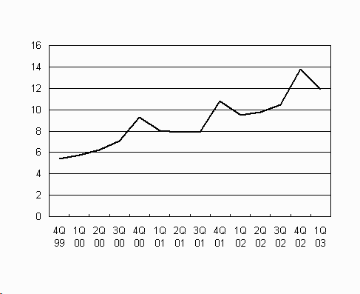
Figure 1: Quarterly U.S. On-line Retail Sales in Mio USD, 2003 (Source: US Census Bureau)

Here, we should add that within the framework of existing technology, different expert estimates of on-line retail’s future potential are typically up to around 10% of the total retail.
According to Census Bureau, the on-line (or e-commerce) retail sales are the sales of goods and services that correspond to the orders placed by the buyers on-line, or, by the prices and terms of sales negotiated on-line. Here, the “on-line” notion includes Internet, Extranet, Electronic Data Interchange (EDI), electronic mail, or other on-line system. However, this definition typically excludes the travel, ticketing, financial services, brokers and dealers, as they are initially not classified as retail. In addition, the broadcast (including adult materials) and on-line auctions (except their provisions) are also excluded.

Payment of on-line retail may or may not be performed on-line as seen in the Figure 2. For on-line shopping only the on-line ordering step is needed (SIBIS, E-Commerce, 2002: 8). The payment mode itself thus creates another characteristic for further structuring of the on-line retail. In Slovenia, for example, only 20% of on-line retail orders are also paid on-line.

Payment | On-line order | Off-line order
On-line | Included | Not included
Off-line | Included | Not included
Figure 2: The basic categories included into the notion of on-line retail sales

We should also recall that the customers might use the Internet only to collect the information, which may lead to off-line purchase. Let us illustrate this with a table of rough estimates for Slovenia, where the on-line retail is still in the early stage of development (0.2% of total retail compared to 1.5% in US), however, the much larger share is contributed to the off-line purchase generated with on-line information gathering. These all, of course, pose many questions for the definition and the scope of the B2C electronic commerce.
 | Shopping information
Ordering mode | On-line | Off-line
On-line order | 0.20% | 0.05%
Off-line order | 1.00% | 98.75%

Figure 3: Approximate estimates of on-line retail in Slovenia 2002 according to on/offline information gathered and on/offline mode of order (Source: RIS)

Security, confidentiality, privacy and credibility

From the consumer’s point of view, the on-line purchase is heavily linked with the issues of credibility, security, privacy and confidentiality. Let us briefly introduce these four notions:
- One of the most common worries with creating efficient and trustworthy on-line commerce relate to the security of financial transactions, which occurs over the network (Palubo and Herbig, 1998: 258). These concerns are not merely about security of value, but also about the trust in information society (Udo, 2001: 165). Typically, the notion of security includes all measures that ensure integrity, availability and confidentiality of information system.
- Credibility on the web is closely connected to the process of gathering online information, which should be accurate, based on expert opinion, and comprehensive. Further on, when using websites to obtain information, consumers are often asked to divulge personal information. Credibility of the web is thus related to a trust that company is fair, serious and truthful, so that consumers are not afraid to provide their personal information.
- Privacy is the basis of human dignity and other human rights and values, like freedom of joining and freedom of speech. It is usually related with disclosure of identity of consumer. Privacy is one of the most important rights in contemporary west society, as found in Privacy & Human Rights 1999 report. As found in Privacy & Human Rights 1999 report, privacy is today threatened mostly by three important trends: globalization (removes geographical restrictions in flow of data), convergence among technologies and multi-media. Privacy is not a one-dimensional concept. The most endangered in contemporary society are information privacy (possibility that individual keeps information about himself private) and privacy of communications, which also includes data transactions. The Privacy@net study revealed that far too many sites collect personal information from consumers without providing adequate protection of that information. The latest Consumers International research on web credibility found that 39 percent of sites that collected personal information did not have an explicit privacy policy. With privacy in a more narrow sense we typically understand the information privacy, that is, a possibility of keeping data and information about oneself secret, or available only to a limited circle that was approved in advance by the person being concerned.
- Confidentiality is a notion close to privacy and it narrows to the fact that data will not be disclosed to or compromised by unauthorized person.

The above concepts are difficult to measure, as they are closely interrelated. As we observe later, some surveys use the privacy and confidentiality as one measurement dimension. In addition, we will see that very often the concept of security highly correlates with the privacy. Nevertheless, in this paper we will basically deal with the concern for security and its impact on on-line shopping.

The security concern and on-line shopping: The SIBIS data

We will illustrate some of the above concepts with the latest findings of the SIBIS project (Statistical Indicators Benchmarking the Information Society), funded by the European Commission under the ‘Information Society Technology’ FP5 Program, running from January 2001 to June 2003. Within the SIBIS project also a General Population Survey (n=1,000 per country) was conducted in 2002/2003. There, the comparisons of the data for 15 EU (for mid 2002) and 10 new accession countries (NAS) are available together with Switzerland and the USA. There exists a lag of six months for the data of NAS countries (January 2003). SIBIS indicators cover the whole array of ICT issues and also the e-commerce and barriers arising from security problems. The indicators also explore the link between the perception of security problems and the decision to buy on-line.

On-line shopping

On average, 20% of the EU population (15 years and more) order products or services on-line, what is labeled here as e-commerce usage. We should note that in US this percentage is more than doubled (reaching almost 45%). Among the candidate countries, only Estonia comes close to EU figure and only few advanced NAS candidate countries are on a comparable level with less developed EU-15 countries (Spain, Greece and Portugal).

The figure bellow shows that the percentage of e-commerce usage is linearly growing with the Internet penetration.

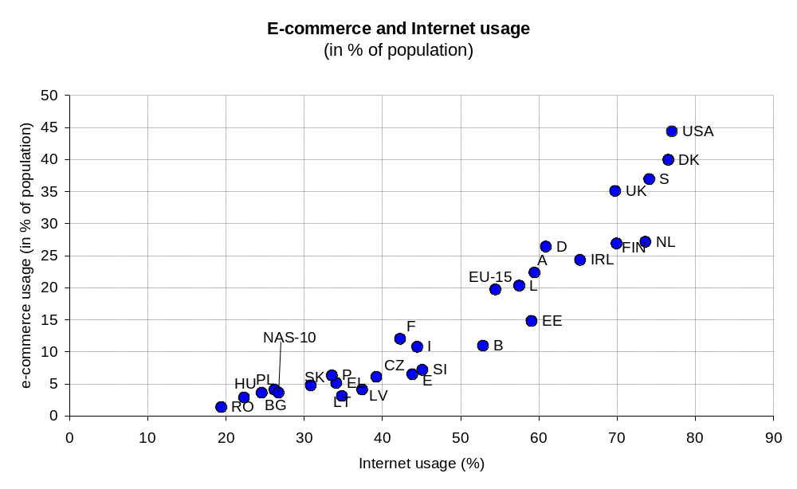
Figure 4: E-commerce usage and Internet usage, SIBIS 2002, GPS, SIBIS 2003, GPS-NAS

The SIBIS survey also shows that at least two years of experience is required to be a more adept e-Commerce participant.

Security concern and privacy concern

Consumers are generally concerned about both, privacy/confidentiality and data security. Concern seems to be lower in continental EU Member States and especially in most of the NAS countries – with Hungary as the lowest – than in the UK, Ireland or the US. Differences between countries are likely to be caused by a large number of factors including the amount of negative experiences, the level of trust in the state and the functioning of society-at-large, and the level of awareness of issues surrounding data protection and privacy. Nevertheless, despite these differences, there is a high correlation between the privacy and security concern.
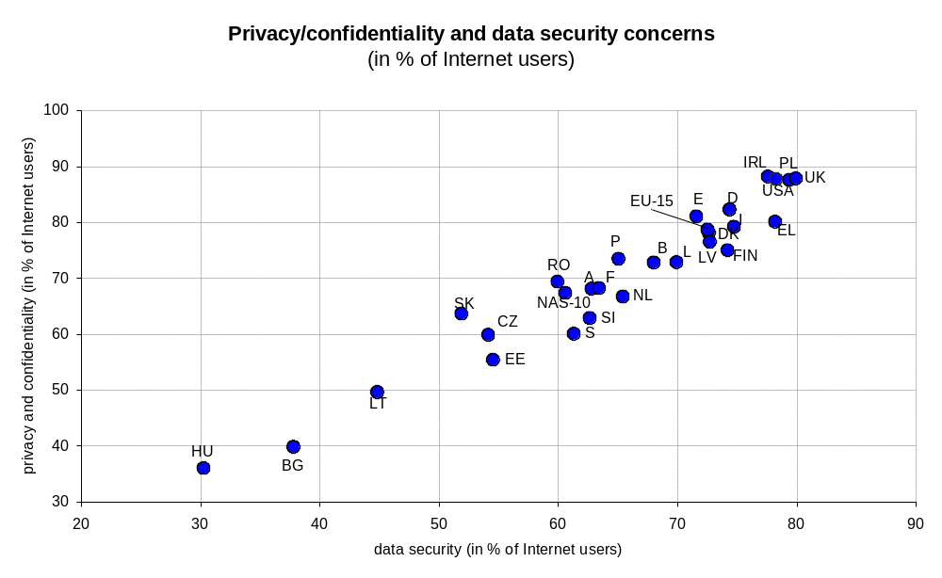
Figure 5: Concerns regarding on-line data security and privacy/confidentiality, SIBIS GPS 2002/3

The correlation is even much stronger if we observe both concerns as percentages of the whole population and not only as the percentage of Internet users.

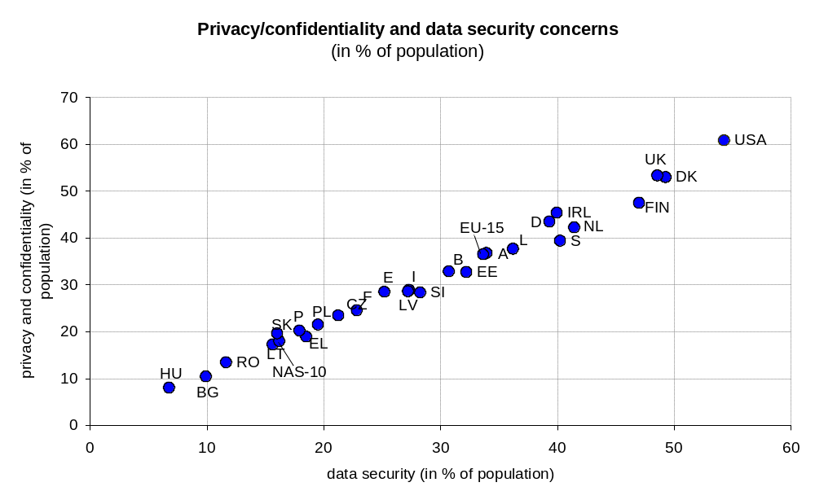
Figure 6: Concerns regarding on-line data security and privacy/confidentiality, SIBIS GPS 2002/3

The figure below shows that the privacy and confidentiality concern does not necessarily grow with the Internet penetration. In Nordic counties the percentage of users at least somewhat concerned about privacy or confidentiality is low in spite of high penetration. Obviously, there exist other (e.g. cultural) factors.

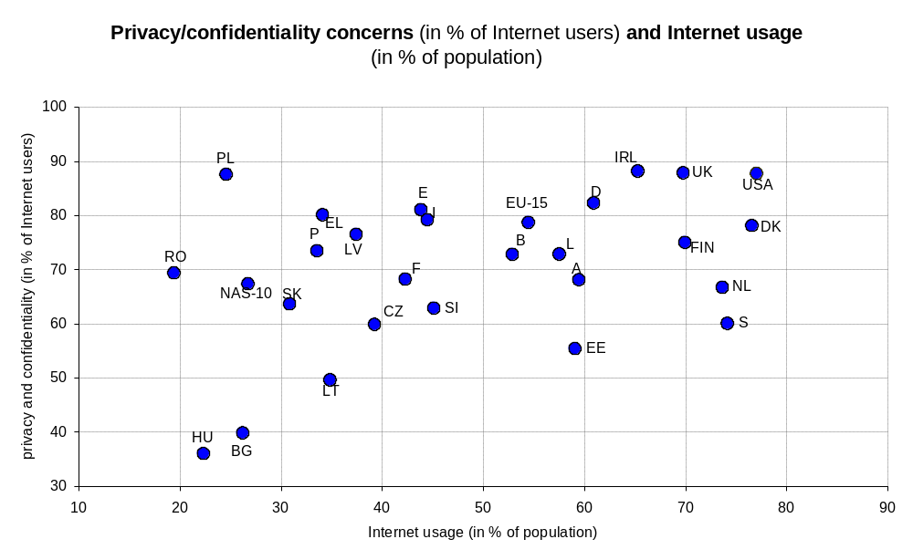
Figure 7: Privacy and confidentiality concern and Internet usage, SIBIS GPS 2002, SIBIS GPS-NAS 2003

Security concern and impact on on-line shopping

Security concern may have a significant impact on online shopping behavior. The figure below shows that this concern among Internet users is high in some NAS countries, as well as in USA and UK where e-Commerce penetration is nearly 50%. It is somehow surprising that the concern seem not to correlate with on-line shopping (i.e. e-commerce), although we could anticipate this already from low correlation between the concern and Internet usage. However, we could say that there may still exist a rough linear trend for EU-15 countries, Switzerland and US, if we exclude Scandinavian countries (which are very specific), while with NAS 10 countries there seem to be no clear pattern. A possible explanation for large number of respondents in SIBIS survey, who do not seem to be affected by electronic breaches or vulnerabilities, is that these respondents are more aware of e-commerce security features and, consequently, are more confident in completing on-line transactions. On the other hand it is also possible that they trust because they are not aware of possible dangers.

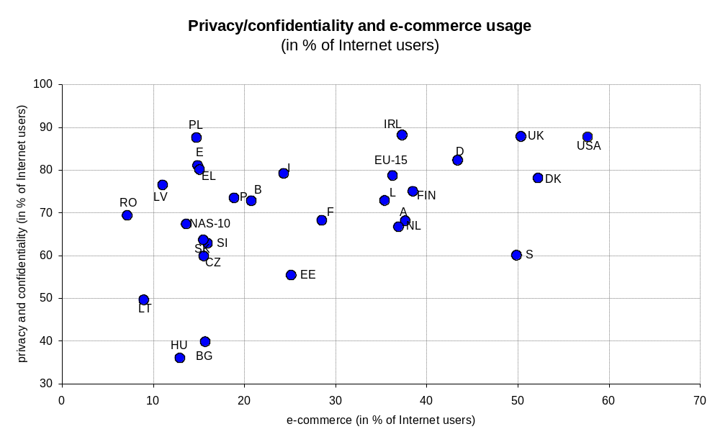
Figure 8: Privacy /confidentiality concern and e-commerce usage, SIBIS GPS 2002, SIBIS GPS-NAS 2003

We get more insight if we observe the customers (regular Internet users) often stopped from buying on-line due to security concerns. The Nordic countries, the US, the UK, Austria and Germany appear as front-runners (quadrant I), while all Mediterranean countries (France, Italy, Spain and Greece) are the laggards (quadrant III). NAS countries are located in the quadrant II, which means low online shopping usage and also relatively low barrier arising from security.
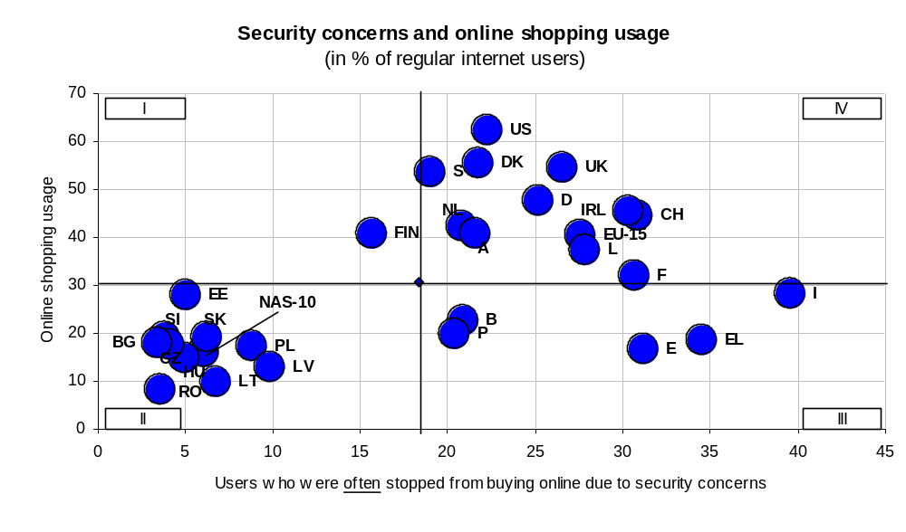
Figure 9: Security concerns and on-line shopping usage (i.e. e-commerce usage), SIBIS GPS 2002, SIBIS GPS-NAS 2003

In the figure bellow we can observe a surprisingly low correlation among the general security concern and the fact that the concerned consumers were actually stopped from buying due to this concern. Of course, the lack of corresponding correlation at national level does not necessary means that there does not exist a strong correlation on personal level.

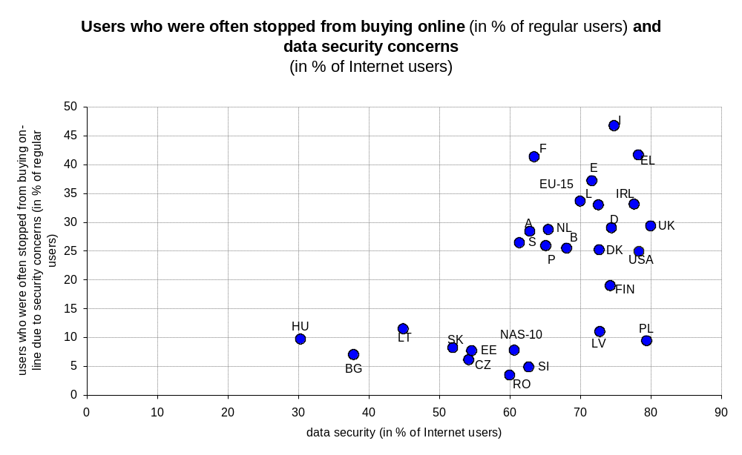
Figure 10: Users who were often stopped from buying online due to security concerns, SIBIS GPS 2002, SIBIS GPS-NAS 2003

Here, we should ponder that only respondents already concerned about security were asked, whether this was a barrier stopping them from buying online. Her, we should add that in general, one third of respondents were saying "yes, often" and another third saying "no, never". The remaining third chose a middle way answering, "yes sometimes". Among NAS countries the share of those being often stopped from buying online due security concerns is particularly independent from the level of this concern.

The socio-demographics of “concerned” users

Let us observe some basic characteristics of the users that expressed concern about on-line security.

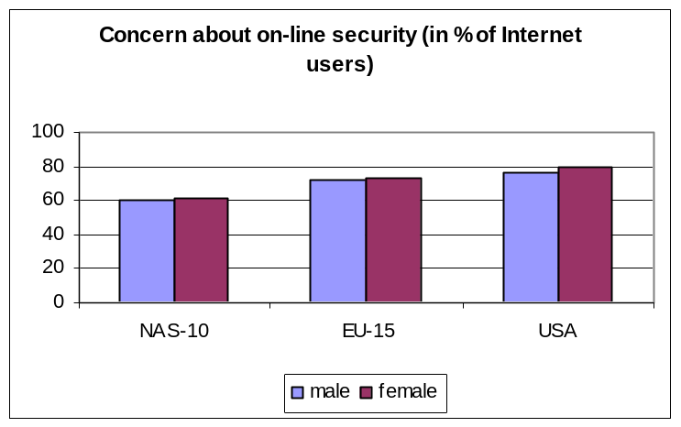
Figure 11: Concern about on-line security by gender, GPS 2002, SIBIS GPS-NAS 2003

We observe little impact arising from gender. It seems that females are slightly more concerned, however the discrepancy is very small.
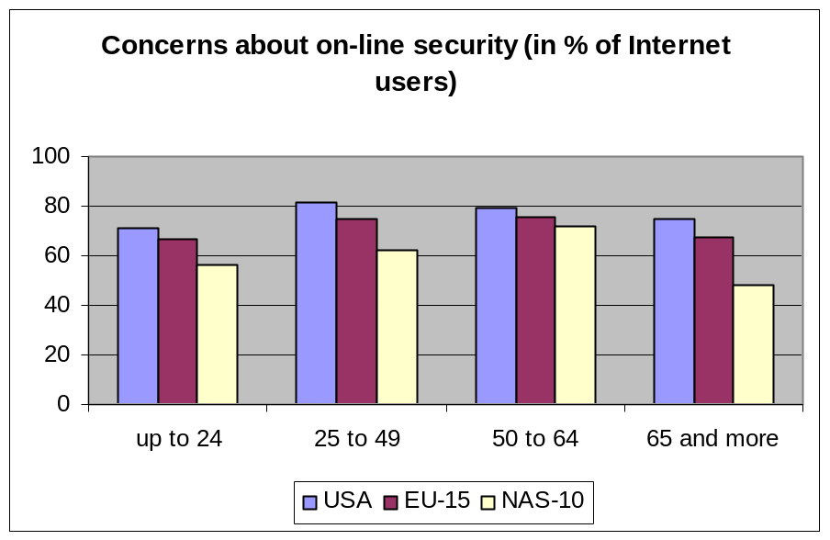

Figure 12: Concern about on-line security by age, GPS 2002, SIBIS GPS-NAS 2003

With respect to age the concern is somehow lower among the youngest and the oldest segments.

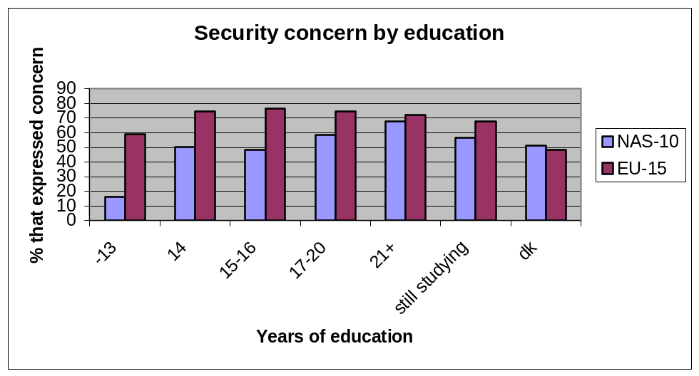
Figure 13: Concern about on-line security by education, GPS 2002, SIBIS GPS-NAS 2003

With respect to the education (i.e. terminal education age according to definition of ESOMAR) we observe that more educated seem to be also the most concerned about security.

The basic conclusion would be that security concerns are only one specific barrier against e-commerce for a certain segment of the public, particularly in some countries. SIBIS elaborations point out that these "over-cautious" users cannot be simply identified by age, sex or educational status.

Security issues and on-line shopping in Slovenia

The basic characteristics

We already saw that Slovenia is slightly bellow EU average in general ICT usage, however, it is much bellow this average with respect to e-shopping. The gap can be attributed to the awkward developments in the key on-line segments (books, music, retail), what caused the unique situation when the top on-line shops are dealing with clothes (e.g. Neckerman) and home improvements/appliances (e.g. Merkur) and not with books and music. Another limiting factor can be the lack of the critical mass needed to develop more elaborated on-line shops.

Nevertheless, the telephone survey from December 2002 showed the major breakthrough for Slovenian e-shopping in 2002, as the radical increase of domestic on-line spending was noted, which for the first time presented the majority of on-line retail spending. As mentioned, the on-line retail presents 0.2% of all retail and close to 20 million Euro per year, which is a 100% increase compared to the year 2001. Survey from December 2002 has also shown that about half of the respondents accomplished purchases in an amount bellow 100 Euro. There are 100,000 Internet users (among the total of 650,000 users in 2002) that already performed some type of on-line order, and 70,000 did it in last 12 months.
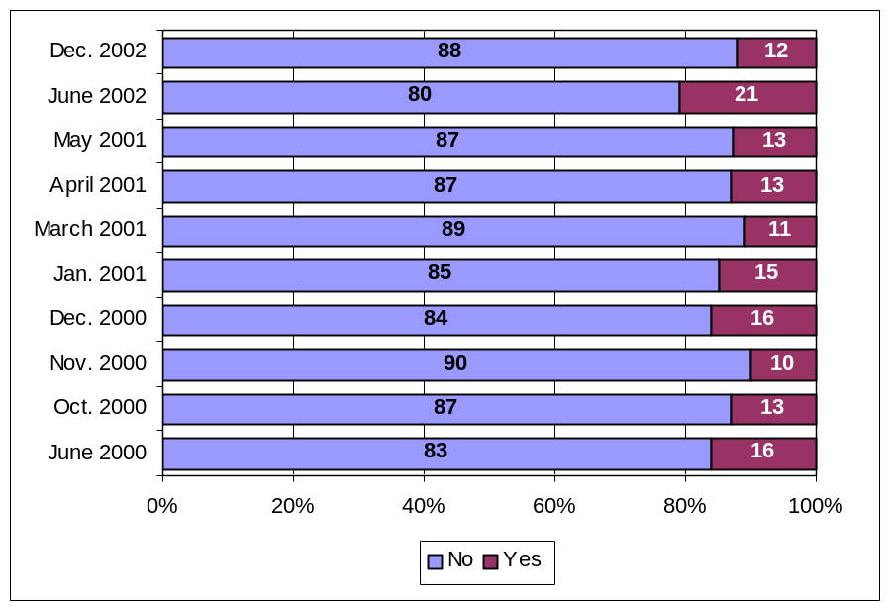
Figure 14: E-shoppers in last 12 months among monthly Internet users (RIS telephone surveys, 2000-2002).

As mentioned, in 2002, the majority of persons accomplished e-purchases only on Slovenian web sites. This is basically the result of the increased entrance of less educated active Internet users in last years. The new users are thus visiting mostly Slovenian websites, as the whole segment of advanced and English speaking users already entered the on-line purchase few years ago.

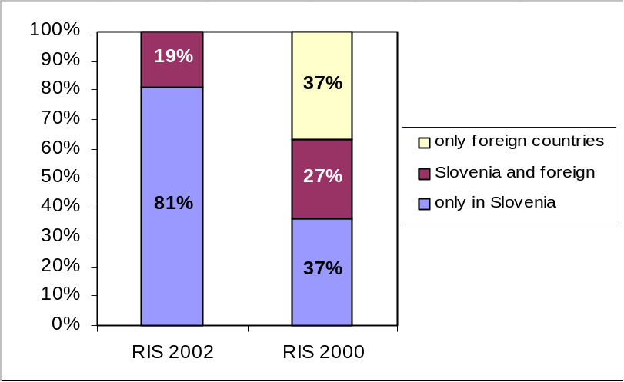
Figure 15: Shares of e-purchasers according to web site location (December 2002, RIS telephone survey, n=48).
With respect to the interests of on-line shopping the Slovenia basically confirms the well-known patterns of the most convenient products and services to be sold on-line.

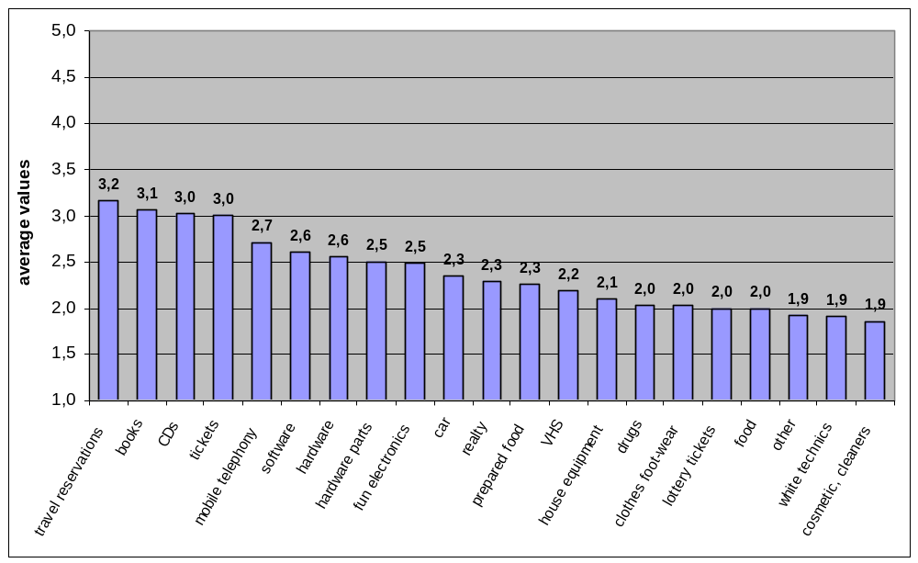
Figure 16: Interest for e-shopping and searching for product information (RIS 2001, n=5,937).

Segmentation of on-line shoppers

Elder (Elder, 1999) has conducted some pioneer segmentation of on-line shoppers among US Internet users. He found five segments of e-purchasers: strong purchasers, freshmen, and generation of plastic cards, careful shoppers and niggards.
The segmentation based on the same questionnaire with RIS data collected on the Web in 2001 showed (Papič, 2002) very similar segments. Despite two-year time lag (which may partly compensate for the lagging in e-shopping of Slovenia behind US) it seems that the on-line segments show surprisingly high robustness:
- First group was named “indifferentist” and contains 19,6% of the respondents. They are not against Internet shopping, but they don’t think it is very useful. They are concerned about security of e-purchase and also about spam, but they are more confident to classical catalogues purchasing.
- The other group is “permanent shoppers”, and it contains 32,6% of the respondents. They see Internet shopping as very handy, because they don’t like to lose their time by classical shopping. They are not concerned about security and privacy issues as well as they are not concerned about spam. They also believe they can get better prices on-line.
- Third group is called “Sunday shoppers”. It contains 35,1% of the respondents. They are very similar to “indifferentist”, apart from using the catalogue shopping.
- The last group is called “freshmen”. They have certain interest, but do not have very positive attitudes towards on-line shopping as they want to see the product before purchase, and they are very concerned about security and privacy issues.
Despite the two groups appearing both in Slovenia and in USA – strong shoppers and freshmen - several differences between Slovenia and USA exist, mostly as a consequence of different environment. It seems that the most important differences between US and Slovenia are technical development of US Internet (also due to time difference), and more equal distribution of Internet users among several demographic groups in US.

Characteristics of on-line shops
Respondents from RIS 2001 Web survey were asked about characteristics of good on-line shops. The most important characteristic is the simple navigation through on-line shop (ahead of the assurance of security) and the least important is possibility of telephone contact with the vendor. We should note here that the results are based on web survey with a self-selection of Internet users, who could be systematically more inclined to experienced on-line shoppers.
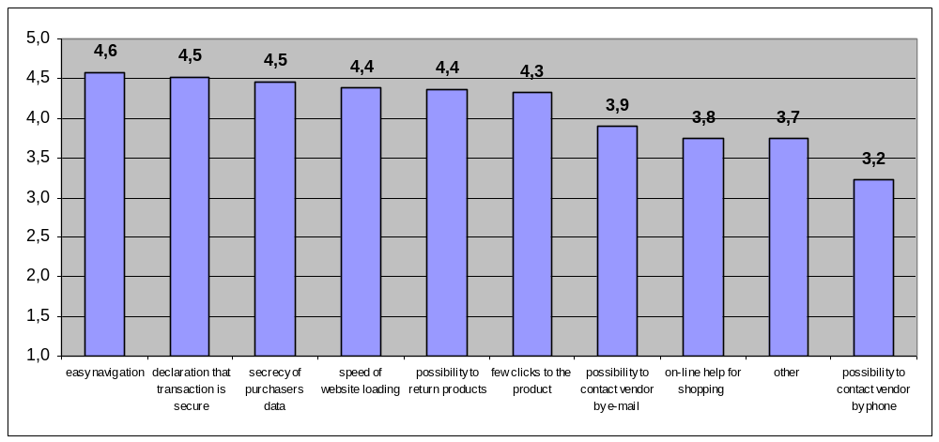
Figure 17: Average values for the features of quality e-shop (RIS 2001 Web survey, n=151).

Concerning the aspects of the presentation of products in Internet shop, for the consumers, the most important aspect on 1-5 five rating scale is the price comparison, links to opinions and critics about the product and the information about accessibility of a product.
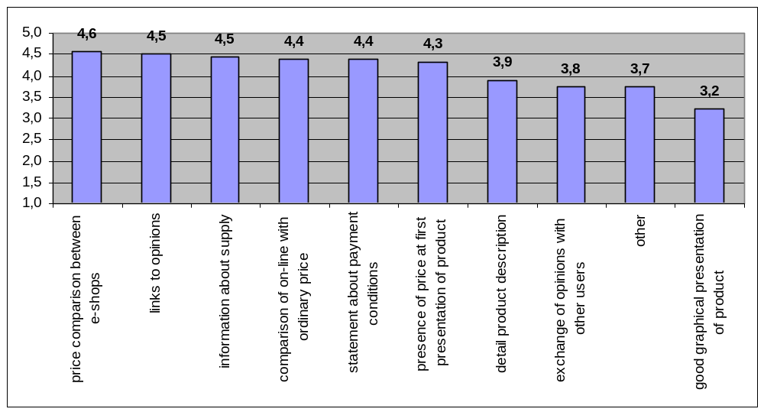
Figure 18: Importance of presentation elements for product presented on websites (RIS 2001, Web survey n=147).

Obstacles for non-shoppers

We tried to found out what are the major obstacles for on-line shopping. For this, the Internet users, who were not on-line shoppers, were asked about reasons for not using on-line shopping.
The main reason for not buying over the Internet is that respondents want to see the product and the preference for the traditional shopping. The next important obstacle is fear about credit card abuse, the lack of need for Internet shopping and the privacy concern.
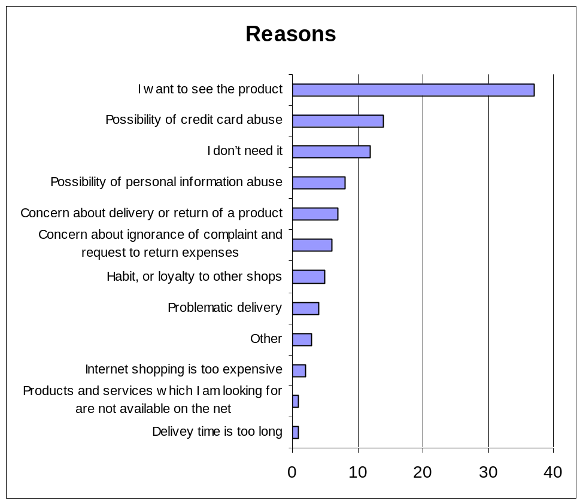
Figure 19: Main reasons why Internet users are not purchasing over the Internet, RIS Telephone interview (June 2002, n=153).
Similar results were obtained when asking to rate the obstacles on 1-5 scale. Again, the main obstacle found is the physical absence of the product. However, the argument that respondents want to see the product, often actually means that he simply lacks a good promotion and the awareness of the advantages of on-line sales (costs, convenience, information, etc.).
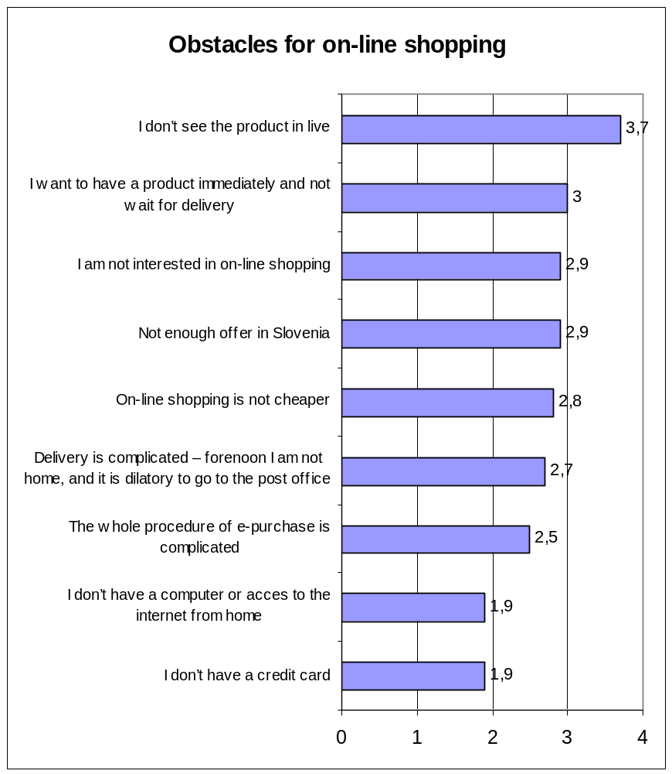
Figure 20: Obstacles for on-line shopping among non-shopper on 1-5 scale, RIS Telephone interview (June 2002, n=156).

Consumer rights issues

Concerning consumer rights, the main problem for e-purchasers was the fact that website was unfriendly, because it was reported as the most serious issue (on a 1-5 scale) encountered by on-line shoppers. Next, there was a problem with the delivery expenses.
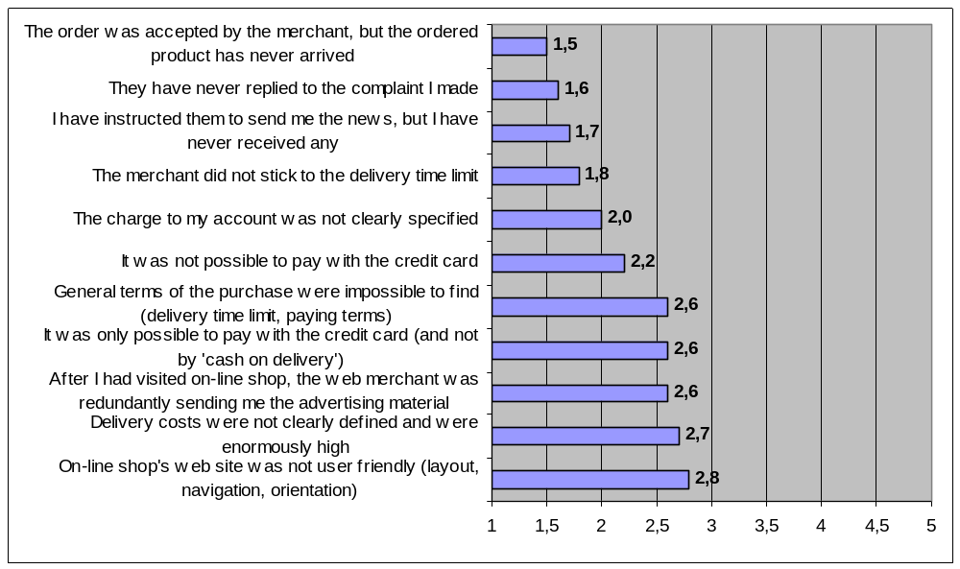
Figure 21: Average values for consumer right problems reported by Slovenian e-shoppers (RIS 2001, n=198).

The above obstacles seem to be consistent across Web and telephone surveys as well as across time period 2000-2002. A slightly different scale among on-line shoppers in December 2002 revealed that the improper navigation was still highly rated among the problems; however, this time the delivery problems and misleading advertising were the main problems. The security concern was not appearing high among option “other”. However, we can observe also the privacy/confidentiality problem the item “Misuse of email for spam messages”, which was experienced by 7% of Slovenian on-line shoppers.

Figure 22: Problems with on-line shopping, RIS telephone survey (2002, n=87).
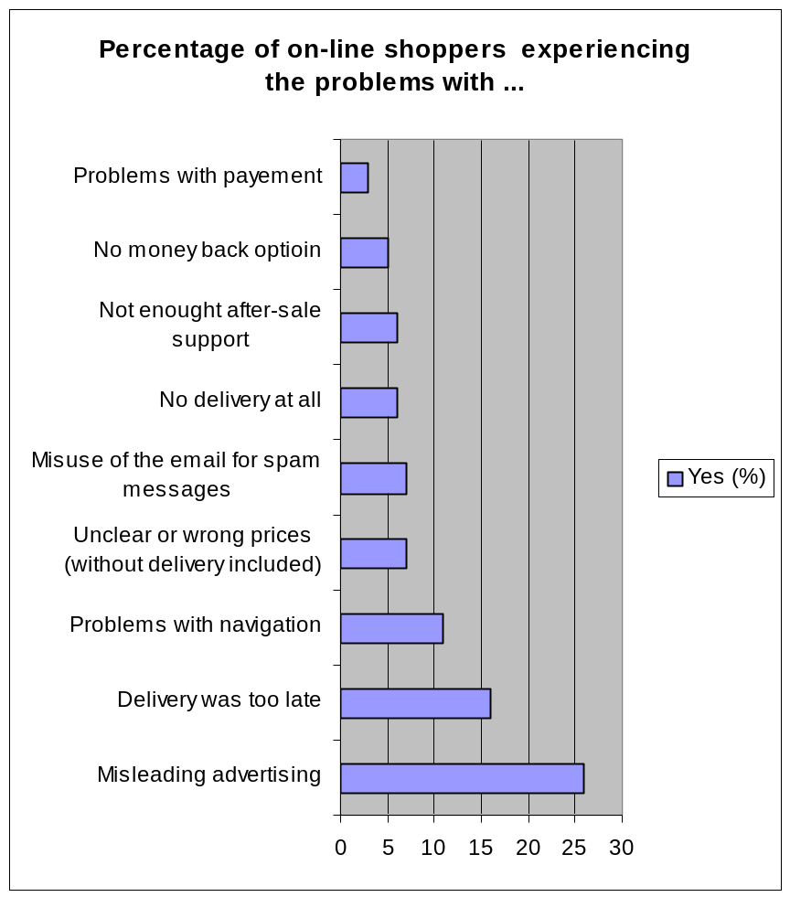Here we should also mention some interesting results from the survey conducted by CATI Company for the needs of the Slovene Consumer’s Association. It was a qualitative study, which provided in-depth insights into consumer’s perceptions and attitudes towards on-line shopping. There the security concern wasn’t aroused as a critical issue. However, it is true that this research was focused more on values and motivations for on-line shopping and not so much on obstacles.
Similarly, the mystery shopping research, which is occasionally performed by Slovenian Consumer’s Association, also did not revealed security concern as an important critical aspect of on-line shopping in Slovenia.

Modeling security concern and on-line shopping

The Slovenian data also enables modeling of the relation among security concern and on-line shopping. We should recall that the SIBIS data were the aggregated data about country characteristics. The corresponding relations at the personal level may thus not be the same.
For example, although there exists a correlation among the security concern and on-line shopping at the country level, this does not mean (although it is somehow likely) that such relation will exist also at the individual level. This well-known methodological problem is often referred as “ecological fallacy”.
For our micro data model we used user’s attitudes towards security concern together with (subjectively) reported on-line shopping. We used the representative RIS telephone survey and also the on-line Web survey, both for 2001.
First, we should observe relatively high values for the agreement with the security related attitude (“I am concerned because of the possibility of credit / payment card abuse”), which are around 3.8 on 1-5 scale in all surveys for all years. The agreement with the statement “It is important to have the notice assurance on a web site that the site is secure” reaches even higher values (4.5). The fear of insecure transaction thus seems to be a somehow important obstacle for on-line shopping, although the SIBIS results show that this rarely manifest in preventing the users from buying. Our assumption in the model is that fear of security abuse will negatively effect the on-line purchase. We also assume that positive attitudes to on-line purchasing will have positive affect, as well as the intensity of Internet usage.
variable | indicator(s)
security concern (FEAR)** | I feel inconvenient about possibility of credit / pay card abuse. (1 - totally disagree, 5 - totally agree)  I worry about security of data on the internet (1 - totally disagree, 5 - totally agree)*
attitude to on-line shopping (ATTITUDE)*** | One common factor from the following variable (all on scale 1-5):  - Internet shopping interests me.  - I know the on-line offer (of goods) very well.  - Comparative to other ways of sale, this way is much better.  - I miss a big shop on the Internet in Slovenia.
the level of internet usage (USE) | How often do you use internet? (1 - many times a day, almost daily, weekly, monthly, 5 - less than once a month*)
actual purchase (BUY) | Have you, in the last 12 months, purchased something at home or in foreign county? (1 - yes, 2 - no)
Figure 23 Variables for analysis of online shopping behavior
Here are some comments to the table:
(*) There were two surveys with the same indicators. One was telephone survey and the other web survey, both in 2001. Italic text indicates additional indicator for privacy concern in web survey and additional option about the level of Internet usage in web survey.
(**) Indicators in web survey were constructed by Likert measurement procedure.
(***) Indicators were constructed by factor analysis. Extraction method was Principal Axis Factoring. Constructed factor in telephone survey explain 58,5% of variance, and factor in web survey explain 64,7% of variance.
We tested the same model with data from representative telephone survey from March 2001 (n = 358) and with data from web survey RIS 2001 - WWW (n = 9,648). T-test from the telephone survey has shown that the attitudes on on-line shopping significantly differs between those who had purchased something and those who hadn’t, while privacy concern does not show significant differences among the two groups. On the other side the web survey has shown that both t-tests are significant (partially also due to larger sample).

Telephone survey |  |  | WEB survey
Standardized solution:  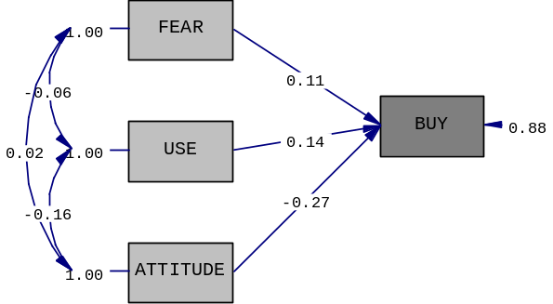R-square: 0,114 (Adjusted R-square: 0,106)  F-value: 13,8 (sig. is less than 0,001) |  |  | Standardized solution:  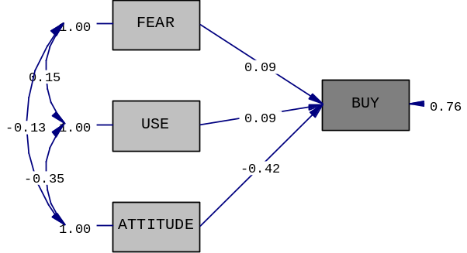R-square: 0,208 (Adjusted R-square: 0,202)  F-value: 32,36 (sig. is less than 0,001)
variable | Beta | t-value | variable | Beta | t-value
FEAR | 0,11 | 2,01 | FEAR | 0,09 | 2,05
USE | 0,14 | 2,68 | USE | 0,09 | 1,86
ATTITUDE | -0,27 | -5,11 | ATTITUDE | -0,42 | -8,65
Figure 24 Results of regression analysis with LISREL modeling: online explaining online shopping behavior
Direct influence of security concern on actual purchase in web survey was small (0.9 on standardized scale) and on the edge of statistical significance (t=2.01), very similar to the results from representative telephone survey (0.11, t=2.05). The Internet usage has also very weak influence in Web survey (where the respondents were more homogeneous and intensive internet users), but somehow stronger in telephone survey. In both surveys the attitudes has far the strongest influence on on-line shopping.
In this specific example it thus seems that the security concern itself does not have the prevailing impact on on-line shopping. Nevertheless, this attitude is strongly mixed with other attitudes towards the on-line shopping and it is relatively complicated to isolate this concept. In addition, as we saw from the SIBIS data, the security concern is truly relatively low in Slovenia, so these results cannot be generalized to other countries. However, this small study clearly demonstrates the challenges of measuring the concepts and their inter-relations.

Bibilography

- Consumer international (2002): Credibility on the web: An international study on the internet.
- Consumers International (2001): Privacy@net
- Dertousoz, M. (1997): What Will Be. Harper Edge, San Francisco.
- Frank, Franzak, Pitta, Dennis, Fritshe Steve (2001): Online relationships and the consumer’s right to privacy, Journal of Consumer Marketing, vol. 18, No. 7
- Kovačič, Matej, Vehovar, Vasja (2000): Attitudes toward internet Privacy: Slovenian internet user’s view
- McCrohan, Kevin (2003): Facing the threats to electronic commerce, Journal of Buseinnes & Industrial Marketing, vol. 18, No. 2
- Negroponte, N. (1995): Being Digital. MIT Press, Cambridge Mass.
- Palumbo, Fred, Herbig, Paul (1998): International marketing tool; the Internet. Industrial Management & Data Systems, No. 6.
- Papič, Ivan (2002): Segmentacija e-nakupovalcev v Sloveniji. Magistrsko delo. Ekonomska fakulteta, Ljubljana
- Privacy & Human Rights 1999, http://www.privacyinternational.org/survey/Overview.html, May, 23 2000.
- Salisbury David W., Pearson, Rodney A., Pearson, Alison W., Miller, David W.(2001): Perceived security and World Wide Web Purchase intention.
- SIBIS Pocket Book 2002/03, Measuring the Information Society in the EU, the EU Accession Countries, Switzerland and the US
- SIBIS (2002) – WP 5: Topic Report, Topic: Security and Trust; www.sibis-eu.org
- SIBIS (2002) – WP 5: Topic Report, Topic: E-commerce¸www.sibis-eu.org
- Survey RIS (2001): Spletna anketa, e-nakupovanje končnih potrošnikov, www.ris.org
- Survey RIS (2002): E-nakupovanje končnih potrošnikov, www.ris.org
- Surveys RIS, http://www.ris.org/ and Zasebnost/Privacy 99, http://www.ljudmila.org/matej/zasebnost
- Toffler, A: (1980): The Third wave. New York: Bantam.
- Udo, Godwin J. (2001): Privacy and security concerns as major barriers for e-commerce: a survey study, Information Management & Computer Security, vol. 7, No.4
- US Census Bureau; http://www.census.gov/mrts/www/current.html

http://www.census.gov/mrts/www/current.html
Consumers international, 2002, Credibility on the web, international study of the credibility of consumer information on the internet.
ibid.
Consumers International, 2001
Consumers International’s “Credibility on the web” study
SIBIS question on e-commerce usage: For your private purposes, have you used it in the last 12 months: - to order a product or service: (1) yes; (2) no; (3) DK. Only Internet users were asked.
SIBIS question on privacy/confidentiality concerns: How concerned are you about privacy and confidentiality on the Internet, i.e. personal information about you being misused by third parties?
SIBIS question on data security concerns: How concerned are you about data security on the Internet, i.e. the loss or manipulation of your data? Only Internet users were asked. Answers for both questions: (1) very concerned; (2) somewhat concerned; (3) not concerned; (4) DK.
SIBIS question on influences of security concerns: Are these concerns stopping you from using the Internet to buy goods or services online: often, sometimes, or never?: (1) often; (2) sometimes; (3) never; (4) DK; (5) never tried to buy on-line. Only respondents who were at least somewhat concerned about data security or privacy/confidentiality were asked.
SIBIS topic report on Security and Trust analysed this indicator by age and professional status, without finding very significant variations to this pattern.

