

Vendor Compliance Guide

Revised 12/20/11

Big Rock Sports, LLC

Table of Contents:

Big Rock Sports ..…………….……………………………………………..1

Table of Contents …..……………………………………………………….2

Our Vision …..……………….……………………………………………….3

Vendor Compliance Guide Overview.……………………………………..4

Compliance Requirements

I. General Inbound Shipment Requirements and Carrier Routing.......6

II. BRS Inbound Carrier Routing Guide……………………………….. 8
III. Labels, Forms, and Packaging ....…………………………………….11
IV. Bar Code Compliance ………………………………………………..18
V. Damaged Package, Dimensions, and CPSIA Law ….……………..20
VI Vendor Compliance Error Codes ….……………..………………….22 VII. Gun Vendor Compliance .……………………………………………23
VIII. EDI-ASN Compliance. ..……………………………………………...25
1X. Non Compliance …….…………………………………..………………28
X. Returns ...…………………………………………………………………26

Appendixes:
Signature Required
A. Vendor Compliance Acknowledgment Form .…..………………….31
B. BRS Quick Check List …………..……………………………………32
C. Location Information.………………………………………………….33
D. Bar-Coding Standards ……………………………………………...36
E. EDI-ASN Standards …..………………………………………….37
F. SPS Commerce Contact Information ….………………………..38
G. How to Measure …………………………………………………39

OUR VISION
Big Rock Sports vision is to be our Customers’ first choice for hunting, fishing and camping equipment in each and every market we serve. To earn our Customers’ trust and to meet their unique needs, we will provide valued solutions with the best prices, products and services that make our Customer’s lives easier.

Our Target Customers
Big Rock Sports serves three customer groups, each with different needs:
• Independent Retailers of sporting goods
• Regional Retail chains
• Major Retailers of sporting equipment
Our challenge is to meet the needs of all these customers by offering the products, prices, and services that will create the right value for each group.

Our People
Ultimately, Big Rock Sports success is not driven by the products we offer, or the services we provide. It is determined by the employees who work in our Company. We will educate and empower our people to perform their jobs properly and we will reward the achievement of excellence.

All of Big Rock Sports Employees commit to provide our customers knowledgeable and friendly assistance whenever needed, regardless of where each job is performed. All are 100% committed and customer focused for all of us to prosper.

Our Products
The Merchandise we offer must help our customers provide a dominant product offering in there selected markets and to allow them to grow their business while providing a wide variety of products to meet their customers expected needs.

This challenge requires:
• Always being in-stock.
• Dominant product offerings meeting and exceeding the expectations of our customers.
• Product lines tailored to each individual market based on the geographic, demographic, and seasonal characteristics of each market.
• Presentations and signage which answer questions and solve problems.
• Evolving product selection which reflects our customers changing lifestyles and their increasing demand for quality.

Our Commitment
We are committed to simplifying our dealings with customers and suppliers in order to be the low cost operator and merchant in our Industry. At Big Rock Sports, our goal for lowering cost means reducing our costs as a percent of sales, not minimizing spending. In growing our business, Big Rock Sports will invest in our communities. We will communicate to our customers and communities their importance to us.

Vendor Compliance Guide Overview

Development of Big Rock Sports Compliance Guide:
In order to expedite the receiving of merchandise at Big Rock Sports Distribution Operations, BRS has developed this Vendor Compliance Guide. This Guide must be followed by all suppliers for all inbound shipments, regardless of size, destination or current understanding of what is “Acceptable”.

Meeting Compliance:
Though it is our intent to allow the vendor community time to meet all elements of this program/guide, it is paramount that we have a 100% commitment as quickly as possible combined with continued adherence to this guide and the various elements of the guide.

Vendor Compliance Guidelines:
Big Rock Sport Vendor Compliance Guide has been broken down into two parts.
1. General Compliance Guidelines.
2. Appendixes providing more details on specific areas addressed.

Vendor Compliance Team:
To support the implementation and adherence to the various issues addressed in the guide. Big Rock Sports has put in place a Logistic and Compliance support team available to the Vendors at:
compliance@bigrocksports.com
The team’s goal is to assist in helping Vendors support and meet the requirements of this guide. This team will assist in the process of continual improvement for both the guide and the business practices affected by the guide’s requirements. Big Rock Sports Primary Vendor Merchant is also available for assistance.

Contact:
This guide and all details are subject to change. E-mail notification will be attempted with all changes. We advise vendors to regularly review BRS web site for postings of changes.

Big Rock Sports
www.bigrocksports.com

Vendor login and password are necessary to access BRS vendor portal. If you do not currently have a login, please contact the BRS Merchant Department or our Vendor Compliance Team at:

compliance@bigrocksports.com.

Big Rock and Distribution Operations:

Though this guide will reference Big Rock Sports in general, all requirements apply to all Big Rock Sports Distribution Operations. Currently Big Rock Sports operates 5 Distribution Centers. Any and all purchase orders or other transactions referencing Big Rock Sports or any of our operating companies listed below are covered by this compliance guide.

Distribution Operations for Big Rock Sports are as follows:

Henry’s, LLC  Hamlet N.C. | AWR, LLC  Fresno C.A. | CSI Sports, LLC Sauk Rapid M.N.
All Sports, LLC  Clackamas O.R. | MT Sports, LLC Billing M.T.

Big Rock Sports Routing Guide:
In addition to Big Rocks Sports Compliance Guide, the BRS Routing Guide is also available to all Vendors online at Big Rock Sport Web site:

www.bigrocksport.com

As we make changes to the Routing Guide we will again attempt to communicate via e-mail to the vendor community and they will be directed to the website for the latest details.

Important Note:
In order to maintain working contact with BRS Vendors, all vendors are required to return to Big Rock Sports, Appendix A. This acknowledgement contains contact information critical to ensure the correct people are contacted regarding information or issues.

Email or Fax Acknowledgement form to:
Big Rock Sports
C/O Vendor Compliance
compliance@bigrocksports.com
Fax: 252/727/0026

I. General Inbound Shipping Requirements and Carrier Routing:

Normal receiving hours at all Big Rock Sports locations are:

7:00 AM to 2:00 PM local time, Monday through Friday.

A. Appointments:
1. All preferred BRS carriers and the U.P.S. Carrier have pre- arrange standing appointments.
2. The names of preferred carriers are listed in the Big Rock Sports Routing Guide.
3. All Truckload or Container shipments not controlled through BRS Routing Guide and all LTL shipments in excess of 100 cartons and/or 8 pallets must always be scheduled by the shipper regardless.

Distribution Center contacts for Inbound Traffic and dock appointments.

Henry’s LLC  Inbound Email:  rc-inbound@bigrocksports.com  Dispatch: 910-582-4252 ext.  6719  Distribution Center Code: RC | All Sports, LLC  Inbound Email:  cl-inbound@bigrocksports.com  Dispatch: 503-650-7500 ext. 4111  Distribution Center Code: CL | CSI Sports, LLC  Inbound Email:  sr-inbound@bigrocksports.com  Dispatch: 320-252-4193 ext. 3211  Distribution Center Code: SR
MT Sports, LLC  Inbound Email:  bm-inbound@bigrocksports.com  Dispatch: 406-252-1610 ext. 4427  Distribution Center Code: BM | AWR, LLC  Inbound Email:  fr-inbound@bigrocksports.com  Dispatch: 559-237-8365 ext. 6115  Distribution Center Code: FR

B. Pallet Standard:
1. All LTL, Truckload and Container shipments must be made on pallets.
a. BRS requires pallet measuring 40X48 and 4 way lift access.
b. Product must be secured and protected by the pallet.
c. If your product can not meet requirement contact your Merchant and provide a suggested solution for delivery and material handling on the receiving dock as soon as possible.

 Important Note:
Loose or poorly unitized shipments will be reported to the vendor and/or refused delivery. Any added cost in unloading associated to poor shipment quality will be charged back to the vendor.

2. Proper loading decisions effect productivity, transportation costs, employee safety, equipment cost and the protection of your product.

Proper loading technique Improper loading technique
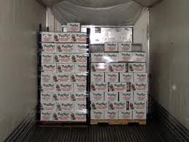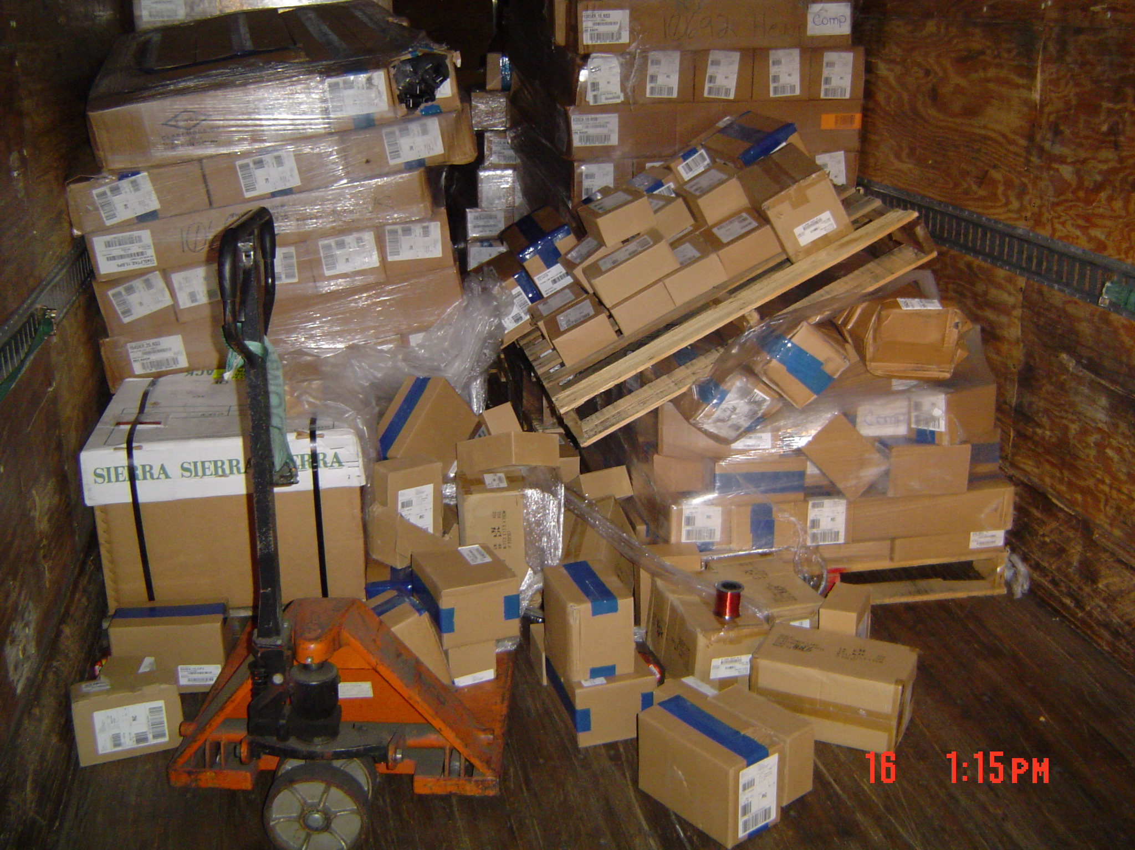

Big Rock Sport prefers the straight load but all forms are acceptable.

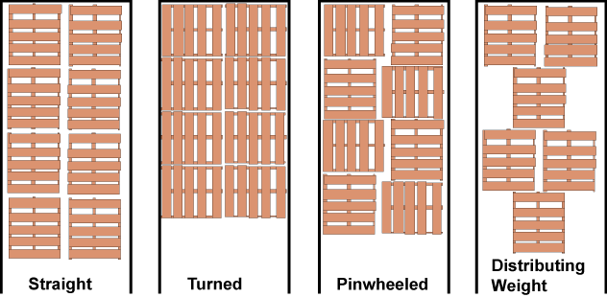

II. BRS Inbound Carrier Routing Guide
A. Logistics and Routing:
1. Information Access:
a. Inbound logistical support.
b. Routing Guide information.
c. U.P.S. shipper number associated with the U.P.S. Collect Inbound Shipping Program.

Contact:
compliance@bigrocksports.com.

2. All shipments where Big Rock is responsible for freight cost MUST ship in accordance with Big Rock Sports Routing Guide.
3. The Routing Guide provides carrier contact information and identifies the preferred carriers for all inbound Truck Load and LTL shipments and inbound locations.

B. Prepaid and Add:

1. “Prepaid and Add” is not an acceptable freight term.
2. When Big Rock Sports is responsible for freight the shipment
must be made in accordance with the Routing Guide and shipped Freight Collect.
3. Big Rock Sports will not pay for freight charges that are added to invoices.

C. Truckloads:

1. All Prepaid or Collect Term Truckload shipments must have a scheduled dock appointment.
2. No unscheduled shipments will be received.
3. Failure to comply will result in added freight cost for the shipper and any cost associated to collect shipments will be charged back to the vendor.

D. Prepaid Term:

1. Vendors with Prepaid terms (all cost being paid directly by the shipper) and Ownership Designation of F.O.B. point “Destination” are encouraged to use the preferred carriers listed in the Routing Guide.
2. For scheduling and performance concerns, shipment can be made by the vendor’s carrier of choice but a delivery appointment MUST be scheduled or shipment may be refused.

3. All other inbound Truck Load and LTL carrier traffic including Prepaid F.O.B. “Origin” Shipment should use the Big Rock Sports Routing Guide.

E. UPS Shipments-Any single shipment with less than 10 cases or under 300 pounds combined:

1. Big Rock Sports has chosen U.P.S. as our primary small parcel carrier.
2. All small parcel shipments where Big Rock Sports are responsible for freight cost must be shipped COLLECT on U.P.S.
3. These shipments must be shipped under the U.P.S. Freight Collect Program.
Details are available at:
www.ups.com
or by contacting:
compliance@bigrocksports.com.

4. Vendors must use this method to make shipments when terms of purchase are COLLECT and not prepaid.
5. Freight collect should not be confused with C.O.D. or prepaid shipments.
6. Collect shipments made through U.P.S. will have all billing charged to Big Rock Sports.
7. “Prepaid” and “add” is not acceptable term for Shipments made through U.P.S.
8. Prepaid shipments must ship at the cost of the vendor.
9. No accessorial charges will be accepted for shipments made through U.P.S. This includes overweight or special handling charges without prior written approval by Big Rock Sports Compliance Team.

F. United Parcel Service (U.P.S.) ONLY:

1. BRS requests that vendors make only one shipment per day and no more than 2 shipments per week.
2. Written approval from BRS Compliance Team is necessary, if a vendor has shipments exceeding one shipment per day and more than 2 shipments per week.
3. If you have more then one PO leaving the same day the shipment should be routed as a single shipment.

Example:
Vendor has 5 PO’s ready to ship all the same day.
Each PO has 3 cartons weighing 50 pounds. In total the vendor has 9 cartons with a weight of 450 pounds.
Vendor should consolidate on one pallet and shipped under the LTL guide lines instead of U.P.S.

G. Truckload Shipments-20 pallets or more

1. Freight Collect truckload shipments:

a. Freight Collect truckload are required to scheduled for pick- up by Big Rock Sports Traffic personnel (252-808-8756). Or contact compliance@bigrocksports.com

b. A carrier will be assigned to all truckload orders.

c. Carriers’ dispatch personnel will call your shipping department on the day prior to the shipment date to schedule the pick-up.

d. Vendor must insure that the Carrier calls the BRS location receiving the shipment for a dock appointment.

e. If a carrier fails to make a pick-up on time or a carrier has failed to call to confirm pickup, contact BRS Compliance by 3 PM on the scheduled shipment date.

f. All Collect and Prepaid truck-load shipments must be sealed at the vendor’s dock, and the seal number recorded on all copies of the Bill of Lading.

g. In-transit security for the shipment is provided by the seal record on the Bill of Lading. Big Rock Sports expects vendors to provide accurate counts on all orders.

Important Note:
All Freight Collect shipments must be made as collect shipments, NOT C.O.D.-Any Shipment that is more than 20 pallets and/or greater than 15000 pounds must be arranged with our transportation group at: compliance@bigrocksports.com.

H. LTL Shipments-250 pounds or 11 cases or more being shipped:

1. Big Rock Sports requires that all inbound LTL shipments (Collect and Prepaid) be routed on a Big Rock Sports core LTL carrier specified in the Big Rock Sports Routing Guide.

2. The Packing List must detail the following:
a. Big Rock Sports purchase order number
b. Big Rock Sports item number in numerical sequence
c. Quantities shipped
d. Shipper’s name
e. Packing List Number

3. The bill of lading must detail the following:
a. Big Rock Sports purchase order number(s)
b. Vendor Shipment Number

4. Any orders that arrive at a Big Rock Sports location without the corresponding purchase order number will be delayed in delivery or refused and returned to shipper.

III. Label, Forms and Packaging

A. General Requirements:

1. BRS prefers each shipping carton contain only one item, from one specific PO and be associated to one A.S.N.-Shipment.
2. Every carton shipped to any Big Rock Sports Distribution center is required to be marked with a properly formatted UCC128 Label.
3. All modes of shipment and for multiple pallet or carton shipments each carton must have the proper labels applied.
4. BRS does realize that in some cases one SKU per carton is not always practical or cost effective.
5. If you do need to ship in a Mixed Carton please refer to that section below on how to pack and label.
6. Items should never be shipped in less than inner pack quantities.
7. Do not send items loose in the carton with more than 1 unique SKU mixed in a carton.
8. Packing of unique SKU’s in a plastic bag though not preferred is acceptable to provide clear separation of each unique item in any carton.

B. Labeling:

1. UCC128 Format

UCC128 LABELS
UCC128 labels are to be affixed to each carton and/or pallet and provide information about a particular shipment. The follow information needs to be on each label.
Vendor name and address, BRS DC ship to location, Carrier information, BRS PO#, Vendors ASN # and a human readable as well as scannable barcode.
UCC128 labels follow a specific guideline as set forth by the BRS, and the information is in adherence with U.C.C. ( Uniform Code Council) and EAN (European Article Numbering) Standard Guidelines.
The SSCC-18 (Serial Container Shipping Code) found on every UCC128 label is a 20 digit number, human readable as well as scannable, which allows a BRS to identify you as a vendor, the product contained within each carton.
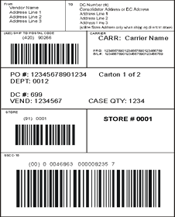

2. UCC128 labels are required for all cartons. If the shipment is only 1 SKU per pallet, a pallet level UCC128 label is acceptable. The UCC128 label must not be covered or obscured by any other label.

C. PACKING LIST:

1. Each shipment (PO-ASN) requires a packing list to be sent with the shipment.

2. Packing Lists must be machine printed and legible to the user.

3. If there are multiple Purchase Orders in a shipment, each PO must have a separate packing list.

4. The packing list must be clearly located in a plastic “packing lists enclosed” pouch on the exterior of the first carton of each PO and visible to the loader.

5. For truckload shipments, the cartons containing packing lists must be easily accessible prior to unloading. Please place them at the rear of the trailer facing the un-loader.

6. The packing list must identify:
a. Big Rock Sports item number(s) in numerical sequence

b. Big Rock Sports Purchase Order number

c. Vendor Model of Factory number

d. Quantity shipped

e. Shipper’s name.

7. Each PO must have a separate packing list sent with the shipment.

8. Sample of a generic packing list below:

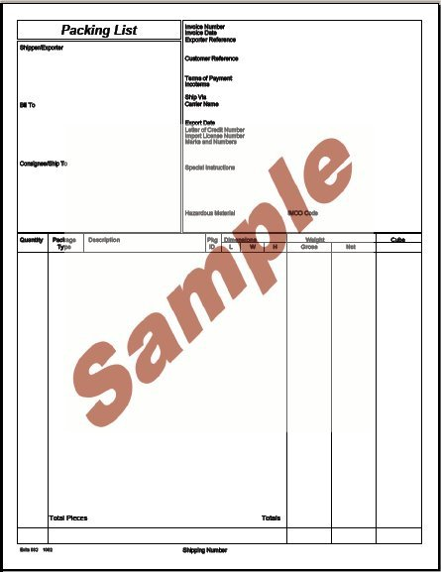

D. Bill of Lading:

1. Bill of Lading must be machine printed and legible to the user.
2. Big Rock Sports requests that all vendors use the VICS Bill of Lading.
3. Our core carriers have adopted the VICS format.
4. The VICS Bill of Lading standard and documentation can be found on http://www.vics.org/.
5. When making multiple shipments on one day all shipments must be combined on a master Bill of lading to move as a single shipment. There should never be more then one bill of lading per day.
6. Bill of Lading needs to show:

a. Ship From, Ship to Address,
b. Bill of Lading Number.
c. Carrier Name.
d. The location and address and consignee information
e. Clearly identify shipment contents.
f. Show all purchase orders included in the shipment.

7. Sample of a Bill of Lading Sort Form:

Date | Bill of Lading – Short Form – Not Negotiable |  |  |  |  |  |  |  |  |  |  |  |  |  |  |  | Page 1 of 41
Ship From |  |  |  |  |  |  |  |  | Bill of Lading Number:
[Name]
[Street Address]
[City, ST ZIP Code]
SID No.:
Ship To |  |  |  |  |  |  |  |  | Carrier Name:
[Name]  [Street Address]  [City, ST ZIP Code]  CID No.: |  |  |  |  |  |  |  |  | Trailer number:  Serial number(s):
Third Party Freight Charges Bill to |  |  |  |  |  |  |  |  | SCAC:
[Name]  [Street Address]  [City, ST ZIP Code] |  |  |  |  |  |  |  |  | Pro Number:
Special Instructions:  Sample |  |  |  |  |  |  |  |  | Freight Charge Terms (Freight charges are prepaid unless marked otherwise):  Prepaid   Collect   3rd Party 
 |  |  |  |  |  |  |  |  | ❑ Master bill of lading with attached underlying bills of lading.
Customer Order Information
Customer Order No. |  |  |  |  | # of Packages |  |  |  | Weight |  |  | Pallet/Slip  (circle one) |  | Additional Shipper Information
 |  |  |  |  |  |  |  |  |  |  |  | Y | N
 |  |  |  |  |  |  |  |  |  |  |  | Y | N
 |  |  |  |  |  |  |  |  |  |  |  | Y | N
 |  |  |  |  |  |  |  |  |  |  |  | Y | N
Grand Total
Carrier Information
Handling Unit | Package |  |  |  |  |  |  |  |  |  |  |  |  |  |  |  |  |  | LTL Only
Qty | Type | Qty |  | Type |  | Weight |  | HM (X) |  | Commodity Description  Commodities |  |  |  |  |  | NMFC No. |  | Class
Where the rate is dependent on value, shippers are required to state specifically in writing the agreed or declared value of the property as follows: “The agreed or declared value of the property is specifically stated by the shipper to be not exceeding _______________ per _______________. |  |  |  |  |  |  |  |  |  |  | COD Amount: $  Fee terms: Collect  Prepaid  Customer check acceptable 
Note: Liability limitation for loss or damage in this shipment may be applicable. See 49 USC § 14706(c)(1)(A) and (B).
Received, subject to individually determined rates or contracts that have been agreed upon in writing between the carrier and shipper, if applicable, otherwise to the rates, classifications, and rules that have been established by the carrier and are available to the shipper, on request, and to all applicable state and federal regulations. |  |  |  |  |  |  | The carrier shall not make delivery of this shipment without payment of charges and all other lawful fees.  Shipper Signature
Shipper Signature/Date  This is to certify that the above named materials are properly classified, packaged, marked, and labeled, and are in proper condition for transportation according to the applicable regulations of the DOT. |  |  | Trailer Loaded:   By shipper   By driver |  |  |  | Freight Counted:   By shipper   By driver/pallets said to contain   By driver/pieces |  |  |  |  |  |  |  | Carrier Signature/Pickup Date  Carrier acknowledges receipt of packages and required placards. Carrier certifies emergency response information was made available and/or carrier has the DOT emergency response guidebook or equivalent documentation in the vehicle. Property described above is received in good order, except as noted.

E. Shipping Carton Information:

1. UCC128 Labels and Interleaved 2 of 5 Labels:

a. Shipping Labels, UCC128 labels, Interleaved 2 of 5 labels should all be correct to the product that is contained within the Shipping Carton. The Shipping Carton must have a UCC128 scannable.

UCC128 Label Scannable Bar-code.



b. If combining PO’s in a shipping carton is necessary they must be physically separated. UCC128 labels are prefer method of showing that separations. Other packaging methods that would provide for clear separation of items by PO are acceptable.

c. If combining PO’s in a shipping carton a referenced on the the outside of the carton must be marked in 1” or greater sized letters showing “MULTIPLE PO” and have all PO numbers contained on the shipping label or be marked on the outer carton.

d. For conveyance within our distribution centers, the minimum and maximum master carton dimensions are as follows:

Minimum = (9” length x 9” width x 3” height), weighs >= 1 pound
Maximum = (30” length x 24” width x 24” height), weighs <= 50 pounds
Or (36” length x 23” width x 23” height), weighs < = 50 pounds
Or (42” length x 22” width x 22” height), weighs <= 50 pounds

Important Note:
If your product does not meet the specification above please contact your merchant with the actual dimensions and weight for directions on packaging and shipment.

e. Shipments arriving via U.P.S., FedEx Ground, DHL, or any other package service delivery are required to have the individual cartons consecutive markings of 1of X, 2 of X, etc.

2. Master Carton:

a. A master carton is defined as a shipping carton which contains multiple, smaller, inner packs of the same item.

b. Master Cartons cannot contain more than one type of Stock Keeping Unit (SKU). The outside of each master carton must have the following:

(Interleaved 2 of 5 label)


c. I 2 of 5 Label Requirements:
- Vendor Product name
- Item number
- style number or factory number
- Total quantity contained in the master carton

3. Mixed shipping Carton:

a. A mixed shipping carton is defined as a shipping carton which contains multiple SKU’s (each in its own inner pack box or bag) within the same carton.
b. All mixed master cartons must be clearly marked minimum 1” letters “MIXED.”
c. All items in the same carton are preferred to be under the same PO.
d. It is preferred each inner cartons be labeled with the appropriate UCC128 label.
e. If it is necessary to ship mixed PO’s the cartons will have to be clearly marked minimum 1’ letters “MIXED POs.”

4. Inner Pack Carton:

a. The inner pack carton is the smallest carton used and contains multiple selling units (SKU) of the same item (typically 6 or 12 of an item).

b. Interleaved 2 of 5 U.P.C. (barcode) is also required for inner pack cartons.

c. An inner pack carton CANNOT contain more than one SKU.

d. When inner pack cartons are shipped in a mixed carton then each inner pack must have the appropriate UCC128 label.

e. If the inner pack is part of a single master case then there is not a need for the UCC128 label on each inner pack.

(Interleaved 2 of 5 Label Information)

f. I 2 of 5 Label Requirements:
- Vendor name
- Item number
- style/model number or factory number
- Total quantity contained in the inner pack carton,

Important Note:
Interleaved 2 of 5 barcodes are used for both master pack identification and inner pack identification.
UCC128 labels are container IDs that are associated to specific PO –ASN – Shipment. Whereas Interleaved 2 of 5 barcodes are at the master pack and inner pack level for standard packaging by the vendor.

Example:
Vendor indicates that they are sending 36 of an item on the UCC128 label, the product is shipped in inner cartons of 6 with an interleaved 2 of 5 barcode indicating 6 per carton for a total of 6 cartons within the shipping container ID indicating 36 were shipped under the UCC128 Carton ID.

5. Individual Item Labeling:
a. U.P.C. barcodes must follow the prescribed standards established by the Uniform Commercial Code (UCC).

b. Each item or selling unit must contain the following information:

(U.P.C.-A)


c. Requirement of Label:

- Item number, style number, or factory number
- U.P.C. (barcode) for that individual item
- A warning label for all hazardous material must be have a package display on the individual selling unit.

Information concerning interleaved 2 of 5 U.P.C. barcodes, or barcodes in general can be found at: www.gs1.org

IV. Bar-coding Compliance (UPC)

A. Technology:
1. As technology and our customer’s requirements change, so
may the requirements put forth in this compliance guide.
Technology has allowed for Bar Coding innovations and
improvements which assist the vendor and Big Rock Sports
to streamline processing of Inbound Shipments.

2. UCC128 label for Container ID

3. Interleaved 2 of 5 master pack and inner pack coding
4. Individual Selling unit UPC barcode for unit and product

a. Each individual selling unit must have a UPC barcode
identifying the unit and product.

b. Additionally, Big Rock Sports must have a label
indicating in Inner pack value within the carton, the
Interleaved 2 of 5.

c. Each shipping-master carton must be marked with a
UCC128 label, and with interleaved 2 of 5 bar codes.

d. I 2 of 5 bar codes may also be known as “Pack 14”
codes or “ITF14” codes. I 2 of 5 bar codes must be
the correct size that has mandated by the Uniform
Commercial Code (UCC).

e. If you do not have or are unclear about UCC128
labels Please contact SPS Commerce, if you do not
have 1 2 of 5 bar codes or are unclear able this label, please contact the UCC for direction via the Internet at:
www.uc-council.org
Or Call:
Phone (937) 435-3870.

B. UPC and Label Standards:

1. Each item or selling unit must have a correct and scannable U.P.C. barcode.

2. U.P.C. labels cannot be obstructed in any way.

3. Each inner pack must have an Interleaved 2 of 5 indicating the pack code amount.

4. Each master carton must have an Interleaved 2 of 5 label of the item on the outside of the carton indicating the master pack code.
Recall that a master carton cannot contain more than one type of SKU, but rather contains several inner packs of the SKU item.

5. An incorrect or missing U.P.C on an item will result in the return of the merchandise to the vendor at the vendor’s expense and/or a noncompliance charge plus applicable handling charges for the corrections needed.

V. Product Dimensions, Damaged Packaging and CPSIA Laws:

A. BRS Requirements for Product Dimensions:

1. Product dimension data for all stocked items is mandatory.

2. Weights and measurements for each packing level that Big Rock Sports will potentially handle the product are mandatory.

3. This information should be supplied to the appropriate Merchant at the time of item set up.

4. New and maintenance data can be conveniently communicated via the Big Rock Sports vendor web site at

www.bigrocksports.com,
PRODUCT MAINTENANCE option.

5. Measurements needing to be captured are:
a. Master pack
b. Inner pack
c. Each

6. BRS request vendors review the “How to Measure” Appendix G on the explanation of each unit of measurement. If assistance is needed contact:

measure.help@bigrocksports.com.

7. Vendors can update measurements by logging onto Big Rock Sports website and using tab “Product Maintenance” then click on Update Weights/Measures followed by re-load. If you do not see the product listing.
8. You can update one item at a time.

9. You can run a report and view

10. You can click download.

11. Decimal Placement calculates out to two decimal places.

12. Allowable Tolerances Applicable Freight Classification standard manufacturing tolerances are understood. If there is a change in packaging we need to be notified prior to shipments being received.

13. Packaging changes need to not be reported unless the changes made are significantly different from the previous reported information.

14. Example of the “Item Weights/Measures at www.bigrocksports.com

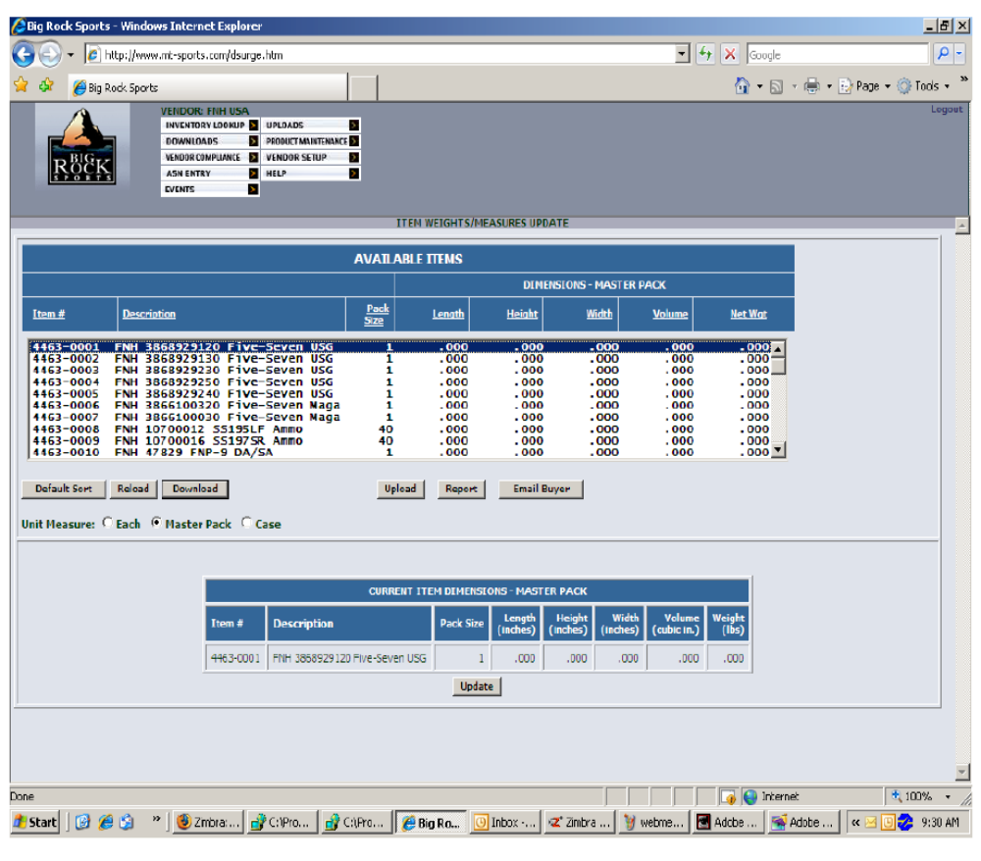

Important Note: It is mandatory that any and all changes to master carton dimension, quantity or inner-pack quantity or dimension be communicated to your merchant. Changes that are made without communication are subject to noncompliance charges of wrong pack code.

B. CPSIA Laws:

1. Big Rock Sports expects all products purchased from each vendor to be in full compliance with CPSIA regulations.

2. All suppliers are required to notify Big Rock Sports in writing their compliance status and sign the Vendors Certification of Compliance form.

3. This form is available from your merchant and the BRS Merchant Department.

For more information about the CPSIA law go to the CPSC web site or use this link http://www.cpsc.gov/about/cpsia/cpsia.html.

C. Defective Packaging:

1. Defined as poor quality packages that are not salable due to:

a. Inadequate gluing, stapling, sealing,

b. Use of a lightweight container that is not conducive to the weight and/or size of the product.

c. This type of product will be sent back collect to the manufacturer on a Return Authorization Number with a handling charge assessed. This handling charge is a percentage of the return value.

VI. Vendor Compliance Error Codes:

The follow Vendor Compliance Error Codes are reported to BRS Vendors via Fax or E-Mail after processing of Inbound Shipments. Each Coded Error requires added Processing time and cost to BRS and could result in charge back to the vendor.

1. No UPC
2. Unscannable UPC
3. No UPC on Master Pack
4. No UPC on No Break
5. Wrong UPC
6. No ASN
7. No Visible UPC
8. SO/PO not separated
9. No visible Packing List
10. No UCC128 Label
11. Un-scannable UCC128 Label
12. Wrong Pack Code
13. No Packing List

Vendor Error Code Reports are sent to point of contact that was provided by the vendor at set up, typically Sales or Customer Service department.

Any questions or concerning these reports should be addressed to: compliance@bigrocksports.com

VII. Compliance Specific to Gun Vendors

A. ATF:
- 1. All firearms are required to ship according to the ATF Federal Regulations (Bureau of Alcohol, Tobacco, Firearms and Explosives).

- a. Regulations can be found at http://atf.gov/.

- b. Vendors not shipping according to the ATF Federal Regulations will receive one (1) written warning.

- c. Vendors continuing to ship against these regulations after a written warning is issued will be reported to the Regulations Bureau of Alcohol, Tobacco, Firearms and Explosives.

- 2. When shipping firearms directly to Big Rock Sports, Vendors must require an Adult Signature be obtained upon receipt.

- a. Federal law requires that common and contract carriers who deliver firearms in interstate commerce obtain written acknowledgement of receipt from the actual recipient.

- b. This is outlined in the ATF Safety and Security Information for Federal Firearms Licensees found at http://atf.gov/.

B. Chamber Indicators:
  - 1. Chamber Indicators need to be used to give visual indications that the firearm does not have any ammunition, live or spent, in the chamber or magazine.

- a. All Lever Action Long Guns must have the action secured and/or a visible Chamber Indicator.

- b. Long Guns that cannot be disassembled must also have visible Chamber Indicators.

- c. Chamber Indicators that are built into firearms will be accepted.

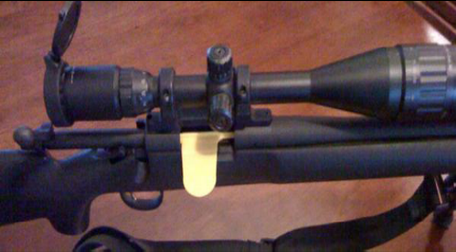

- 2. All Hand Guns must have a visible Chamber Indicator of some type.

- 

- 3. All Bolt Action Long Guns must have the bolt removed from the chamber.

- 4. All Pump, Semi-Auto and Double Barrel Shotguns must have the barrels removed.

- 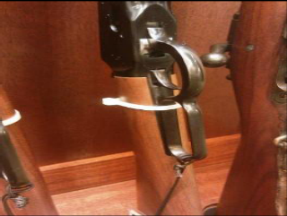

  - 5. Zip Ties can be used providing that they are clearly visible, unable to fall into the chamber and/or have a flag at the end:

  - 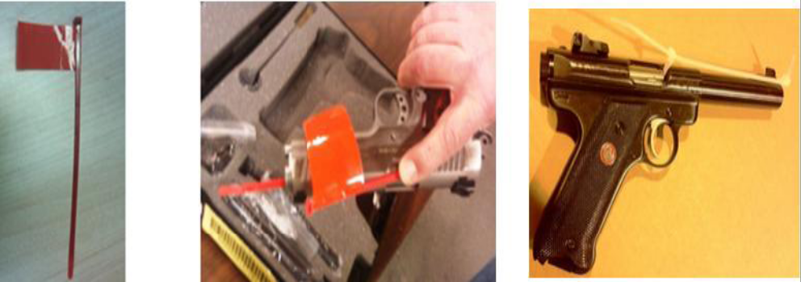

C. Receiving Firearms with Live Ammunition

- 1. First Offence
- Could results in a written warning and will require a mandatory response explaining steps taken by offending Vendor to improve processes.

- 2. Second Offence
- Could result in Fines up to $25,000 deducted from invoice.

- 3. Third Offence
- Could result in Fines up to $50,000 deducted from invoice and suspension

Important Note:
The Safety of BRS employees and Our Customer’s safety are paramount to Big Rock Sports. In the event of live ammunition found in chambers or magazine of a weapon, when the firearm is received the Vendor will be contacted immediately and the appropriate action will be taken.

VIII. EDI Compliance
(Refer to appendix D)

A. Big Rock Sports requires that all suppliers to participate in and support
our EDI requirements for all purchasing and financial transactions.

B. We have two methods that are in compliance with BRS
1. True Electronic Data Interchange (EDI)
2. Partnership with SPS commerce Web Form Option.

C. Both Big Rock Sports and SPS Commerce have full capabilities to
support all organizations with implementing either of these solutions.

D. We are requiring that all suppliers be EDI compliant by June 30,
2012. Each vendor MUST chose one of these two options. Details
on how to contact SPS are provided in the appendix E.

The documents types that we are currently requiring are:
850-Purchase Order
856-ASN
810-Invoices

Documents that we support but are not required at this time are:
855-PO Acknowledgement
997-Acknowledgment

E. The SPS tool referred to as web-forms support our EDI requirements and is the only other option from true EDI support.

F. Web forms has been implemented to replace the past fax
and e-mail options which are no longer acceptable or
compliant starting July 1,2012 .

Please contact our support team at edihelp.bigrocksports.com
and/or spscommerce.com with any questions on this requirement.

(Are Not Currently Supporting EDI):
G. If you are not currently supporting this requirement please
indicate on Appendix A with a detailed explanation and any questions you may have.

H. To discuss EDI implementation please refer to
the contact information provided at the end of this guide.

IX. Non Compliance

A. Transportation Compliance-Method and adherence to routing guide

Transportation non compliance charges are as follows:

1st Occurrence: $100.00

2nd Occurrence: $250.00

3 or more: $500.00 per occurrence

The following are subject to penalty:

- Use of noncompliant carrier per BRS routing guide.

- Declared Value added to UPS Shipments.

- Use of wrong UPS account for Inbound shipments.

- Freight for a Drop Ship order charged to BRS UPS Account.

- Use of BRS UPS account to ship to customer not associated with BRS

- Shipment with prepaid freight terms shipped collect.

- Freight charges added to a Non Drop Ship Invoice.

Additionally any actual freight cost to BRS as a result of non compliance will be charged back to the vendor on top of the occurrence fines listed above.

B. Vendor Compliance:

1. Vendors will be held accountable for non-compliance with Big Rock Sports requirements. Not meeting our requirements adds unnecessary cost and burden on Big Rock sports and directly impacts the service we provide to our customers.

2. We are implementing a cost recovery program. These will become effective on the dates show below. On the dates show these requirements will go into full effect. The vendor will receive a warning for the first occurrence after will be subject to the following cost recovery fees.

D. The following are subject to cost recovery:

- Vendor not using EDI. ASNs must be sent EDI or EDI Web form. Fax or email ASN’s are no longer permitted. ASN must be received prior to the goods arriving at the receiving facility.

  - $100.00 per PO-shipment
    - Including Any shipment of a canceled or closed PO

- No UPC code (scannable and human readable) on sellable unit, label incorrect or un-scannable

  - $100.00 per SKU occurrence
  - plus actual labor cost to re-labeling the items.

- Improper or missing UCC128 shipping label.

  - $100 per occurrence

- No packing slip or incorrect/incomplete packing slip

  - $100.00 per occurrence

- Quantity variances due to inaccurate information on EDI transmission between the PO, ASN and Invoice.

  - $25.00 per occurrence
.

E. Specific Fire Arms Safety Compliance:

1. Receiving Firearms with Live Ammunition:

a. First Offence: Could result in a written warning and will require a
mandatory response explaining steps taken by Vendor to improve
processes.

b. Second Offence: Could result in fines up to $25,000.

c. Third Offence: Could result in fines up to $50,000

X. Returns

A. Big Rock Sports return policy dictates that we give our customer replacement product or credit on any return.
B. We in turn expect our vendors to honor all Return To Manufacturer (RTM) documents covering customer returned/defective merchandise which are issued by Big Rock Sports.
C. Timely processing of these goods is paramount due to limited space of storing these defective items.
D. There are two options to choose from when determining the specific method to be used by Big Rock Sports in handling your product. The exact policy may be dependent on factors such as product, value, cost of returning, size of product, etc. The options are listed below in order of Big Rock Sports preference.

Option 1:
a. Product will be destroyed in the field by our field sales force or distribution center personnel if product is returned to a DC.
b. No inspection or authorization will be required by vendor. Big Rock Sports will bill the vendor for full credit.
c. A consolidated monthly debit memo will be issued by Corporate Accounts Payables using the Actual Cost Layered Inventory pricing.
d. ACLI pricing is defined as Big Rock Sports cost of getting product on the shelf.
e. ACLI includes invoice cost of product plus inbound freight plus distribution center add-ons if applicable less rebates or program allowances.)
f. Items with MSDS sheets are considered HAZMAT by Big Rock Sports and cannot be field destroyed.
g. HAZMAT items must be accepted back by the vendor, if possible, or the vendor must allow Big Rock Sports to donate or markdown and sell the items, if possible, after credit is given.
h. If vendor opts to require Big Rock Sports to hold for inspection or call for authorization, a five percent add-on will be applied to the value of each RTM.
i. Add-on will be waived if vendor provides a blanket authorization.
j. 30 days after RTM request is made the appropriate information has not been received from a vendor the goods will be packaged and returned to the vendor freight collect and full credit taken.
Option 2:
a. Product will be returned freight collect to location designated by vendor.
b. If product can be returned by parcel carrier, the vendor’s shipper number must be provided to be communicated to all Big Rock Sports Distribution Centers.
c. The center will bill the vendor for full credit and a consolidated monthly debit memo will be issued by Corporate Accounts Payables using the Actual Cost Layered Inventory pricing. (See option 1 for definition of ACLI pricing.)
d. If vendor opts to require Big Rock Sports to call for authorization, a five percent add-on will be applied to the value of each RTM.
e. Add-on will be waived if vendor provides a blanket authorization.
f. In the event that a vendor requires product to be returned there is a 30 day limit for issuing an applicable RTM number. If appropriate information has not been received from a vendor the goods will be packaged and returned to the vendor freight collect and full credit taken.

Important Note: Consolidated monthly debit memo at ACLI is mandatory for all vendors. Big Rock Sports merchandising department has the option of negotiating an allowance for suppliers and items. Big Rock Sports merchandising also has the option of negotiating a policy outside the above options when product category demands a different agreement. However, such negotiations are strongly discouraged since Big Rock Sports return system is designed to most efficiently handle the above two options. Agreements contrary to the above options should be discussed with your Big Rock Sports Director of Purchasing to ensure specialized policy can be implemented utilizing Big Rock Sports system.

E. PRODUCT RETURNS – BUYBACKS
1. Product buyback negotiation by Big Rock Sports Buying
Department and Vendor Representative must include the
following mandatory information:
a. Return method:
- Destroy
- Donate
- Return location (if applicable),
F. Estimated value and payment method consolidated debit memo.
1. See Product Returns – Customer Option 1 for
definition.
2. Locations and items involved
3. Authorization, and time frame.

G. PRODUCT RECALLS-
1. Any product that is subject to either a vendor or regulatory
agency recall must be communicated to the Big Rock Sports
Merchant that is responsible for you product immediately.
2. Big Rock Sports will pass back to the vendor any and all cost
associated to supporting this recall to include labor for
processing the return and any administrative cost in
supporting this program.

Appendix A

Big Rock Sports Vendor Acknowledgement Form
Signature
Required

Vendor Name: ______________________ BRS Vendor: # _____________
Address: ______________________
______________________
Circle one
______________________ Received BRS Vendor Compliance Guide Y or N
and Routing Guide?

Our company is currently in compliance with the following requirements (check each that apply). If not compliant then please indicate date that you expect to be compliant and provide primary contact information for the individual in your company who will be supporting this. Compliance
In Compliance Future Date
Shipping Requirements and Carrier Routing Yes No ___________
Labels, Forms, and Packaging Yes No ___________
Damaged Package, Dimensions, and CPSIA Law Yes No ___________
Bar Codes, UCC, I2of5,and UPC A Yes No ___________
Error Codes Yes No ___________
Gun Safety Yes No ___________
EDI-ASN Yes No ___________
Returns Yes No ___________
Labeling Yes No ___________
Packaging Yes No ___________
Shipping Yes No ___________

If No on any of the above but your company has future plan to implement compliance please indicate date in the “Future Date” field. (If necessary additional document(s) are acceptable.)
If your company will not comply with any of the listed above, indicate reasons for not complying with BRS
________________________________________________________________________________________________________________________________________________________________________________________________________________________________________________________________________________________

Shipping Preference:

Package____ LTL____ Truck Load____
Terms:
BRS Pays Freight_____ You the vendor Pays Freight_____

Company Rep Signature Required:
_______________________

Title of Company Reprehensive

Vendor Compliance Contact Person:

Name: _______________________
E-Mail: _______________________ Phone: __________________________

Transportation Compliance Contact Person:

Name: _______________________
E-Mail: _______________________ Phone: __________________________

Big Rock Sports Merchant handling this account: ____________________________________________

Please forward Appendix A to: compliance@bigrocksports.com Fax to: 252-727-0026

Appendix B
Big Rock Sports Checklist
Listed below is a “quick” reference of the Big Rock Sports compliance requirements as contained in this Vendor Guide. Please use this as a quick check to ensure all requirements are met. For complete instruction and explanation of these requirements, refer to the Vendor Manual.

- 1. EDI Partnership/or Web-form

- 2. Compliant with BRS Gun Safety Policy

- 3. Shipping in accordance with BRS Routing Policy

- 4. Using UCC128, I to of 5, and UPC-A Labels

- 5. Using Packing slips and Bill of Lading forms

- 6. Vendor Dimensions are loaded

- 7. Familiar and in compliance with CPSIA Laws

- 8. Understand Return Policy

Appendix C

Warehouse Address Locations
Warehouse Phone Numbers

Henry’s, LLC  148 Sportsman Drive  Hamlet, NC 28345  PH 910-582-4252 Fax 866-561-5749 | AWR, LLC  3816 S. Willow Ave  Fresno, CA 93725  PH 559-237-8365 Fax 559-237-8360 | CSI Sports, LLC  360 Industrial Blvd.  Sauk Rapids, MN 56379  PH 320-252-4193 Fax 320-252-7177
MT Sports, LLC  650 Carbon St  Billings, MT 59102  PH 406-252-1610  Fax 406-252-1611 | All Sports, LLC  11245 S.E. Hwy 212  Clackamas, OR 97015  PH 503-650-4182  Fax 503-650-4191

Note: Receiving hours for all locations is 7:00 AM-2:00 PM local time. Some hours will vary due to certain circumstances. Please see the inbound contact chart located under the General Inbound Shipping Requirements and Carrier Routing and contact the proper inbound dispatch for current details.

Appendix D

Bar Coding Standards

POINT OF SALE GUIDELINES

1. Big Rock Sports Companies supports three bar code types (symbologies) for use at point of sale.
A. Universal Product Code Version A (UPC-A) accounts for well over 99% of all bar codes in Big Rock Sports system and represents the overwhelming choice for all
U.S. Manufacturers and Retailers.
B. Big Rock Sports also supports and accepts UPC Version E (UPC-E)
C. Big Rock Sports also supports and accepts European Article Number (EAN) bar
code symbologies.

UPC-A Bar Code

1. UPC-A is a 12-digit numeric bar code used to uniquely identify a consumer package (saleable unit).
A. It consists of:
1. Manufacturer's ID Number (6 or 8 digits) assigned uniquely to each member company by the UCC.
2. Item Number assigned and controlled by your company to identify each of your items. The item number must be unique for each item type (size, color, model, etc.).
3. 1-digit Check Digit located in the twelfth position of the code. The check digit is derived from a standard arithmetic formula based upon the first 11 digits of the code (see Page 16). It is used as a numeric check to verify the integrity of the other eleven digits when scanned or manually key entered.

UPC-E Bar Code

1. The UPC-E bar code is simply a zero suppressed version of UPC-A. Use of the 8-digit UPC-E code is dependent upon applying for and receiving a number systems character of "0" and a manufacturer's ID number capable of being zero suppressed using a standard arithmetic formula. Its purpose is to accommodate smaller-sized consumer packages limited in the amount of space available for applying a bar code symbol.

EAN-13 Bar Code

1. The EAN bar code is the European equivalent of the UPC code. The EAN code is 13 or 8 digits long and includes a country of origin identifier. Use of the EAN code is typically limited to manufacturers located or conducting the majority of their business outside the United States.

REQUIREMENTS

“UPC” will be used synonymously for UPC-A, UPC-E, EAN-8, and EAN-13 bar codes for the remainder of this document. Minor UPC mistakes can lead to major problems. Following are a few important points to remember concerning the production, placement, and detail of the UPC code:

1. Selling Units - Each selling unit (individual product or case) which is intended for retail sale to consumers should be marked with a unique UPC code. See details in Unique Codes. All shipping units containing multiples of the same products that are not sold by the case should be marked with an Interleaved 2 of 5 (UPC SCC) Shipping Container Code (See Point of Receipt Guidelines).

THIS IS VERY IMPORTANT! - NEVER PUT THE INDIVIDUAL PRODUCT BAR CODE ON THE OUTSIDE OF A MULTI-PACK.

2. Unique Codes - If a product can be sold either by the piece or by the case, do not place the individual bar code on the outside of the case. The case bar code should be a different bar code and should be the only one visible on the outside of the case.

THIS IS VERY IMPORTANT! NEVER PUT THE SAME UPC CODE ON A CASE OF PRODUCT AS WELL AS ON THE INDIVIDUAL PRODUCT CONTAINED WITHIN THE CASE.

3. Mark Your Products - The preferred method for representing the UPC code for your product is to incorporate the UPC code into the graphic design for the package or printing the UPC code directly on the package itself. This eliminates the need for manual application of any type (i.e. stick on labels). The use of printed and manually applied UPC code labels is discouraged as it is more labor intensive, creates more opportunity for label tampering/fraud, and requires much consideration as to how the labels will be applied (adhesive, staple, location, etc.). Special consideration will be given to products that, by their nature, can not have the UPC code incorporated into the graphic design for the package.

4. Size of Symbol - All magnifications should be based on the nominal (or 100%) size of 1.020" x 1.469" (including the required quiet zone). The nominal size UPC symbol has an “X” dimension of 13 mils (thousandths of an inch). The “X” dimension is the width of the narrow element. This can be reduced down to 80% (which is an “X” dimension of 10.4 mils) or increased up to 200% (which is an “X” dimension of 26 mils). Truncation (shortening the height of the bars) is allowed only when absolutely necessary in order to fit the bar code onto the product. Even so, the bars should not be reduced to a height of less than 1/2" tall. Truncation for the purpose of graphic designs is not acceptable.

5. Quiet Zone - Allot enough white space on both sides of the symbol itself. This allocation must be at least 3/32 of an inch on both the right and left sides of the symbol. Otherwise, the bar code cannot be scanned.

6. Contrast of Symbol - Big Rock Sports scanners, as do most point of sale scanners, employ red lasers. This means that our scanners are blind to red, and most shades of purple and blue. Do not use these colors when producing bar code symbols.

7. Human Readable - Print all digits beneath the bar code symbol on all products (UPC-A 12-digits; UPC-E 8-digits; EAN-8 8-digits, EAN-13 13-digits).

8. Verify Before Printing - Manufacturers are well advised to have any prospective bar code symbol scanned to verify it is accurate and scannable prior to acceptance. Failure of a bar code to scan will result in package changes later at your expense.

9. Label Quality - Products which may be stored or displayed outside (such as plants, lumber, etc.) should have labels which can withstand exposure to sun and water without fading or falling off the product.

10. Location of Symbol - The location of your bar code is very important. The UPC code must be easily accessible. Generally, boxed goods should have the UPC code on the top or sides of the product. Carded goods should be coded on the front or back. Products with lengths exceeding 5 feet (rods, combos, etc...) should be coded on BOTH ends of the product. Keep in mind ALL bar code tags must be securely attached.

11. Data - Submit the bar code information to Big Rock Sports prior to shipment. The data should include:
A. Big Rock Sports 8-digit item number
B. Your model number and product description
C. All digits of the bar code number; i.e., for UPC-A include all 12 digits
D. Quantity (The quantity should reflect the number of consumer selling units. For example, if the product is sold by the piece or by the case, a bar code must be defined for the individual piece with a quantity of 1 associated with that bar code, and an additional bar code must be assigned for the entire case with the quantity indicating the number of pieces within the case.)

This information must be entered in Big Rock Sports data system in order for the codes to be scannable.

12. Verify before Shipping - Test scan your UPC codes prior to shipment. This will help ensure there are no quality problems with the code, the check digit is correct, and the bar code has been applied to the correct product.

13. ANSI Standards - The print quality of all bar codes should meet ANSI Bar Code guidelines. Big Rock Sports requires all symbols to have a Grade “C” rating which ensures the best print quality and scanning performance. Contact the UCC for the ANSI Bar Coding Print Quality guidelines

LFT ITEMS AND BAR CODES

The following bar coding guidelines should be used for labeling product Big Rock Sports sells by the foot, (i.e. rope, chain, etc.), and linking the quantity for those bar codes in Big Rock Sports data system.

PRODUCTS SOLD BY LFT

1. Instruct the vendor to apply a UPC bar code which represents the number of feet for the selling unit. The UPC should be communicated to Big Rock Sports along with the number of feet within the product the UPC is applied to. This will allow the product to be identified when scanned at point-of- receipt, during Inventory and at point-of-sale.
2. If the product is shipped in a master container or on a pallet, instruct the vendor to apply an I 2 of 5 bar code to each multi-pack level. The Interleaved 2 of 5 should be communicated to Big Rock Sports along with the number of feet within the packaging level the I 2 of 5 is applied to. This will allow the product to be received quickly and accurate at point-of-receipt and verified during inventory.

3. The UPC should be added to Big Rock Sports data system for the number of selling units the bar code represents. For example, if the product is 10 feet of leader material, the UPC should be added for a quantity of 10. Having the number of selling units entered as the quantity will assist with receiving issues.

4. The (I 2 of 5) should be added to Big Rock Sports data system for the number of selling units within the shipping container. For example, if the vendor is shipping five 10-foot pieces of leader, the (I 2 of 5) should be added for a quantity of 50. The (I 2 of 5) would be used during receiving and inventory to scan the 50 feet of leader within the shipping unit.

GENERAL UPC GUIDELINES

AS ESTABLISHED BY THE UNIFORM CODE COUNCIL

1. New Products - A new UPC number should be used only when a product is initially introduced or an existing product is substantially changed.

2. Price Changes - A price change by the manufacturer or distributor and regional price differences are not sufficient reasons for assigning a new UPC to a product.

3. Unique Products - When products are identical except in color, they must have a separate, unique UPC code for each color. The same would hold true for different sizes of the same product (i.e.;7’ foot pole 12-30lb, 6’6” Pole 30-50#, etc.), or different package quantities of the same product (12 pack of hooks, 6 pack of hooks, etc.)

4. Add On Codes - The UPC symbol should not include a reference to data codes, place of manufacture, or other information sometimes included on consumer packages.

5. Multiple UPCs - A manufacturer should not assign a different UPC number to the same product. For example, product XYZ manufactured by the same company but at different locations should be assigned the same UPC regardless of place of manufacture. Competing manufacturers for the same item will have different UPC numbers for their item due to the uniqueness of their manufacturer's ID number.

6. Multi-pack Consumer Units - Products sold in multipacks must carry a unique UPC for the smallest consumer sale unit and a different UPC number for each aggregation. For example, a package of 4 hooks must have its own unique UPC code. If the same manufacturer offers for sale (at the consumer level) a package of 6 hooks, that consumer unit must carry a different UPC code. The quantity assigned to each UPC must reflect the number of consumer selling units

(see discussion on Quantity for more information).

7. Re-use of UPC Numbers - A UPC number should not be reused for a minimum period of 4 years after the last shipment to any distributor. The general rule is that manufacturers should be sure that pipelines are empty and all retailer’s stock exhausted before re-using the UPC.

8. Promotional Packs - Products modified for seasonal or promotional reasons must carry a unique UPC code. For example, if a manufacturer offers a special promotional package containing (within or affixed to the original product) a free item, this consumer package should have a unique UPC code.

HOW TO CALCULATE THE UPC-A CHECK DIGIT
0 12345 11114 ?

1. Starting at the left, sum all the characters in the ODD positions (that is, first from the left, third from the left, and so on), starting with the number system character. 0 + 2 + 4 + 1 + 1 + 4 = 12
2. Multiply the sum obtained in Step 1 by 3. 3 x 12 = 36
3. Again, starting at the left, sum all the characters in the EVEN positions. 1 + 3 + 5 +1 + 1 = 11
4. Add the product of Step 2 to the Sum of Step 3. 36 + 11 = 47
5. The modulo-10 check digit value is the smallest number which when added to the sum of Step 4 produces the next highest multiple of 10. In this example, the next highest multiple of 10 in Step 4 is 50. Adding 3 to 47 equals 50; therefore, 3 is the check digit for this bar code. Note: If the sum in Step 4 is a multiple of 10, the check digit would be zero. (3 + 47 = 50) check digit is 3

UPC = 0 12345 11114 3

HOW TO CALCULATE THE I 2 OF 5 (SCC-14) CHECK DIGIT

2 00 12345 11114 ?

1. Starting at the left, sum all the characters in the ODD positions (that is, first from the left, third from the left, and so on), starting with the package indicator. 2 + 0 + 2 + 4 + 1 + 1 + 4 = 14
2. Multiply the sum obtained in Step 1 by 3. 3 x 14 = 42
3. Again, starting at the left, sum all the characters in the EVEN positions. 0 + 1 + 3 + 5 + 1 + 1 = 11
4. Add the product of Step 2 to the Sum of Step 3. 42 + 11 = 53
5. The modulo-10 check digit value is the smallest number which when added to the sum of Step 4 produces the next highest multiple of 10. In this example, the next highest multiple of 10 is 60. Adding 7 to 53 equals 60; therefore, 7 is the check digit for this bar code. Note: If the sum in Step 4 is a multiple of 10, the check digit would be zero. (7 + 53 = 60) check digit is 7

I 2 OF 5 = 2 00 12345 11114 7

Appendix E

EDI-ASN Guidelines Standards

1. GENERAL ASN GUIDELINES

A. An Advance Shipment Notification allows for the receiving department to have shipment information ready in the system before the arrival of the Vendors shipment.
B. An ASN also allows for the use of UCC128 labels to indicate each item that is being shipped within the vendors order.
C. Container ID numbers indicate the contents of each carton for the ASN.
D. An ASN must be sent within 12 hours of shipment.
E. All ASNs must arrive at the receiving location prior to the arrival of product.
F. Any shipment arriving without an ASN will be subject to charge back.
G. Vendor Compliance Error Reports sent to your Customer Service department will document “No ASN” for the shipment.
H. Do not attempt to send the ASN after this notification, the shipment has already been processed.
I. One PO per Shipment (ASN) is preferred, simplifying receiving and reconciling with EDI invoice (810). However if necessary multiple purchase orders can combined on one ASN.
J. It is imperative that the shipment number be displayed on each document in the shipping/receiving process. The shipment number is the unique number that appears on the ASN (EDI – BSN02).
This number must be displayed on the packing slip, shipping label and on the EDI invoice. (EDI-BIG10).

2. Forms
A. There are two forms of Advance Shipment Notifications that are in Compliance with Big Rock Sports.
1. EDI Partnership
2. EDI/Web form Partnership

B. Complete EDI specifications may be found on the SPS Commerce Website, On the Big Rock Sports Vendor website, or by contacting BRSedi@bigrocksports.com or edihelp@bigrocksports.com

C. Questions relating to EDI can be sent to BRSedi@bigrocksports.com or edihelp@bigrocksports.com

Appendix F
SPS Commerce Contact Information

Although Big Rock Sports has no association with SPS Commerce, we
recognize that many of our vendors are currently using SPS as their
EDI and UCC128 label provider.
www.spscommerce.net
Username: bigrockvendor
Password: spscommerce
SPS Commerce has dedicated support representatives that are knowledgeable on the Big Rock Sports program and can guide you through the set up and test process. You can reach them at (888)739-3232 or e-mail at: clientservices@spscommerce.com
If you have questions regarding the use of the SPS portal, you can
contact SPS at hubsupport@spscommerce.com. You should receive a response within 24 hours. A second email address to receive help is customersupport@spscommerce.com.

SPS Commerce
Accenture Tower
333 South Seventh Street
Suite 1000
Minneapolis, MN 55402
Toll-Free Phone: 866-245-8100
Main: 612-435-9400
Fax: 612-435-9402

Appendix G

How to Measure



