Payment of Fees
All fees are due and payable to the University on August 1, 2018. A minimum payment option is available to students that are unable to pay their account in full by the due date.

Minimum Payment Option
All charges incurred by a student will be consolidated into one account. The student will be billed and must make a payment by the due date indicated on the bill. An option will be provided on the monthly bill for the minimum payment. Students that elect to make the minimum payment will incur a finance charge of 1% per month on the unpaid billed balance after the due date. Students will not be allowed to register for future terms until their account balance is paid to $200 or less and their account is in good standing.

Fall 2018 Due Dates
Due Date | Minimum Amount Due
8/1/2018 | 25% Adjusted Amt. Due
9/1/2018 | 33% Adjusted Amt. Due
10/1/2018 | 50% Adjusted Amt. Due
11/1/2018 | Full Remaining Balance

The minimum payment amount is calculated by taking the total charges on your account and subtracting any anticipated financial aid or third party credits currently showing on the student account. This gives you the Adjusted Amount Due. The Adjusted Amount Due is multiplied by the appropriate Minimum Amount Due percentage. Unless your financial aid and/or third party credit is greater than or equal to the total amount due, you owe a payment.

Cancellation
A payment of the minimum due or greater by the first payment due date will secure your courses. Students who register on or before 8/8/2018 may choose to pay their minimum payment by 9/1/2018 to prevent cancellation. However, late payment fees and finance charges will be applied if a payment was due on 8/1/2018. If your classes are canceled for nonpayment and you wish to be reinstated, the minimum payment will be required plus a $250 late registration fee. When payment is received, you will be charged for all classes that were canceled.

Past Due Accounts
Students who are past due on their monthly minimum payments will not be permitted to register for future terms, receive transcripts and/or diplomas, or be allowed to charge at the bookstore. E-check payments are subject to a fourteen (14) day hold to ensure the payment clears the bank. This hold prevents the release of documents during that period. For immediate release, payment must to be made by cash, certified check, or pin-based debit card in the Cashier’s Office, or online by credit card. Students with small balances of $200 or less may have their financial hold preventing enrollment removed if their account is in good financial standing.

Bookstore Charging Privileges
Only students with student accounts in good financial standing will be allowed to use their student ID at the bookstore to charge items to their student account. Those students that fail to make their required minimum payments will not be allowed to use their student charge in the bookstore until the account is no longer past due.
Late Payment Fees and Finance Charges
A $25.00 late payment fee is assessed to student accounts if a payment is not received and processed by the due date.
The University will assess a 1% per month finance charge on any billed amount that remains unpaid after the payment due date. To avoid finance charges, the student would need to pay the Adjusted Amount Due in full by the due date.
Financial Aid and Refunds
The first step to receiving financial aid is filling out the Free Application for Federal Student Aid (FAFSA). Please make sure to use the Federal School Code 002519 on the FASFA to make sure that UMSL gets your information. Once the Financial Aid Office receives your FAFSA, which takes about 3-5 business days, it can take an additional 1-2 weeks for the application to be processed.

Once your application has been processed, you need to accept or decline your awards. Once accepted, the aid will show up as anticipated and can be taken into account during billing.

Aid can disburse as early as 10 days prior to the start of the semester. The Financial Aid Office will verify that you are in the required number of credit hours and then request the funds. The University will receive the funds and apply them to your student account. If there is a credit balance, the account would be eligible for a refund. Charges that are added to a student account after a refund has been processed becomes the student’s responsibility.

The refund process does not start until you see a refund line item in MyView. From that date, if you have direct deposit, your refund will take 3-5 business days to reach you. For students that do not have direct deposit set up, a check will be mailed to your local mailing address. This takes 7-10 business days from when your refund is processed. Refunds of Parent Loans are refunded to the parent in the form of a check and mailed to the address on file for that parent.

If a credit card payment has been made within 120 days, any refund must be returned to that credit card.

There are times that you could be eligible for a refund and have a balance on your student account. If this occurs, the refund will be sent back to the Cashier’s Office, which may cause a delay in the refund process. No refund of a departmental credit is given if there is a balance due on a student account. A refund takes up to four (4) weeks processing time after withdrawal, dropped classes, receipt of excess financial aid, or overpayment made on the student’s account. To receive a refund of less than $25, a specific request must be made to the Cashier’s Office.

Metropolitan / Illinois Students
Undergraduate students who reside in Illinois qualify for the Metropolitan Tuition rate. Graduate students who reside in the following counties may also qualify for the Metro rate: Adams, Bond, Calhoun, Christian, Clinton, Greene, Jackson, Jefferson, Jersey, Macoupin, Madison, Marion, Monroe, Montgomery, Morgan, Pike, Randolph, Sangamon, Scott, St. Clair, Washington, and Williamson.
Payments
Online payments may be made at http://ebill.umsl.edu. You may make a payment from your savings or checking account with no service fee, or by MasterCard, Visa, Discover or American Express credit card with a 2.75 % service fee.

You can make payment in office at 285 Millennium Student Center. We accept cash, check and pin based debit cards.
You may mail in a check or money order paid to the order of the University of Missouri. Checks will only be accepted when the amount of the check does not exceed the amount due.

There is a drop box located outside the Cashier’s Office, 285 Millennium Student Center. You can pay by check or money order. All payments received are final; no changes or adjustments are allowed to the payment amount once the payment has been processed.
Payments made with YOUR online banking service may result in a significant delay in the processing. Please have your bank mail checks to the address on the cover of this brochure. We make no guarantees that your payment can be received and processed by the due date.

Any communications concerning disputed debts, including instruments tendered as full satisfaction of a debt must be sent to: Account Disputes, One University Blvd, 289 MSC, St. Louis, MO 63121-4400
Delinquent Indebtedness
The University will pursue any and all collection efforts and practices including referring accounts to collection agencies and reporting to the credit bureaus. Accounts may be assessed additional collection charges of 30% of the balance when it is referred to a collection agency. Your Missouri state income tax refund may also be intercepted to partially or fully satisfy a past due debt to the University.

Returned Checks
Any check not honored by your bank will result in a $20 returned check fee. If the returned check, including e-check payments was attempting to pay a prior term balance, your classes may be canceled.

Electronic billing
The University no longer sends paper bills to students that have e-consented and are enrolled in the current term. A billing notification will be sent to your campus e-mail monthly notifying you that your current bill is available online. The bill is usually created around the 10th of the month with a due date of the 1st of the following month. You can view your bill anytime from MyView.

Fall 2018 Due Dates

Failure to make payment on 8/1/2018 will not result in cancellation, but a $25.00 late payment fee and a 1% finance charge will be assessed. Payment due date is based on a student's original registration date for the term. Subsequent add/drop activity will not alter the payment due date.
Full payment of any past term balance and appropriate Fall minimum payment are due on 9/1/2018 to avoid the cancellation of your Fall classes.

Withdrawal
Fees will be reassessed for students who officially withdraw from the University or drop classes. Fees included in this reassessment are Tuition and Course or Supplemental Fees. If the meeting dates for your course are different from the regular session meeting dates, please contact the Cashier's Office as your fee reassessment for withdrawal or dropping may differ from the regular reassessment.

It is the student’s responsibility to formally notify the Registrar’s Office and to follow proper procedures when withdrawing from the University. Failure to pay fees, failure to receive financial aid, failure to attend class or refusing financial aid does NOT constitute an official withdrawal from the University of Missouri – St. Louis.

Fall 2018 Reassessment Schedule
Due Date | Minimum Amount Due
8/1/2018 | 25% Adjusted Amt. Due
9/1/2018 | 33% Adjusted Amt. Due
10/1/2018 | 50% Adjusted Amt. Due
11/1/2018 | Full Remaining Balance
Withdrawal/Drop Date | Fee % Reassessed | Fee % Due University
Through Aug 26, 2018 | 100% | 0%
Aug 27, 2018 through  Sep 3, 2018 | 60% | 40%
Sep 4, 2018 through  Sep 10, 2018 | 40% | 60%
Sep 11, 2018 through  Sep 17, 2018 | 20% | 80%
Sep 18, 2018 and Thereafter | No Reassessment | 100%

If your classes do not start on 8/20/2018 and end on 12/15/2018 please contact the Cashier’s Office as your fee reassessment for withdrawal or dropping may differ from the regular reassessment.

Right to Modify
The University reserves the right to modify by increase or decrease the fees charged for attendance and other services at the University, including but not limited to tuition or educational fees, at any time when in the discretion of the governing board the same is in the best interest of the University, provided that no increases can or will be effective unless approved by the governing board not less than thirty (30) days prior to the beginning of the academic term (semester, etc.) to which the fees are applicable, with all modification of fees to be effective irrespective as to whether fees have or have not been paid by or on behalf of a student prior to the effective date of the modification.

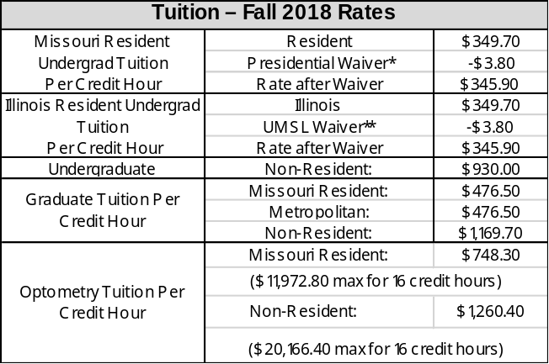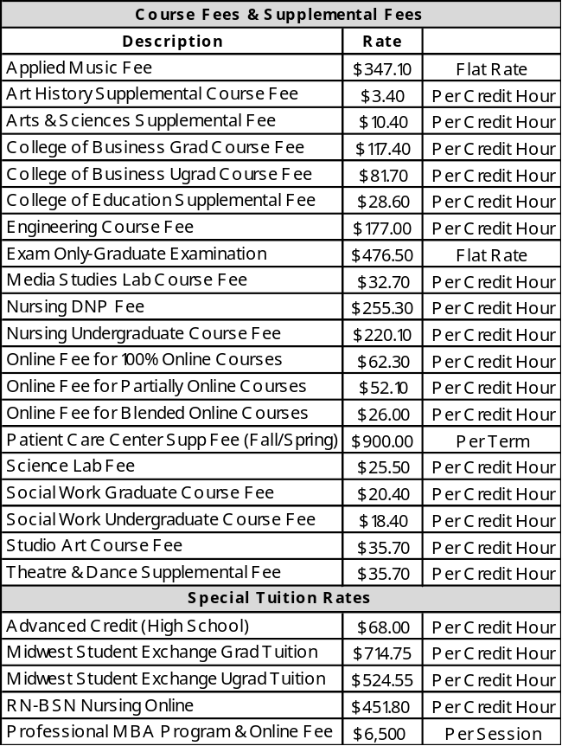

*For the 2018‐19 academic year, the University of Missouri Board of Curators approved a 2.1 percent increase in the Missouri Resident Undergraduate tuition charge, the amount allowed under current state law. However, as a result of an agreement reached with the general assembly to protect the university’s state appropriation, the campus will waive part of that increased charge and will only require payment of 1 percent more than the previous semester in Fall 2018. This waiver will be reevaluated for Spring 2019 and in future years.

**The actual tuition rate is $349.70 per credit hour. The UMSL waiver of $3.80 reduces the rate to $345.90



FALL 2018

GUIDE TO

PAYING FEES

8/20/2018 – 12/15/2018

Cashier’s Office
285 Millennium Student Center
One University Boulevard
St. Louis, MO 63121-4400
Phone: (314) 516-5151
Fax: (314) 516-5302
Website: umsl.edu/cashiers
E-mail: cashiers@umsl.edu
Online Account Access:
Students: http://myview.umsl.edu
Parents: http://ebill.umsl.edu

Cashier’s Office Regular Hours of Operation:

Monday - Tuesday 8:00am-6:00pm
Wednesday - Friday 8:00am-5:00pm
We are closed each Wednesday from
2:00-3:00 p.m. for Staff Development
Please check the Cashier’s Office homepage for special hours of operation

Late Registration Fee
of $250 will be applied when a student registers on or after the first day of courses.
August 20, 2018

