

User Experience Guidelines

Web Guidelines for Content Editors and Developers

Executive Summary

This User Experience Guidelines document is a tool that gives guidelines on creating accessible and usable web pages. The document is split into two parts, one for content editors and one for developers. There is some overlap between the two however, and where this is the case the content is duplicated. The document contains an introduction to usability and accessibility and the advantages of improving them. Further reading and resources are also provided at the end of each section. Contact details are also provided in the Appendix.

Contents
User Experience Guidelines 1
Web Guidelines for Content Editors and Developers 1
Executive Summary 2
Contents 3
User Experience Guidelines for Content Editors 9
1 Overview 9
1.1 What is Usability? 9
1.2 Short term benefits of Usability 9
1.3 Long term benefits of Usability 9
1.4 How Usability is measured 10
1.5 What is accessibility 11
1.5.1 People with cognitive disabilities 11
1.5.2 People with restricted mobility 11
1.5.3 Deaf and hearing impaired people 12
1.5.4 Blind and partially sighted people 12
1.6 Why accessibility is important 12
1.6.1 Accessibility is a legal responsibility 12
1.6.2 Accessibility is good for business 13
1.6.3 Accessibility boosts search engine performance 13
1.6.4 Accessibility increases brand loyalty 13
1.7 How web accessibility is measured 13
1.8 The Importance of Consistency 14
1.9 Avoiding the drawbacks of consistency 15
1.10 The impact of following these guidelines 16
2 Best Practice for Web Content 17
2.1 Writing for the web 17
2.2 Images 18
2.3 Lists 20
2.3.1 Bulleted Lists 21
2.3.2 Ordered Lists 21
2.3.3 Paired Lists 21
2.4 Paragraphs 21
2.5 Tables 22
2.6 Emphasising text 23
2.7 Abbreviations 23
2.8 Size, shape and location 24
2.9 Avoid the use of colour alone 25
2.10 Using text within an image 26
2.11 Creating page titles 27
2.12 Writing descriptive link text 28
2.13 Writing descriptive headings 29
2.14 Consistent identification of content 30
Further reading 30
3 Best Practice for Information Architecture 32
3.1 Creating an Information Architecture 32
3.2 Number of items 33
3.3 Labels 33
3.4 Navigation 34
3.4.1 Left/Right hand side Navigation 34
3.4.2 Breadcrumb Navigation 35
3.4.3 Utility Navigation 36
Further reading 36
4 Best Practice for Wireframes 37
4.1 Deciding on content 37
4.2 Headings on Pages 38
4.3 Visibility of Calls to Action 39
4.4 Links 39
4.4.1 Wording of Links 42
4.4.2 Lists of Links 42
4.5 Text 44
4.5.1 Type size 44
4.5.2 Leading (line height) for your type 44
4.5.3 Aligning Text 44
4.5.4 Spacing between paragraphs 44
4.5.5 Characters per line 45
4.5.6 Hierarchy of headings 45
4.5.7 Background Images 45
Further Reading 46
5 Best practice for creating PDF’s 47
5.1 Alternative text for images 47
5.2 Mark-up with a PDF 48
5.3 Creating a meaningful reading order 49
5.4 Human language of the whole PDF 50
Further reading 51
6 Best practice for multimedia content 53
6.1 Providing transcripts 53
6.1.1 How are transcripts created? 53
6.2 Providing captions 55
6.3 Providing a media alternative 56
6.4 Captioning for live content 56
6.5 Providing an audio description 57
6.6 Volume control for audio 57
6.7 Ensure media can be paused 58
6.8 Avoid flashing content 59
Further reading 59
User Experience Guidelines for Developers 62
7 Best Practice for Web Content 62
7.1 Lists 62
7.1.2 Bulleted Lists 62
7.1.3 Ordered Lists 62
7.1.4 Paired Lists 63
7.2 Paragraphs 63
7.3 Tables 63
7.4 Emphasising text 64
7.5 Abbreviations 65
7.6 Creating a page title 66
7.7 Identify content consistently 67
Further reading 67
8 Best Practice for PDFs 69
8.1 Mark-up with a PDF 69
8.2 Alternative text for images 70
8.3 Creating a meaningful reading order 71
8.4 Using sufficient colour contrast 72
8.5 Human language of the whole PDF 73
Further reading 74
9 Best practice for multimedia content 76
9.1 Providing transcripts 76
9.1.1 How are transcripts created? 76
9.2 Providing captions 78
9.3 Providing a media alternative 79
9.4 Captioning for live content 79
9.5 Providing an audio description 80
9.6 Volume control for audio 80
9.7 Ensure media can be paused 81
9.8 Avoid flashing content 82
Further reading 82
10 Best Practice for Information Architecture and Wireframes 84
10.1 Creating a meaningful reading order 84
10.2 Finding content on your site 85
10.3 Provide controls for forms 87
10.4 Provide consistent navigation 88
Further Reading 89
11 Best Practice for Creative Designs 90
11.1 Do not rely on shape, size or visual location 90
11.2 Avoid the use of colour alone 91
11.3 Using sufficient colour contrast 92
11.4 Using text within an image 94
11.5 Provide controls for animated content 94
11.6 Provide consistent navigation 95
Useful tools 95
Further reading 96
12 Best Practice for Flash 97
12.1 Alternative text for images within Flash 97
12.2 Creating a meaningful reading order 99
12.3 Using sufficient colour contrast 100
12.4 Ensure that text is resizable 100
12.5 Provide support for keyboard devices 101
12.6 Provide controls for animated content 101
12.7 Use descriptive link text 102
12.8 Visible focus indicators 102
12.9 Human language of the Flash content 102
12.10 Triggering events on input 103
12.11 Identify errors within the Flash 103
12.12 Labelling form controls within the Flash 104
Further reading 105
Useful tools 106
13 Best Practice for HTML and CSS 107
13.1 Creating a meaningful reading order 109
13.2 Ensure text is resizable 111
13.3 Provide support for keyboard devices 112
13.4 Provide skip links for repetitive content 112
13.5 Use descriptive page titles 115
13.6 Visible focus order of content 116
13.7 Visible focus indicators 116
13.8 Identify the human language of the whole page 118
13.9 Identify the human language of parts of the page 119
13.10 Identify errors on a page 120
13.11 Labelling form controls 121
13.12 Fieldset and legend elements 122
13.13 The label element 123
13.14 Providing expected data format and example 124
13.15 Help with errors within a form 124
13.16 Prevention of errors within a form 125
13.17 Validating your web pages 126
Resources 126
Further reading 126
14 Best Practice for JavaScript, AJAX and ARIA 128
14.1 Using ARIA landmark roles 128
14.2 Avoiding keyboard traps 129
14.3 Provide controls for animated content 130
14.4 Visible focus order of content 130
14.5 Triggering events on focus 131
14.6 Triggering events on input 133
14.7 Unconventional features and behaviour 134
Further reading 134
ARIA Information 135
Appendix: Contact Details 136

User Experience Guidelines for Content Editors

1 Overview

1.1 What is Usability?
Improving usability is the process of making something easier to use. In the context of the web it means that any user of the website can achieve what they want to achieve quickly and easily. There are many aspects of usability to consider. Firstly there are different user types, for example in terms of site usage or confidence on the web in general. Usability experts will often talk in terms of ‘The User’, which unless specified refers to the general spread of typical users of any given site. The second consideration is that there are different situations which arise in terms of a user’s journey through a website, for example specific content pages and higher level landing pages will be very different in terms of the user’s goals and mentality. Finally the combination of these two points means that different users will be using the site in different situations. Therefore it is important to design the site in order to satisfy all these conditions.

1.2 Short term benefits of Usability
Creating a usable site will create a better experience for the users. On a short-term basis, if users can achieve their goals more quickly and more easily, then the website is doing its job. The user goals may overlap with the business goals of the organization; for example a user might want to sign up for a newsletter, and a business goal could be to increase the number of sign-ups for the newsletter. A more usable website also enhances business goals off-line. For example, if more users are able to sign up to an event and find directions to it, more people will attend that event. Improved usability can also persuade users to do something that they were not fully intent on doing when they entered the site. If the site makes processes easy and efficient, a user is likely to improve their impression of the site and the organisation, and may be persuaded to interact or transact with them further.

1.3 Long term benefits of Usability
Improved usability affects long-term business goals as well. Positive and negative experiences will be remembered by the user, and also recounted to other people. The effect of a users ‘experience’ of a site Usability contributes to a user’s emotional experience; if a website becomes frustrating or confusing to use, users can become very negative in their emotions and therefore their opinion of the site. Users often do not visit that site again if they can avoid it, and may recount their experiences to friends or colleagues. Conversely if a user has a positive experience they will want to return to the site again. They may develop a sense of loyalty to the site and will also tell other people about it.

Word of mouth and indeed social media are extremely important factors in determining user’s opinions of websites; therefore an increase in usability can significantly improve the number of new visitors to a site as well as the number of return hits.

1.4 How Usability is measured
Usability can be difficult to measure easily; however there are three main ways to measure it. The first is to compare the site’s performance before and after improvements have been made. This can be done by using Key Performance Indicators (KPIs); these are sets of quantitative data measuring things like number of hits, average time on site, number of new visitors, and goal conversion. These can be measured with any analytics package such as Google Analytics. The disadvantage of this method is that it measures overall site performance, but it may be wrong to attribute the results to usability. Other aspects such as marketing, advertising or periodic fluctuations in website use may be contributing to any increase or decrease in site performance.

The second method to measure usability is to test the website on real users. If done properly, this can give you real insights into the strengths and weaknesses of the website. It is the most realistic method to get some real feedback from users, however it can be costly and takes time and planning. Online surveys can serve as a quicker and cheaper way to get feedback from real users, although surveys are limited in terms of response type and the richness of the data that is recorded.

The third method is to evaluate the site against a set of usability heuristics. Heuristics are a set of statements that relate to the performance and usability of a site, for example ‘Text is broken up by headings’ or ‘The logo is a clickable link to the home page’. This makes it easy to read through them and place either a ‘yes’ or ‘no’ beside each one. They can be generic heuristics or they can be specific to one website. This can also show an accurate comparison of before and after improvements have been made to a website. Heuristics can be limited in terms of what they show, for example to really implement the heuristic method thoroughly; one would have to go through the list once for every different type of user.

1.5 What is accessibility
Accessibility is something that will be relevant to everyone at some point in their lives. Whereas some people have recognised disabilities that permanently affect the way they use technology, others may experience a temporary loss of ability at some stage. Age can also be a contributing factor, with people experiencing a drop in visual and hearing acuity in later life.

In summary, there are many reasons why someone might find the web a challenging environment. There are however many things you can do to ensure that your website delivers an inclusive experience for everyone.

1.5.1 People with cognitive disabilities
Summary: The range of cognitive and learning disabilities is extraordinarily diverse. Conditions such as Dyslexia, Autism and Attention Deficit Hyperactivity Disorder are all encompassed within this group.

General advice: People with cognitive disabilities often benefit from being able to customise content. For example, changing colour schemes, line length or controlling animated content. Keep page layouts across your website consistent, and make sure that navigation mechanisms are clear.

1.5.2 People with restricted mobility
Summary: People with restricted mobility often rely on devices other than a mouse to control their computer. Devices vary depending on the ability of each individual, but typically include keyboards, speech recognition, eye tracking, or head/mouth wands.

General advice: Most non mouse devices are supported by ensuring that all aspects of your website can be used with only a keyboard. Provide clear visual indicators for the current location of keyboard focus on the page, and use skip links to provide easy shortcuts for bypassing large chunks of content on the page.

1.5.3 Deaf and hearing impaired people
Summary: People who are born profoundly deaf may have British Sign Language (BSL) as their primary language. Others may lose some or all of their hearing at some point during their lives, and in some cases may benefit from wearing a hearing aid.

General advice: Deaf or hearing impaired people will find audio content the biggest challenge. Provide transcripts and captions for the multimedia content on your website, and use clear and simple language for the benefit of people who have BSL as their primary (and English as their secondary) language.

1.5.4 Blind and partially sighted people
Summary: People who have little or no usable sight may use a screen reader to translate on screen information into synthetic speech or electronic Braille. Partially sighted people may use screen magnification software to enlarge content by as much as x32 magnification. People with mild conditions such as colour blindness are also encompassed within this group.

General advice: Blind and partially sighted people benefit from consistent page layouts and logical ordering of content. Ensure that text can be resized easily on your website and consider offering a choice of alternative colour schemes.

1.6 Why accessibility is important

1.6.1 Accessibility is a legal responsibility
If your organisation is located within Great Britain, accessibility is a legal requirement. The Equality Act (2010) in the UK, and Disability Discrimination Act (1995) in Northern Ireland, both require services to be accessible to people with disabilities. Statutory codes of practice from the Equality and Human Rights Commission (EHRC) confirm that websites are considered to be a service, regardless of whether a charge is made for accessing content or not.

1.6.2 Accessibility is good for business
At its heart, accessibility is about enabling more people to use your website. Whether your website drives revenue, promotes a cause, or delivers civil services, accessibility could increase your audience by as much as 17% - 10 million people (based on statistics provided in the BS8878 Standard).

1.6.3 Accessibility boosts search engine performance
Accessible websites can be indexed more efficiently by search engines. Audio, video and graphical content cannot be understood by a search engine, but content in text format can. Providing alternative text content (descriptions, transcripts and captions) is one of the cornerstones of good accessibility, and it also gives search engines much more to work with.

1.6.4 Accessibility increases brand loyalty
When someone finds a website easy to use and accessible, they will often become a loyal visitor. More importantly, they will often recommend the site to people they know. In marketing terms, personal recommendations are an extremely powerful tool, and accessibility can certainly contribute to that goal.

The most important reason to create an accessible web experience is to ensure that your website is as inclusive as possible. By providing an accessible website you are actively encouraging people with disabilities to engage with your establishment whilst demonstrating an ongoing commitment to people with disabilities.

1.7 How web accessibility is measured
The Web Content Accessibility Guidelines (WCAG) 2.0 is the globally recognised benchmark for building accessible websites and measuring web accessibility. Your website can achieve three different levels of accessibility under these guidelines:

- Level A, the most basic level;
- Level AA, the intermediate level;
- Level AAA, the highest level.

Because UCL is a public sector organisation, the Central Office of Information (COI) requires that your website meets Level AA accessibility. This is a reasonable and realistic goal for most websites regardless of sector however. Whereas Level A does not offer the all round experience needed by people with some disabilities, Level AAA introduces challenges that require additional planning (and possibly budget). We always encourage you to aim for the highest level of accessibility possible, but recommend Level AA as a good place to start.

1.8 The Importance of Consistency
Consistency is a theme that appears frequently in usability literature. It is imperative that any website has a strategy in place defining what should be presented in the same way and what should be presented in a different way. The principle of consistency is based on the fact that users have to learn how a site works when they encounter a new one. For example, they have to get used to where the navigation is and how it behaves, page layouts, how different types of links and buttons behave, what content is related to which sections of the website, and how any other interactive or dynamic elements behave. This ‘learning’ of a website is done largely on an unconscious level; users will not spend a lot of time deliberately learning these things. Rather, as they use a site, they will simply get used to how it is laid out and how it behaves.

Users generally expect that each page on a website behaves in the same way. If for example most pages contain the UCL logo that acts as a clickable link to the homepage, users will expect that to be true for every page. If this is not true on one page, this will confuse users. For example if a page instead contains a text link to the homepage, the user must then search for it again in order to get back to the homepage. If this is also true for other pages, this is something else for the user to learn. When a site displays many inconsistencies like this example, the number of things that the user has to learn quickly becomes unmanageable. If the logo was always the link to the homepage however, the user will get used to it very quickly. The behaviour will then become automatic, which requires very little effort in terms of memory.

Consistency essentially helps transfer the user’s skill from one place to another. Consistency improves the user’s productivity and reduces the number of errors made because the user can easily predict how the system is going to behave. This will lead to an improved experience for the user, and also will strengthen user’s expectations in terms of their own ability, leading to feelings of mastery and improved confidence.

The key aspects of the page that should stay consistent across a wider site are:

- The appearance and placement of the logo;
- The appearance and placement of the header;
- The appearance and placement of navigation, including breadcrumb trails;
- The appearance and behaviour of links;
- The font and size of various text;
- The logic of the flow between page elements (for keyboard and screen reader users);
- The positioning of accessibility tools;
- Wording for both normal text and alt text.

1.9 Avoiding the drawbacks of consistency
Whilst consistency is an extremely important rule to subscribe to, it is possible to apply the rules too strictly and there are some drawbacks to this. The main drawback is that strict rules naturally imply reduced flexibility of layout and design. This can mean that some pages are not allowed the flexibility required to design optimally for the user goals and may follow some rules that are simply not necessary or practical to implement. It is important therefore to think through each ‘rule’ and ensure that it applies to the majority of pages. Generally, the most important elements to enforce consistency on are those in the page header, the footer and the navigation. The strictness of other rules should be considered carefully. They could allow for flexibility within the rules. For example, if there is a rule that defines how a list of links should be presented, then many different options should be given. For example list length should generally be kept short, but there are many cases where it can be lengthened without decreasing the user experience. Therefore, an exact number of links cannot be enforced across all pages, and therefore will not be consistent.

1.10 The impact of following these guidelines
If these guidelines are followed correctly, then the site in question will be accessible by a much larger percentage of the population. The site will also be in compliance with legal obligations in terms of accessibility. Furthermore, the site will be easier to use for all users, helping them to accomplish their goals, and in turn helping to increase the usage and revenue of the website.

2 Best Practice for Web Content

2.1 Writing for the web
It is no understatement to say that the content of a website is its most important feature, and without relevant and useful content, improvements in terms of usability will shrink in importance. It is also imperative to note that writing for the web is a very different skill to writing prose as normal. This is because the act of reading web content is very different to reading a book or a newspaper. Web users are often in more of a browsing state of mind and do not often sit at a screen and read pages and pages of text. It is also worth noting that a web page will often have distractions around text, for example images, moving parts, videos or advertisements.

The following guidelines should be followed when writing for the web:

- Write as concisely as possible and aim for a slightly shorter sentence length than usual. Generally try to make one point per sentence;
- Generally, a sentence should contain no more than twenty words, and a paragraph should contain no more than six sentences;
- Avoid using abbreviations where possible;
- Avoid using acronyms where possible; if they are used then the first case of it should be accompanied by the full expanded version;
- Acronyms could also include an extension which appears on hover;
- Avoid using jargon. The content on any given page should be easily understandable by the intended audience of that page. The use of jargon can often make content difficult to understand;
- Avoid using words like ‘actually’, ‘really’, ‘quite’ and ‘basically’;
- Use capitalisation, bold and italics only to draw attention to a small number of words. Avoid using them for extended phrases or prose because they can slow down reading pace;
- Avoid using underlining as a method of attracting attention; it is not only difficult for dyslexic users but can also be confused with links;
- When headings are used to break up text, headings should be descriptive of the content underneath it;
- Headings should also make logical and sequential sense by themselves;
- Practice the use of an active voice rather than a passive voice;
- Make the first sentence descriptive of the rest of the paragraph. Users will often scan a page in search of relevant content. They are more likely to recognise the first sentence rather than a sentence in the middle of a paragraph; if it is relevant content then it is more likely to attract their attention. If the paragraph is arguing a point, then begin with the conclusion.

Figure 1: A news story beginning with the conclusion before going into the detail of the research

2.2 Images
Using images as part of your web content is essential for creating a visually engaging page. Images help to break up the flow of text and draw people into the page by making it more visually appealing.

Not everyone can see images on a web page. People using screen readers may not be able to physically see an image, but they can access textual information about the image instead. You should provide a text description for each image you add to your web pages. The description must convey the same information as the image so if your image contains the words “Information for Prospective and Current Students” the text description should contain the same words.

The Silva CMS allows you to enter an image’s text description by editing an image’s ‘title’ field. There is a limit of 240 characters on the amount of information you can provide here. However, there may be cases where you need to provide more information about your image than is possible in a short description. You may need to describe the processes in a flow chart or diagram or you might have an illustration that shows how a car engine works. Either way you cannot provide equivalent alternative information with 240 characters. You need to take a different approach with this type of content. You can either:

- Place a long description of the image in text next to the image itself or;
- Provide a link near to the image to a page containing the long description.

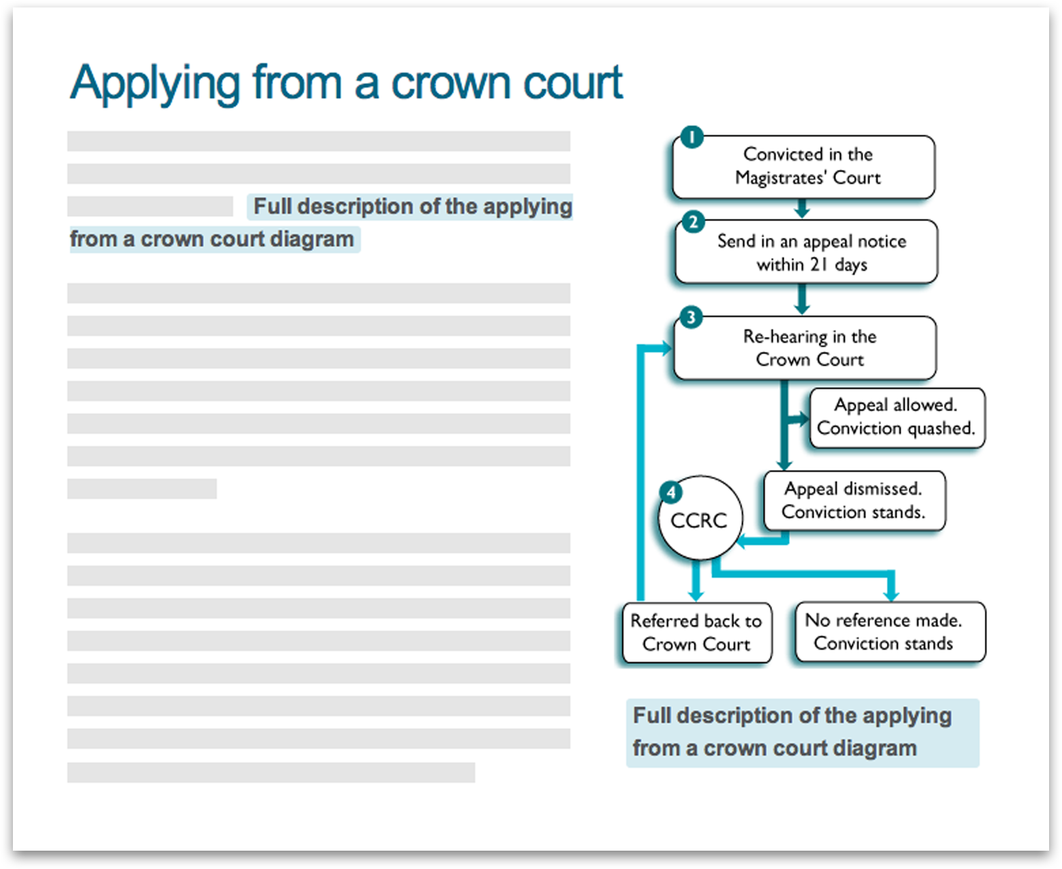
Figure 2: Links to a full text description of the diagram are provided below the diagram itself and also in the content of the page.
In some cases, you may want to add images to a page to improve the visual appearance of the page rather than those that convey information. If your image does not convey information or does not help add to the reputation of the organisation then you may want to consider leaving the text description for the image empty. If the description is left empty then the presence of the image is not announced to people using assistive technologies (Note, this is not possible within the Silva CMS – if you do need this, contact silva-support@ucl.ac.uk). This effectively means you are allowing people using assistive technologies to skip over the image in the same way a sighted person might visually skip over the image.

If you are unsure whether an image needs a description or not, the best option is to always provide a description. In this way, someone using a screen reader or Braille device can decide for themselves if the content in the image is relevant to them.
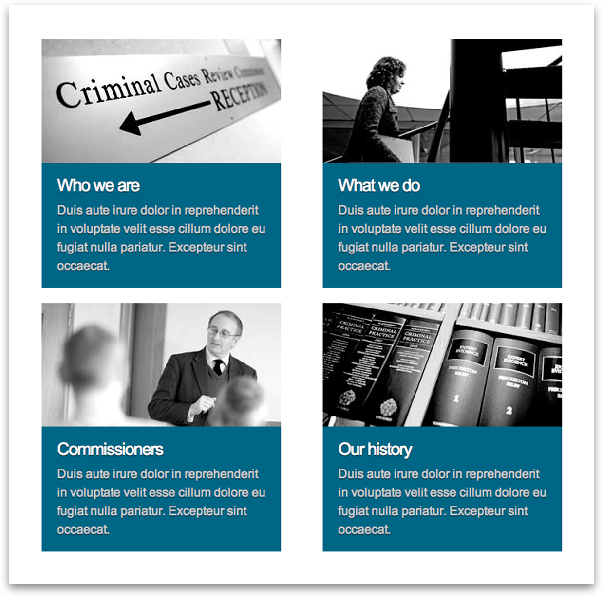
Figure 3: Images that do not convey any important information should have ‘null’ alternative text descriptions.

2.3 Lists
Lists are an excellent way to break up text and help to keep people interested in your page. Lists make content clearer, easier to scan and easier for readers to identify important information. However, too many lists can disrupt the flow of content on a page. Lists should only be used to group two or more items of similar content.

There are three different types of lists you can use on a web page. They are bulleted, ordered and paired lists, which are all available using the Silva content management system.

2.3.1 Bulleted Lists
Bulleted lists are the most common type of lists used on web pages and the type of list you will probably use more often. You should use this type of list for content that does not have a specific order, for example a list of books:

- Hound of the Baskervilles
- Treasure Island
- The Picture of Dorian Gray

2.3.2 Ordered Lists
If you are adding a list to your page that has a specific order you should use an ordered list. Ordered lists can be preceded with numbers, letters or roman numerals.

- Fill out the registration form
- Check your email
- Activate your account

2.3.3 Paired Lists
Paired lists consist of pairs of related content. Paired lists are also known as definition lists and are less frequently used on web pages than bulleted and ordered lists:

Cat:
A feline mammal with thick soft fur and no ability to roar!

2.4 Paragraphs
As stated it is important to use paragraphs when writing your web copy, as too much text in one block can be difficult to read online. Short, succinct paragraphs of roughly 60 words will make it easier for many people to read and enjoy the content on your pages. You should front load paragraphs by putting key points at the start of them.

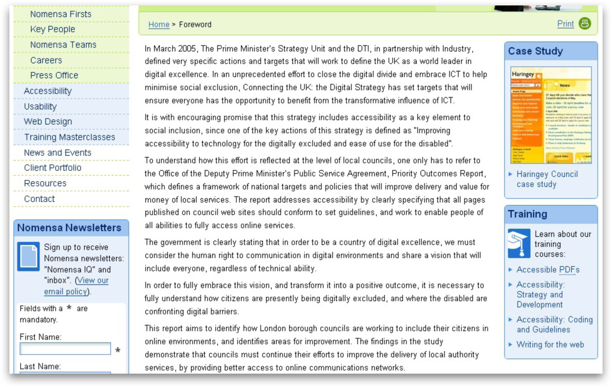
Figure 4: Paragraphs are used to make the content on the page easier to read.

2.5 Tables
If you need to add tables of data to your web pages you can also do this through the Silva content management system. Tables should only be used for displaying data and should not be used to create different ways of laying out page content.

When tables are used they should be kept simple. Depending on the design of the table, all tables must have either column or row headings. This is an extremely important point to keep in mind. People using assistive technologies use table headings to help understand the relationships between rows and columns in the table.

The Silva CMS allows you to use table headings (or ‘headers’ as it terms them), which you should always use. If table headings are missing, then it can make it difficult for people using assistive technologies to understand the content in the table.

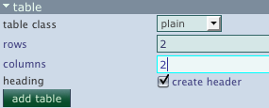
Figure 5: Inserting tables using Silva.

2.6 Emphasising text
You may want to emphasize small portions of text in your web copy to make it stand out to your readers. The Silva CMS will allow you to use bold and italicised text to highlight important sections of your content.

Emphasised words help people find what they need from your content by getting the key points across to your audience quicker. You should be careful not to use too much as it can have the opposite effect making text harder to scan and read. When emphasising your text think about:

- Who your audience is;
- What your audience wants from the page;
- What you want to focus on.

Make sure you emphasise the right things and only emphasize one or two words or phrases at most per paragraph.
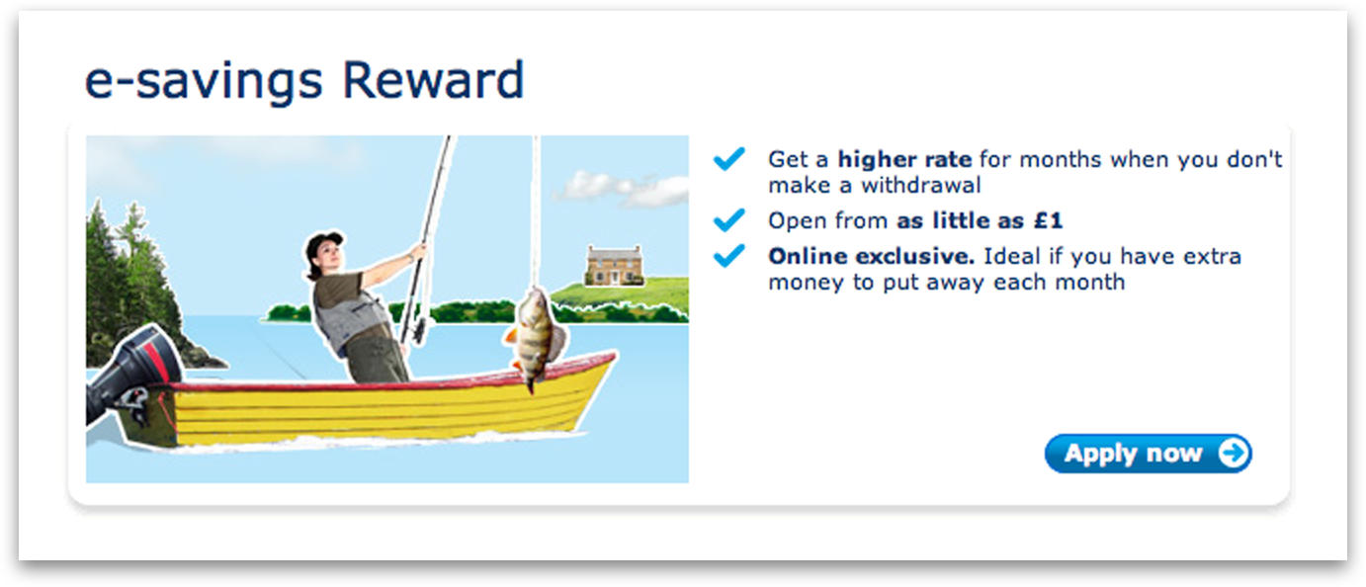
Figure 6: Using bold to highlight important words.

2.7 Abbreviations
At some point you may need to include abbreviations within your web copy. It is important to ensure that where abbreviations are used they are written out in full the first time they occur in the content. Some abbreviations may be more obvious than others, but you should appreciate that not everyone may understand the abbreviation. You should also consider that some abbreviations might have different meanings in different contexts. Take the following abbreviations as an example.

- ROI - Return on Investment or Republic of Ireland;
- BTP - Business Transaction Performance or British Transport Police.

To include an abbreviation in your copy you can either write out the abbreviation followed by the full meaning in brackets or vice versa.

- ROI (Return on Investment);
- Return on Investment (ROI).

2.8 Size, shape and location
The occurrence of information identified by sensory characteristics such as shape, size, visual location or orientation is more common than you might imagine on the web. You have probably come across copy such as ‘use the menu on the left’ or ‘click the map on the right’ more than once. While these instructions may make sense to sighted people, those with visual impairments may struggle to interpret them.

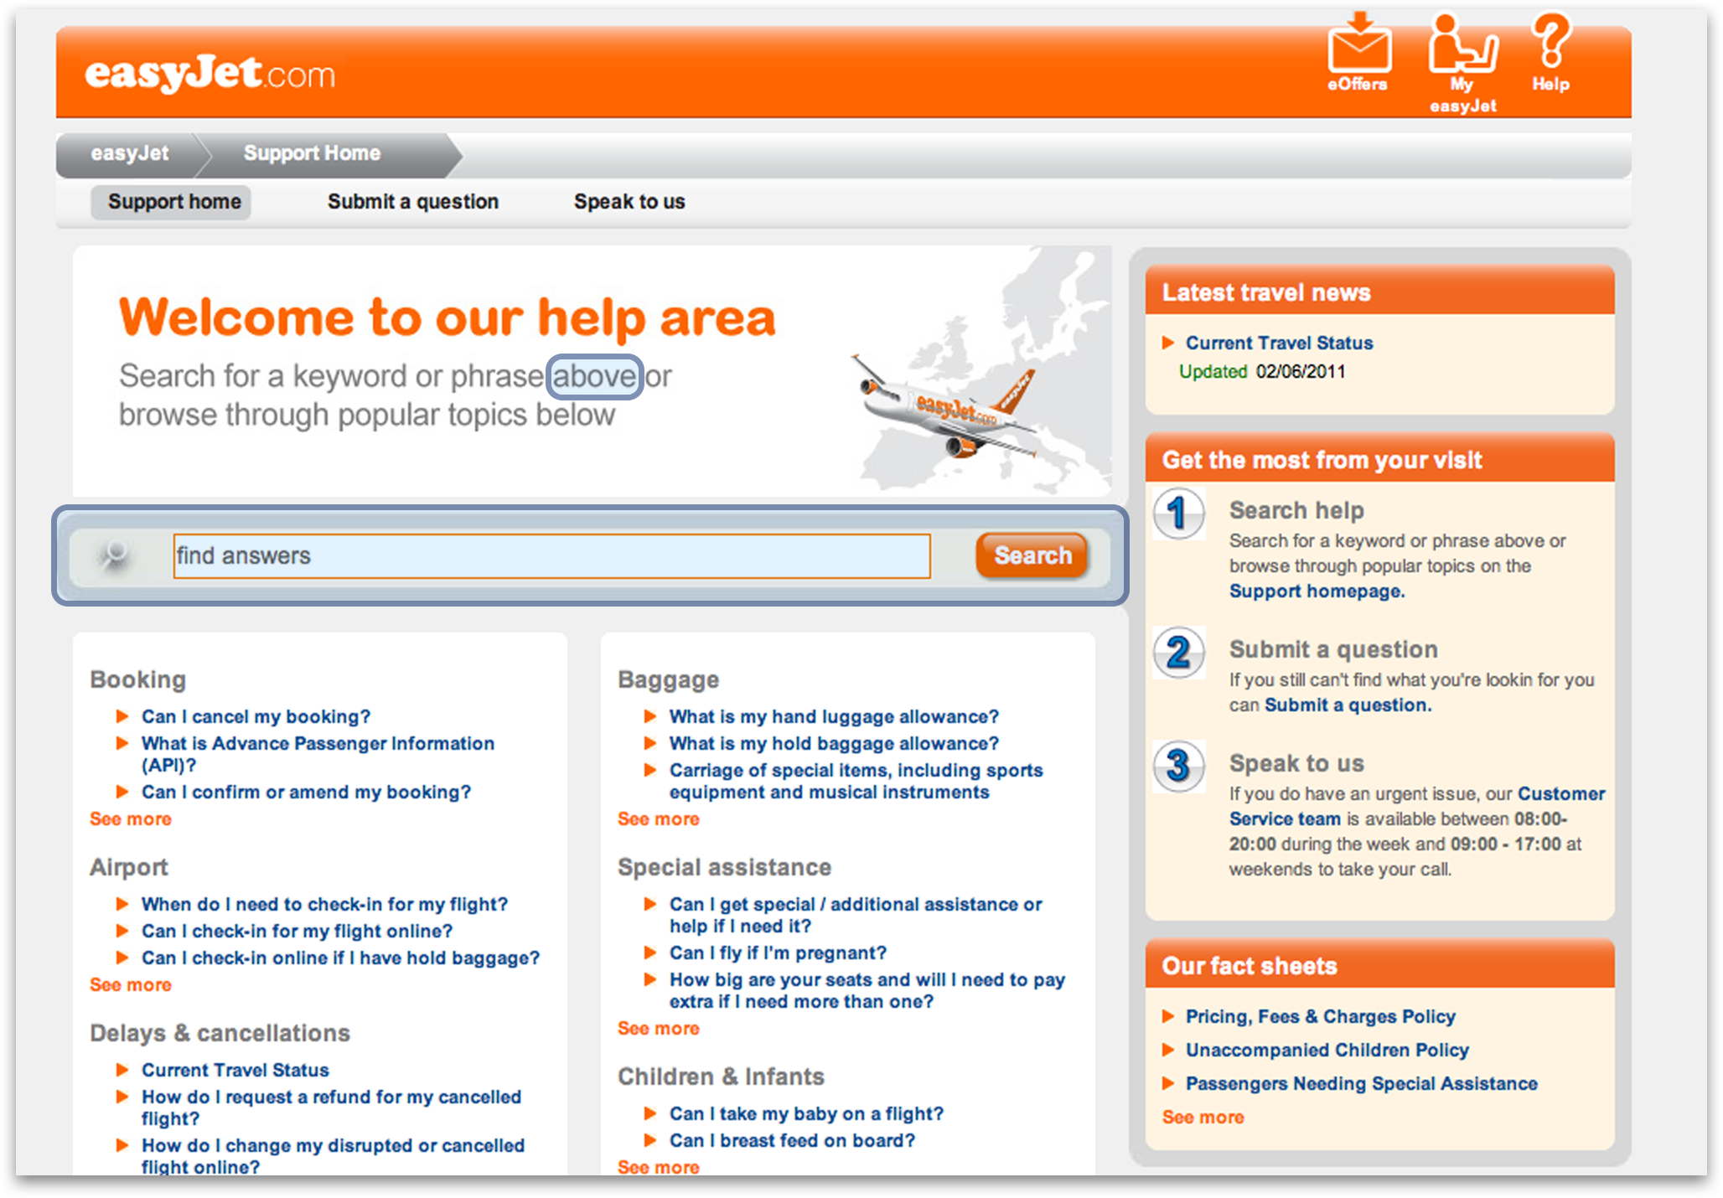
Figure 7: The content conveys information based on visual location.
You may have also come across websites that use icons or graphics to represent navigation items or provide additional information about a subject. Some people may not be able to interpret the true meaning of icons and graphics, while other people may not have access to information conveyed in this manner at all (see section 2.2). To help everyone understand the purpose and meaning of icons or graphics you should provide a text label as an accompaniment.

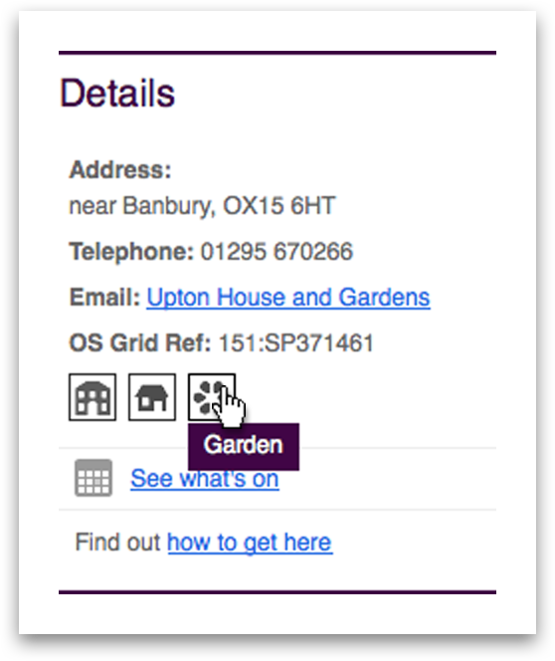
Figure 8: Icons with text labels available on hover.

2.9 Avoid the use of colour alone
In the same way some people cannot perceive shape, size or visual location, some people cannot perceive colour at all. Other people such as those who are older or have sight deficiencies may not be able to see colour well. People with partial sight may have limited colour vision.

Your web content should not rely on colour alone to convey information, but instead use colour to enhance access to information on your website. Colour should be used with a text description to communicate your message. For example do not write ‘select the green button’, instead write ‘select the green Next button’.

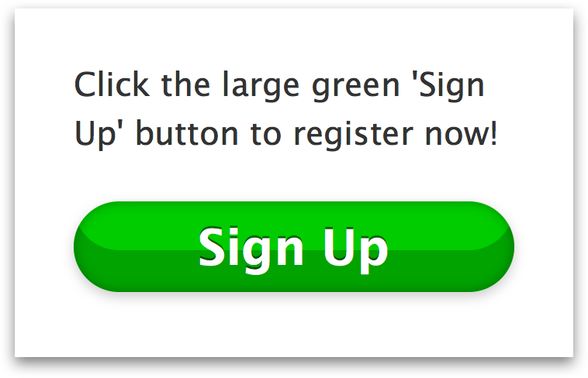
Figure 9: Using text and colour to convey information.

2.10 Using text within an image
As we have seen throughout this chapter, people access content on the web in different ways and have different requirements for viewing content. People who wear glasses or those with low vision often adjust the text size, fonts or colours on a website to enable them to read the content more easily.

When commissioning images for your website which contain text, you should keep in mind that people who need to make adjustments to text will not be able to adjust the text in the images. This means you should only consider using images of text where absolutely necessary. You may need to consult UCL Web Services to see if the information you are trying to convey as an image might be more appropriate translated into code (HTML/CSS).

If you do decide to use images of text then you should make sure that any text in the image is a minimum of 16pts in size. This should allow the majority of people to read the text in the image sufficiently well.
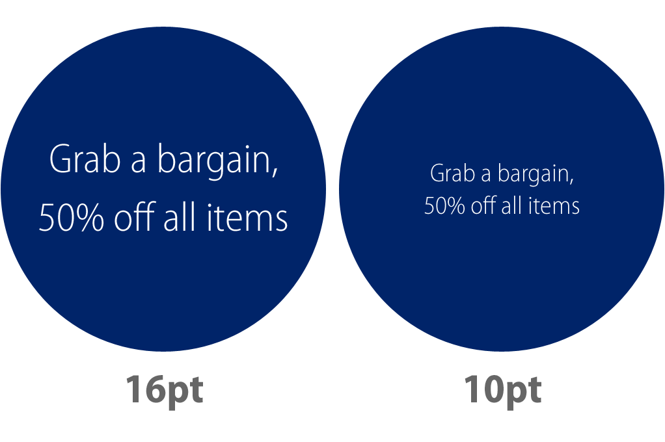
Figure 10: Text in images should be at least 16pts in size to aid readability.

2.11 Creating page titles
The title is one of the most important parts of your page. The page title should be unique to your website and clearly describe the topic or purpose of the page. The page title helps people understand if the content on the page is relevant to them. Page titles can also help people identify the section of the website hierarchy in which the current page exists.

The page title usually consists of three parts, the name of the page, the section of the website containing the page and the name of the website. It appears at the very top of the browser window and is one of the first things someone using assistive technology will encounter when they reach the page.
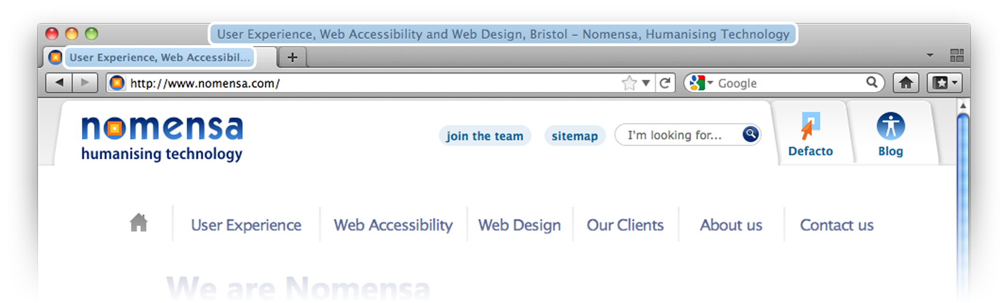
Figure 11: Providing descriptive page titles.
As the page title is likely to contain a reasonable amount of content, it is best to put the most important information at the beginning of the page title. If people are visiting your page then they are interested in its content so putting the name of the page first is the best option. The name of the section containing the page should come next to help people understand where they are within the website hierarchy, followed by the name of the website. This order of content works best because people do not have to listen or read through the whole page title before understanding if the content on the page is relevant to them. They can grab the meaningful information quickly and either read further down the page or leave the page to find more appropriate content.

The Silva CMS allows you to set the title of a Silva folder by editing its ‘title’ field. You can then change the way the title automatically displays in the left hand menu by editing its ‘short title’ field (in the ‘properties’ tab). For more information on this, email silva-support@ucl.ac.uk

You should make sure when adding and editing the name of the page that the name clearly describes the topic of the page and contains relevant keywords. For example if you were writing about the Tower of London and in particular the White Tower, the name of your page should be ‘The White Tower’. Your full page title might be something like this:

Name of the page, Section of the website - Name of the website
The White Tower, The Tower of London – Historic Royal Palaces

2.12 Writing descriptive link text
You may want to add links to pages and documents from your content to give people access to additional related information. When adding links it is important to make sure the phrase used for the link can be understood if the link is read in isolation. People using assistive technologies in particular those using screen readers very often jump from link to link using the ‘tab’ key to navigate more quickly through a set of pages. If the phrase used for the link does not make sense when read by itself, people will have to read the surrounding page content in order to decipher the link and understand where it might lead. This can be a frustrating experience for people who are unable to see the page.

You should avoid using phrases for links such as:

- Click here;
- More information;
- Read more.

Instead use phrases that have context and can be understood by everyone. Using clear and simple phrases for links will also help people with cognitive impairments, as they can sometimes be confused if there are multiple means of navigation on a page.

Several tips for writing good link phrases include:

- Use the title of the page the link is leading to;
- Do not use entire sentences as links.

When linking to documents use the name of the document as the link and provide the type and size of the document as part of the link text, for example “London Underground Map (PDF, 2MB)”.

2.13 Writing descriptive headings
Headings are particularly useful for people who use assistive technologies to access your web content. Many assistive technologies have short cut keys that allow people to move between similar page elements. In screen readers such as Jaws people can move between headings on a page. Cycling between headings is an excellent way of working out what information is available on the page. This makes it easier for people to scan and make sense of the page.

When adding them to your page in your content management system, you need to make sure you use headings in the correct order.

The Silva CMS has a pre-defined set of options for adding headings: ‘title’, ‘heading’, ‘sub’, ‘subsub’. These options are not simply a choice of headings you can use anywhere on your web page. They should be used for a specific purpose and must descend in order.

The page title should be the first heading on the page and should automatically be output as a heading by the content management system. In the Silva CMS, the first heading should use Silva’s ‘title’ heading. All headings within this section should then cascade sequentially down from there. Headings should only drop one level at a time, so after using the ‘title’ setting, you must use the ‘heading’ setting:

Title: Codebreakers: The Inside Story of Bletchley Park

Heading: Introduction
Heading: The Production of Ultra Intelligence
Sub: Life in and out
Sub: The Duty Officer
Sub: A Naval Officer
Sub: The Z Watch

2.14 Consistent identification of content
People using screen readers and other types of assistive technology rely on components of web pages to be consistent. When using these types of technology many people depend on their familiarity with features on a website as a strategy to help navigate and operate the website. Consistency is the key to this strategy. If features of the website are labelled or referenced in a different manner on different web pages then it is far more difficult to use this strategy as a means of traversing a website. Inconsistencies of this type may also be confusing and increase the cognitive load for people with cognitive impairments.

Take care to use a consistent set of words and phrases to reference features and components on your website. Consistency also extends to alternative text descriptions for images. Where the same image has been used on different web pages it should have the same text description. As mentioned previously, this may be something which is handled by your content management system when you first upload an image but it is worth being aware of.

Further reading
- UNDERSTANDING-WCAG20 – Textual equivalents-http://www.w3.org/TR/UNDERSTANDING-WCAG20/text-equiv-all.html
- UNDERSTANDING-WCAG20/time-limits-required-behaviors.html-http://www.w3.org/TR/UNDERSTANDING-WCAG20/time-limits-required-behaviors.html
- UNDERSTANDING-WCAG20/content-structure-separation-programmatic.html-http://www.w3.org/TR/UNDERSTANDING-WCAG20/content-structure-separation-programmatic.html
- QUICK REFERENCE – Info and relationships-http://www.w3.org/WAI/WCAG20/quickref/#qr-content-structure-separation-programmatic
- UNDERSTANDING-WCAG20 – Info and relationships-http://www.w3.org/TR/UNDERSTANDING-WCAG20/content-structure-separation-programmatic.html
- QUICK REFERENCE – Info and relationships-http://www.w3.org/WAI/WCAG20/quickref/#qr-content-structure-separation-sequence
- UNDERSTANDING-WCAG20 – Use of color-http://www.w3.org/TR/UNDERSTANDING-WCAG20/visual-audio-contrast-without-color.html
- QUICK REFERENCE – Use of color-http://www.w3.org/WAI/WCAG20/quickref/#qr-visual-audio-contrast-without-color
- Checking colour contrast-http://www.nomensa.com/blog/2010/checking-colour-contrast/
- UNDERSTANDING-WCAG20 – language of page-http://www.w3.org/TR/UNDERSTANDING-WCAG20/meaning-doc-lang-id.html
- QUICK REFERENCE – Language of page-http://www.w3.org/WAI/WCAG20/quickref/#qr-meaning-doc-lang-id
- Headings and lists are you using them correctly-http://www.nomensa.com/blog/2006/headings-and-lists-are-you-using-them-correctly/
- This isn’t just alt text this is really great alt text-http://www.nomensa.com/blog/2006/this-isnt-just-alt-text-this-is-really-great-alt-text/
- Writing web content- http://www.usability.gov/pdfs/chapter15.pdf

3 Best Practice for Information Architecture

The Information Architecture (IA) of a website defines the way all the pages are structured and how they relate to each other. An Information Architecture should look like a tree diagram or a hierarchy such as this:

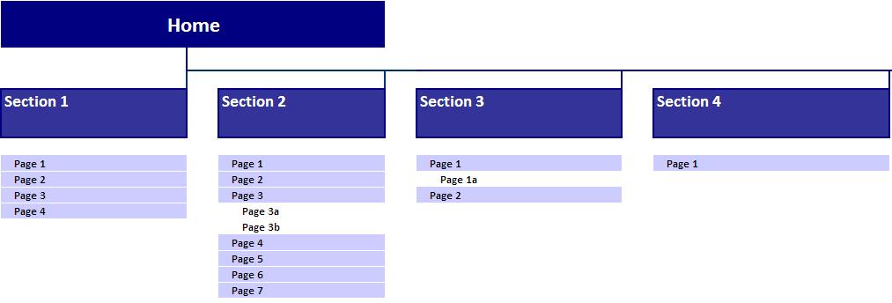
Figure 12: An example Information Architecture diagram

3.1 Creating an Information Architecture
The process of creating an Information Architecture of a site generally involves deciding upon two things. Firstly some similar and related content needs to be identified. For example content about directions to a venue is similar to content describing the venue itself. Therefore it might be decided that these two pieces of content should be in the same section. Secondly it needs to be decided how important each piece of content is; this will help decide at which level to place the content. It is best to think about this process from the user’s point of view, if not indeed with real users. If the task or information is imperative to a key user goal, then the content should be placed at a high level, which will be readily available from the homepage. If the task or information is not as important or is secondary information that not many users will want to see, it should be placed lower down in the Information Architecture.

Some related content might be placed in a different section if another way of grouping the content has the overriding vote. This is unavoidable in most cases; in these cases cross links should be used between sections, which allow the users to access related content quickly and easily.

3.2 Number of items
There are certain guidelines to follow when creating an Information Architecture. It is a good idea to consider the appearance of the wireframes at this stage. For example, if there are twenty top level sections of a website, the homepage will need to provide navigation to all twenty of those sections. This is going to be cumbersome on the homepage as the user is forced to read through and choose between twenty different labels.

It is good practice to limit the number of options at each stage; top level navigation items should ideally be less than ten. Lower down in the Information Architecture it may become appropriate to have more than ten ‘child’ pages from a single ‘parent’ page. One case is where there is a section of the site that contains a lot of similar content, for example a guidance section might contain very similar content for thirty different processes. Then the Information Architecture can be flexible and contain all thirty items, and there should be appropriate navigation on the parent page so that it does not take up too much space.

3.3 Labels
Naming pages within the Information Architecture needs to be considered carefully. This is because the label name will be used in navigation, and will often be the only piece of information that the user has to go on when deciding where to go next. Therefore the label must be descriptive of the content it leads to. The following guidance should be followed:

- Labels should use common language that the general public will understand;
- Labels should not be too long, aim for using less than five words;
- Labels should not be ambiguous or overly vague in meaning or interpretation;
- Labels should be the same as the main heading of the page that it leads to; or an amalgamation of the label name and the name of a higher level page, for example the application form page in a section about postgraduate courses might have the heading: ‘Apply for a postgraduate course’ rather than ‘Application form’.

3.4 Navigation
People find different navigation strategies effective for their individual requirements. For example, some people may find it easier to use a main menu rather than be overwhelmed with a sitemap. Other people may find a search form much quicker to use than a more conventional navigation method. Different ways of navigating in the UCL corporate identity web templates include:

- Left (and occasionally right) navigation;
- Breadcrumb Navigation;
- Searching;
- Navigating by in-page links;
- Utility Navigation links (in the header and footer)
Offering different navigation methods means that users can choose to navigate via the method they feel more comfortable with.

The search box and the utility navigation links should be consistently placed in the header and footer. The other methods of navigation have best practice guidelines associated with them.

3.4.1 Left/Right hand side Navigation
This type of navigation essentially presents the Information Architecture to the user, but not all at once. From here they should be able to easily understand the structure of the site and understand where they are currently and where it is possible to go. On any given page the user should be able to see all the child pages available from that page, as well as being able to navigate upwards to the direct parent pages.

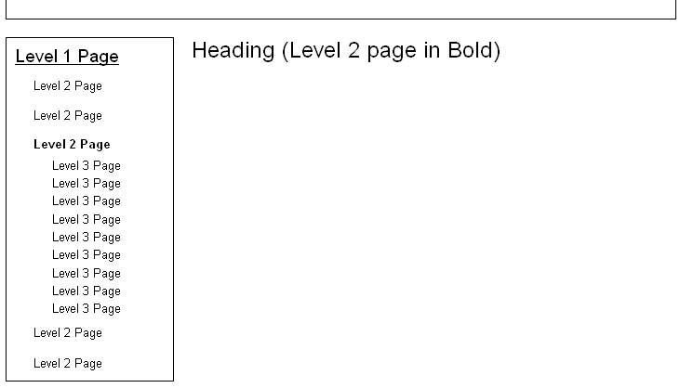
Figure 13: Left navigation should show 'child' pages from the current page and direct 'parent' links

The left hand navigation should not include a link to the main UCL homepage. The breadcrumb trail will include this; in addition to the logo being a clickable link to home.

3.4.2 Breadcrumb Navigation
A breadcrumb trail can be a useful way of helping people easily identify relationships between pages on your website. The extra contextual information that this provides can be extremely useful for people with cognitive and learning disabilities. A breadcrumb trail should tell the user the route from the homepage to the current page.

Figure 14: Breadcrumb trails should include all pages in the direct path from the homepage to the current page.
Users should be able to click on any of the links in the breadcrumb, apart from the last item (current page), which should appear in plain text. For example if a user is on a 5th level page they should be able to navigate to any of the pages directly above it in the Information Architecture; its 4th level parent page, 3rd and 2nd level parent pages, as well as the homepage.

The breadcrumb should appear just below the header and each item should be separated by a ‘>’ symbol. It is important to avoid using the ‘|’ or ‘/’ symbols as these could potentially make the breadcrumb items look like tabs instead.

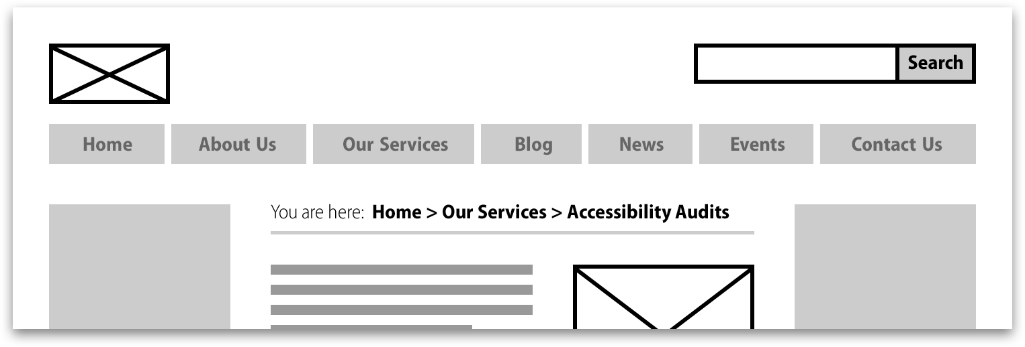
Figure 15: A breadcrumb is a great way for visitors to understand their current location on deeply nested pages.

3.4.3 Utility Navigation
In the UCL corporate identity web templates utility links appear in the header or the footer. They should be very generic links, which will be useful to the vast majority of users. A good example is ‘Contact Us’. It should also include any links to legal documents such as an Accessibility Statement or any copyright information.

Navigation via in page links will be discussed in the chapter on wireframes.

Further reading
- Navigation mechanisms quick reference- http://www.w3.org/WAI/WCAG20/quickref/#qr-navigation-mechanisms-refs
- Navigation mechanisms- http://www.w3.org/TR/UNDERSTANDING-WCAG20/navigation-mechanisms-refs.html
- Navigation mechanisms quick reference- http://www.w3.org/WAI/WCAG20/quickref/#qr-navigation-mechanisms-mult-loc
- Navigation mechanisms- http://www.w3.org/TR/UNDERSTANDING-WCAG20/navigation-mechanisms-mult-loc.html#
- Accessible design needs good foundations- http://www.nomensa.com/blog/2006/accessible-design-needs-good-foundations/
- Headings, Titles and Labels- http://www.usability.gov/pdfs/chapter9.pdf

4 Best Practice for Wireframes

As discussed in other sections, there are certain areas of pages that will already be defined before design is considered. These areas include the header, footer and the various forms of navigation. The rest of the page includes the ‘main body’ of the page and the right hand side panel. Generally these are the areas which the designer or content editor has the most freedom over in terms of what content is displayed and how it is presented to the user.

4.1 Deciding on content
The decision of what content to include on any given page can be a difficult one, largely because different stakeholders will have different ideas about what is most important to include. There may also be certain policies in place depending on the organisation which state guidelines about what should be prominently displayed and what features should be present, for example a feature for user feedback about customer service might be strongly desired.

Wherever there is still relative flexibility about page content, the options need to be carefully considered. To create the most usable pages, the process needs to be looked at from the user’s point of view. This process is often referred to as ‘User Centred Design’, and often results in contrasting ideas from the stakeholder’s views. Often if an organisation places their content on the web, the content is tailored to how experts understand and use the content. However, a user centred design process involves thinking about how all the users of the site understand and prefer to use the content. The following things should be considered when deciding on page content:

- Who will be using this page?
- Why will they be using this page?
- What are their key goals?
- What will they want to do next?

These questions will help decisions be made on many things; most important of all what content is displayed to the user. However they will also help decide on what calls to action to include, the tone of voice used and how useful various features are.

It is imperative that key user goals are supported on each page. For example if users want to research about courses and possibly apply for one, they should always have a call to action on the page which allows them to move closer to completing their goal. This does not mean placing an Apply button on every single page however; rather it requires some thought on each page about what the user will want to do next.

4.2 Headings on Pages
The heading of a page should be located near the top left of the main body of the page, in large font. As mentioned it should be identical to its Label name in the Information Architecture. There are some exceptions to this rule that need to be considered on a case-by-case basis. It is possible to provide a longer more descriptive heading for example on a page where users are performing an action rather than browsing information.

Other headings on the page should be descriptive of the content underneath them, and should be aligned to the left of the main body of the page. The reason for this is that users often scan pages in an ‘F’ shape like so:
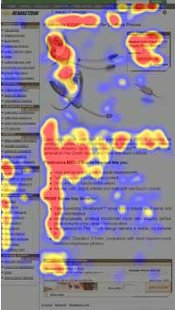
Figure 16: Users scan in various places on a page but an F shape is discovered when the most looked at parts of the page are considered

4.3 Visibility of Calls to Action
Once the most useful calls to action have been defined, they should be made very prominent on the page. Visual prominence depends heavily on the rest of the page, for example a red button with capital text and exclamation marks would not stand out in a page full of them. However, it is important to remember all of the following when trying to make an element visually prominent:

- Size;
- Location;
- Colour contrast;
- Brightness;
- White space around the element.

Consistency is crucial again in this case; if key calls to action are in different places on each page, this will detract from the visual prominence of them because the user will not expect them to be in a certain place. Conversely, if key calls to action are always placed on the right of the main body of content on a page for example, then users will unconsciously get used to this and will find them easily.

Whilst the layout and presentation of each individual page can vary, it is important to remain consistent in the strategy; for example providing a consistent column layout for pages (split them into four columns or three etc.) displaying images in pre defined sizes and locations and how text is presented. The following guidelines refer to the best practice of presenting text.

4.4 Links
The use of links in a website is immensely important and creates very efficient navigation for users. Links can direct users quickly to a completely separate part of a site, another website entirely or simply to a ‘child’ page. This is incredibly useful, but sometimes links can cause confusion or set erroneous expectations. Due to the wide implementation of links, link refinement and optimisation can have a significantly positive effect on the user experience.

There are several different types of links:

- Internal links to deeper content in the same section;
- Cross links to a different section of the same site;
- Links to a different subsite;
- External links to a completely different site.

Links can also differ in the following ways:

- Visited and unvisited links;
- Links that direct to another page in the same window, open a page in a new window, open a new tab or open a pop up box.

It is important to distinguish between different types of links so that users can set their expectations in terms of what will happen upon the click of a link. For example, if a user expects a link to open up a new window, they may click on it and still expect to be able to see content on the page they are on. If the link instead directs them to another page in the current window they will not be able to do this. Furthermore, if a user is unsure about what will happen when they click on a given link, they will be less willing to click on it and therefore less willing to ‘explore’ the site. The styling of a link needs to give the user an indication of what type of link it is, so that they know what to expect before they click on it.

It is also very important to distinguish links from normal text, for this reason it is important not to use the colour blue for normal text, as this is the conventional colour for links and therefore users will associate it with links.

The colour blue should be used for all text links, unless they have already been visited in that session, in which case they should be the colour purple, as shown below.

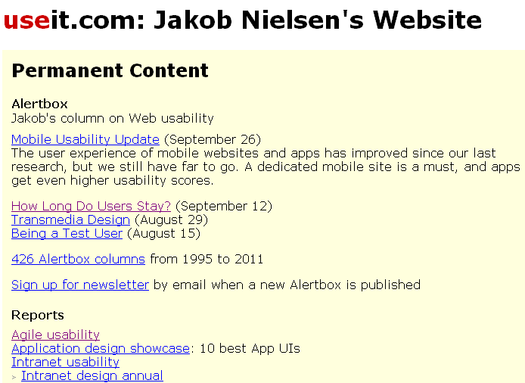
Figure 17: Links should change to a purple colour when visited.
If a link opens up a new window, the user should be warned of this. This can be done by stating it in the link name, for example ‘Application Form (opens in a new window)’. The following icon could also be placed just after the link name:

Figure 18: An icon indicating that the link will open in a new window
External links should appear different to internal links wherever possible. There are three common ways to do this.

- The wording of external links can make explicit the fact that it links to a separate website, for example ‘Read full story on the Times.com’.
- The placement of links could help indicate that a link is external. For example all links placed in the right hand panel of a page could be external, and all links placed in the middle (main) panel of a page could be internal. Note however that this method is dependent on the ratio of the two types of links, and that the exact rules are flexible as long as they are consistent.
- The third method is to create a different visual styling to external links. Some external links are styled as panels or advertisements that have a completely different appearance to normal links. The styling does not have to be this extreme however; it could simply be enlarged text or the addition of a box around the links.

Any of these methods can be used to indicate link type, and application of two or all of them can only help to reduce confusion and help to set user expectations.

4.4.1 Wording of Links
Making link phrases clear and concise helps people understand which page they will reach when following a link on the page. Ensure that each link uses clear and simple language that accurately indicates the page the link leads to.

Writing meaningful link phrases is a key part of the process when developing the information architecture and wireframes for your website. The terminology used for link phrases in both the Information Architecture and wireframes should be considered at an early stage to avoid possible accessibility issues.

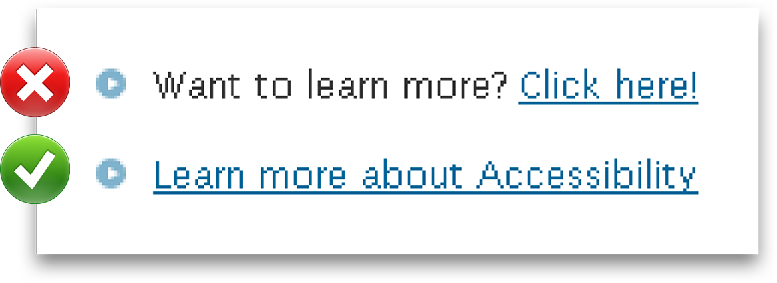
Figure 19: Choosing your link phrases is important.
All link phrases should be clear and accurately indicate where the link will lead. One way of thinking about link phrases is in terms of signposts. If a signpost reads ‘Bristol’ and you followed the signs you would expect to reach ‘Bristol’ rather than ‘Bournemouth’. Avoid using general terminology such as “read more” and “click here”.

4.4.2 Lists of Links
Lists can be a good way of breaking up large blocks of text, highlighting to the user that the list items are important and making it easier for them to scan. However, it is fairly typical that when users scan lists, they often miss items. While a vertical list is easier to scan than normal prose, users still miss some items because of the nature of visual search. Some of this effect can be attributed to the wording of the items; if the exact wording is not what the user expects then the words will not ‘jump out’ at them. The nature of scanning means that users are less likely to read each list item fully and work out its meaning. The other main aspect that contributes to users missing items is the length of the list. At a certain point it becomes difficult to scan a list quickly.

If there are too many list items that need to be displayed, the possibility of splitting the list into two (or more) lists should be considered. For example, a list of a hundred animals would be difficult to scan, so they could be split into animal types such as Birds, Mammals etc. If the animal types are used as headings with the appropriate animals in separate lists underneath, the user’s task is greatly reduced.

Another alternative to make long lists easier to scan is to put them in alphabetical order. If there are a thousand items in a list, and users always know which one they are looking for, then putting the list in alphabetical order greatly reduces the searching time. The list could also be split into categories this way by providing skip links at the top of the page for items that start with each letter. However this is only a realistic solution if the users know what they are looking for before they start, and if there are a limited number of possible alternate names for an item.

It is difficult to define exact numbers for optimum list length because it can depend on the following things:

- The type of list items;
- The length of items themselves;
- The surrounding environment;
- The logic of the list order.

For a list of quick links on a homepage for example, it is best practice to limit the list to 6 or 7 items. Beyond this, the list becomes a lot harder to take in all the information by scanning, and instead each item must be read individually, something which testing has shown that users do not often do. However, this recommendation assumes that a homepage will generally have a lot of other important content on it, and therefore the surrounding environment around the list is busy. Deeper pages in a site are often less busy in terms of surrounding content, so the recommended number of maximum list items could be extended on these pages.

4.5 Text

4.5.1 Type size
The minimum type size can vary depending on the audience, but for body text ensure that the text is no smaller than 12pt. Many websites use up to 18pt size text; this is perfectly acceptable if the design allows for it.

4.5.2 Leading (line height) for your type
The space between each line should be sufficient for the text size. As a general rule, online text requires a slightly larger leading than normal text to allow for an easier read.

4.5.3 Aligning Text
Text should be left aligned. Do not use centrally aligned text, right aligned or justified blocks of text as this can become uncomfortable or difficult to read. This is especially important for large paragraphs.

4.5.4 Spacing between paragraphs
There should be sufficient spacing between paragraphs of text. If headings are used to break up paragraphs, sufficient spacing should be placed between the bottom of a paragraph and the top of the next heading. Be sure that the spacing allows for natural breaks in the type, but also retains context if required; for example the spacing between a heading and the following paragraph should be tighter to show that they are related.

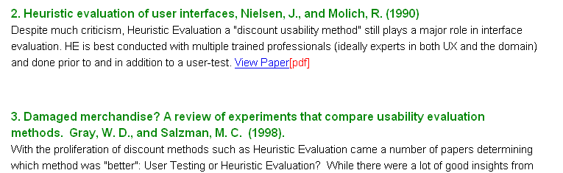
Figure 20: It is best practice to place significantly more white space between paragraphs than between the heading and the text of a paragraph

4.5.5 Characters per line
The ‘measure’ is the width of a line of text. The recommended width of a line for the web is 50-80 characters long. Beyond this, text becomes difficult or uncomfortable to read and it is difficult to keep track of which line you are reading. Lines of text can be shorter than 50 if the design requires.

4.5.6 Hierarchy of headings
The style of the headings used on the site should be of appropriate styles so that it is clear there is a hierarchy in place. For example, a Silva CMS ‘title’ format should be larger than a ‘heading’ format and so on.

4.5.7 Background Images
Generally images should not be placed behind or in the background of text. This is because the imagery and colours can interfere with the legibility of the text in a variety of ways. However, there are exceptions to this rule. If any imagery is placed as a background, make sure that the text is still more prominent than the image. The following rules should be followed:

- Ensure the image is a light colour for black text, or a dark colour for white text;
- Ensure that the imagery does not contain a pattern which is distracting;
- Ensure that the imagery is adding context to the text and is relevant on every page where it is applied.

Further Reading
- Design process and evaluation- http://www.usability.gov/pdfs/chapter1.pdf
- Page layout- http://www.usability.gov/pdfs/chapter6.pdf
- Headings, Titles and Labels- http://www.usability.gov/pdfs/chapter9.pdf
- Effortless layouts- http://www.nomensa.com/blog/2011/5-tips-for-effortless-layouts/
- Text Appearance- http://www.usability.gov/pdfs/chapter11.pdf
- Opening links in a new window- http://www.sitepoint.com/beware-opening-links-new-window/
- The F shaped reading pattern- http://www.useit.com/alertbox/reading_pattern.html

5 Best practice for creating PDFs

5.1 Alternative text for images
Text is the most basic format used to present information and is vital for providing equivalent information for people using access technologies. For example, a person who cannot see or hear could use a Braille reader to read out the alternative text of an image in an HTML page.

Alternative text for images is equally import for PDF documents. Typically this is something that is added to an image in the original document and will be translated across when converted to PDF. However, if it this not the case, a text alternative can be added using the ‘TouchUp Properties’ panel:

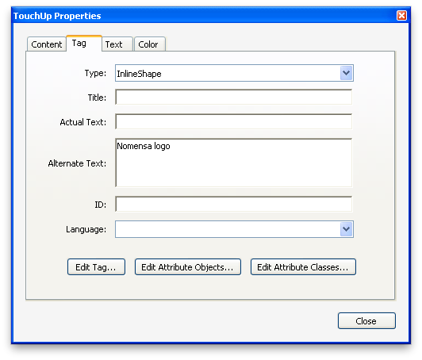
Figure 21: Add alternative text for images using the 'Touch Up' panel.
Images that are purely decorative and do not require alternative text can be removed from the PDF tagging information by converting the element to an artefact. This can be achieved by right-clicking on the tag within the ‘Tags’ panel and selecting “Change tag to artefact.” Any empty element can them be deleted.

Adding alternative text for images and changing decorative images to artefacts will ultimately improve the information presented and the flow of your PDF.

5.2 Mark-up with a PDF
Structure and relationship is crucial to delivering information in a PDF. Without it, the meaning of content portrayed to the user can be lost.

Improving the structure and relationships within a PDF will often begin with the source document. For example, a Word document should use headings, lists and tables where suitable for structuring data and avoid simply using text size, font weight and line drawing features to create similar visual effects.

Adobe Acrobat Professional will allow you to check and improve the information and relationship portrayed in the PDF using the ‘Tags’ panel:

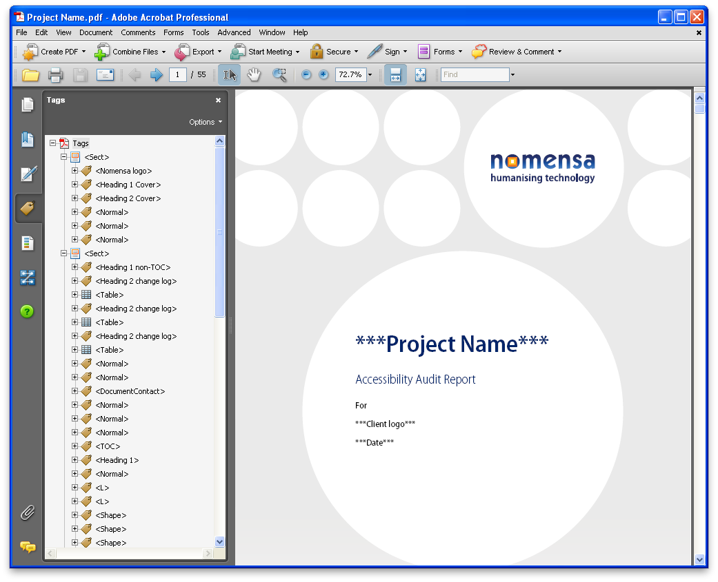
Figure 22: Tags panel can be used to change the relationship of the content.
Setting the ‘Options’ feature to ‘Highlight content’ will allow you to select content within the PDF and edit the tag of an element to one that is suitable. For example, visual headings that have been automatically tagged by Acrobat as a paragraph (<P>) can be updated to using a heading tag, which will repurpose the content to provide better meaning for people such using screen readers and other types of assistive technology.

5.3 Creating a meaningful reading order
Structuring pages in your document correctly is a very important part of creating an accessible PDF. The order in which content visually appears on your page may not necessarily correlate to the order of the content for a screen reader; particularly if you have used unconventional methods when creating columns and positioning content in the document.

The order of the PDF document can be checked using the “Order panel” in Acrobat Professional:

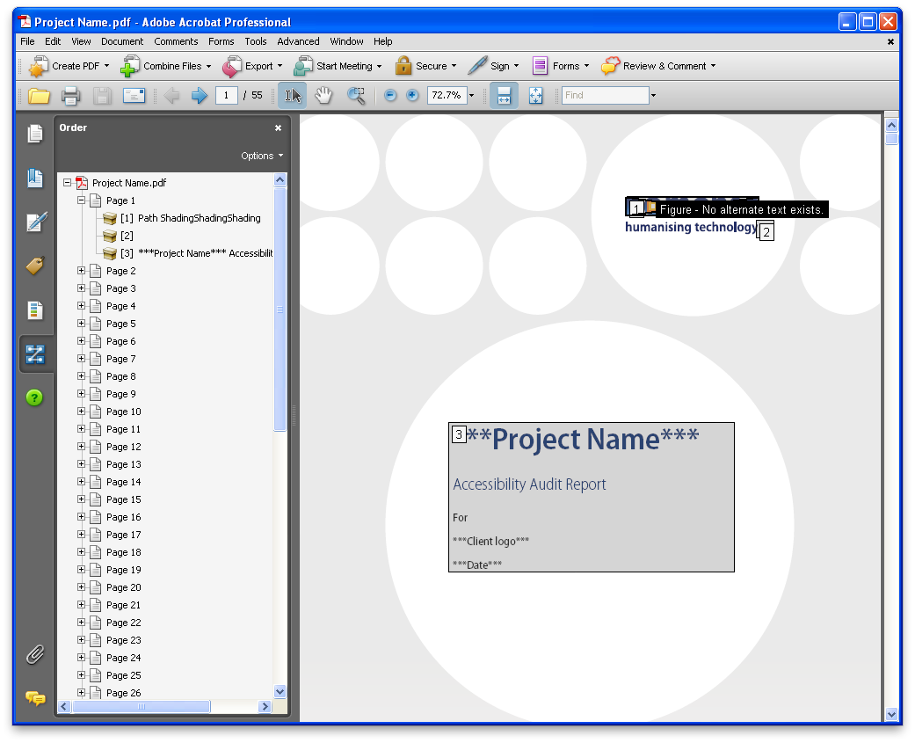
Figure 23: Use the 'Order Panel' to create a meaningful sequence.
The reading order can then be adjusted using the ‘TouchUp reading order’ tool:

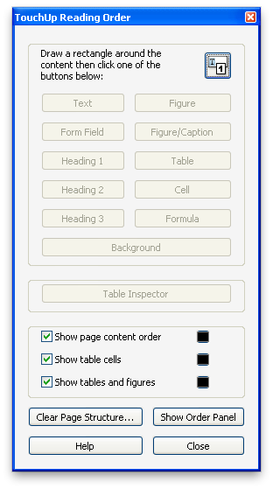
Figure 24: Make top-level changes to the content using the 'TouchUp Reading Order' panel.
This method allows you to adjust top-level reading order of the document quickly, without having to adjust the individual tags of the content.

5.4 Human language of the whole PDF
The content of a PDF document may be written in one language or it may be written in a number of different languages. No matter what language is used, it is important to make sure the primary language of the document is identified.

The language of content in a PDF document can be specified on any element using the ‘Tags’ panel:
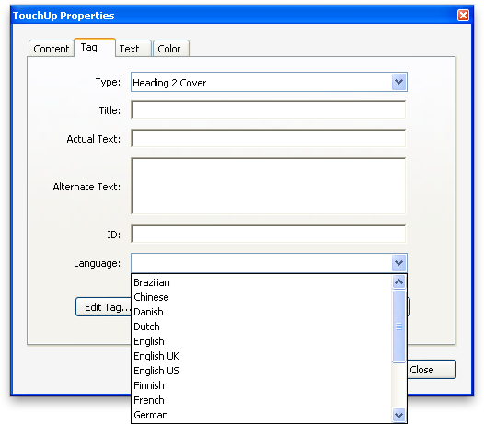
Figure 25: The ‘TouchUp Properties’ tab can be used to set the language of the document.
To specify the language of all of the content in a document, simply select or create a tag that wraps all of the content and specify a language property.

Individual words or sentences in a different language can also be specified using the tags that encompass just that word or sentence.

Further reading
- UNDERSTANDING-WCAG20 - content structure separation- http://www.w3.org/TR/UNDERSTANDING-WCAG20/content-structure-separation-programmatic.html
- QUICK REFERENCE – content structure separation - http://www.w3.org/WAI/WCAG20/quickref/#qr-content-structure-separation-programmatic
- QUICK REFERENCE – content structure separation- http://www.w3.org/WAI/WCAG20/quickref/#qr-content-structure-separation-sequence
- UNDERSTANDING-WCAG20 – language of page- http://www.w3.org/TR/UNDERSTANDING-WCAG20/meaning-doc-lang-id.html
- QUICK REFERENCE – language of page- http://www.w3.org/WAI/WCAG20/quickref/#qr-meaning-doc-lang-id
- UNDERSTANDING-WCAG20 – non text content- http://www.w3.org/TR/UNDERSTANDING-WCAG20/text-equiv-all.html
- UNDERSTANDING-WCAG20 – timing adjustable- http://www.w3.org/TR/UNDERSTANDING-WCAG20/time-limits-required-behaviors.html
- This isn’t just alt text. This is really great alt text- http://www.nomensa.com/blog/2006/this-isnt-just-alt-text-this-is-really-great-alt-text/
- Headings and lists are you using them correctly- http://www.nomensa.com/blog/2006/headings-and-lists-are-you-using-them-correctly/

6 Best practice for multimedia content

6.1 Providing transcripts
Whether your content is pure audio, video only, or combined audio video multimedia, you will need to provide a transcript. A transcript is a text-based document that contains the spoken dialogue, sound effects, and descriptions of the action taking place. Deaf and hearing-impaired people will benefit from reading the spoken dialogue and descriptions of sound effects. People who are blind or partially sighted will also benefit if the transcript includes descriptions of important visual activity. You should place a link to your transcript immediately before the place where the multimedia content is displayed on the page. This ensures that people can find it easily before they reach the multimedia content itself.

6.1.1 How are transcripts created?
Assuming the transcript will include different types of information, depending on the contents of the original file. Assuming you are creating a transcript for a piece of audio and video multimedia content, the following steps should be taken:

Step 1: Spoken dialogue
The first step is to include all the spoken dialogue for deaf and hearing-impaired people to read. You start with the character’s name, followed by the things they say.

Alice:
“The weather is dreadful this morning isn’t it?”

Bob:
“It is indeed. Nice weather for ducks though!”

Alice:
“I’ll put the kettle on.”

Step 2: Visual descriptions
The next step is to include some short descriptions of the scene itself. This is to help blind or partially sighted people discover where the scene takes place.

Bob stands by a window, looking out at the rain. Alice is nearby, but just out of sight.

Alice:
“The weather is dreadful this morning isn’t it?”

Bob:
“It is indeed. Nice weather for ducks though!”

Alice:
“I’ll put the kettle on.”

Step 3: Sound effects
The last step is to include descriptions of any key sound effects. In this example you do not need to mention the rain because it can be clearly heard and seen, but there may be other important noises you need to include.

Bob stands by a window, looking out at the rain. Alice is nearby, but just out of sight.

Alice:
“The weather is dreadful this morning isn’t it?”

Bob:
“It is indeed. Nice weather for ducks though!”

Alice:
“I’ll put the kettle on.”
An enormous clap of thunder makes Bob jump away from the window.

6.2 Providing captions
For people with severe hearing impairments or deafness audio tracks (both within movie files and pure audio) will not be perceivable to them. As such a visible captions track should be provided for them. Captions not only include dialogue, but also include information about who is speaking and identify important information conveyed through sound that is not visible on screen. Providing captions will ensure that people with a hearing impairment will be able to access all of the content within synchronized media such as movies and audio broadcasts.

There are two types of caption tracks that are often found in use on the Internet.

- Open captions are generally embedded into the media itself and are constantly displayed on screen. This represents the most basic method for providing captions and is sufficient to pass this success criterion. However, this is likely to irritate people who do not require visible captions, as they will be unable to turn them off.
- Closed captions are not embedded into the video; they can be turned on or off by activating a button or link within the media player interface. This will ensure that people who need captions are able to use them, whilst those that do not require them can turn them off if required.
Captions should flow in a logical order that accurately conveys the meaning presented in audio tracks at any given time. If captions are accurately synchronised with video in this way the resultant meaning should be coherent and easily understandable.

Example
For example, if we were creating captions for a period drama we would include the following text:

A horse and cart can be heard approaching on the gravel driveway. Elizabeth can be heard running down the stairs.

Elizabeth: Mother, He’s here, He’s here...

Elizabeth’s Mother: (from the back of the house) Already? I thought he was not due until tomorrow evening.

There are many different technologies that can be used to provide closed or open captions. The one that you choose to use will depend largely on the technology that you are using to present the synchronised media.

If possible it is worthwhile providing closed captions as opposed to open captions. This will allow people to choose whether or not to show or hide them.

6.3 Providing a media alternative
For people with blindness or severe visual impairments visual content is not likely to be easily perceivable for them. As such, synchronised media such as video content poses a potential accessibility issue for people with severe visual impairments and blindness.

There are a couple of different ways that this issue can be dealt with:

- The first option is to provide an audio description of the visual content within the movie. For more information on this point please refer to section 6.5.
- The other option is to provide another media alternative such as a transcript presented in pure text. Since plain text is a baseline technology that almost everyone can access in one form or another, a plain text transcript should theoretically be accessible to everyone. For more information on transcripts and how to provide them please refer to section 6.1.
By providing a media alternative in plain text or by providing an audio description track you will ensure that people with blindness or severe visual impairments are able to access and understand content that would otherwise rely on visual perception to be understood.

It is worthwhile mentioning that for level A accessibility only one of these methods needs to be provided. However, in order to achieve level AA accessibility, both an audio description track and a text alternative will need to be provided.

6.4 Captioning for live content
The issues and solutions identified section 6.2 apply to live synchronised media as well as pre-recorded media. For example, a live video conference on the Internet would require captions for people who are unable to hear or are browsing using a device that does not support audio content. It is likely that these captions would need to be transcribed in real time and as such this can be tricky to implement. However, this is a requirement to pass level AA accessibility and as such should be taken into consideration if live broadcasts are made. If it is not possible to create captions in real time it is worthwhile considering pre-recording the content or presentation and presenting it at a later date complete with captions. For more information on this point please refer to section 6.2 above.

6.5 Providing an audio description
For people who are blind or have severe visual impairments visual content is not perceivable for them. As such, synchronised media such as video content poses a potential accessibility issue for these users.

One of the methods used to provide information about content that relies on visual perception is to provide an audio description of the video content. An audio description is a selectable track that is intended to describe content or actions that cannot be perceived by people who are blind or have severe visual impairments.

An audio description should augment any existing audible content as opposed to replacing it. It should provide information about actions, characters and scene changes in existing pauses in the audio content.

For example, if audio description were being used to describe a game of poker, it could be used to identify peoples’ actions, reactions and information about any people joining or leaving the game. Audio description does not attempt to provide information about actions or events that are already adequately identifiable through the audio part of the track.

6.6 Volume control for audio
For people who use assistive technologies such as screen reading software, sound that plays on a webpage can inhibit their ability to navigate the page effectively. Screen reading software relays content on the Internet to the person using a synthesised ‘voice’. Audible content on the Internet can therefore pollute the same audible space used by the screen reader software. Since most screen reader packages are now software based this situation is exacerbated since the computers master volume will affect the volume of both the web based content and the screen reader itself. As such, individual volume controls should be provided for all audible content on your web page. It must be possible for people to completely disable the sound for audio content on a web page (either by reducing the sound level to 0 or by activating a ‘mute’ control).

If sound plays automatically on a web page, people who use screen reading software are likely to find it hard to identify the controls for turning off the audible content. As such it is important that if an audio track plays automatically it plays for no longer than 3 seconds in total. If an audio track is longer than three seconds in length, it is best to ensure that it does not play automatically. Instead, it should only be started when activated by the person using the page.

6.7 Ensure media can be paused
Lots of video and synchronised media on the Internet contains textual content. If you consider the requirement for captioning when it comes to video and audio content on the Internet this is even more likely to be the case. This is great for people who are deaf or have other severe hearing impairments. However, if it is not possible to pause or extend the rate at which text on the screen is updated people are likely to find it difficult or impossible to read the text comfortably.

For this reason it is important that people are able to pause and restart content from where it was last stopped. This will make it possible for people to intermittently stop and start automatically updating content in such a way that they will have sufficient time to read text at a rate that is comfortable for them.

It is also important to note that content should not play by default. If content can play, scroll or update periodically it should only do so if it has first been requested by the user. For example, a video on a web page should not start playing as soon as the page is loaded. Instead it should only start to play when someone activates the play button associated with the movie. It is also worthwhile noting that the controls for interacting with video content should be keyboard accessible. This will ensure that people who are unable to use a mouse will still be able to interact with synchronised media on the Internet effectively.

6.8 Avoid flashing content
People should be able to access all the content on a page without inducing seizures due to photosensitivity. Seizures can be triggered in some people by content that flashes at certain frequencies.

If you have flashing content on your website such as video or animated sequences, make sure it is kept to a minimum and does not flash for more than a few seconds. Some people are more sensitive to red flashing than to other colours, so keep this in mind when adding this type of content to your website.

If you do have flashing content on your website, you should ensure that the content does not flash more than three times in any 1 second period or the flashing area of content is small enough so it does not cause seizures for people with photosensitivity.

Further reading
- What are transcripts-http://www.nomensa.com/blog/2010/what-are-transcripts/
- UNDERSTANDING-WCAG20 – Audio only and video only-http://www.w3.org/TR/UNDERSTANDING-WCAG20/media-equiv-av-only-alt.html
- UNDERSTANDING-WCAG20 - Captions-http://www.w3.org/TR/UNDERSTANDING-WCAG20/media-equiv-captions.html
- QUICK REFERENCE - Captions-http://www.w3.org/WAI/WCAG20/quickref/#qr-media-equiv-captions
- UNDERSTANDING-WCAG20 – Media equivalent or audio description-http://www.w3.org/TR/UNDERSTANDING-WCAG20/media-equiv-audio-desc.html
- QUICK REFERENCE – Media equivalent or audio description-http://www.w3.org/WAI/WCAG20/quickref/#qr-media-equiv-audio-desc
- UNDERSTANDING-WCAG20 – Live Captions-http://www.w3.org/TR/UNDERSTANDING-WCAG20/media-equiv-real-time-captions.html
- QUICK REFERENCE – Live Captions-http://www.w3.org/WAI/WCAG20/quickref/#qr-media-equiv-real-time-captions
- UNDERSTANDING-WCAG20 – Audio description-http://www.w3.org/TR/UNDERSTANDING-WCAG20/media-equiv-audio-desc-only.html
- QUICK REFERENCE – Audio description-http://www.w3.org/WAI/WCAG20/quickref/#qr-media-equiv-audio-desc-only
- UNDERSTANDING-WCAG20 – Audio control-http://www.w3.org/TR/UNDERSTANDING-WCAG20/visual-audio-contrast-dis-audio.html
- QUICK REFERENCE – Audio control-http://www.w3.org/WAI/WCAG20/quickref/#qr-visual-audio-contrast-dis-audio
- UNDERSTANDING-WCAG20 – Timing Adjustable-http://www.w3.org/TR/UNDERSTANDING-WCAG20/time-limits-required-behaviors.html
- QUICK REFERENCE – Timing Adjustable-http://www.w3.org/WAI/WCAG20/quickref/#qr-time-limits-required-behaviors
- What is audio description-http://www.nomensa.com/blog/2010/what-is-audio-description/
- What are captions-http://www.nomensa.com/blog/2010/what-are-captions/
- What are web captions-http://www.nomensa.com/blog/2009/what-are-web-captions/
- What is audio description-http://www.nomensa.com/blog/2010/what-is-audio-description/
- What are captions-http://www.nomensa.com/blog/2010/what-are-captions/
- What are web captions-http://www.nomensa.com/blog/2009/what-are-web-captions/
- QUICK REFERENCE – Media equivalents-http://www.w3.org/WAI/WCAG20/quickref/#qr-media-equiv-av-only-alt

User Experience Guidelines for Developers

7 Best Practice for Web Content

7.1 Lists
Lists are an excellent way to break up text and help to keep people interested in your page. Lists make content clearer, easier to scan and easier for readers to identify important information. However, too many lists can disrupt the flow of content on a page. Lists should only be used to group two or more items of similar content.

There are three different types of lists you can use on a web page. They are bulleted, ordered and paired lists, which are all available in the Silva content management system.

7.1.2 Bulleted Lists
Bulleted lists are the most common type of lists used on web pages and the type of list you will probably use more often. You should use this type of list for content that does not have a specific order, for example a list of books:

- Hound of the Baskervilles;
- Treasure Island;
- The Picture of Dorian Gray.

7.1.3 Ordered Lists
If you are adding a list to your page that has a specific order, you should use an ordered list. Ordered lists can be preceded with numbers, letters or roman numerals.

1. Fill out the registration form
2. Check your email
3. Activate your account

7.1.4 Paired Lists
Paired lists consist of pairs of related content. Paired lists are also known as definition lists and are less frequently used on web pages than bulleted and ordered lists:

Cat:
A feline mammal with thick soft fur and no ability to roar!

7.2 Paragraphs
It’s important to use paragraphs when writing your web copy, as too much text in one block can be difficult to read online. Short, succinct paragraphs of roughly 60 words will make it easier for many people to read and enjoy the content on your pages. You should front load paragraphs by putting key points at the start of them.

Figure 26: Paragraphs are used to make the content on the page easier to read.

7.3 Tables
If you need to add tables of data to your web pages you can also do this through your content management system. Tables should only be used for displaying data and should not be used to create different ways of laying out page content.

When tables are used they should be kept simple. Depending on the design of the table, all tables must have either column or row headings. This is an extremely important point to keep in mind. People using assistive technologies use table headings to help understand the relationships between rows and columns in the table.

In your content management system you should have options for inserting tables. You may even have the option to choose to use table headings or not. You should always choose to use table headings. If table headings are missing, then it can make it difficult for people using assistive technologies to understand the content in the table.

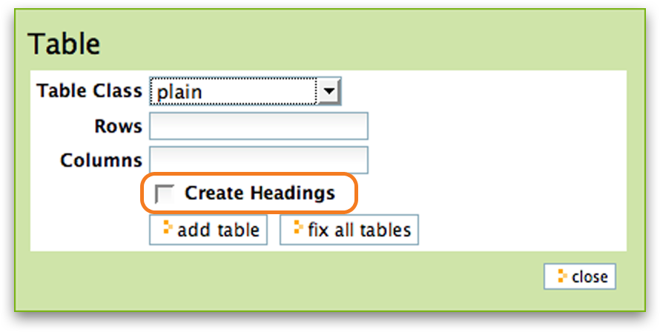
Figure 27: Inserting tables using a content management system.

7.4 Emphasising text
You may want to emphasize small portions of text in your web copy to make it stand out to your readers. Most content management systems allow you to use bold and italicised text to highlight important sections of your content.

Emphasised words help people find what they need from your content by getting the key points across to your audience quicker. You should be careful not to use too much as it can have the opposite effect making text harder to scan and read. When emphasising your text think about:

- Who your audience is;
- What your audience wants from the page;
- What you want to focus on.

Make sure you emphasise the right things and only emphasize one or two words or phrases at most per paragraph.

Figure 28: Using bold to highlight important words.

7.5 Abbreviations
At some point you may need to include abbreviations within your web copy. It is important to ensure that where abbreviations are used they are written out in full the first time they occur in the content. Some abbreviations may be more obvious than others, but you should appreciate that not everyone may understand the abbreviation. You should also consider that some abbreviations might have different meanings in different contexts. Take the following abbreviations as an example.

- ROI - Return on Investment or Republic of Ireland;

- PID - Project Initiation Documentation or Pelvic Inflammatory Disease;

- BTP - Business Transaction Performance or British Transport Police.

To include an abbreviation in your copy you can either write out the abbreviation followed by the full meaning in brackets or vice versa.

- ROI (Return on Investment);
- Return on Investment (ROI).

7.6 Creating a page title
The title is one of the most important parts of your page. The page title should be unique to your website and clearly describe the topic or purpose of the page. The page title helps people understand if the content on the page is relevant to them. Page titles can also help people identify the section of the website hierarchy in which the current page exists.

The page title usually consists of three parts, the name of the page, the section of the website containing the page and the name of the website. It appears at the very top of the browser window and is one of the first things someone using assistive technology will encounter when they reach the page.
Figure 29: Providing descriptive page titles.
As the page title is likely to contain a reasonable amount of content, it is best to put the most important information at the beginning of the page title. If people are visiting your page then they are interested in its content so putting the name of the page first is the best option. The name of the section containing the page should come next to help people understand where they are within the website hierarchy, followed by the name of the website. This order of content works best because people do not have to listen or read through the whole page title before understanding if the content on the page is relevant to them. They can grab the meaningful information quickly and either read further down the page or leave the page to find more appropriate content.

In most content management systems content authors can control only part of the title. The name of the page is usually the only part content authors can edit. The name of the section containing the page will be automatically generated depending on the location of the page in the site. The website name will be the same across each page in the site and will be added by the developers.

You should make sure when adding and editing the name of the page that the name clearly describes the topic of the page and contains relevant keywords. For example if you were writing about the Tower of London and in particular the White Tower, the name of your page should be ‘The White Tower’. Your full page title might be something like this:

Name of the page, Section of the website - Name of the website
The White Tower, The Tower of London – Historic Royal Palaces

7.7 Identify content consistently
People using screen readers and other types of assistive technology rely on components of web pages to be consistent. When using these types of technology many people depend on their familiarity with features on a website as a strategy to help navigate and operate the website. Consistency is the key to this strategy. If features of the website are labelled or referenced in a different manner on different web pages then it is far more difficult to traverse a website. Inconsistencies of this type may also be confusing for people with cognitive impairments.

Take care to use a consistent set of words and phrases to reference features and components on your website. Consistency also extends to alternative text descriptions for images. Where the same image has been used on different web pages it should have the same text description. As mentioned previously, this may be something that is handled by your content management system when you first upload an image but it is worth being aware of.

Further reading
- UNDERSTANDING-WCAG20 – Info and relationships- http://www.w3.org/TR/UNDERSTANDING-WCAG20/content-structure-separation-programmatic.html
- QUICK REFERENCE - Info and relationships- http://www.w3.org/WAI/WCAG20/quickref/#qr-content-structure-separation-programmatic
- UNDERSTANDING-WCAG20 – Use of colour- http://www.w3.org/TR/UNDERSTANDING-WCAG20/visual-audio-contrast-without-color.html
- QUICK REFERENCE – Use of color- http://www.w3.org/WAI/WCAG20/quickref/#qr-visual-audio-contrast-without-color
- UNDERSTANDING-WCAG20 – Navigation mechanisms- http://www.w3.org/TR/UNDERSTANDING-WCAG20/navigation-mechanisms-title.html
- QUICK REFERENCE – Navigational mechanisms- http://www.w3.org/WAI/WCAG20/quickref/#qr-navigation-mechanisms-title
- UNDERSTANDING-WCAG20 – consistent behavior consistent functionality- http://www.w3.org/TR/UNDERSTANDING-WCAG20/consistent-behavior-consistent-functionality.html
- QUICK REFERENCE – Consistent behavior consistent functionality- http://www.w3.org/WAI/WCAG20/quickref/#qr-consistent-behavior-consistent-functionality
- Headings and lists are you using them correctly- http://www.nomensa.com/blog/2006/headings-and-lists-are-you-using-them-correctly/
- tables more than just rows and cells- http://www.nomensa.com/blog/2008/tables-more-than-just-rows-and-cells/

8 Best Practice for PDFs

8.1 Mark-up with a PDF
Structure and relationship is crucial to delivering information in a PDF. Without it, the meaning of content portrayed to the user can be lost.
Improving the structure and relationships within a PDF will often begin with the source document. For example, a Word document should use headings, lists and tables where suitable for structuring content and avoid simply using text size, font weight and line drawing features to create similar visual effects.

Adobe Acrobat Professional will allow you to check and improve the information and relationship portrayed in the PDF using the ‘Tags’ panel:

Figure 30: Tags panel can be used to change the relationship of the content.
Setting the ‘Options’ feature to ‘Highlight content’ will allow you to select content within the PDF and edit the tag of an element to one that is suitable. For example, visual headings that have been automatically tagged by Acrobat as a paragraph (<P>) can be updated to using a heading tag, which will repurpose the content to provide better meaning for people such using screen readers and other types of assistive technology.

8.2 Alternative text for images
Text is the most basic format used to present information and is vital for providing equivalent information for people using access technologies. For example, a person who cannot see or hear could use a Braille reader to read out the alternative text of an image in an HTML page.

Alternative text for images is equally import for PDF documents. Typically this is something that is added to an image in the original document and will be translated across when converted to PDF. However, if it this not the case, a text alternative can be added using the ‘TouchUp Properties’ panel:
Figure 31: Add alternative text for images using the 'Touch Up' panel.
Images that are purely decorative and do not require alternative text can be removed from the PDF tagging information by converting the element to an artefact. This can be achieved by right-clicking on the tag within the ‘Tags’ panel and selecting “Change tag to artefact.” Any empty element can them be deleted.

Adding alternative text for images and changing decorative images to artefacts will ultimately improve the information presented and the flow of your PDF.

8.3 Creating a meaningful reading order
Structuring pages in your document correctly is a very important part of creating an accessible PDF. The order in which content visually appears on your page may not necessarily correlate to the order of the content for a screen reader; particularly if you have used unconventional methods when creating columns and positioning content in the document.

The order of the PDF document can be checked using the “Order panel” in Acrobat Professional:

Figure 32: Use the 'Order Panel' to create a meaningful sequence.
The reading order can then be adjusted using the ‘TouchUp reading order’ tool:

Figure 33: Make top-level changes to the content using the 'TouchUp Reading Order' panel.
This method allows you to adjust top-level reading order of the document quickly, without having to adjust the individual tags of the content.

In large organisations such as UCL many people will not have a copy of Adobe Acrobat Professional. In these instances it should be sufficient to make use of Microsoft Word, saving the document as a PDF natively. However, if this method is used it is important to ensure that Word “Styles” are used. This will ensure that the semantic structure of the document is preserved (e.g. headings should be identifiable visually as well as through the underlying source of the document – by people who use assistive technologies such as screen readers). If headings are marked presented as ‘normal’ text and visually altered using text size and bold controls the semantic information relating to the text will not be available to people who use assistive technologies such as screen readers.

8.4 Using sufficient colour contrast
Colour contrast of foreground and background text can play a big part in the readability of content for partially sighted people. Using foreground and background colours that contrast well makes it much easier for people to read content comfortably. There are some exceptions to the 4.5:1 ratio recommended by the Level AA success criteria:

Large Text: Large-scale text and images of large-scale text have a contrast ratio of at least 3:1. Large text is considered to be above 18pt or above 14pt and bold.

Incidental: Text or images of text that are part of an inactive user interface component, that are pure decoration, that are not visible to anyone, or that are part of a picture that contains significant other visual content, have no contrast requirement.

Logotypes: Text that is part of a logo or brand name has no minimum contrast requirement.
Contrast of foreground and background colour combinations can be tested using a number of tools, such as the Colour Contrast Analyser:

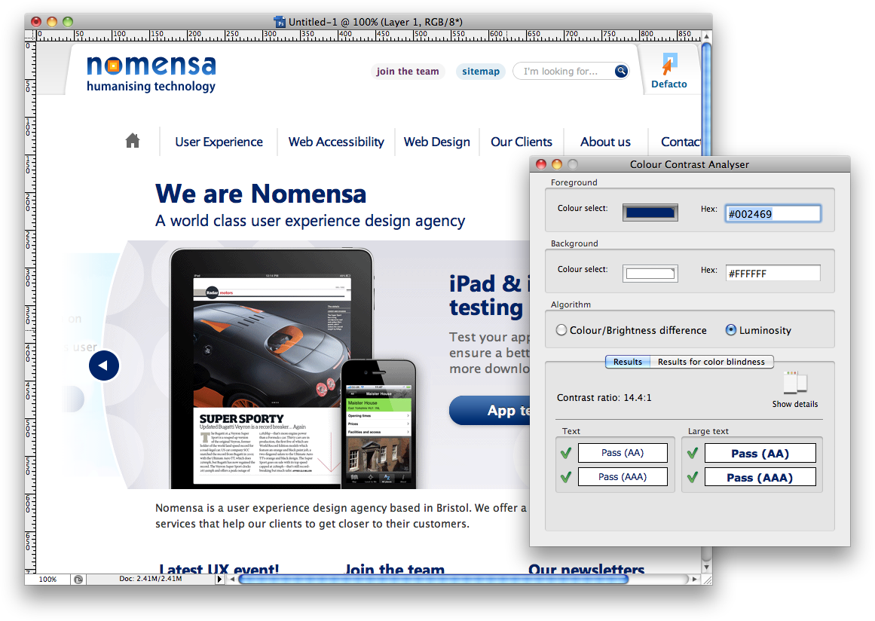
Figure 34: Use the Colour Contrast Analyser to check contrast ratios.
It is very difficult to adjust the colour combinations used in a PDF document and therefore it is important to check colour contrast of the original source document before proceeding to PDF.

8.5 Human language of the whole PDF
The content of a PDF document may be written in one language or it may be written in a number of different languages. No matter what language is used, it is important to make sure the primary language of the document is identified to assistive technologies.

The language of content in a PDF document can be specified on any element using the ‘Tags’ panel:
Figure 35: The ‘TouchUp Properties’ tab can be used to set the language of the document.
To specify the language of all of the content in a document, simply select or create a tag that wraps all of the content and specify a language property.

Individual words or sentences in a different language can also be specified using the tags that encompass just that word or sentence.

Further reading
- UNDERSTANDING-WCAG20 – Textual equivalents-http://www.w3.org/TR/UNDERSTANDING-WCAG20/text-equiv-all.html
- UNDERSTANDING-WCAG20/time-limits-required-behaviors.html-http://www.w3.org/TR/UNDERSTANDING-WCAG20/time-limits-required-behaviors.html
- UNDERSTANDING-WCAG20/content-structure-separation-programmatic.html-http://www.w3.org/TR/UNDERSTANDING-WCAG20/content-structure-separation-programmatic.html
- QUICK REFERENCE – Info and relationships-http://www.w3.org/WAI/WCAG20/quickref/#qr-content-structure-separation-programmatic
- UNDERSTANDING-WCAG20 – Info and relationships-http://www.w3.org/TR/UNDERSTANDING-WCAG20/content-structure-separation-programmatic.html
- QUICK REFERENCE – Info and relationships-http://www.w3.org/WAI/WCAG20/quickref/#qr-content-structure-separation-sequence
- UNDERSTANDING-WCAG20 – Use of color-http://www.w3.org/TR/UNDERSTANDING-WCAG20/visual-audio-contrast-without-color.html
- QUICK REFERENCE – Use of color-http://www.w3.org/WAI/WCAG20/quickref/#qr-visual-audio-contrast-without-color
- Checking colour contrast-http://www.nomensa.com/blog/2010/checking-colour-contrast/
- UNDERSTANDING-WCAG20 – language of page-http://www.w3.org/TR/UNDERSTANDING-WCAG20/meaning-doc-lang-id.html
- QUICK REFERENCE – Language of page-http://www.w3.org/WAI/WCAG20/quickref/#qr-meaning-doc-lang-id
- Headings and lists are you using them correctly-http://www.nomensa.com/blog/2006/headings-and-lists-are-you-using-them-correctly/
- This isn’t just alt text this is really great alt text-http://www.nomensa.com/blog/2006/this-isnt-just-alt-text-this-is-really-great-alt-text/

9 Best practice for multimedia content

9.1 Providing transcripts
Whether your content is pure audio, video only, or combined audio video multimedia, you will need to provide a transcript. A transcript is a text-based document that contains the spoken dialogue, sound effects, and descriptions of the action taking place. Deaf and hearing-impaired people will benefit from reading the spoken dialogue and descriptions of sound effects. People who are blind or partially sighted will also benefit if the transcript includes descriptions of important visual activity. You should place a link to your transcript immediately before the place where the multimedia content is displayed on the page. This ensures that people can find it easily before they reach the multimedia content itself.

9.1.1 How are transcripts created?
Assuming the transcript will include different types of information, depending on the contents of the original file. Assuming you are creating a transcript for a piece of audio and video multimedia content, the following steps should be taken:

Step 1: Spoken dialogue
The first step is to include all the spoken dialogue for deaf and hearing-impaired people to read. You start with the character’s name, followed by the things they say.

Alice:
“The weather is dreadful this morning isn’t it?”

Bob:
“It is indeed. Nice weather for ducks though!”

Alice:
“I’ll put the kettle on.”

Step 2: Visual descriptions
The next step is to include some short descriptions of the scene itself. This is to help blind or partially sighted people discover where the scene takes place.

Bob stands by a window, looking out at the rain. Alice is nearby, but just out of sight.

Alice:
“The weather is dreadful this morning isn’t it?”

Bob:
“It is indeed. Nice weather for ducks though!”

Alice:
“I’ll put the kettle on.”

Step 3: Sound effects
The last step is to include descriptions of any key sound effects. In this example you do not need to mention the rain because it can be clearly heard and seen, but there may be other important noises you need to include.

Bob stands by a window, looking out at the rain. Alice is nearby, but just out of sight.

Alice:
“The weather is dreadful this morning isn’t it?”

Bob:
“It is indeed. Nice weather for ducks though!”

Alice:
“I’ll put the kettle on.”
An enormous clap of thunder makes Bob jump away from the window.

9.2 Providing captions
For people with severe hearing impairments or deafness audio tracks (both within movie files and pure audio) will not be perceivable to them. As such a visible captions track should be provided for them. Captions not only include dialogue, but also include information about who is speaking and identify important information conveyed through sound that is not visible on screen. Providing captions will ensure that people with a hearing impairment will be able to access all of the content within synchronized media such as movies and audio broadcasts.

There are two types of caption tracks that are often found in use on the Internet.

- Open captions are generally embedded into the media itself and are constantly displayed on screen. This represents the most basic method for providing captions and is sufficient to pass this success criterion. However, this is likely to irritate people who do not require visible captions, as they will be unable to turn them off.
- Closed captions are not embedded into the video; they can be turned on or off by activating a button or link within the media player interface. This will ensure that people who need captions are able to use them, whilst those that do not require them can turn them off if required.
Captions should flow in a logical order that accurately conveys the meaning presented in audio tracks at any given time. If captions are accurately synchronised with video in this way the resultant meaning should be coherent and easily understandable.

Example
For example, if we were creating captions for a period drama we would include the following text:

A horse and cart can be heard approaching on the gravel driveway. Elizabeth can be heard running down the stairs.

Elizabeth: Mother, He’s here, He’s here...

Elizabeth’s Mother: (from the back of the house) Already? I thought he was not due until tomorrow evening.

There are many different technologies that can be used to provide closed or open captions. The one that you choose to use will depend largely on the technology that you are using to present the synchronised media.

If possible it is worthwhile providing closed captions as opposed to open captions. This will allow people to choose whether or not to show or hide them.

9.3 Providing a media alternative
For people with blindness or severe visual impairments visual content is not likely to be easily perceivable for them. As such, synchronised media such as video content poses a potential accessibility issue for people with severe visual impairments and blindness.

There are a couple of different ways that this issue can be dealt with:

- The first option is to provide an audio description of the visual content within the movie. For more information on this point please refer to section 9.5.
- The other option is to provide another media alternative such as a transcript presented in pure text. Since plain text is a baseline technology that almost everyone can access in one form or another, a plain text transcript should theoretically be accessible to everyone. For more information on transcripts and how to provide them please refer to section 9.1.
By providing a media alternative in plain text or by providing an audio description track you will ensure that people with blindness or severe visual impairments are able to access and understand content that would otherwise rely on visual perception to be understood.

It is worthwhile mentioning that for level A accessibility only one of these methods needs to be provided. However, in order to achieve level AA accessibility, both an audio description track and a text alternative will need to be provided.

9.4 Captioning for live content
The issues and solutions identified in section 9.2 above apply to live synchronised media as well as pre-recorded media. For example, a live video conference on the Internet would require captions for people who are unable to hear or are browsing using a device that does not support audio content. It is likely that these captions would need to be transcribed in real time and as such this can be tricky to implement. However, this is a requirement to pass level AA accessibility and as such should be taken into consideration if live broadcasts are made. If it is not possible to create captions in real time it is worthwhile considering pre-recording the content or presentation and presenting it at a later date complete with captions. For more information on this point please refer to section 9.2.

9.5 Providing an audio description
For people who are blind or have severe visual impairments visual content is not perceivable for them. As such, synchronised media such as video content poses a potential accessibility issue for these users.

One of the methods used to provide information about content that relies on visual perception is to provide an audio description of the video content. An audio description is a selectable track that is intended to describe content or actions that cannot be perceived by people who are blind or have severe visual impairments.

An audio description should augment any existing audible content as opposed to replacing it. It should provide information about actions, characters and scene changes in existing pauses in the audio content.

For example, if audio description were being used to describe a game of poker, it could be used to identify peoples’ actions, reactions and information about any people joining or leaving the game. Audio description does not attempt to provide information about actions or events that are already adequately identifiable through the audio part of the track.

9.6 Volume control for audio
For people who use assistive technologies such as screen reading software, sound that plays on a webpage can inhibit their ability to navigate the page effectively. Screen reading software relays content on the Internet to the person using a synthesised ‘voice’. Audible content on the Internet can therefore pollute the same audible space used by the screen reader software. Since most screen reader packages are now software based this situation is exacerbated since the computers master volume will affect the volume of both the web based content and the screen reader itself. As such, individual volume controls should be provided for all audible content on your web page. It must be possible for people to completely disable the sound for audio content on a web page (either by reducing the sound level to 0 or by activating a ‘mute’ control).

If sound plays automatically on a web page, people who use screen reading software are likely to find it hard to identify the controls for turning off the audible content. As such it is important that if an audio track plays automatically it plays for no longer than 3 seconds in total. If an audio track is longer than three seconds in length, it is best to ensure that it does not play automatically. Instead, it should only be started when activated by the person using the page.

9.7 Ensure media can be paused
Lots of video and synchronised media on the Internet contains textual content. If you consider the requirement for captioning when it comes to video and audio content on the Internet this is even more likely to be the case. This is great for people who are deaf or have other severe hearing impairments. However, if it is not possible to pause or extend the rate at which text on the screen is updated people are likely to find it difficult or impossible to read the text comfortably.

For this reason it is important that people are able to pause and restart content from where it was last stopped. This will make it possible for people to intermittently stop and start automatically updating content in such a way that they will have sufficient time to read text at a rate that is comfortable for them.

It is also important to note that content should not play by default. If content can play, scroll or update periodically it should only do so if it has first been requested by the user. For example, a video on a web page should not start playing as soon as the page is loaded. Instead it should only start to play when someone activates the play button associated with the movie. It is also worthwhile noting that the controls for interacting with video content should be keyboard accessible. This will ensure that people who are unable to use a mouse will still be able to interact with synchronised media on the Internet effectively.

9.8 Avoid flashing content
People should be able to access all the content on a page without inducing seizures due to photosensitivity. Seizures can be triggered in some people by content that flashes at certain frequencies.

If you have flashing content on your website such as video or animated sequences, make sure it is kept to a minimum and does not flash for more than a few seconds. Some people are more sensitive to red flashing than to other colours, so keep this in mind when adding this type of content to your website.

If you do have flashing content on your website, you should ensure that the content does not flash more than three times in any 1 second period or the flashing area of content is small enough so it does not cause seizures for people with photosensitivity.

Further reading
- What are transcripts-http://www.nomensa.com/blog/2010/what-are-transcripts/
- UNDERSTANDING-WCAG20 – Audio only and video only-http://www.w3.org/TR/UNDERSTANDING-WCAG20/media-equiv-av-only-alt.html
- UNDERSTANDING-WCAG20 - Captions-http://www.w3.org/TR/UNDERSTANDING-WCAG20/media-equiv-captions.html
- QUICK REFERENCE - Captions-http://www.w3.org/WAI/WCAG20/quickref/#qr-media-equiv-captions
- UNDERSTANDING-WCAG20 – Media equivalent or audio description-http://www.w3.org/TR/UNDERSTANDING-WCAG20/media-equiv-audio-desc.html
- QUICK REFERENCE – Media equivalent or audio description-http://www.w3.org/WAI/WCAG20/quickref/#qr-media-equiv-audio-desc
- UNDERSTANDING-WCAG20 – Live Captions-http://www.w3.org/TR/UNDERSTANDING-WCAG20/media-equiv-real-time-captions.html
- QUICK REFERENCE – Live Captions-http://www.w3.org/WAI/WCAG20/quickref/#qr-media-equiv-real-time-captions
- UNDERSTANDING-WCAG20 – Audio description-http://www.w3.org/TR/UNDERSTANDING-WCAG20/media-equiv-audio-desc-only.html
- QUICK REFERENCE – Audio description-http://www.w3.org/WAI/WCAG20/quickref/#qr-media-equiv-audio-desc-only
- UNDERSTANDING-WCAG20 – Audio control-http://www.w3.org/TR/UNDERSTANDING-WCAG20/visual-audio-contrast-dis-audio.html
- QUICK REFERENCE – Audio control-http://www.w3.org/WAI/WCAG20/quickref/#qr-visual-audio-contrast-dis-audio
- UNDERSTANDING-WCAG20 – Timing Adjustable-http://www.w3.org/TR/UNDERSTANDING-WCAG20/time-limits-required-behaviors.html
- QUICK REFERENCE – Timing Adjustable-http://www.w3.org/WAI/WCAG20/quickref/#qr-time-limits-required-behaviors
- What is audio description-http://www.nomensa.com/blog/2010/what-is-audio-description/
- What are captions-http://www.nomensa.com/blog/2010/what-are-captions/
- What are web captions-http://www.nomensa.com/blog/2009/what-are-web-captions/
- What is audio description-http://www.nomensa.com/blog/2010/what-is-audio-description/
- What are captions-http://www.nomensa.com/blog/2010/what-are-captions/
- What are web captions-http://www.nomensa.com/blog/2009/what-are-web-captions/
- QUICK REFERENCE – Media equivalents-http://www.w3.org/WAI/WCAG20/quickref/#qr-media-equiv-av-only-alt

10 Best Practice for Information Architecture and Wireframes

10.1 Creating a meaningful reading order
The order in which content is presented in the wireframes will have impact on the order in which content is arranged when translated into code. The visual flow of a web page does not always need to reflect the underlying order of the code. Nonetheless both should follow a meaningful sequence for people accessing your site to ensure the content makes sense when read in different ways.

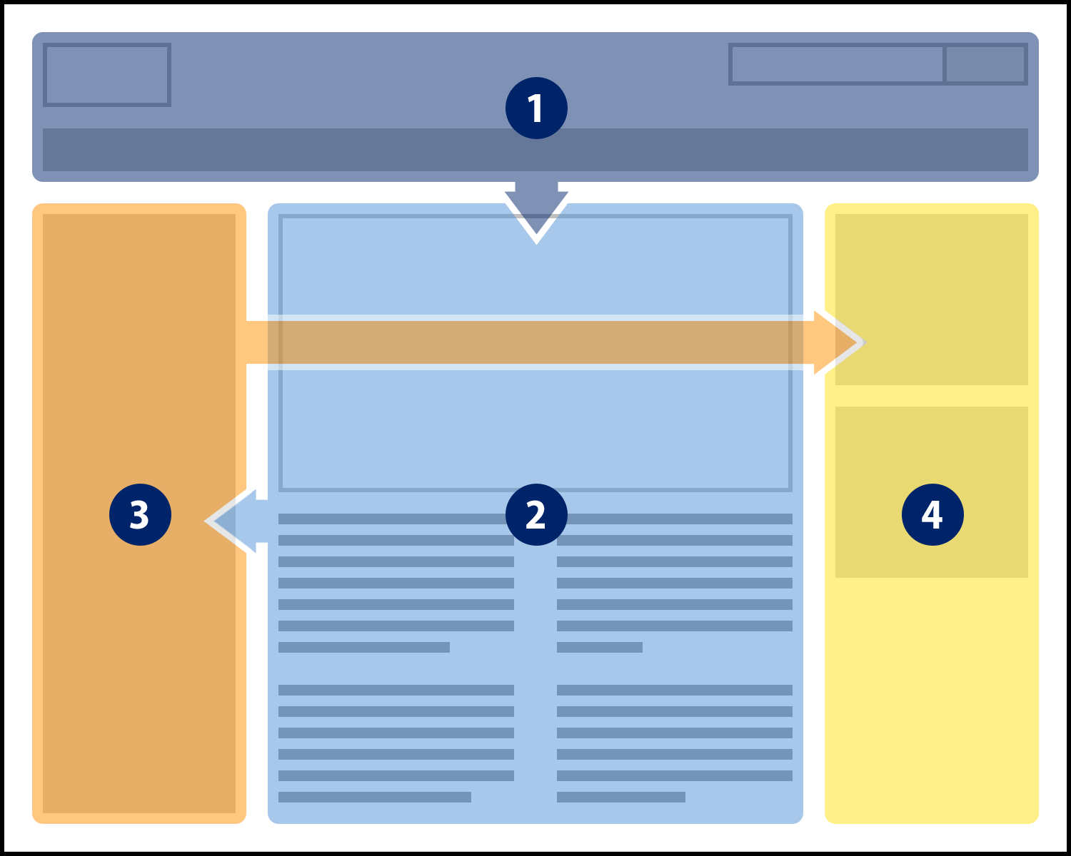
Figure 36: Content within the HTML should follow a logical order and not necessarily the visual flow.
For people who use assistive technologies such as screen readers, the visual arrangement of elements on the screen is effectively meaningless. Of greater importance to people who use screen readers is the order of the content within the HTML code. This is because people who use screen readers will typically read web based content in a procedural manner. If the content is not organised in a meaningful sequence people who use assistive technologies such as screen readers are likely to find it difficult to interpret the content on your website.

Be sure to structure your wireframes in a logical order with the sequence following a top-to-bottom, left-to-right order assuming the language of the page is read left-to-right. Consider the example wireframe below:

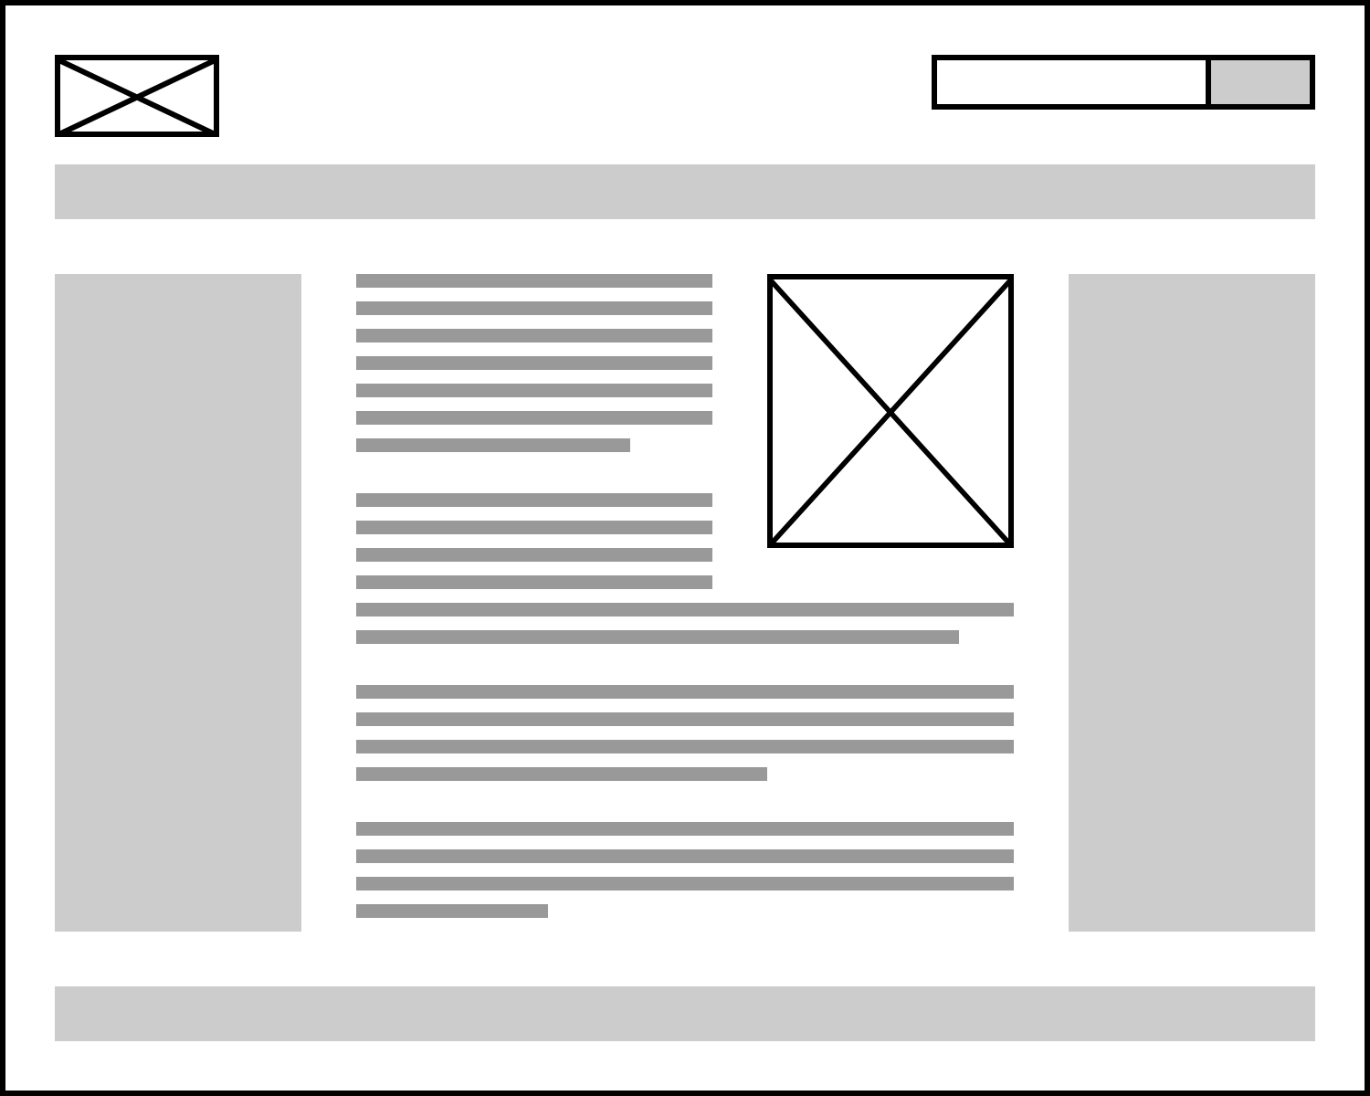
Figure 37: A typical layout of a webpage.
This represents a fairly common layout found on the Internet today. When converted to HTML the content should appear in the following order: header, left sidebar, content, right sidebar and finally the footer.

10.2 Finding content on your site
People find different navigation strategies effective for their individual requirements. For example, some people may find it easier to use a main menu rather than be overwhelmed with a sitemap. Other people may find a search form much quicker to use than a more conventional navigation method.

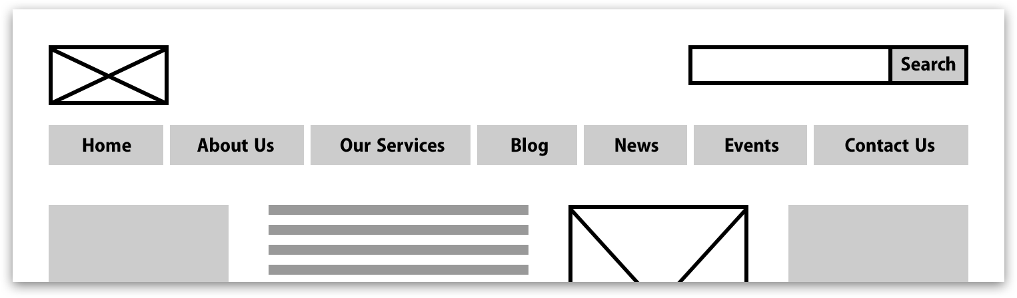
Figure 38: A search can be an easy and fast way for visitors to find content.
Providing different ways to navigate content will increase the likelihood that people will successfully find the information they require from your website. To achieve this, a wireframe should when appropriate look to include features such as:

- A sitemap;
- Site search;
- Site navigation;
- Related web page links;
- Table of contents.

By providing a variety of ways to help people find information on your website you will ensure that visitors to your website will have a better chance of locating the content they are looking for. Clear and consistent navigation areas will also help people understand their current location within the site hierarchy.

For websites that are likely to have a deeply nested page hierarchy it is also worthwhile considering providing a breadcrumb trail.

Figure 39: A breadcrumb is a great way for visitors to understand their current location on deeply nested pages.
A breadcrumb trail can be a useful way of helping people easily identify relationships between pages on your website. The extra contextual information that this provides can be extremely useful for people with cognitive and learning disabilities.

10.3 Provide controls for forms
Specifying the layout and functionality of a form is often done at the wireframe stage of a project. It is essential to ensure that all forms on your wireframes, regardless of the number of fields in the form have a submit button. Providing submit buttons allow people to submit data in their own time.

For example, a drop-down select control that does not use a ‘go’ button may cause the page to change without them realising.
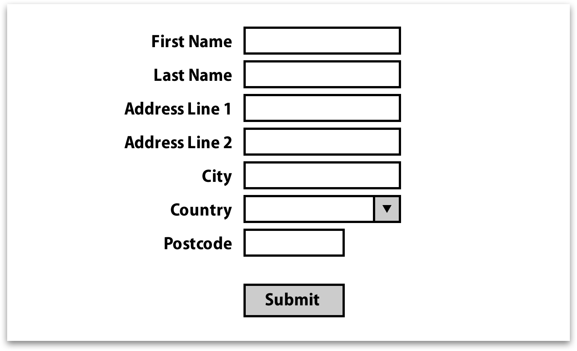
Figure 40: Always provide a submit button for forms.
Entering information into form fields which do not include submit buttons often has unpredictable results such as reloading the page or presenting new content without prior warning. For people unable to see the page or those who may not be able to react quickly enough these types of changes to the page can be extremely frustrating and disorientating.

10.4 Provide consistent navigation
Consistent layout and navigation will help everyone find the information they require from your website, but will be most beneficial for people with cognitive impairments and those with partial or no sight.

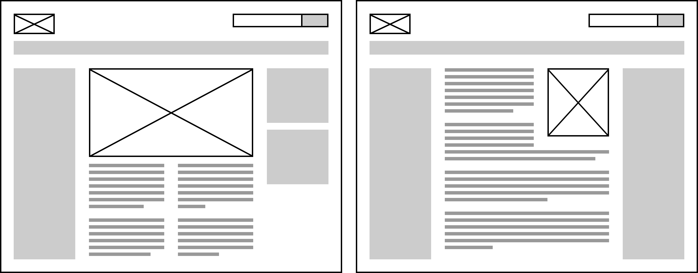
Figure 41: Keep the location and functionality of navigational tools consistent across pages.
People with partial sight who use assistive technologies such as screen magnifiers often use visual clues and the spatial location of elements within a page as a means of quickly finding content. Therefore, consistency is the key to helping them navigate around a web page efficiently.

Creating a consistent navigation and layout during the wireframe stage is crucial, as it will often set the precedent for the rest of the project; if not addressed at this stage, it could be a complex issue to resolve later in the project.

Further Reading
- QUICK REFERENCE – Info and relationships-http://www.w3.org/WAI/WCAG20/quickref/#qr-content-structure-separation-sequence
- UNDERSTANDING-WCAG20 – Info and relationships-http://www.w3.org/TR/UNDERSTANDING-WCAG20/content-structure-separation-sequence.html
- QUICK REFERENCE – Navigational mechanisms-http://www.w3.org/WAI/WCAG20/quickref/#qr-navigation-mechanisms-mult-loc
- UNDERSTANDING-WCAG20 – Navigational mechanisms-http://www.w3.org/TR/UNDERSTANDING-WCAG20/navigation-mechanisms-mult-loc.html
- Accessible design needs good foundations-http://www.nomensa.com/blog/2006/accessible-design-needs-good-foundations/
- UNDERSTANDING-WCAG20 – On Input-http://www.w3.org/TR/UNDERSTANDING-WCAG20/consistent-behavior-unpredictable-change.html
- About web usability-http://www.usability.com.au/about/index.cfm
- QUICK REFERENCE – On Input-http://www.w3.org/WAI/WCAG20/quickref/#qr-consistent-behavior-consistent-locations

11 Best Practice for Creative Designs

11.1 Do not rely on shape, size or visual location
It is important to ensure that instructions provided on your website do not depend on people being able to identify objects by shape, size or location. For example, blind and partially sighted people will struggle to find the “round” button, but should have no trouble in finding the button labelled “send” instead.

Some people may also have trouble understanding information conveyed using graphical symbols. It is important to use visible text where possible along with graphical symbols to convey the meaning of content; particularly for lesser known symbols and iconography that might be specific to your creative designs.


Figure 42: Icons can be confusing when taken out of context.
These “mystery meat” symbols should therefore be supported with visible text in the creative designs. This text might appear next to the shape or appear on keyboard focus and mouse hover as a tooltip, allowing people to understand the meaning of the graphical symbols.

In addition to this, elements within the page should not be identified simply by their visual location on the page. Consider a web page with a left sidebar. The side bar contains a login form. Within the main content area there is a line of text that reads “sign in using the form to the left”. This is unlikely to cause any issues for sighted people. However, a person using a screen reader will not be able to identify the ‘left’ portion of the page since screen reader software interacts with web pages in a linear manner. People using screen readers do not have any concept of ‘left’ and ‘right’ when listening to a web page. They are only aware of content ‘above’ and ‘below’. In order to make this type of information accessible a textual hook needs to be provided as well. If the login form were identified using a heading that read “login”, the instructions could reference this element by means of a textual hook as well as visual location (e.g. “sign in using the ‘login’ form to the left”). This will make it easier for people who cannot see the page to identify the form without too much trouble.

11.2 Avoid the use of colour alone
Colour or differences in colour should not be the only way content can be identified. This builds on top of a previous section that dealt with people’s perception of shape, size and location.

Colour is often used to identify particular content such as links, but for someone with colour blindness it can be hard to identify these links when colour alone is used. Therefore additional visual cues should be used to highlight changes in the content on the creative designs. Text is the recommended way to provide the additional identification because it is accessible by everyone. There are several ways you can include a visual cue to distinguish between content. For example a link can be visually distinctive from surrounding text by:

- Providing an underline by default for links;
or
- Using a contrast ratio of 3:1 with surrounding text and an underline when it receives focus.

Including these visual indicators in the creative designs will help to ensure people are able to differentiate between different types of content on a website.
In addition to this, colour alone should not be used to identify regions or elements within a web page. Consider a page with a large green button containing the text “Sign up” allowing visitors to sign up for a service. Within the content area there is a line of text that reads “Click the large green button to register now”. Although most people would have no problems identifying the button, those with blindness or limited colour vision would not be able to identify it. However, if the line of text within the content were changed to read “Click the large green ‘Sign up’ button to register now” people with visual impairments will be able to identify the button by its textual content without relying on the colour cue that had been provided.
Figure 43: Context, along with colour, is used to identify the content.

11.3 Using sufficient colour contrast
The contrast between foreground and background colours on a website can play a big part in how easy the content is to read for people with partial sight. Using foreground and background colours that contrast well makes it much easier for people to read content more comfortably.

The Web Content Accessibility Guidelines recommend that foreground and background colours have sufficient contrast, achieving a 4.5:1 ratio or higher. In reality it is not practical for all colours on a website to meet this ratio. Some exceptions to this recommendation are listed below:

Large Text: Large-scale text and images of large-scale text have a contrast ratio of at least 3:1. Large text is considered text that is at least 18pt in size or 14pt and bold.

Incidental: Text or images of text that are part of an inactive user interface component, that are pure decoration, that are not visible to anyone, or that are part of a picture that contains significant other visual content, have no contrast requirement.

Logotypes: Text that is part of a logo or brand name has no minimum contrast requirement.
The contrast between foreground and background colour combinations can be tested during the creative design process using a number of tools, such as the Colour Contrast Analyser:
http://www.paciellogroup.com/resources/contrast-analyser.html

Figure 44: Use the Colour Contrast Analyser to check contrast ratios.
If your brand palette does not provide enough colour combinations with sufficient contrast to meet the 4.5:1 ratio, there are three options available:

- Your brand colour palette is updated; or
- Techniques are used to get around the issue, such as a contrasting drop-shadow around text in images, or using white/black backgrounds rather than coloured ones; or
- A style switcher could be implemented to give people a choice about which colour scheme they use. For example, the default style might be your fully branded one, and a higher contrast version is made available by selecting a link. The higher contrast version is then applied throughout the site for that person. For an example style-switcher please see:
http://style-switcher.nomensa.com/

11.4 Using text within an image
It is important to give people the ability to adjust the presentation of text such as colour, font size, font family, background colour or line spacing to meet their reading requirements. With this in mind, the creative designs need to carefully consider what can be replicated using current HTML and CSS techniques. This will help to avoid the need to use images of text on the final website.

If text within an image must be used, make sure the text within the image is at least 18pts in size and follows the recommendations in success criterion 1.4.3 Contrast (minimum). Using this font size and use colours with sufficient colour contrast will make ensure the text in the image is large enough for the majority of people to read.

Logo branding is an exception to this rule, as the presentation of this information can often be critical to the brand and appearance.

11.5 Provide controls for animated content
Moving, scrolling, blinking or automatically updating content can be very distracting for some people, preventing them from using the page. Other people such as those using screen-reading software may not be able to access this type of content at all.
Movement on screen that is initiated automatically and not by the person browsing the page should be avoided where possible. Types of moving content may include scrolling news feeds, photo carousels, videos, animations and advertisements. Never assume they will want to see this type of content play automatically. For some people with cognitive impairments it can prevent them from using the page at all.

With this in mind, the creative designs need to consider how content that updates or plays can be paused or stopped and visualise this in the design. It will often result in the creative designs incorporating clearly labelled controls located near the blinking, scrolling or auto-updating content. These controls should enable people to play, pause or stop the content when they decide. If these controls are not considered at the creative design phase, it could become difficult to incorporate them in to the site at a later date.

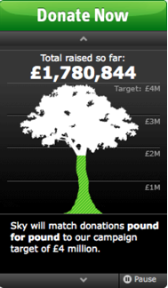
Figure 45: Panel with the option to control animated content

11.6 Provide consistent navigation
Ensuring the location and presentation of navigational elements is consistent will benefit people who visually scan the design to locate content on a site. In particular, it will also help people using screen magnifiers that display a small portion of the screen at a time. These people use visual clues and the location of elements within a page as a means of quickly finding repeated content such as navigation.

A design should maintain a level of consistency of common elements such as site links and navigation. This includes where it is positioned on the page as well as the styling used to indicate the current page and/or section. The exception to this might be the homepage, where it is considered acceptable to have a slightly different layout from other pages.

Useful tools
- Colour contrast analyser-http://www.paciellogroup.com/resources/contrast-analyser.html

Further reading
- Quick Reference – Sensory Characteristics-http://www.w3.org/WAI/WCAG20/quickref/#qr-content-structure-separation-understanding
- Designing accessible icons part 1 of 2-http://www.nomensa.com/blog/2010/designing-accessible-icons-part-1-of-2/
- Designing accessible icons part 2 of 2-http://www.nomensa.com/blog/2010/designing-accessible-icons-part-2-of-2/
- QUICK REFERENCE – Use of colour-http://www.w3.org/WAI/WCAG20/quickref/#qr-visual-audio-contrast-without-color
- Designing-for-the-web-http://www.nomensa.com/blog/2007/designing-for-the-web/
- QUICK REFERENCE – Colour contrast-http://www.w3.org/WAI/WCAG20/quickref/#qr-visual-audio-contrast-contrast
- Checking-colour-contrast-http://www.nomensa.com/blog/2010/checking-colour-contrast/
- QUICK REFERENCE – Images of text-http://www.w3.org/WAI/WCAG20/quickref/#qr-visual-audio-contrast-text-presentation
- QUICK REFERENCE – Time limits-http://www.w3.org/WAI/WCAG20/quickref/#qr-time-limits-pause
- QUICK REFERENCE – Consistent navigation-http://www.w3.org/WAI/WCAG20/quickref/#qr-consistent-behavior-consistent-locations

12 Best Practice for Flash

12.1 Alternative text for images within Flash
Images in Flash can have alternative text in the same way HTML image elements can. Textual alternatives are extremely important for people with blindness or severe visual impairments. For example, screen reader software will announce the textual alternative for an element when it receives focus if a textual alternative has been provided. This makes it possible for people with blindness to identify the meaning associated with, or the purpose of, an element that would otherwise not be perceivable to them.

The Flash Professional authoring tool's ‘Accessibility panel’ will allow you to make a Flash object accessible by adding a “Name” value. This is where you can provide a textual alternative for non-text content within a Flash movie. Using the “Name” field you should provide a meaningful text alternative that will be read out by assistive technologies such as screen readers. It is also important to ensure that the 'Make object accessible' checkbox in the ‘Accessibility panel’ is checked. This will ensure that the textual alternative is exposed to assistive technologies such as screen readers.

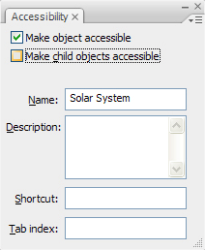
Figure 46: The 'make object accessible' checkbox should be ticked
If non-text content cannot be summarised using a short textual alternative, a longer description of the object can be provided by making use of the “Description” field in the Flash accessibility panel. For example, an image of a graph cannot be accurately described using a short text description. A longer description of the graph and the statistics that it represents can therefore be provided using the “Description” field. Note that the “Name” field should still be used to identify the non-text content at its most basic level (e.g. “Graph showing voting statistics from the 2010 general election”).

If the 'Make object accessible' checkbox in the ‘Accessibility panel’ is unchecked the object to which it applies will not be exposed to assistive technologies such as screen readers. This can be extremely useful in certain circumstances. For example, if an image is purely decorative in nature or is not needed to convey meaning it can be hidden using this technique. It will still be visible to sighted people, but people who use assistive technologies such as screen readers will not be aware that it exists. This is akin to giving an image a blank alt attribute in html.

As a rule of thumb:
- If non-text content is a control or link, the textual alternative must be provided and should be used to identify the purpose of the control as opposed to the content of the image. For example, if a button is an image and does not contain text the buttons accessible ‘name’ must be set and should identify the purpose of the button as opposed to the content of the image;
- If the non-text content supplements the surrounding textual content a description should be provided that describes the content of the image;
- If the non-text content does not provide any important or supplementary information it can be hidden from assistive technologies such as screen readers.
It is also important to provide textual alternatives for the Flash content in its entirety. This textual alternative should attempt to describe the content of the Flash movie in plain text so that people are able to access an alternative to the Flash content should they not have a Flash player installed on their computer. In order to provide a textual alternative for an entire flash movie the body of the <object> element should be used. If the content of the movie can be transcribed this can either be provided as part of the text inserted into the body of the object element, or a link can be provided that directs people to another page containing a full transcript (see code example below). This text will only be visible to people who do not have Flash installed on their computers.

<object>
<param name=”wmode” value=”transparent” />
<param name=”foo” value=”bar” />
This flash component contains slides from the recent meeting about falling cheese
sales in Cheddar. A <a href=”/cheese-sales-transcript.html”>full transcript</a> of
the content in this movie has also been provided.
</object>

12.2 Creating a meaningful reading order
For people who use assistive technologies such as screen readers, the reading order of the content within a Flash movie has an extreme impact on the legibility of the content. Whereas a sighted person will be able to determine reading order based on the location of elements on screen, a person using a screen reader will not be able to do this. As such the order of the content within a Flash movie will need to be explicitly set using the “Tab Index” property. This property essentially allows the developer to set the order in which Flash elements or objects appear to people using assistive technologies such as screen readers.

If “tab index” is being used to set the order of content, every accessible object or element must be assigned a “tab Index” value. This is not limited to objects that are focusable (such as buttons) but also includes accessible elements such as text which may not be focusable but is still exposed to the visitor to your website.
Elements within a Flash movie will receive focus in order ranging from the object with the lowest tab index to the object with the highest tab index. In order to set the tab order for an element, open the accessibility panel (“Window” > “Other Panels” > “Accessibility”) and select the object on the stage to which you wish to assign a “tab index” value. The fields within the accessibility panel should now be editable. Simply enter a numeric value between 1 and 65535 into the “tab index” field. The values do not have to be sequential, but two objects should not have the same value. For example, 1, 50, 110, 500, 5000 is fine.
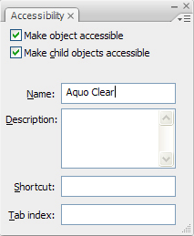
Figure 47: Every element must be assigned a 'tab index' value
It is important to check the tabbing order of the Flash content to ensure that people using keyboards are presented with the information in an order that makes sense. Be sure to check this order when making changes or further developing the Flash content. To visualize the tab order, select “View > Show Tab Order”. The tab index for objects will then appear in the upper-left corner of each object.

12.3 Using sufficient colour contrast
Flash is subject to the same guidelines as HTML/CSS for contrast levels of foreground and background colours. The colour contrast ratio can be tested using the Colour Contrast Analyser to ensure that colour combination pass the 4.5:1 (3:1 for large text) ratio.

12.4 Ensure that text is resizable
For people with severe visual impairments the ability to change the size of text can be fundamental to their ability to read text on their screen.

Flash does not natively support the ability for text resizing. However, this functionality can be purposely built into Flash movies and widgets. It is worth mentioning that this should ideally be built into Flash content at the start of the development phase. If this functionality is built into Flash content at a later date it could affect other parts of the movie and the way it functions thus resulting in a larger volume of work and maintainability issues.

12.5 Provide support for keyboard devices
Actions within Flash content can be made keyboard accessible which will help to ensure assistive technologies such as screen readers can easily submit responses and navigate the content. This is achieved using the click event for standard components, which ensures the action occurs when someone clicks the element with a mouse, or when they move focus to the element and select it with the keyboard.

In some browsers such as Firefox and Safari it is not possible to move keyboard focus into Flash content. Even if the Flash content and the surround HTML content is keyboard accessible it may not be possible to access the Flash content using a keyboard alone.

Until the browser vendors address this issue, the responsibility is on the Flash developer to provide a solution. The example below is just one of the accepted solutions for this issue:
- Two focusable HTML objects are identified for each Flash movie in the HTML document. One of these should appear before the Flash movie, one after. These can be any HTML elements that are capable of receiving keyboard focus such as links, buttons or form fields.
- The “tabindex” attribute of the Flash object (within the HTML) is given a value of 0. This causes the Flash object to become part of the tabbing order of the page.
- Normally the focus order will be maintained within the Flash movie. When focus is moved away from the last element within the order of the Flash movie focus will be moved back to the first element within the movie. However, this ‘focus wrap’ can be detected in Flash and focus can then be shifted to the first focusable HTML element that appears after the Flash movie, thus allowing people to move between Flash and HTML with greater ease.

12.6 Provide controls for animated content
Content on a page which continuously scrolls or updates can be hard to read or may distract people with cognitive or learning disabilities from reading other text on the page. As such people should be able to stop or extend the amount of time it takes for the content to update. If your Flash movie contains moving content, providing controls to stop or pause the moving content will allow people to read any text within the movie in their own time.

Flash does not provide a mechanism for achieving this out of the box so this functionality will need to be purposefully built into the Flash movie.

Another option for content that scrolls or automatically updates is to ensure that the content scrolls through one complete cycle, then comes to a halt. One way of achieving this is to use the “setTimeout” function to scroll or update content for a specified amount of time before it comes to a halt.

12.7 Use descriptive link text
Some people, particularly those using access technologies, will move through a web page by tabbing from link to link, without pausing to read the nearby page content. It is important therefore to ensure that the link text accurately reflects the target of the link, thus preventing people from having to read content in order to understand where the link will take them.

12.8 Visible focus indicators
Flash content is subject to the same criteria as HTML when it comes to providing highly visible focus indicators. When an element receives focus using the keyboard it should visually change so that it stands out from the rest of the content on the page. This will make it possible for sighted people using keyboards to identify which element has focus at any given time. It is extremely important for people to be able to identify which link or control will be activated when they hit the space bar or carriage return key.

12.9 Human language of the Flash content
The aim of providing the language of a page is to inform browsers, screen readers and other types of assistive technology about the primary language of the page. Identifying the human language of the page rather than the computer language helps these technologies display the page using the appropriate pronunciation, characters and scripts for that language.

The primary language of the content within the page should be set using the HTML element.

The language code of Flash content can also be set by adding it to the Flash object:

<object lang="en" xml:lang="en" … >
<param name="movie" value="myMovie.swf"/>
…
</object>

12.10 Triggering events on input
Flash content is subject to the same requirements as HTML when it comes to providing submit buttons for form controls. Forms should only be submitted or processed when requested by the person using the form. If simply interacting with a form control causes the form data to be submitted or causes a change of context people with cognitive disabilities, learning disabilities and those with severe visual impairments are likely to become confused and disorientated. The reason for this is that they have not knowingly initiated the change of context. If forms are processed when (and only when) a submit button is activated, people can easily predict what is going to happen on the page, which creates a more unified and understandable experience for them.

12.11 Identify errors within the Flash
Clear instructions and descriptive form errors will help everyone understand how to correct any errors within a Flash form. The error message can be inserted into the control's accessible description so that it is readable by assistive technology when the control receives focus.
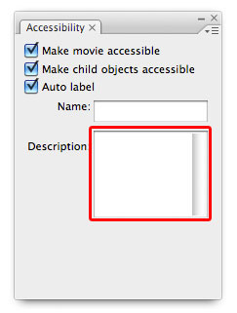
Figure 48: The Flash accessibility control tab, which can be used to add error messages.
As with HTML forms, error messages should be shown in text as close to the form field containing the error message as possible. Error messages should also be clearly indicated using colours and another visual indicator such as an icon or bold formatting.

12.12 Labelling form controls within the Flash
Except for checkboxes and radio buttons, Flash components are not given an associated label by default. This means that a text label has to be placed adjacent to its control manually, using the ‘label component’. There are two accepted ways of doing this:

- The label can be set by assigning the form control an accessible name using the accessibility panel. Please refer to success criterion 1.1.1 for more information on how to set the accessible name for a Flash object.
- A label can be defined by making use of the ‘label’ component. Assuming the 'auto-label' feature is enabled in the Accessibility Panel, the Flash Player will automatically associate the label text with the corresponding components.
In order to use the auto-label functionality:

- Make sure the text description for each form control is placed adjacent to the control itself and is not hidden from assistive technology.
- Select the movie stage, open the accessibility panel and ensure that the ‘Auto label’ option is checked.
- The Flash movie will attempt to associate each form control with an appropriate label. Once this has been done the Flash movie will need to be tested using a screen reader to ensure that the auto labelling functionality has worked as expected.
- If the auto-labelling functionality has not given the desired results, the form controls should be explicitly assigned a label. To do this, uncheck the ‘Auto label’ option in the accessibility panel and give each control an appropriate ‘Name’.
It is worthwhile mentioning that form labels are subject to the same criteria as form labels in HTML. If a form field requires data to be entered in a specific format this should be made explicit using the label text and an example should be provided where applicable.

Further reading
- QUICK REFERENCE – Textual alternatives-http://www.w3.org/WAI/WCAG20/quickref/#qr-text-equiv-all
- UNDERSTANDING-WCAG20 – Textual alternative-http://www.w3.org/TR/UNDERSTANDING-WCAG20/text-equiv-all.html
- QUICK REFERENCE – Meaningful sequence-http://www.w3.org/WAI/WCAG20/quickref/#qr-content-structure-separation-sequence
- UNDERSTANDING-WCAG20 – Info and relationships-http://www.w3.org/TR/UNDERSTANDING-WCAG20/content-structure-separation-sequence.html
- QUICK REFERENCE – Colour contrast-http://www.w3.org/WAI/WCAG20/quickref/#qr-visual-audio-contrast-contrast
- UNDERSTANDING-WCAG20 – Colour contrast-http://www.w3.org/TR/UNDERSTANDING-WCAG20/visual-audio-contrast-contrast.html
- QUICK REFERENCE – Resize text-http://www.w3.org/WAI/WCAG20/quickref/#qr-visual-audio-contrast-scale
- QUICK REFERENCE – Keyboard operable-http://www.w3.org/WAI/WCAG20/quickref/#qr-keyboard-operation-keyboard-operable
- Scrolling Flash content-http://www.w3.org/WAI/GL/WCAG20-TECHS/flash.html#FLASH35
- Blinking Flash content-http://www.w3.org/WAI/GL/WCAG20-TECHS/flash.html#FLASH36
- UNDERSTANDING-WCAG20 – Language of page-http://www.w3.org/TR/UNDERSTANDING-WCAG20/meaning-doc-lang-id.html
- Language of elements-http://www.w3.org/WAI/GL/2010/WD-WCAG20-TECHS-20100708/flash.html#FLASH13

Useful tools
- Colour contrast analyser-http://www.paciellogroup.com/resources/contrast-analyser.html

13 Best Practice for HTML and CSS
Every single element defined within the HTML specification has a purpose. As such, the elements that you choose to make use of impart a certain amount of information about that element and its relationship to other elements on the page. This information is used by browsers and assistive technologies such as screen readers to convey information on the page to people.

For example, browsers will automatically allow links marked up using the <a> element to receive focus using a keyboard. If a <div> element had been used instead a person using a keyboard would not be able to move focus to it. This is becoming more of a problem since developers have been able to repurpose standard HTML elements to behave like links using JavaScript.

Many assistive technologies such as screen readers rely on well written HTML code for streamlined navigation. For example, a person using a screen reader will be able to skip from one heading to another using a shortcut key. This is extremely useful since it allows people who use screen-reading software to get an idea of the pages structure easily. However, the screen reader will only consider an element a ‘heading’ if it has been marked up using an HTML heading element (<h1> through to <h6>).

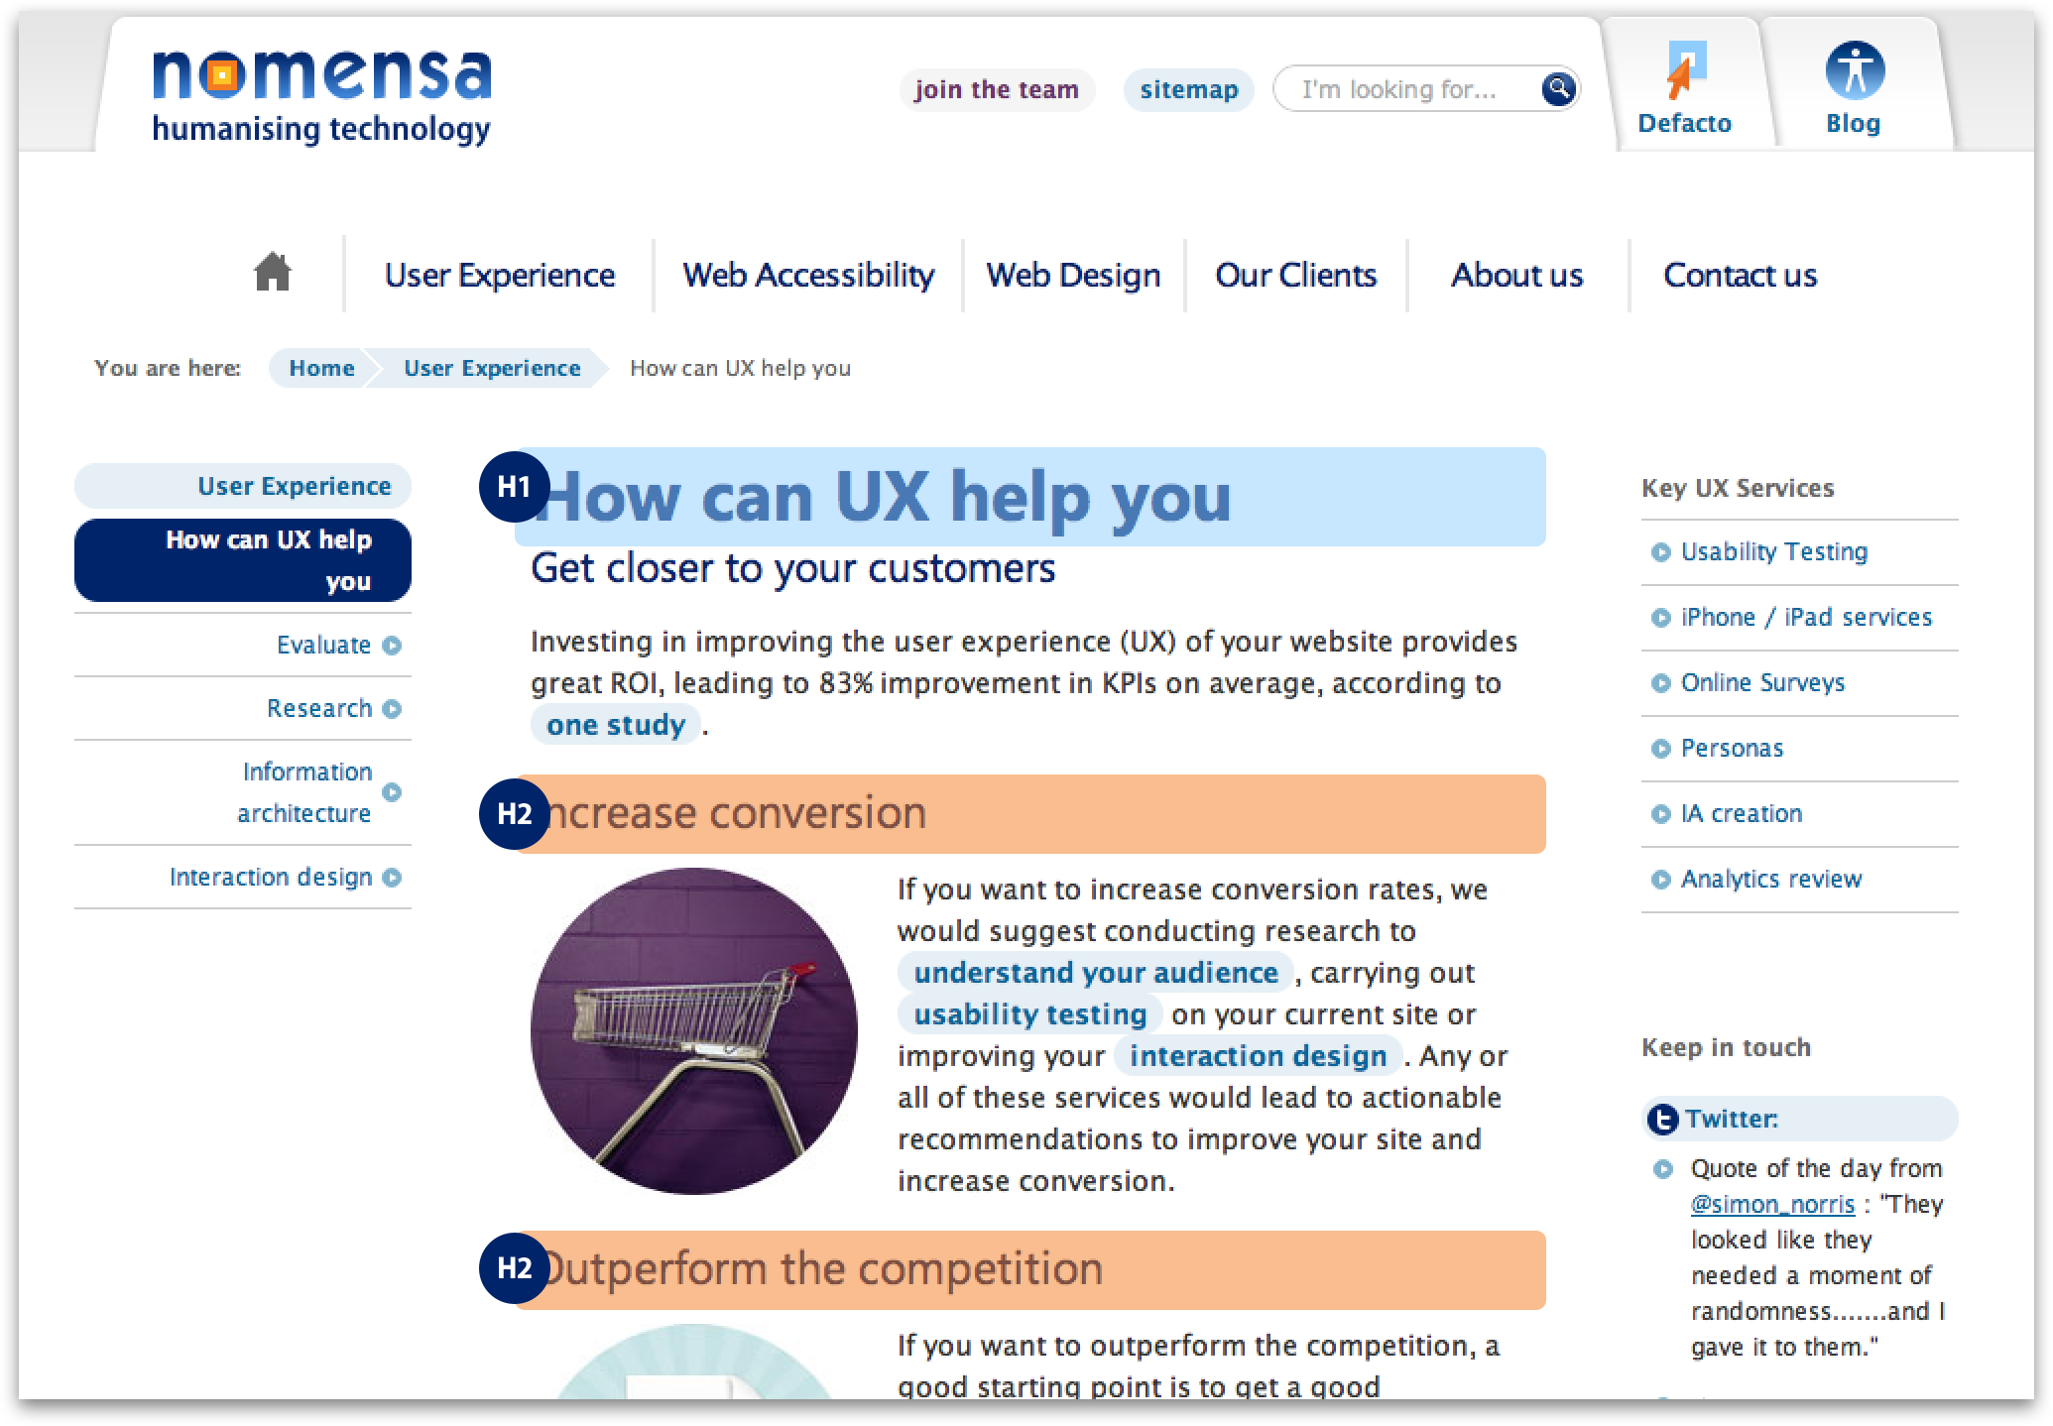
Figure 49: Use nested heading to seperate and structure content.
On the other hand, if more generic elements are used and styled to look like headings using CSS, assistive technologies such as screen readers are not likely to identify them as headings. This can make it significantly harder for people who use screen readers to navigate the content on your website.

In addition to this, using HTML elements for their intended purpose has many benefits for accessibility. Consider a form input with a text label. If the text label is marked-up using the <span> element, instead of the <label> element, it cannot be associated with the form field to which it belongs. For sighted people the location of the text label near to the form field should be sufficient to identify the purpose of the field.

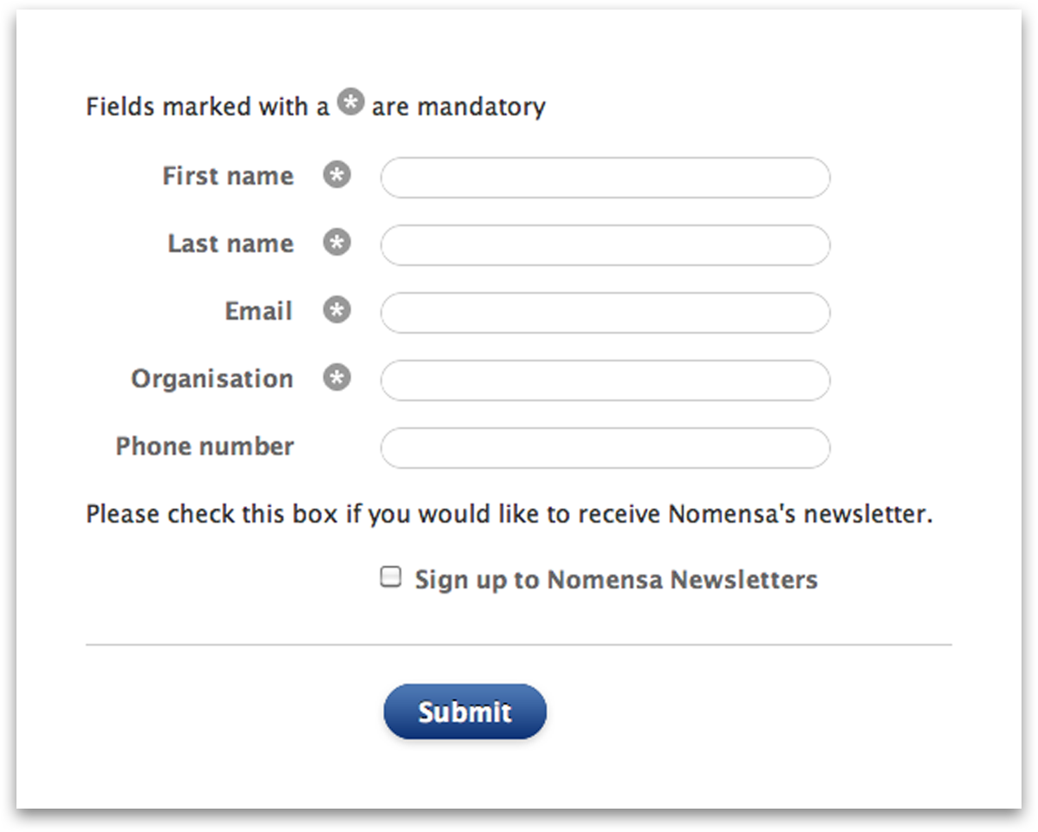
Figure 50: Use labels for form elements and associate them correctly.
However, for people who use assistive technologies such as screen readers the relationship between form field and label is likely to be much harder to establish. If the HTML <label> element had been used instead of a <span> element this issue would be much easier to rectify. The <label> element has an attribute that makes it possible to provide an explicit relationship between a form field and its text label. The ‘for’ attribute of the <label> element must have the same value as the ‘id’ attribute of the associated form field. Ensuring the ‘for’ and ‘id’ values are the same will create the relationship between the text label and the form field.

<label for=”q”>Search</label>
<input id=”q” name=”search” type=”text” />

If a form field is correctly associated with a label, when a person using a screen reader moves focus to the form field, the software will automatically find and read out the label. This makes it much easier for people using assistive technologies such as screen readers to identify the purpose of a form field. In addition to this a correctly marked up label acts as an extended “hit area”. If the label is clicked, focus will be moved to the corresponding form field automatically. This is extremely beneficial for people with poor hand to eye coordination such as those with motor neuron diseases.

13.1 Creating a meaningful reading order
Structuring your pages correctly is a very important part of creating an accessible website. The order in which content appears on your website needs to be considered from the very beginning of the web development process. The content on your website should be displayed in an order which allows the information presented to make sense when read through from top to bottom. While this sounds like a common sense approach, it is surprising how many web developers get this wrong.
Some techniques for coding web pages allow content to be presented visually in an order that is different from the underlying code order. For people using screen-reading software that reads the content of the page aloud, it is important the underlying source order makes sense and has not been altered to create the visual presentation of the page.

It is important for web developers to think about the underlying code order of the page before concentrating on the visual appearance. Undoubtedly the visual appearance will have some impact on the code order, however it is essential to get the code order correct first and worry about the visuals later.

Imagine a page containing information about web accessibility and web design. Visually the information has been split into two columns, with web accessibility information in the left column and web design information in the right column.

To a sighted person this content can be easily understood. However to someone who cannot see the page (who may be listening to the content instead) it may not be quite so easy to understand. Looking at the underlying code order, we can see the information is grouped together without any structure or thought given to the order in which the content is presented.

<div class="box">
<span class="menu1">Web Accessibility</span>
<span class="menu2">Web Design</span>
<span class="item1">Accessibility Audits</span>
<span class="item2">User experience design</span>
<span class="item3">Accessible PDFs</span>
<span class="item4">Template Development</span>
<span class="item5">Accessibility Guardianship</span>
<span class="item6">Defacto CMS</span>
</div>

Here is an example http://www.w3.org/TR/2010/NOTE-WCAG20-TECHS-20101014/F1.html of someone using a screen reader or other types of assistive technology may have difficulty understanding what the purpose of this content is. In order to correct this problem, the content must be ordered correctly:

Web Accessibility
Accessibility Audits
Accessible PDFs
Accessibility Guardianship
Web Design
User experience design
Template development
Defacto CMS

Once the content is in the right order, each item can be marked-up using the appropriate HTML elements. The titles ‘Web Accessibility’ and ‘Web Design’ are marked up as headings, while the lists of services are marked up using unordered lists.

<h2>Web Accessibility</h2>
<ul>
<li>Accessibility Audits</li>
<li>Accessible PDFs</li>
<li>Accessible Media Player</li>
</ul>

<h2>Web Design</h2>
<ul>
<li>User experience Design</li>
<li>Template Development</li>
<li>Defacto CMS</li>
</ul>

While this may be an extreme example, it helps to highlight how important it is to think about the underlying order of the content for your pages.

13.2 Ensure text is resizable
As a web developer, it is important to make sure your pages are flexible in terms of layout and font size. Not everyone views websites in the same way. People will be viewing your website on a number of devices such as desktop computers, laptops, netbooks, smart phones, tablets and televisions. These devices may have different resolutions as well as different orientations. With so many different options to keep in mind it is vital that your website can adapt to display its content in the most appropriate manner for the particular device.

Not only will the layout of your website need to adapt, you will also have to ensure the elements within the page are flexible to render the content with a variety of different font sizes. People with mild visual impairments may need to increase the text of size in their browser in order to read the content on the webpage more easily. If this happens, the containers holding your web page content as well as the content itself should either increase or decrease in size without obscuring any of the content or restricting the functionality of the page.

To achieve this, a few things need to be kept in mind when writing your style sheets. First of all, avoid setting font size in pixels, as Internet Explorer browsers cannot resize text set in pixels. This means if you set your font sizes in pixels and someone tries to resize the text of your website in Internet Explorer the text size will not change. Instead set the font size on the body element using percentages. Another thing to avoid is setting the base font size on the body in ‘ems’. Setting sizes in ‘ems’ on the body causes the text in Internet Explorer browsers to enlarge dramatically if the font size is increased. See http://www.gunlaug.no/contents/wd_additions_13.html for more information about the ‘Em Font Resizing Bug’. Using ‘ems’ for font sizes elsewhere in your style sheets is a good method to use however, and can often be far more accurate than using percentages.

13.3 Provide support for keyboard devices
As a web developer it is important to bear in mind that many people use a keyboard to navigate websites as opposed to a mouse. People who use a keyboard to navigate your website will only be able to activate links and controls that have been coded using elements intended for that purpose.
For example, an element that has been marked-up as a <div> will not be recognised by a keyboard as an interactive element. On the other hand, links (<a>), buttons (<button>) and form elements (<input>, <select> and <textarea>) will be recognised and can therefore be activated using keyboard commands.

It is becoming increasingly common for developers to use HTML elements coupled with JavaScript to replicate the behaviour of links and form controls. For people who use a mouse this is unlikely to cause any immediate issues. However, this is far from the case for people who use a keyboard for interacting with a web page. If a <div> element combined with JavaScript were used instead of a link, a person using a keyboard would not be able to interact with it since it would not be recognised as an interactive element on the page.

It is essential that the correct HTML elements be used for their intended purpose in order for pages to function as expected when used by people using keyboards or keyboard emulators. It is essential to test each component or piece of functionality on your website thoroughly with a keyboard alone to iron out problems with any keyboard related accessibility issues.

Be sure to keep in mind this approach when coding your web pages as rectifying these types of issues further down the line can be time consuming and costly.

13.4 Provide skip links for repetitive content
Different people use different mechanisms for interacting with their computers and the Internet. For people who cannot see or have poor co-ordination it can be hard, if not impossible, to use a mouse effectively. For this reason, many people choose to use a keyboard rather than a mouse. This has a fundamental impact on the way in which people use their computers and as such has as much of an impact on the way that people use the web.

For example, people who navigate using a keyboard generally read web pages sequentially from top to bottom. This is because rather than pointing at elements on the page and clicking with a mouse, they will move through the page one element at a time using the tab or arrow keys. If large blocks of content such as long lists of links (e.g. a main menu) are repeated on each page it can be extremely frustrating having to tab or arrow through these lists before reaching the main content. People with more severe physical disabilities, such as quadriplegia, will often use assistive devices such as head or mouth wands to press keys on the keyboard. For these people pressing keys to move past repetitive blocks of content can be tiring at best and physically exhausting at worst.

One of the techniques used to assist people with this issue is the use of internal page navigation often known as ‘skip links’. A skip link will direct people to a different section of the same page. For example, many sites include a link at the top of the page that moves the keyboard focus to the main content region when it is activated. This means that people who use a keyboard for navigation will be able to bypass any elements that appear at the start of the page gaining easier access to the information that they are looking for. A skip link can be implemented much like any other link on a web page. The only difference is that the ‘href’ attribute of the <a> tag should reference the ‘id’ of the target element/region on the page prefixed with the ‘#’ character:

<a href=”#content”>Skip to content</a>
<div id=”navigation”>
<ul>
... Links go here...
</ul>
</div>
<div id=”content”>
... Content goes here...
</div>

For people who use assistive technologies such as screen readers a number of other methods can be used to browse web pages. For example, a person using a screen reader will be able to skip through the page by moving between headings (normally by using the ‘h’ key). This allows people who use screen readers to get an idea of the structure of the page and makes it easier for them to access specific sections of the document with ease. The screen reader software interacts directly with the source of the page, and as such can only identify headings on the page if HTML heading elements are used. If headings are marked up using some other HTML elements and styled to look like headings using CSS, screen reader software will not identify them as headings. As a result this will inhibit the person’s ability to skip through the page on a heading-by-heading basis.

Instead of:

HTML: <span class=”myheading”>Introduction</span>

CSS: .myheading{font-size:2em;}

Use:

HTML: <h2>Introduction</h2>

CSS: h2{font-size:2em;}

Headings should be used to identify discrete regions and sections of a page and as such should always cascade down the page from one level to the next. For example, there should always be only one master heading on any given page. This should identify the primary content on the page and should be fairly concise. Following on from this, level 2 headings should be used to identify regions of the page such as content, navigation and sidebars. Level 2 headings should be followed by level 3 headings, level 3 headings followed by level 4 headings, and so forth.

Ensuring that links are marked up as lists (where there are at least three links within any one group) will also make pages easier to navigate for people who use assistive technologies, such as screen readers. When a person using a screen reader encounters a list the software will announce the presence of the list and the number of items within it. The person using the screen reader can then decide to either browse through the list, or to bypass it entirely. This can make it easier for people to bypass blocks of links that they have no interest in.

13.5 Use descriptive page titles
Every page of your website should have a unique title which summarises the content found on that page. The page title is located at the top of the browser window. In browsers that support tabs, the page title is also often repeated in the tab for each page displayed.
Figure 51: Describe the page accurately using the title element.
Page titles play an important part in helping people understand where they are within your website. As the page title is located in the <head> of the page, it is one of the first things that is encountered when the page loads. This helps people with certain cognitive disabilities understand which page they are on in the website as well as the page’s location within the website. It also helps people decide if the content on the page is relevant to them. If it is not they can navigate away from the page without having to wade through all the content to see if it is appropriate.

Page titles should be short and concise helping people to scan them easily or listen to them quickly. Ideally page titles should contain the name of the page, the top level section the page is within and the name of your website, in the following format:

Name of page - Section - Name of the website

Some people argue over whether to put the name of the website as the first item in the page title or the name of the page. The most important information should be placed first in the page title as this is the first piece of content people will digest when reading or listening to the page title. If the name of the website is first in the title, people have to read or listen to the whole title before understanding which page they are viewing. Front loading the important information in the title speeds up this orientation process, helping people to find information on the page that little bit quicker.

As a developer, you may be responsible for making sure the page titles are output in the correct format. If you are using a content management system, this usually requires setting up the format for page titles in the base templates for the website.

Both the name of the page and the section of the site should be created automatically. The name of the page will be the value entered by the content editors when creating pages for the website. The section the page lives within should be pulled automatically from the website hierarchy depending on where the content editor places their page. Depending on the content management system used, the name of the site may need to be manually entered into the templates, or if you are using a system such as WordPress or Drupal, the name of the site can be pulled from the main settings entered when setting up the website.

13.6 Visible focus order of content
For people who navigate web pages using a keyboard the order in which interactive elements appear in the page can have a significant effect on the usability and accessibility of the page. When people move the keyboard focus from one element to another using the tab key they generally expect the content to be presented in a logical order.

People using keyboards often move through a web page in a top to bottom, left to right fashion, moving through content in a predictable and logical manner. This helps them to understand where the keyboard focus is on the page, understand the relationships between items of content on the page and which elements they can interact with. If content is not presented in a logical order it is harder to identify where the keyboard focus is on the page and interact with the page content.

13.7 Visible focus indicators
For sighted people who use a keyboard for navigation, being able to identify which element can be activated any given time is an important factor for accessibility. By default, many browsers provide a thin black dotted line around the element that has keyboard focus.

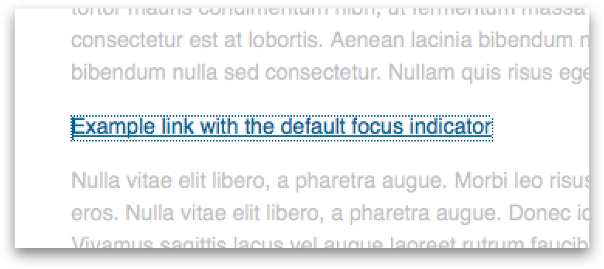
Figure 52: The default focus indicator.
Although this is a good start, the thin black dotted line can be quite hard for people to see in certain circumstances. As such it is good practice to enhance the display of the focus indicator using CSS: focus pseudo class. Using this class, we can easily highlight each element when it gains keyboard focus. This can be done by inverting the foreground and background colours of an element when it gains focus. This makes the element with focus immediately identifiable on the page as it visually stands out from the other links and interactive elements on the page.

HTML

<a href=”path/to/page.html”>My link</a>

CSS

a, a:link{
color:#000;
background-color:#FFF;}

a:focus{
color:#FFF;
background-color:#000;}

Often web developers will remove the default focus indicator (thin black dotted line) because it does not fit with the look and feel of the page. This is generally considered bad practice, because it can make it extremely difficult for people using keyboards to navigate easily around the page. If you do decide to remove the default focus indicator using CSS, make sure that you replace it with other appropriate styles using the techniques suggested above.

13.8 Identify the human language of the whole page
The content of your website may be written in one language or it may be written in a number of different languages. No matter what language is used, it is important to make sure the primary language of the website is identified in the code. Identifying the primary language of the page does not mean identifying which computer language (PHP, Python or Java) you are using for your website. Instead it means identifying which language the content is written in such as English, Russian or Arabic. If the correct language is identified in the code people using screen readers and other types of assistive technologies are automatically presented with information using the correct accent and pronunciation for the language.

The primary language of your page is the language the majority of your content is written in. For example if your page is predominantly written in English then your primary language should be set as English.

Once the primary language of your pages has been chosen, you will need to find the language code that corresponds to that language. Language codes usually consist of two letters, however four letter codes can be used for further defining the language into different dialects. A two letter language code ‘en’ could be used to define ‘English’, whereas the four letter language code ‘en-GB’ could be used to distinguish British English from American English ‘en-US’. Please note ‘en-UK’ is not a valid four-letter language code.

The language code needs to be applied to each page of your website. To set the primary language of your page as English you can use the ‘lang’ attribute along with the ‘en’ language code and apply this to the HTML element at the beginning of each page. To find the right language code, use the Language SubTag Lookup Tool: http://people.w3.org/rishida/utils/subtags/index.php.

For HTML use:

<html lang=”en”>

If you are using XHTML, you will need to apply an additional attribute to set the language used in an XML document. The ‘xml:lang’ attribute serves the same purpose as the ‘lang’ attribute and should use the same language code. Your pages will not pass the W3C HTML validation check without this attribute.
<html lang=”en” xml:lang=”en” xmlns="http://www.w3.org/1999/xhtml">

You must use both attributes when using XHTML as the ‘lang’ attribute takes precedence over the ‘xml:lang’. If you use ‘xml:lang’ without the ‘lang’ attribute some screen readers will not recognise the value of the ‘xml:lang’ attribute and will instead read out the content on the page using the default language of the screen reader. For example if someone has set their screen reader to ‘French’ and decides to read a page written in English where only the ‘xml:lang’ with a value of English had been used, the screen reader would read out the English content with a French accent.

13.9 Identify the human language of parts of the page
If a web page is written in a number of different human languages each section of content that is written in a language other than the default language used should be identified using the ‘lang’ attribute. Consider a page written primarily in English. The default language should be declared using the ‘lang’ attribute on the <html> element. If a smaller section of this page were written in French, this section would also need to be identified by the same means. However, instead of applying the ‘lang’ attribute to the <html> element, it should be applied to the container that the French text resides in.

<html lang=”en”>
<head>
…
</head>
<body>
<div id=”content”>
<p>Everything in this section should be written in English</p>
</div>
<div id=”sidebar” lang=”fr”>
<p>Tout dans ce récipient doit être rédigé en français</p>
</div>
</body>
</html>

If a link on a web page points to a page written in a different language the link should be given an attribute that identifies the language of the destination page. This is the ‘href-lang’ attribute that can be given a 2- or 4-character language code in the same manner as the ‘lang’ attribute. However, the ‘href-lang’ attribute should be used to identify the default human language of the destination page as opposed to the language of the current page.

<a href=”path/to/French/page.html” href-lang=”fr”>
View this page in French
</a>

For people who use a screen reader to access content on the Internet, making use of this attribute will alert them to the fact that the language of the destination page is written in French.

13.10 Identify errors on a page
Many people who use the Internet are not able to perceive visual identifiers such as size, colour and shape. As such if form errors rely on one or more of these identifiers alone, people who are blind or have severe visual impairments may find it hard to identify them. When form errors are found they should be identified in text so these users are able to identify them and rectify the errors. This does not mean that visual identifiers cannot be used. However, purely visual identifiers should not be the only means of identifying errors occurring on a form.

It is good practice to include a list of all the errors encountered at the start of the form. Error messages in text should also be indicated next to each form field that contains an error. This will help people correct their mistakes, as they will be able to understand how many errors have occurred and where they have occurred.

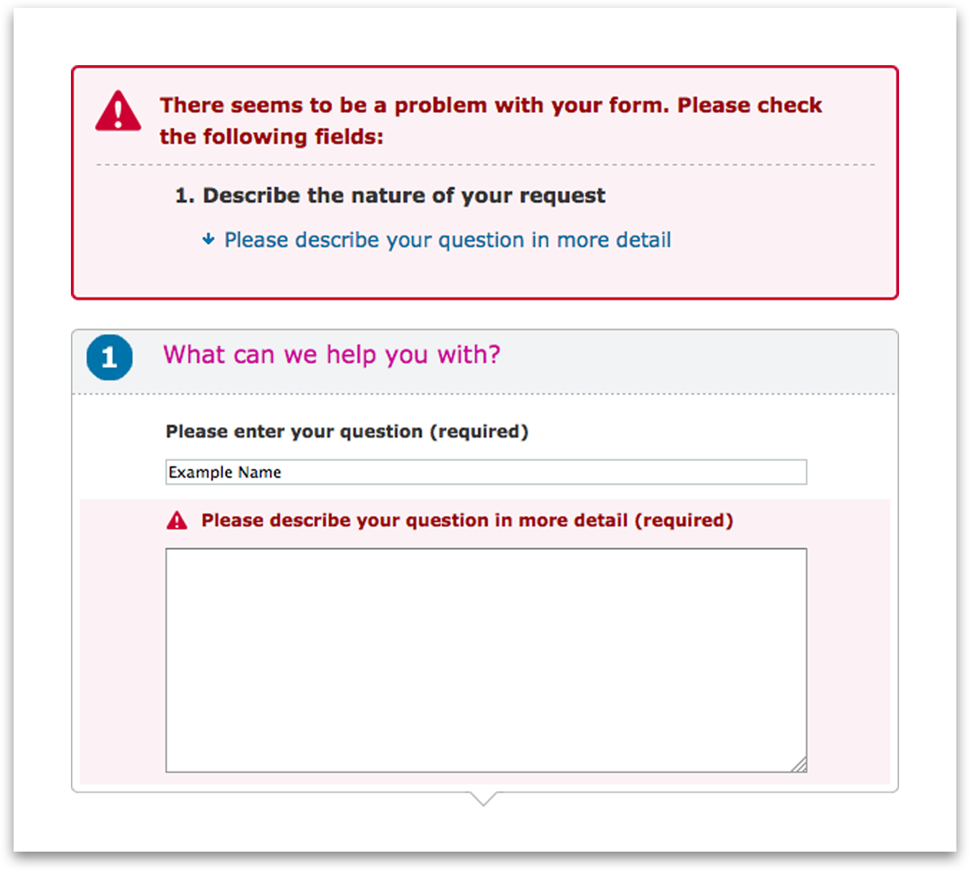
Figure 53: Error messages included in the form and as a summary at the top.

13.11 Labelling form controls
Providing relevant information and advice about online forms and how to use them can make the process of filling in forms significantly easier for the majority of visitors to your website. The provision of instructions for forms should be evaluated on a per-form basis. For example, a simple search form should not require detailed instructions in order for people to use it. It would generally suffice to ensure that there is a relationship in the code of the page between the search field and its label. Supplementary information can be provided by ensuring the forms submit button accurately describes the action that will take place when the form is submitted. For a simple search form the following code should achieve this:

<form action=”/search/” method=”POST”>
<div>
<label for=”q”>search</label>
<input id=”q” type=”text” name=”search” />
<input type=”submit” value=”Search” />
</div>
</form>

Where more complex forms are used, further instructions should be provided to help people enter information easily. There are a number of different techniques that can be used to provide this information.

13.12 Fieldset and legend elements
The <fieldset> and <legend> elements should be used to provide information about forms in their entirety, or about different sections of the same form. The fieldset element should be used to group related fields together. The <legend> element is designed to complement the <fieldset> element and should be used to provide a description of the field grouping defined by the <fieldset> element.

<form action=””>
<fieldset>
<legend>Sign up</legend>
<label for=”uname”>Enter a username</label>
<input id=”uname” type=”text” name=”uname”>
<label for=”pword”>Enter a password</label>
<input id=”pword” type=”password” name=”pword”>
<label for=”fname”>Your first name</label>
<input id=”fname” type=”text” name=”fname”>
<label for=”lname”>Your last name</label>
<input id=”lname” type=”text” name=”lname”>
<label for=”email”>Your email address</label>
<input id=”email” type=”text” name=”email”>
<input type=”submit” name=”submit” value=”Log in”>
</fieldset>
</form>

By default the fieldset element will appear with a thin black line around it. This makes it easier for people to visually identify distinct sections of each form. The legend element will display the text within it much as a label would. This is certainly useful for sighted people but has benefits for people who use assistive technologies such as screen readers as well.

Although support for the fieldset and legend elements varies from one screen reader package to the next, it is worthwhile including them in your pages as they provide additional information about the relationships between fields in the form. When a person using a screen reader moves keyboard focus to a form field, many screen reader packages will look to see if the form field is nested within a fieldset element. If it is, it will look for the corresponding legend element and read it out before reading out the form label of the field. For example, if the “First name” field in the code example above were to receive keyboard focus, many screen readers would read out “Sign up, Your first name”. This helps people to orientate themselves within the form and can greatly improve and streamline the form filling in process.

It is worth noting that some screen reader packages will read this out every time a form field gains focus. If too many fieldset elements are nested within one another, the resulting information can be quite frustrating for people who use screen readers. As such, it is good practice to nest fieldset elements only as deep as is necessary or reasonable. In addition to this, wherever the legend element is used it should be kept as short and concise as possible. This will ensure that people who use screen readers will not be forced to listen to long strings of text each time they move keyboard focus to a new field.

13.13 The label element
The label element should be used in conjunction with form fields such as <input>, <textarea> and <select> elements. The label element has a number of accessibility benefits built into it that, if used correctly, can provide significant improvements for people with and without disabilities. For example, the label element can be associated with a form field by using specific attributes in the code of the page. This binding between a form field and a label makes it possible for screen reader software to identify the corresponding label whenever a form field gains focus and announces it to the person using the form. This significantly improves the form filling process for people who use screen readers as it make it easy for people to understand what type of information to enter into each form field.

In addition to this, a correctly associated form label acts as an extended hit area. If a label is clicked focus will be moved to the corresponding form field automatically. For people with poor motor control (such as people with Parkinson’s disease) this has significant benefits. To bind a form label and field together, the field must be given a unique “id” attribute. This id can then be referenced by the label element using the “for” attribute.

It is worth mentioning that the position of form labels in relation to their fields also has an impact on accessibility. For the majority of form fields the label should appear immediately before the field. However, for checkboxes and radio buttons the form label should wrap the field itself and the text appearing immediately after the form field.

Normal (most) form fields:
<label for=”q”>Search</label>
<input id=”q” type=”text”/>

Checkboxes and radio fields:
<label for=”confirm”>
<input id=”confirm” type=”checkbox” name=”conf”/>
I have read and agree to abide by the terms and conditions of this site.
</label>

13.14 Providing expected data format and example
If a form field requires data to be entered in a specific format, information about the format and an example should be provided as part of the label text. This will make it easier for people to identify how the data should be entered and will help to reduce errors in the form submission. For example, if a form field expects a date to be entered in a specific format people should be made aware of the format and an example should be provided.

<label for=”date”>
Your date of birth in the format dd/mm/yyyy (e.g. 01/02/2003)
</label>
<input id=”date” type=”text”/>

13.15 Help with errors within a form
If errors are detected when a form is submitted, these errors should be identified and corrections suggested where possible. For example, if a form field expects the name of a month to be entered but the month in numeric format had been entered instead, either of the following errors would be appropriate:
- “Please select from one of the following values: ‘January’, ‘February’, ‘March’, ‘April’, ‘May’, etc.”
- “You entered ‘12’ for the field ‘Month’. Did you mean ‘December’?”
This will help people to not only identify the error that they have made, but will also provide guidance on how to resolve the error.

If a form field requires data to be entered in a specific format, but there is no finite number of options, information about the expected format should be provided. For example, if a person submitted an email address in an incorrect format the resulting error might read “Please enter your email address in the format ‘john.doe@domain.com’”. This will help people to identify the expected format and correct the error with greater ease.

13.16 Prevention of errors within a form
When entering sensitive information into a form such as entering your credit card details or personal information, the website should allow people to modify their information after it has been submitted in case mistakes were made. People with disabilities may be more likely to make mistakes when completing online forms. For example, a person with a learning disability may enter letters or numbers into forms incorrectly. For non-reversible transactions this is likely to have serious consequences, particularly if submitting the form has monetary or legal implications.
If any of the forms on your website are intended for this or similar purposes, people should be given the opportunity to review their submission and amend any errors in the data before finally submitting the form. For example, most online stores will ask people to review all of their payment information in a summarised format before submitting the form and processing the payment. Many stores go one step further, requiring people to select a checkbox on the page confirming that they have reviewed their order and that all information is correct before submitting the form. This ensures that people are given every opportunity to review information before committing to a financially or legally binding contract.

If any of the forms on your website cause legally binding transactions people should be given the opportunity to amend any of the information they have provided before submission. In addition to this it is worthwhile providing a checkbox to ensure that the person has reviewed their submitted information and it is all correct. This checkbox should be required in order for the form to be processed.

13.17 Validating your web pages
When writing HTML and CSS code, the HTML validator and CSS validator are invaluable tools. Your web page templates should be checked with both tools to ensure your markup is written correctly according to the rules of the language used. It is essential to run your templates through the validator and correct any mistakes found before integration into a content management system occurs. The earlier you can find and correct mistakes the easier they are to fix.

As you make changes to your code it is important to revalidate your pages HTML and CSS to ensure mistakes have not crept in. This is especially important when working in large teams, as one mistake in the HTML can have an impact on the rendering of CSS and JavaScript files on your site.
Once your pages have been integrated into your chosen content management system, you should again check your HTML is valid. It is important when you purchase a content management system to make sure it can output valid HTML or XHTML.

Resources
- HTML validator-http://validator.w3.org/
- CSS Validator-http://jigsaw.w3.org/

Further reading
- Using html lists-http://www.nomensa.com/blog/2011/using-html-lists/
- Using html headings-http://www.nomensa.com/blog/2010/using-html-headings/
- Tables more than just rows and cells-http://www.nomensa.com/blog/2008/tables-more-than-just-rows-and-cells/
- QUICK REFERENCE – visual audio contrast scale-http://www.w3.org/WAI/WCAG20/quickref/#qr-visual-audio-contrast-scale
- UNDERSTANDING-WCAG20 – Resize text-http://www.w3.org/TR/UNDERSTANDING-WCAG20/visual-audio-contrast-scale.html
- UNDERSTANDING-WCAG20 – keyboard operation-http://www.w3.org/TR/UNDERSTANDING-WCAG20/keyboard-operation-keyboard-operable.html
- QUICK REFERENCE – keyboard operation-http://www.w3.org/WAI/WCAG20/quickref/#qr-keyboard-operation-keyboard-operable
- UNDERSTANDING-WCAG20 –skip links-http://www.w3.org/TR/UNDERSTANDING-WCAG20/navigation-mechanisms-skip.html
- Using html lists-http://www.nomensa.com/blog/2011/using-html-lists/
- Using html headings-http://www.nomensa.com/blog/2010/using-html-headings/
- What are skip links-http://www.nomensa.com/blog/2004/what-are-skip-links/
- UNDERSTANDING-WCAG20 – Focus order-http://www.w3.org/TR/UNDERSTANDING-WCAG20/navigation-mechanisms-focus-order.html
- QUICK REFERENCE – Focus order-http://www.w3.org/WAI/WCAG20/quickref/#qr-navigation-mechanisms-focus-order
- UNDERSTANDING-WCAG20 – Focus visible-http://www.w3.org/TR/UNDERSTANDING-WCAG20/navigation-mechanisms-focus-visible.html
- Using css focus pseudo class-http://www.nomensa.com/blog/2009/using-css-focus-pseudo-class/

14 Best Practice for JavaScript, AJAX and ARIA

14.1 Using ARIA landmark roles
One of the challenges facing web developers today is in providing semantic information about a sites structure or state to people who use assistive technologies such as screen readers. A sighted person will be able to quickly glance at your page and identify the main regions within it. For example, a sighted person will easily be able to identify the main navigation, sidebars, header, footer and main content. However, people who use assistive technologies such as screen readers are likely to find it significantly harder to identify these regions.
ARIA stands for Accessible Rich Internet Applications. It is an emerging specification that aims to provide semantic information about HTML and widgets to people who use assistive technologies such as screen readers. One significant benefit of the ARIA specification is that it allows regions of content within HTML documents to be tagged with information about its specific role in relation to the rest of the HTML document. For example, the main navigation on your site can be tagged so that information about its purpose is conveyed to people who use assistive technologies such as screen readers. This is achieved using the role attribute:

<div id=”nav” role=”navigation”>
<ul>
<li><a href=”#”>Link 1</a></li>
<li><a href=”#”>Link 2</a></li>
<li><a href=”#”>Link 3</a></li>
</ul>
</div>

Other ARIA landmark roles include:
- Application;
- Banner;
- Complimentary;
- Content info;
- Form;
- Main;
- Search.

14.2 Avoiding keyboard traps
Many people are unable (or choose not to) use a mouse for navigating websites. A significant number of these people will use a keyboard instead. People who rely on the keyboard for navigation will move through the page sequentially by hitting the tab key. It is entirely possible to render the keyboard unusable if JavaScript is implemented in such a way that the default functionality of navigational keys is overwritten. Consider the following piece of code:

$(document).ready(function(){
$(‘a.trap’).keydown(function(event){
event.preventDefault();
var href = $(this).attr(‘href’);
var text = $(this).text();
window.open(href, text);
});
});

This piece of code repurposes a link so that when it has focus and a key is pressed a new window will open. This has implications for accessibility in itself. However, it serves as a good example of a keyboard trap. When a person using a keyboard for navigation presses the tab key to move focus away from the link a new window will be opened and focus will remain on the link. Focus does not move away from the link because the default action associated with the event has been prevented (see the line event.preventDefault();). As such, every time a person using a keyboard attempts to move focus away from the link a new window will be opened and focus will remain where it was. This code example actually presents a more significant issue for people who use a keyboard as opposed to a mouse. Since the event that triggers this script is not specific to the tab key, any key that is pressed on the keyboard will cause it to run. This has the effect of completely disabling the keyboard. If the person visiting your website were completely reliant on the keyboard for navigation they would effectively be locked out of their computer with no option to turn it off and start again.

14.3 Provide controls for animated content
JavaScript can make it very easy to provide slide-show type functionality on your website. In many ways this kind of functionality can enhance your website and engage visitors in ways that would not have been possible before. However, scrolling and auto-updating content can also be distracting for a significant number of people. For example, a person with severe dyslexia may find that scrolling content on a page distracts their attention away from the text that they are attempting to read. As such, if JavaScript is used to scroll or update content on a page, controls should be provided to ensure that the scrolling or updating can be paused. In terms of best practise it is advisable to ensure that content does not scroll by default. Instead, the visitor to your website should be able to start and stop the scrolling if they desire. If content must scroll by default it is advisable to ensure that the content is scrolled through once, when the page first loads, and stops at the end of its first cycle.

14.4 Visible focus order of content
JavaScript is commonly used to show, hide or insert content into HTML documents dynamically. This can make it much easier to provide an enriching experience for people who visit your website. However, if not implemented correctly, some people may find it hard to identify dynamic content when it is added to your web pages. For example, a blind person using a keyboard for navigation is likely to find it hard to find content that is opened in a lightbox. This is because of the way in which lightbox widgets have traditionally functioned. The majority of lightboxes insert HTML into the bottom of the documents source and position it over the rest of the content in the page using absolute positioning. This is fine for sighted people. However, a non-sighted person using a keyboard is likely to have to tab through the page in its entirety before they are able to interact with the lightbox itself.

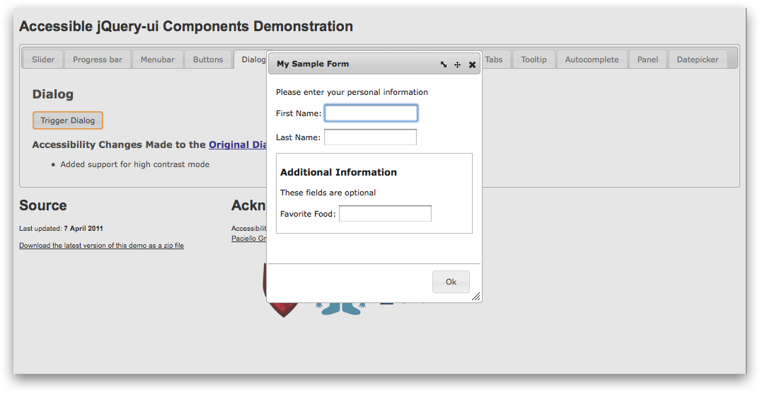
Figure 54: Lightboxes can have accessibility implications.
For non-sighted people who are not aware that this is how lightboxes function, a link that causes a lightbox to open is likely to appear broken. The same can also be said for a lot of tabbed interfaces and other JavaScript plug-ins on the web today. As a rule of thumb, if content is shown, hidden or inserted into the DOM, it should be inserted into the document immediately after the element that triggered the action. For example, if a link is used to open a lightbox, the HTML for the lightbox should be inserted into the source of the document immediately after the link that was clicked. This will make it easier for people who use a keyboard for navigation to find the content that has been loaded or inserted into the page.

14.5 Triggering events on focus
The focus and blur events can be used to great effect if they are used to supplement a persons’ browsing experience. However, if they are used in such a way that they seize control of interactive elements from the person using the site they can be extremely damaging in terms of accessibility.
For people who use a keyboard for navigation, the focus event can cause significant issues if used in such a way that moving focus to an element causes some sort of action that is unexpected. For example, if a form is submitted when the submit button receives focus people who are unable to see their screen are likely to be confused and disorientated. As far as they are concerned, they did not activate the submit button and as such the form should not have been submitted.

Conversely, the focus and blur events are frequently used to display or remove tooltips or extra information when an element receives or looses focus. This is a perfectly valid thing to do, but accessibility is an extremely important consideration to make when building this type of functionality. Consider a search form on a web page. Many websites use JavaScript to add a default visible label within the field itself. When the search field receives focus, this visible label is removed, and replaced when focus is moved away from the field only if the field is left empty.

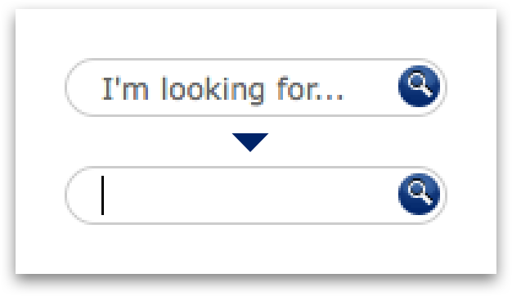
Figure 55: Placeholder text used on a form element.
This is a perfectly valid case for making use of focus and blur events. However, a blind person using a screen reader would never find this ‘label’ since whenever they move focus to the field it is removed. To circumnavigate this issue, we need to ensure that a correctly marked up label is provided and bound to the form field. This HTML label can be positioned off screen using absolute positioning. This will ensure that the actual HTML label is available to people who use screen readers, and that a visible alternative is available for sighted people.

HTML

<label class=”rm” for=”q”>search</label>
<input type=”text” id=”q”>

CSS

.rm {position: absolute; left: -999em;}

14.6 Triggering events on input
Many sites on the web today make use of JavaScript to submit forms when someone selects an option from a drop down select box. This kind of functionality is frequently employed to provide widgets that allow people to dynamically filter search results or content on a page.
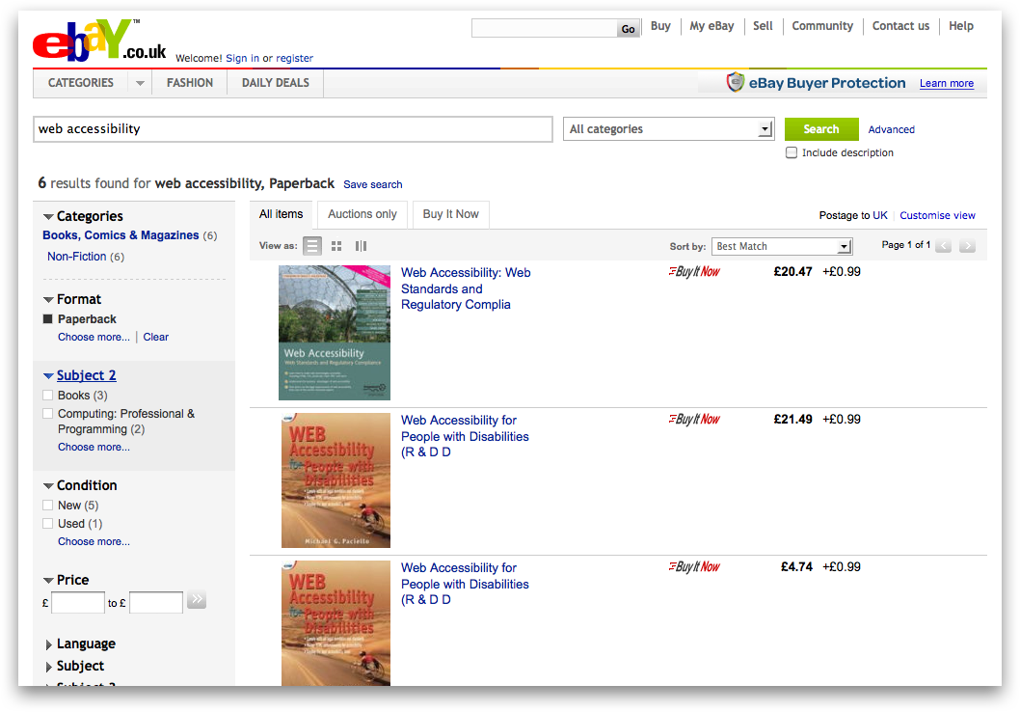
Figure 56: Provide submit buttons for form elements.
Sighted people are often able to identify new or updated content on the page when JavaScript is used in this way. However, for people who are blind this change to the page may not be so apparent. Furthermore, if a blind person using a screen reader were to make a selection from a select box that prompted a page refresh they would likely find themselves confused and disorientated. Strictly speaking, every single form on a page should have a submit button. JavaScript should not be used to submit forms automatically. Control over form submissions should be left in the hands of the person using the form. This will ensure that web pages containing forms will behave in an entirely predictable manner and will reduce the amount of potential confusion surrounding form submissions.

14.7 Unconventional features and behaviour
It is commonplace to find all sorts of widgets on the web today that were not originally accounted for in previous HTML specifications. On a day-to-day basis you are likely to encounter slider widgets, drag and drop functionality and all sorts of other user interface components. One of the main problems that this presents for web developers today is in exposing semantic information about these widgets, user interface components and their states at any given time to visually impaired people.

Consider a video player on a web page. The video player has a slider bar that:

- Identifies the current position of the video;
- Allows people to skip to a different part of the video with ease.

This is great for sighted people. However, HTML lacks the semantic capability to present this information to people who use assistive technologies such as screen readers in a dynamic way. For example, it is very hard to identify the current position of a video to a person using a screen reader using only JavaScript and HTML.

This checkpoint therefore tries to address some of the accessibility implications of creating bespoke or non-standards compliant features on a website and aims to provide guidance on what tools a developer can use to create the best possible experience for every user, regardless of any disability they might have.

Further reading
- WAI-ARIA Overview-http://www.w3.org/WAI/intro/aria.php
- Wai aria document landmark roles-http://www.nomensa.com/blog/2010/wai-aria-document-landmark-roles/
- Screen readers and aria landmark roles-http://www.nomensa.com/blog/2010/screen-readers-and-aria-landmark-roles/
- UNDERSTANDING-WCAG20 – keyboard trapping-http://www.w3.org/TR/UNDERSTANDING-WCAG20/keyboard-operation-trapping.html
- QUICK REFERENCE – Keyboard trapping-http://www.w3.org/WAI/WCAG20/quickref/#qr-keyboard-operation-trapping
- Keyboard traps-http://www.nomensa.com/blog/2011/keyboard-traps/
- UNDERSTANDING-WCAG20 – Time limits pause-http://www.w3.org/TR/UNDERSTANDING-WCAG20/time-limits-pause.html
- UNDERSTANDING-WCAG20 - Focus order-http://www.w3.org/TR/UNDERSTANDING-WCAG20/navigation-mechanisms-focus-order.html
- QUICK REFERENCE - Focus-order-http://www.w3.org/WAI/WCAG20/quickref/#qr-navigation-mechanisms-focus-order
- Accessible tabs part 1 the problem-http://www.nomensa.com/blog/2011/accessible-tabs-part-1-the-problem/
- Accessible tabs part 2 the solution-http://www.nomensa.com/blog/2011/accessible-tabs-part-2-the-solution/
- UNDERSTANDING-WCAG20 – On focus- http://www.w3.org/TR/UNDERSTANDING-WCAG20/consistent-behavior-receive-focus.html
- QUICK REFERENCE – On focus-http://www.w3.org/WAI/WCAG20/quickref/#qr-consistent-behavior-receive-focus
- UNDERSTANDING-WCAG20 – On Input-http://www.w3.org/TR/UNDERSTANDING-WCAG20/consistent-behavior-unpredictable-change.html

ARIA Information
- Aria Specification - http://www.w3.org/TR/wai-aria/
- Using WAI-ARIA roles - http://www.w3.org/TR/wai-aria/usage
- Introduction to ARIA - http://dev.opera.com/articles/view/introduction-to-wai-aria/

Appendix: Contact Details
For queries relating to these guidelines - digital-comms@ucl.ac.uk
For any questions about using the Silva content management system - silva–support@ucl.ac.uk
For other, general, web-related questions - web–support@ucl.ac.uk

