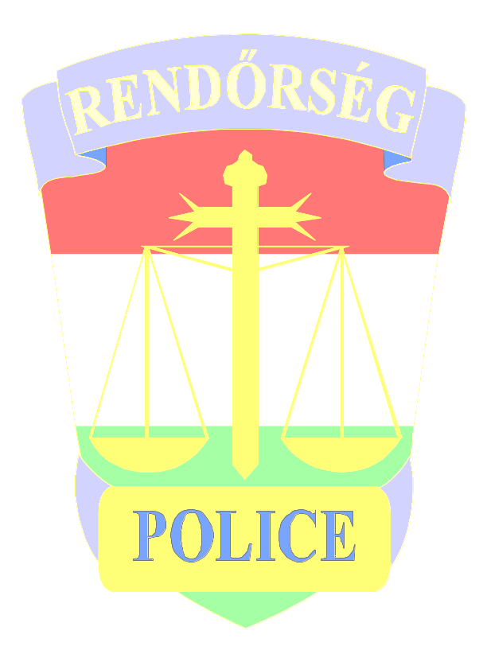
Welcome to county Bekes!

County Bekes waits for tourists and foreigners, who would like to know the sights of the county or would like to spend a few days or weeks in famous resorts of the county. Slogen of the Hungarian Police: We serve and defend you! This slogen concern to you, too! Hungarian Police does evreything for you, to feel yourself in safe and nice by us! Don’t be a victim of a crime! Accept our crime prevention tips, please!

- If you can, stop your car in a guarded parking place!
- Don’t leave personal documents, money, credit cards and documents of vehicle in your car!
- Don’t leave valuable pockets, mobil telephone or other valuable technical articles in your veichle!
- Use safe depozit of hotels, bathes and campings!
- Don’t keep your wallet, credit cards and personal documents in outside pockets of your clothes !
- Take care of your valuables specially in market-places, public transportations and public places, where many people congregate!

Watch out your values, don’t give chance for thieves!

If you became a victim of a crime , turn to a policemen for help , or call number 107 ( police) or number 112( emergency number)!

Bekes County Police Headquarters
Crime Prevention Departman

Numbers of Policing Organization in
county Bekes

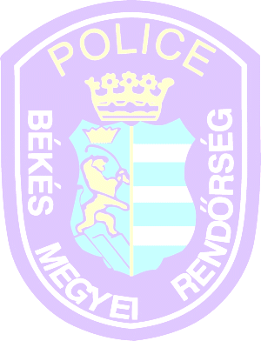  Békés Megyei Rendőr-főkapitányság (Bekes County Police Headquarters ) | 5600 Békéscsaba,  Bartók Béla út 1-3. | T: 06/66/523-700
Békéscsaba  Rendőrkapitányság (Police Headquarters) | 5600 Békéscsaba,  Bartók Béla út 1-3. | T: 06/66/523-700
Békés  Rendőrkapitányság (Police Headquarters) | 5630 Békés,  Rákóczi u 11/13. | T: 06/66/411-644
Gyula  Rendőrkapitányság (Police Headquarters) | 5700 Gyula,  Béke sugárút 51. | T: 06/66/361-644
Mezőkovácsháza  Rendőrkapitányság (Police Headquarters) | 5800 Mezőkovácsháza, Árpád u. 196/198. | T: 06/68/381-255
Orosháza  Rendőrkapitányság (Police Headquarters) | 5900 Orosháza,  Szabadság tér 2. | T: 06/68/411-344
Sarkad  Rendőrkapitányság (Police Headquarters) | 5720 Sarkad,  Árpád Fejedelem tér 4. | T: 06/66/375-622
Szarvas  Rendőrkapitányság (Police Headquarters) | 5540 Szarvas, Szabadság u 25/27. | T:06/66/313-711
Szeghalom  Rendőrkapitányság (Police Headquarters) | 5520 Szeghalom, Kossuth tér 1. | T: 06/66/371-555
Battonya  Határrendészeti Kirendeltség (Border Policing Offices) | 5830 Battonya,  Bajcsy-Zs. u. 78. | T: 06/68/556-080
Lökösháza  Határrendészeti Kirendeltség (Border Policing Offices) | 5743 Lőkösháza,  Vasút u. 1. | T: 06/66/550-420
Kötegyán  Határrendészeti Kirendeltség (Border Policing Offices) | 5725 Kötegyán, Határőrtelep 10. | T: 06/66/572-810
Biharugra  Határrendészeti Kirendeltség (Border Policing Offices) | 5538 Biharugra,  Erzsébet u.1. | T: 06/66/590-910
Gyula  Határrendészeti Kirendeltség (Border Policing Offices) | 5711 Gyula,  Széchenyi tér 5. | T:06/66/562-540

