Preface

Within the scope of my study Business Mathematics and Informatics at the division of the Faculty of Science at the Vrije Universiteit at Amsterdam, I have to write a paper. The subject of this paper is about what e-business is. I chose this subject because nowadays e-business is a hype, in a positive as well in a negative sense.

As we enter the second millenium we experience one of the most important changes in our lives-the move to an Internet-based society. One of the most significant changes is in the manner we conduct businesses, especially in how we manage the marketplace and commerce. (Turban E. et al., 1999). Words like e-business and e-commerce are added to our vocabulary. But what exactly is e-business. Is it the same as e-commerce? In this paper I will try to give a description of e-business and its relation to e-commerce.

I would like to use this opportunity to express my gratitude to Prof. Dr. A.E. Eiben who made all this possible.

Executive Summary

There is no single definition for e-business. Every organization has it own definition for e-business. Also many people use the term e-commerce. Some organizations make a distinction between e-business and e-commerce. Basically these organizations define e-business as the management of business process such as communication and coordination through the use of Internet technologies and e-commerce is define as buying and selling goods and services through the Internet.
Definition of e-commerce given by various sources differs significantly. Some include all financial and commercial transactions that take place electronically, including electronic data interchange (EDI), electronic funds transfer (EFT), and all credit/debit card activity. Others limit e-commerce to retail sales to consumers for which the transaction and payment take place on open network like the Internet. The first type refers to forms of electronic commerce that have existed for decades and the second type has existed for a few years.
Academics give a very broad definition that includes all those communication applications that support commercial activities. Their focus is on electronic commerce as a strategy or business model, rather than on e-commerce as an application or technology. Private research companies, the “e-consultants”, usually cover both the broader definition that focused on business processes or focus on Internet commerce, distinguish between business-to-business and business-to-consumer e-commerce. The business or industry definition can be broader or narrower and the terms used are usually e-business for the former and e-commerce for the latter. Key to the narrower definition is the transactional aspect.
The definition used by statisticians is inevitably more focused and narrow (since it has to be directly measurable). Because statistical offices aim at collecting data on the use of certain technologies/applications (e.g. the Internet, EDI, email, etc) and electronic processes (e.g. electronic stock monitoring, electronic transactions, electronic ordering or purchasing, etc.
Policy makers’ definitions of e-commerce are often very broad in order to capture the impacts of e-commerce, cover all segments of transactions and all sectors in the economy. But policy makers also need narrower definition to respond to specific policy concerns.

E-commerce can be classified by the nature of transaction. The following types are distinguished:
- Business-to-business (B2B);
- Business-to-consumer (B2C);
- Consumer-to-consumer (C2C);
- Consumer-to-business (C2B);
- Nonbusiness e-commerce;
- Intrabusiness (organizational) e-commerce.

Models of B2B:
- Supplier-oriented marketplace;
- Buyer-oriented marketplace;
- Intermediary-oriented marketplace;
- Virtual corporations: networking between business partners;
- Networking between headquarters and subsidiaries;
- Online services to business.
- There are many online services available for businesses, although individual customer can share some of the services. Among the various online services, the ones mostly used by businesses are:
- Travel and tourism services;
- Real estate;
- Electronic payments;
- Online stock trading;
- Electronic auction to business bidders;
- Online publishing and education;
- Online loan and capital makers;
- Other online services.

EDI and standards
Electronic data interchange has been around for almost 30 years in the non-Internet environment. It is a system that standardizes the process of trading and tracking routine business documents, such as purchase orders, invoices, payments, shipping manifest, and delivery schedules. EDI translates these documents into a globally understood business language and transmits them between trading partners using secure telecommunications. The most popular standard is United Nations EDI for Administration, Commerce, and Trade (EDIFACT). In the United States, the most popular standard is ANSI X.12. Traditional EDI users (most Fortune 1,00 or global 2,00 companies) used leased or dedicated telephone lines or a VAN, such as this run by IBM and AT&T, to carry these data exchanges. To distinguish it form Internet-based EDI, EDI on the non-Internet platform is traditional EDI.

Models of B2C e-commerce:
- Direct versus Indirect Marketing
- Full Cybermarketing versus Partial Marketing
- Electronic distributor versus Electronic Broker
- Electronic Store versus Electronic Shopping Mall
- Generalized E-malls/stores versus Specialized E-malls/stores
- Global versus Regional Marketing
- Sales versus Customer Service

E-commerce platforms
The Internet, intranet, and extranet are the most popular platforms for e-commerce. In Internet is the most common platform for B2C e-commerce; the intranet is most the common for platform for corporate internal management; and the extranet is the most common platform for B2B e-commerce.

The Internet is a public and global communication network that provides direct connectivity to anyone over a local area network (LAN) or Internet Service Provider (ISP). The Internet is a public network that is connected and routed over gateways. End users are connected to local access providers (LANs or ISPs), who are connected to the Internet access providers, to network access providers, and eventually to the Internet backbone.

An intranet is a corporate LAN (Local Area Network) or wide area network (WAN) that uses Internet technology and is secured behind company’s firewalls (see security and protection). The intranet links various servers, clients, databases, and application programs like Enterprise Resource Planning (ERP).
An extranet, or “extended intranet”, uses the TCP/IP protocol network of the Internet, to link intranets in different locations. Extranet transmissions are usually conducted over the Internet. Extranets provide secured connectivity between corporation’s intranets and the intranets of its business partners, material suppliers, financial services, government, and customers. Access to intranets is usually limited by agreements of the collaborating parties, is strictly controlled, and is only available to authorized personnel.

Auctions
The Internet provides an infrastructure for executing auctions much cheaper, with many more involved sellers and buyers. Individual consumers and corporations alike can participate in this rapidly growing and very convenient form of E-commerce.
There are several types of auctions, each with its motives and procedures. Klein (1997) classified them into four major categories as shown in Table 1 below.

Auction Type | Coordination  Mechanism | Price discovery | Allocation mechanism | Distribution mechanism
Buyer role | Short-term acquisition of resources, e.g. for demand peaks, auction as a mechanism to achieve an equilibrium | Often experts/professional collectors trying to acquire rare items at a reasonable price | Bargain hunting, gambling motive | Bargain hunting, gambling motive; possible side motive: charity
Supplier role | Short-term allocation of resources, load balance | Exposing items for sale to a charity sufficient breadth of demand, hope for a high price | Clearance of inventory | Attention: direct sales channel, public relations; possible side motive: charity
Auctioneer/  Intermediary role | Often electronic auction without auctioneer | Active high breadth and depth of the auctions, high trading volume results in high returns, competitive advantage over other auctions | Active high breadth and depth of the auctions, high trading volume results in high returns, competitive advantage over other auctions | Limited role because supplier-buyer relation: possible function as service provider for the supplier side
Table 1: Motives of the Participants in Different Auction Types

Netherlands’s e-business
In 1998 the Ministry of Economic Affairs started the “Electronic Commerce Action Plan”. The objective of this action plan is to develop the Netherlands into one of the leading nations in the field of e-commerce. Since the Netherlands already fulfills as the gateway to Europe, the goal is to develop the Netherlands into an “Information Gateway to Europe”.
The Netherlands wants to be one of the leaders in the field of electronic commerce. Its starting position is potentially favorable:
- the market penetration of PCs and the number of subscription to the Internet is relatively high;
- the Netherlands is a nation that “pins” on a large scale (i.e. a system of cashpoint cards protected by a IN code is widely used) and is very familiar with the concept of telebanking;
- the use of EDI and the possession of chipcards (smart cards) is high compared with many Western countries;
- the Netherlands has some important providers, such as Philips, Baan, KPN, Ericsson and Alcatel, and has some European markets leaders in sectors that are important for electronic commerce, such as transport, business and financial services, trade and publishing;
- the Netherlands has a good underlying infrastructure and occupies a key position in the field of logistics and distribution;
- an international outlook, a high standard of education and good linguistics skills are also among the Netherlands’ key assets.

Worldwide it is recognized that there are factors that hinder the rapid development of electronic commerce. These are mainly of an economic, legal and technical nature. This one of the reasons why the Netherlands’ business sector is hesitant to push ahead with E-commerce. SMEs (Small and Medium Enterprises), in particular, are reluctant because the investment in people, hardware and software is high, while the return on investment is uncertain. There is also a shortage of skilled personnel to make the necessary adaptations to business processes. Furthermore, there are still many legal uncertainties, which, in view of the global character of E-commerce, demand internationally coordinated actions.

The introduction and implementation of E-commerce will primarily be market driven. The Netherlands’ government sees its task to ensure that market players are in a position to take advantage of the developments and new opportunities of E-commerce. It does this by:
- creating a climate in which there is a scope for private-sector initiatives;
- increasing opportunities for research and developments;
- creating a clear and consistent legal framework;
- organizing its own position as a market player to enable it to have an encouraging and guiding role.

Table of Contents
Chapter 1 Introduction 1
Chapter 2 Is E-business = E-commerce? 3
2.1 What is E-business? 3
2.2 E-commerce 4
2.2.1 Some E-commerce definitions: 5
2.2.2 Pure versus Partial E-commerce 6
2.2.3 The E-commerce field 7
2.2.4 Classifications of E-commerce applications 7
2.2.5 Classification of the E-commerce field by nature of the transactions 9
2.3 A brief history of e-commerce 9
2.4 Interdisciplinary nature of E-commerce 10
Chapter 3 Business-to-Business and Business to-Consumer E-commerce 12
3.1 Characteristics of B2B E-commerce 12
3.1.1 Supply chain 13
3.1.2 Entities of B2B e-commerce 13
3.2 Models of B2B e-commerce 14
3.3 Other B2B models, Actions and Services 18
3.3.1 Business-to-Business auctions 18
3.3.2 Managed Interactive Bidding 19
3.3.3 Facilitating Auctions and Bartering 19
3.4 From Traditional to Internet-based EDI 20
3.4.1 Traditional EDI 20
3.4.2 Internet-based EDI 22
3.5 Business –to-consumer E-commerce 23
3.6 Business models of B2C 23
Chapter 4 Architecture of Internet, Intranet, and Extranet 25
4.1 The Internet 25
4.2 The Intranet: An Intrabusiness Delivery System 26
4.3 The Extranet 26
Chapter 5 Auction: From theory to practice 29
5.1 Types of auctions 29
5.2 Electronic auctions 29
Chapter 6 E-commerce in the Netherlands 31
6.1 Netherlands’ starting position 31
6.2 Obstacles to electronic commerce in the Netherlands 32
6.3 Role of the government 32
6.4 Some facts and figures of Dutch Internet Spending 34
Bibliography 37

Introduction

In the age of Internet and electronic communications, everything gets an “e” as prefix. The most popular words are e-business and e-commerce. Forecast by many well-known research companies on e-commerce gave staggering numbers on the growth of e-commerce:

- In their report Re-sizing On-line Trade Business, research bureau Forrester (cf. Bell et al., 1998) anticipates a five to ten year period of hyper growth in e-commerce in the United States. In the year 2003 on-line trading in the US will have reached $1.3 trillion
- For the year 2002, and for the same market, IDC (cf. Scharis, 1998) forecast what is said to be a similar estimation, namely a turnover of $1 trillion.
- One-fourth of all U.S. business-to-business purchasing will be done online by 2003 predicts a new study of the business-to-business e-commerce market by The Boston Consulting Group (BCG). BCG estimates that between 1998 and 2003, U.S. business-to-business e-commerce will grow by 33% per year and reach $2.8 trillion in transaction value.

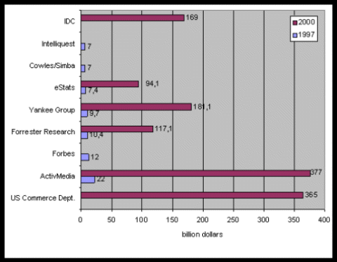
Figure 1.1 Revenues given by different research companies (Source: Digitaal zaken doen, Bouwtekening voor een E-commerce monitor, p. 11)

As depicted in Figure 1.1, e-commerce will generate a lot of revenue. In practice the term e-commerce and e-business are often used interchangeably. What are e-business and e-commerce exactly? In Chapter 2 definitions of e-business will be given that are use by various sources and how they differ from each other. A summary of definitions of e-commerce will be given and also the development of the definitions of e-commerce. Also the difference between e-business and e-commerce will be described. The major form of e-commerce is B2B e-commerce. A big part of the revenues generated with e-commerce are generated with B2B e-commerce. Chapter 3 describes the B2B en B2C e-commerce. Many people associate e-commerce with online shopping also known as e-tailing (e-tailing is the selling of retail goods on the Internet and is a synonymous with business-to-consumer (B2C transaction). Chapter 4 describes something about the Internet, intranet and extranet which are the most popular platforms for e-commerce. The Internet provides an infrastructure for executing auctions much cheaper, with many more involved sellers and buyers. Chapter 5 describes what type of auctions that exist. Chapter 6 describes e-commerce in the Netherlands.

Is E-business = E-commerce?

What is E-business?
According to IBM who was one of the first to use the term e-business (in October 1997), e-business is: ”The transformation of key business processes through the use of Internet technologies”.

Other definitions by other companies and organization are:
- PricewaterhouseCoopers: “At it most basic level, e-business means building the link between our clients and their customers and suppliers… connecting companies, departments, customers and locations. It involves taking processes currently functioning within business and moving them to networks and shared applications. But taken further, e-business is a holistic, integrated strategy-driven undertaking. It demands that enterprise examine, and probably change the way they perform basic business functions: sales, marketing, customer service, purchasing, operations overseas initiative, human resources, finance, and, of course, IT.”
- High Latitude: “E-business is doing many business activities electronically using Internet-centric technologies. The focus of e-business is on the application of Internet technologies in the management of day-to-day business processes.
E-business processes not only include online marketing and sales, but also supply-chain and channel management, manufacturing and inventory control, financial operations and employee workflow procedures across the entire organization.
Essentially e-business technologies empower customers, employees, suppliers, distributors, vendors and partners by giving them powerful tools for information management and communications.
The intent of e-business is to apply the benefits of Internet technologies to better manage a company’s total value-chain with a focus on workflow, distributed workgroup computing and Internet-centric, knowledge-oriented operations at all levels.”
- Whats.com: “e-business (electronic business), derived from such terms as e-mail and e-commerce, is the conduct of business on the Internet, not only buying and selling but also servicing customers and collaborating with business partners”.
- Antares: “E-business is het uitvoeren van bedrijfsvoering waarbij deze intergraal wordt ondersteund middels geautomatiseerde middelen en waarbij dit ook weer maximaal is geintegreerd met geautomatiseerde systemen van klanten, leveranciers en partners”.
- Laudon & Laudon: “The use of the Internet and other digital technology for organizational communication and coordination and the management of the firm”.
- U.S. Census Bureau: “Electronic business (e-business) is any process that a business organization conducts over a computer-mediated network”.

Every organization has its own definition for e-business. E-business is less about technology than it is about business. It’s about doing business differently. As Cec Primeau from PriceWaterhouseCoopers explains: “E-business is a concept, not a product. It’s about using Web-enabled technologies to link your entire value chain.”
In the narrowest sense, e-business is the use of information and Internet technology to conduct business among buyers, sellers and other trading partners. In a broader sense, e-business goes beyond the technology that enables it. Think of it as any other business practice that improves performance, creates value and establishes customer relationships, only it is done electronically over the Internet.

E-commerce
Definitions of e-commerce given by various sources differ significantly. Some include all financial and commercial transactions that take place electronically, including electronic data interchange (EDI), electronic funds transfer (EFT), and all credit/debit card activity. Others limit e-commerce to retail sales to consumers for which the transaction and payment take place on open network like the Internet. The first type refers to forms of electronic commerce that have exist for decades and result in trillions of dollars worth of activity every day. The second type has existed for a few years.

Some definitions are best suited for statistical measurement because they include a list of items that fit within the boundaries of existing statistical classifications; some are best suited to address certain policy concerns. Not only is it possible to construct a typology of definitions, but also to have a typology of views. Some academics give a very broad definition that includes all those communication applications that support commercial activities. Their focus is on electronic commerce as a strategy or business model, rather than on e-commerce as an application or technology. Private research companies, the “e-consultants”, usually cover both the broader definition that focused on business processes or focus on Internet commerce, distinguish between business-to-business and business-to-consumer Internet commerce. But also in the case on Internet commerce various definitions can be found according to what part of the Internet transaction is included.

The business or industry definition can be broader or narrower and the terms used are usually e-business for the former and e-commerce for the latter. Key to the narrower definition is the transactional aspect. A survey of business views on the definition of e-commerce conducted on behalf of Statistics Canada also distinguishes between e-business and e-commerce. According to the findings of the survey, “the notion of transaction, computer-mediation, channels and trigger events were found to be key concepts in defining e-commerce”. Also, industry perception of what are relevant computer-mediated channels or electronic commerce networks on which e-business or e-commerce takes place differs across sectors, hence a definition should clearly specify on what type of networks or applications e-commerce occur.

Public statistical offices are now starting to develop e-commerce-related surveys. The definition used by statisticians is inevitably more focused and narrow (since it has to be directly measurable). Because statistical offices aim at collecting data on the use of certain technologies/applications (e.g. the Internet, EDI, email, etc) and electronic processes (e.g. electronic stock monitoring, electronic transactions, electronic ordering or purchasing, etc), in most cases there is not even the need for a comprehensive definition. For example most of the surveys are now focussing on Internet commerce. Statistical surveys are very rich instruments that can be used to measure not only e-commerce transactions or e-commerce usage but also broader definitions and impacts. Broader definitions of e-commerce can be implemented statistically as long as those definitions are detailed enough (e.g. they disaggregate the transaction in various components, they disaggregate the networks and applications on which e-commerce occurs, etc)
Policy makers’ definitions of e-commerce are often very broad in order to capture the impacts of e-commerce, cover all segments of transactions and all sectors in the economy. But policy makers also need narrower definition to respond to specific policy concerns. For example, there is need for measuring the development of different e-commerce segments since drivers, technological solutions, impacts and policy implications of business-to-business (B2B) and business-to-consumer (B2C) e-commerce are different.

Some E-commerce definitions:
- The Dutch Ministry of Economics Affairs: “all business activities carried out electronically with the intention of improving the efficiency and effectiveness of market processes and business processes”
- European Union: “Electronic commerce is about doing business electronically. It is based on electronic processing and transmission of data, including text, sound and video. It encompasses many diverse activities including trading of goods and services, on-line delivery of digital content, electronic fund transfers, electronic share trading, electronic bills of lading, commercial auctions, collaborative design and engineering, on-line sourcing, public procurement, direct consumer marketing and after sales service. It involves both products (e.g. consumer goods, specialized medical equipment) and services (e.g. information services, financial and legal services); traditional activities (e.g. healthcare education) and new activities (e.g. virtual malls). Electronic commerce is not limited to a particular technology (i.e. TCP/IP) but instead technology neutral. This does not prejudice the fact that TCP/IP represents the technology most commonly used for the purpose of electronic commerce. It cannot be excluded that other protocols are used ”
- IBM: “E-commerce is the ability to offer goods and service through the web”
- U.S. Census Bureau: “Electronic commerce (e-commerce is any transaction completed over a computer-mediated network that involves the transfer of ownership or rights to use goods or service)”
- Whatis.com: “E-commerce (electronic commerce or EC) is the buying or selling of goods and services on the Internet, especially the World Wide Web”
- High Latitude: “E-commerce is the process of managing online financial transaction by individuals and companies. This includes consumer and business-to-business transactions.
The focus of e-commerce is on the system and the procedures whereby financial documents and information of all types are exchanged. This includes online credit card transaction, e-cash, e-billing, e-cheques, electronic invoice, purchase orders and financial statements. E-commerce is particularly concerned with the technologies that enable EDI-type functionality on the Internet.”
- Laudon & Laudon: “The process of buying and selling goods and services electronically involving transaction using the Internet, networks, and other digital technologies.”

In this paper the term e-commerce will be used in its broadest scope, which is basically equivalent to e-business.
E-commerce can also be defined from other perspectives. Kalakota and Whinston (1997) define e-commerce from these perspectives:
- From a communication perspective, e-commerce is the delivery of information, products/services, or payments over telephone lines, computer networks, or any other electronic means.
- From a business process perspective, e-commerce is the application of technology toward the automation of business transactions and workflow.
- From a service perspective, e-commerce is a tool that addresses the desire of firms, consumers, and management to cut service cost while improving the quality of goods and increasing the speed of service delivery.
- From an online perspective, e-commerce provides the capability of buying and selling products and information on the Internet and other online services.

Pure versus Partial E-commerce
E-commerce can take many forms depending on the degree of digitization of the product (service) sold, the process, and the delivery agent (or intermediary). Choi et. al (1997) created a model that explains the possible configurations of these three dimensions (see Figure 2.1). A product can be physical or digital, an agent can be physical or digital, and the process can be physical or digital. These create eight cubes, each of which has three dimensions. In traditional commerce all dimensions are physical (lower left cube) and in pure e–commerce all dimension are digital (upper right cube). All other cubes include a mix of digital and physical dimensions. If there is at least one digital dimension than there is E-commerce (but not a pure one). For example, buying a book form Amazon is not pure, because FedEx delivers the book. However, buying software from EggHead is pure E-commerce because the delivery, payment, and agent are digital.
E-commerce uses several technologies raging from EDI to e-mail. For example, buying food from a vending machine using a smart card can also be seen as E-commerce.

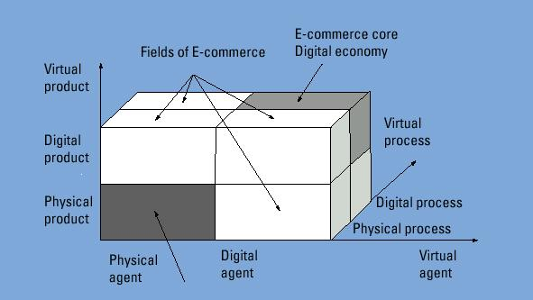
Figure 2.2 The Dimension of Electronic Commerce (Source: Measuring E-commerce: Recommendation for a Dutch E-commerce monitor, p. 18)

The E-commerce field
Many people think E-commerce is just having a Web site, but E-commerce is much more that that. There are dozens of applications of E-commerce such as home banking, shopping in online stores and malls, buying stocks, finding a job, conducting an auction, and collaborating electronically on research and development projects. To execute these applications, it is necessary to have supporting information and organization infrastructure and systems. Figure 2.2 shows that e-commerce applications are supported by infrastructures and their implementation is dependant on four major areas (shown as supporting pillars); people, public policy, technical standards and protocols, infrastructures, and pillars. Figure 2.2 can be viewed as a framework for understanding the relationships among E-commerce components and for conducting research in the field.

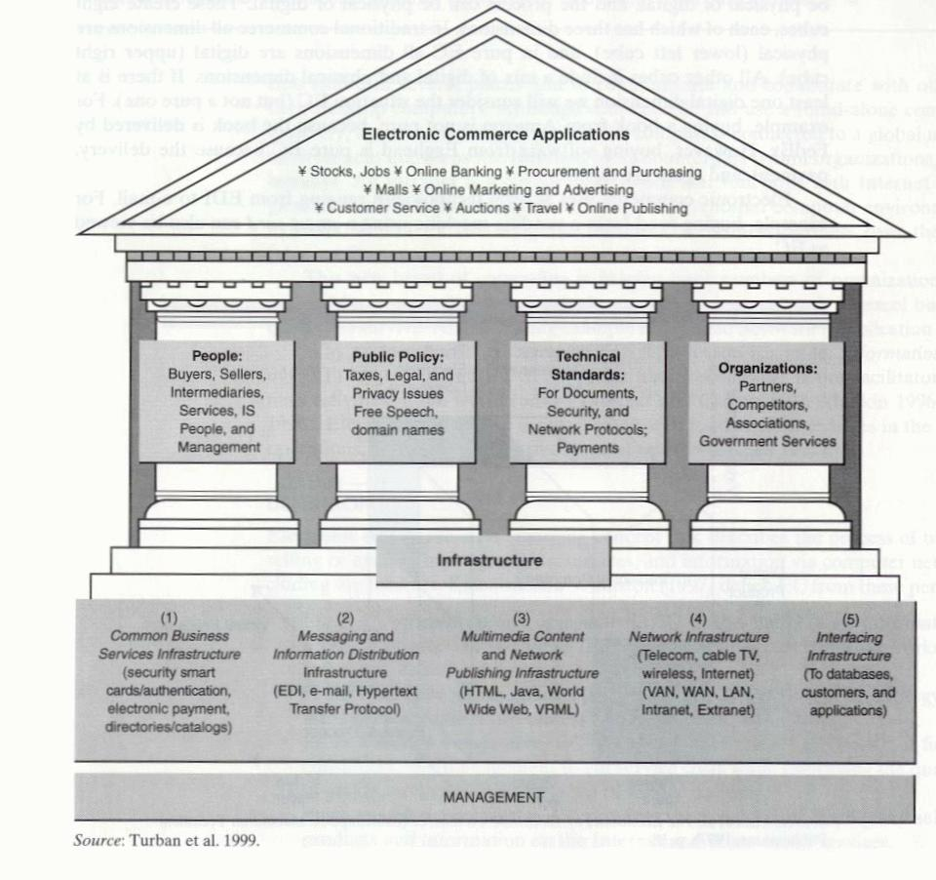
Figure 2.2 A Frame work for Electronic Commerce (Source: Turban et al. (2000), p. 6)

Classifications of E-commerce applications
Applications of E-commerce are divided into 3 categories.
- Buying and selling goods & services. These are usually referred to as electronic markets.
- Facilitating inter- and intraorganization flow of information, communication and collaboration. These are sometimes referred to as inter-organizational systems.
- Providing customer service.

Electronic markets
A market is a network of interactions and relationships where information, products, services, and payments are exchanged. When the marketplace is electronic, the business center is not a physical building but rather a network-based location where business interactions occur (Figure 2.3). As can be seen in the figure, the electronic market is the place where shoppers and sellers meet. The market handles all the necessary transactions, including the transfer of money between banks. In electronic markets, the principal participants-transaction handlers, buyers, brokers, and sellers, are not only at different locations but seldom even know one another. The means of interconnection varies among parties and can change from event to event, even between the same parties.

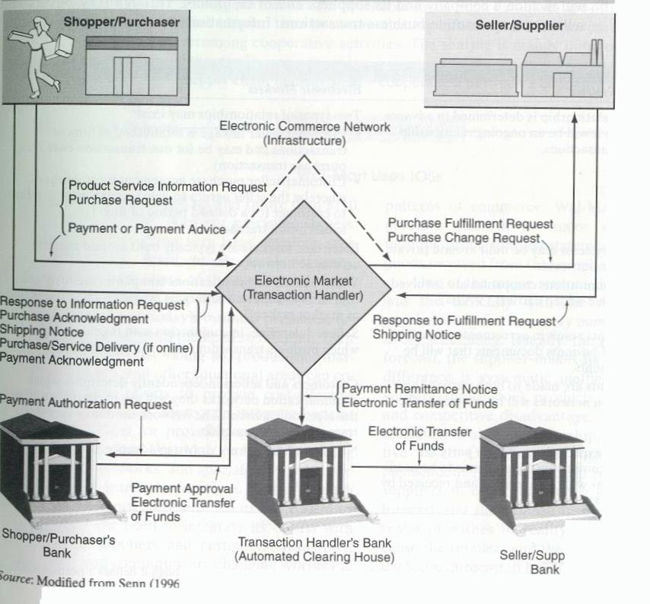
Figure 2.3 Electronic Markets (Source: Turban et al. (2000), p. 7)

Classification of the E-commerce field by nature of the transactions
A common classification of e-commerce is by the nature of transaction. The following types are distinguished:
- Business-to-business (B2B). Most of the e-commerce today is of this type. It includes the IOS transactions and electronic markets transaction between organizations.
- Business-to-consumer (B2C). These are retailing transactions with individual shoppers.
- Consumer-to-consumer (C2C). In this category consumer sells directly to consumers. Examples are individuals selling in classified ads and selling residential property, cars, and so on. Advertising personal services on the Internet and selling knowledge and expertise is another example of C2C. Several auction sites allow individuals to put items up for auctions. Finally, many individuals are using Intranets and other organizational internal networks to advertise items for sale or services.
- Consumer-to-business (C2B). This category includes individuals who sell products and services to organizations, as well as individuals who seek sellers, interact with them, and conclude a transaction.
- Nonbusiness E-commerce. In increased number of nonbusiness institutions such as academic institution, non-profit organizations, religious organizations, social organizations, and government agencies are using various types of e-commerce to reduce their expenses (e.g., improve purchasing) or to improve their operations and customer service.
- Intrabusiness (organizational) E-commerce. In this category we include all internal organizational activities, usually performed on Intranets, that involve exchange of goods, services, or information. Activities can range from selling corporate products to employees to online training and cost-reduction activities.

A brief history of e-commerce
E-commerce applications started in the early 1970s, which such innovations as electronic funds transfer (EFT). However, the extent of the applications was limited to large corporations, financial institutions, and a few daring small businesses. Then came EDI, which expanded form financial transaction to other transaction processing and enlarged the participating companies form financial institutions to manufacturers, retailers, services, and so on. Many other applications followed, ranging from stock trading to travel reservation systems. Such systems were described as telecommunication applications and their strategic value was widely recognized. With the commercialization of the Internet in the early 1990s and its rapid growth to millions of potential customers, the term electronic commerce was coined, and e-commerce applications expanded rapidly. One reason for the rapid expansion of the technology was the development of networks, protocols, software, and specifications. The other reason was the increase in competition and other business pressures. From 1995 to 1999 there were many innovative applications ranging from advertisement to auction and virtual reality experiences. Almost every medium- and large-sized organization in the United States already has a Web site. Many are very extensive; for example, in 1999 General Motors Corporation (www.gm.com) offered 18000 pages of information that included 98,000 links to its products, services, and dealers.

Stage One – Presence: At this level, the organization relies on e-business channels such as e-mail, browsers, and shared databases to gets its message out efficiently. Risks are small, and so are the likely bottom-line benefits. Security and privacy are chief concerns, especially for companies that collect customer information, for experimenting, learning and building commitment.

Stage Two – Integration: Here, companies link customer to internal information such as data about products, pricing and availability.

Stage Three – Transformation: With the e-business infrastructure in place, executives can focus on the job of delineating their core and non-core competencies. E-business allows them to more easily unbundle operations, retaining only those critical to market position.

Stage Four – Convergence: Over time the cross-industry supply chains take place in the form of networked organizations and markets. They represent the new, customer-centered supply chain model. In the emerging model are dynamic supply chains that made exist for only a single contract, a single customer, or a single instant. Customers gain convenience and choice, as the organization benefits from its position in the extended, cross-industry value networks. Maintaining a company’s relationship, reputation, and unique value proposition with its customer becomes a major priority.

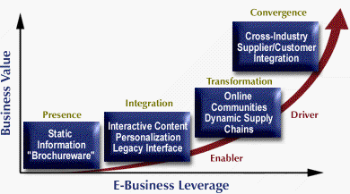
Figure 2.4 Four stages of e-business maturity (Source: PricewaterhouseCoopers, What is E-business?)

Interdisciplinary nature of E-commerce
E-commerce, being a new field, is just developing its theoretical or scientific foundations. It is clear that E-commerce is based on several disciplines. The major disciplines of E-commerce with some sample of the issues with which they are concerned follow:
- Marketing. Many issues of marketing offline are relevant to online E-commerce, for example, cost benefits of advertisements and advertisements strategies. Other issues are unique to E-commerce, ranging from online marketing to interactive kiosks.
- Computer sciences. Many of the issues listed in the infrastructure box of Figure 2.2, such as languages, multimedia, and networks, fall into the discipline of computer sciences. Intelligent agents play a major role in E-commerce as well.
- Consumer behavior and psychology. Consumers behavior is key to the success of B2C trade, but so is the behavior of the sellers. The relationship between cultures and consumers attitude in electronic market is an example of research issue in the field.
- Finance. The financial markets and banks are one of the major participants in E-commerce. Also, financing arrangements are part of many online transactions. Issues such as the Internet as substitute for a stock exchange and fraud in online stock transactions are a sample of the many topics of the field.
- Economics. E-commerce is influenced by economic forces and has a major impact on world and country economies. Also, theories of micro and macroeconomics needs to considered in E-commerce planning, as well as the economic impacts of E-commerce on firms.
- Management information systems (MIS). The information systems department is usually responsible for the development of E-commerce. This discipline covers issues ranging from system analysis to system integration, not to mention planning implementation, security, and payments systems, among others.
- Accounting and auditing. The back-office operations of electronic transactions are similar to other transaction in some respects, but different in others. For example, auditing electronic transaction present a challenge for the accounting profession; so does the development of methodologies for cost-benefit justification.
- Management. E-commerce efforts need to be managed properly, and because of the interdisciplinary nature of E-commerce, its management may require new approaches and theories.
- Business law and ethics. Legal and ethical issues are extremely important in E-commerce, especially in a global market. A large number of legislative bills are pending, and many ethical issues are interrelated with legal ones, such as privacy and intellectual property.
- Others. Several other disciplines are involved in various aspects of E-commerce to a lesser extent-for example, linguistics (translation in international trades), robotics and sensory systems, operations research/management science, statistics, and public policy and administration. Also, E-commerce is of interest to engineering, health care, communication, and entertainment publishing.

Business-to-Business and Business to-Consumer E-commerce

Characteristics of B2B E-commerce
Business-to-business E-commerce implies that both the sellers and the buyers are business corporations, while business-to-consumer E-commerce implies that the buyers are individual consumers. Business-to-business e-commerce is expected to grow to $1,330.9 billion by 2003 and continue to b the major share of the e-commerce market (Freeman 1998, Retter and Calyniuk 1998). The percentage of Internet-based B2B e-commerce compared to the total B2B e-commerce will expand from 0.2 percent in 1997 to 2.1 percent in 2000 and 9.4 percent in 2003. Computing electronics, utilities, shipping and warehousing, motor vehicles, petrochemicals, paper and office products, food, and agriculture are the leading items in B2B e-commerce. See Figure 3.1.

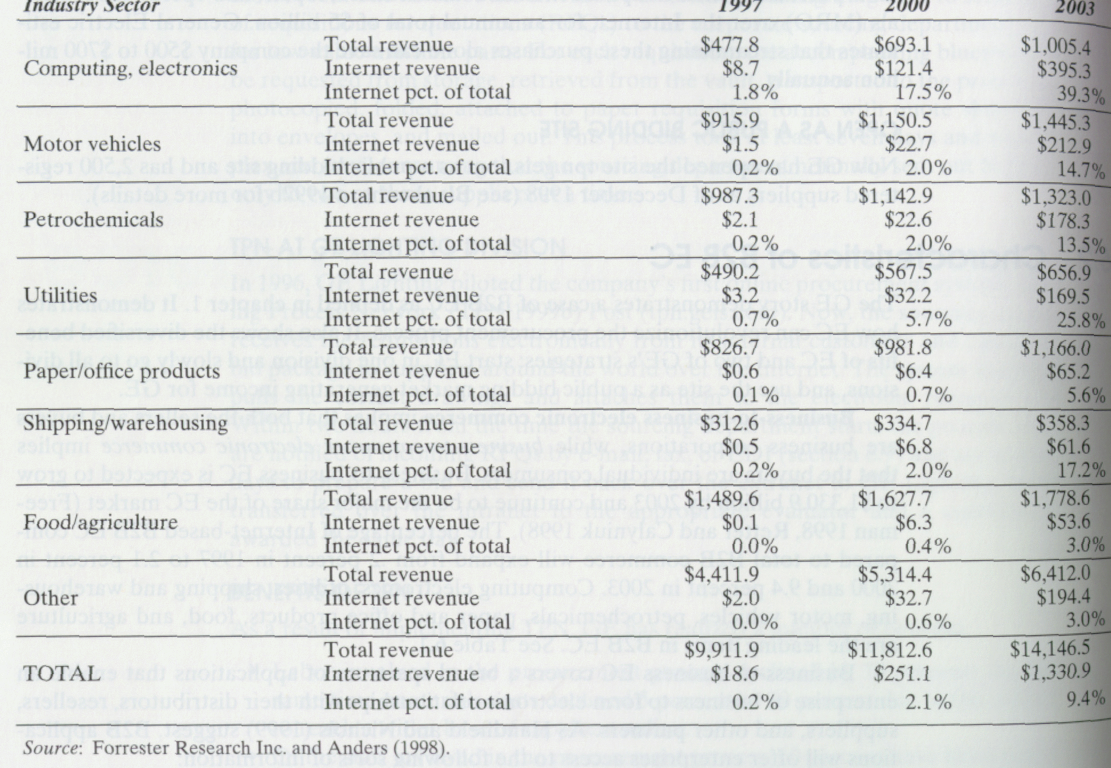
Figure 3.3 Forecasted revenues of the Internet-based B2B e-commerce (dollars in billion) (Source: Turban et al. (2000), p. 200)

Business-to-business e-commerce covers a broad spectrum of applications that enable an enterprise or business to form electronic relationships with their distributors, resellers, suppliers, and other partners. As Handfield and Nichols suggest, B2B applications will offer enterprises access to the following sorts of information:
- Product-specification, prices, sales history
- Customer-sales history and forecast
- Supplier-product line and lead times, sales terms and conditions
- Product process-capacities, commitments, product plans
- Transportation-carriers, lead times, costs
- Inventory-inventory levels, carrying costs, location
- Supply chain alliance-key contacts, partners’ roles and responsibilities schedules
- Competitor-benchmarking, competitive products offering, market share
- Sales and marketing-point of sales (POS), promotions
- Supply chain process and performance-process description, performance measure, quality, delivery time, customer satisfaction

By using B2B e-commerce, business can reengineer their supply chain and partnership.

Supply chain
Even though there are many B2B applications, the relationships between businesses can be best understood in the supply chain context. Consider something as mundane as the manufacture and distribution of cereal. The overall process is shown in Figure 3.2 (Handfield and Nichols 1999). The process actually consist of a number of interrelated processes and roles: all the way from acquisition of grain from farmers (or some other grain suppliers), to the processing of the grain into cereal, the packaging of the cereal into boxes, the transportation of packaged cereal to distributors and grocers, and eventually the purchase by end consumers. Take together these processes and roles are called a supply chain. The supply chain encompasses all the activities associated with the flow and transformation of goods from the raw materials stage all the way to the end user. As shown in Figure 3.2 the supply chain can be broken in three parts-up stream activities involving material and service inputs from suppliers, internal activities involving the manufacturing and packaging of goods, and down stream activities involving the distribution and sale of products to distributors and customers. In the 1990s business managers have come to recognize that management and control of the upstream and the downstream activities – which involved relationships with partners who are technically outside the enterprise- are as important as the internal activities involved in the actual production of products. Historically, many of the processes in the supply chain, especially the upstream and downstream activities, have been managed with paper transaction (e.g. purchases requisitions and orders, invoices, and so forth). This is where B2B e-commerce applications come into play. They can serve as supply chain enablers that can offer a distinct competitive advantage.

Entities of B2B e-commerce
The Internet can provide the most economical B2B e-commerce platform for linking companies without additional network implementation. Since supply chain management encompass “the coordination of order generation order taking, and order fulfillment/distribution of products, services, or information” (Kalakota and Whinston 1997), the involved companies can be studied both from the customers’ and form the purchasers’ point of view. Thus, B2B e-commerce can contribute to lower purchase costs, reduced inventory, enhanced efficiency of logistics, as well as to increased sales and lowered sales and marketing costs. The key entities in B2B e-commerce and their concerns are the following:
- Selling company-with the marketing management perspective
- Buying company-with procurement management perspective
- Electronic intermediary-a third-party intermediating service provider (the scope of the service may be extended to include the order fulfillment)
- Deliver-who should fulfill the JIT delivery
- Network platform-such as Internet, intranet, and extranet
- Protocols and communication-such as EDI and comparison shopping, possibly using software agents
- Back-end information system-possibly implemented using the intranet and Enterprise Resource Planning (ERP) systems.

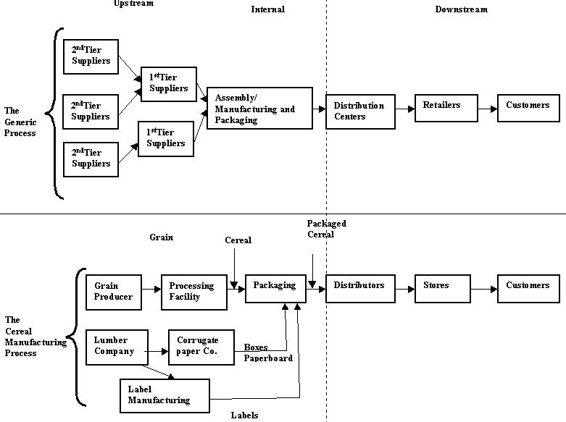
Figure 3.4 Supply Chain of Cereal (Source: Turban et al. (2000), p. 200)

Models of B2B e-commerce
In this section, the business models of B2B are described. The first three models are classified depending upon who controls the marketplace: the supplier, customer, or intermediary. Other important business models are virtual corporation, networking between headquarter and subsidiaries, and online services to business.
- Supplier-oriented marketplace
The most common B2B model is the supplier-oriented marketplace. Most of the manufacturer-driven electronic stores belong to this category. In this model, both individual consumers and business buyers use the same supplier-provided marketplace as depicted in Figure 3.3. The architecture for this B2B model is basically the same as the B2B e-commerce, and the purchasing process is similar.
Another application of the supplier-oriented marketplace is the proprietary action sites like the computer reseller Ingram Micro (http://www.ingram.com/). These sites are only open to approved customers. They are designed to cement relationships between the company and its regular buyers. Sellers can get rid of surplus goods, and business customers can realize deep discounts.

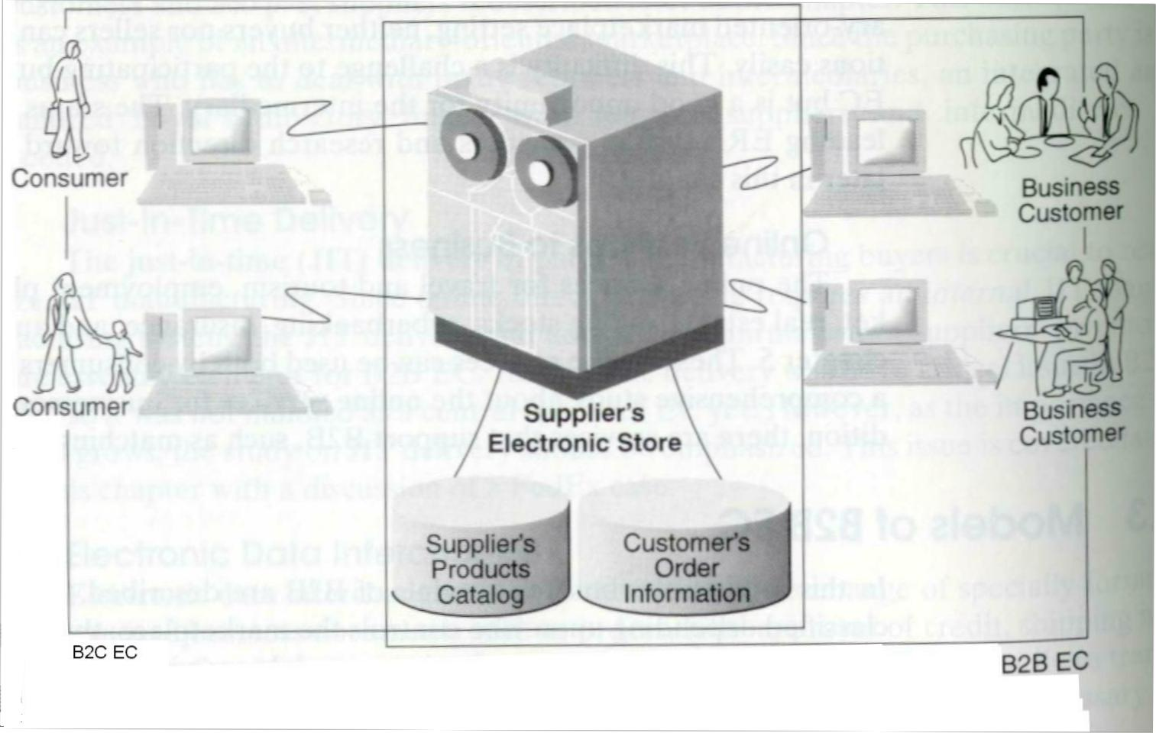
Figure 3.3 Supplier-Oriented B2B Marketplace Architecture (Source: Turban et al. (2000), p. 204)

- Buyer-oriented marketplace
Under the platform of the supplier-oriented marketplace, the buyer’s acquisition department has to manually enter the order information into its own corporate information system. Searching e-stores and e-malls to find and compare suppliers and products can be very costly to big companies like General Electric, who purchase thousands of items on the Internet. Therefore, such big buyers would prefer to open their own marketplace, which we call the buyer-oriented marketplace, as depicted in Figure 3.4. Under this model, a buyer opens an electronic market on its own server and invites potential supplier to bid on the announced requisition of quotations. This model offers a greater opportunity to committed suppliers.

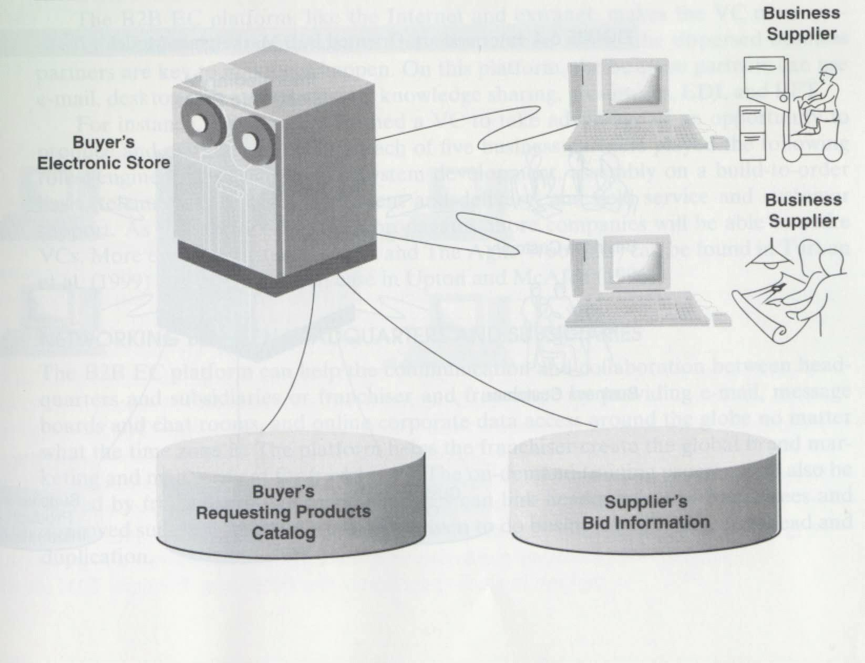
Figure 3.4 Buyer-Oriented B2B Marketplace Architecture (Source: Turban et al. (2000), p. 205)

- Intermediary-oriented marketplace
The third business model is establishing an electronic intermediary company, which runs a marketplace where business buyers and sellers can meet as depicted in Figure 3.5.

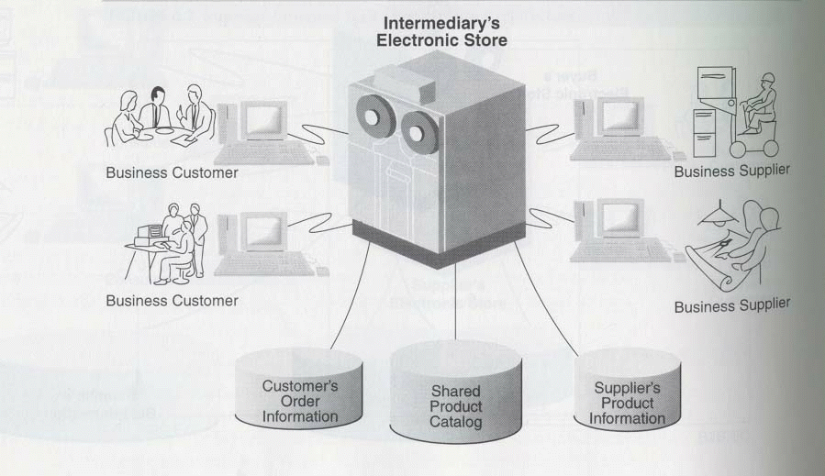
Figure 3.5 Intermediary-Oriented B2B Marketplace Model (Source: Turban et al. (2000), p. 206)

- Virtual corporations: networking between business partners
One the most interesting organization structures is the virtual corporation (VC). A virtual corporation is an organization composed of several business partners sharing costs and resources for the purpose of producing a product or service. According to Goldman et al. (1995), permanent virtual corporations are designed to create or assemble productive resource rapidly, frequently, concurrently, or to create or assemble a broad range of productive resources. The creation, operation, and management of a VC are heavily dependent on the B2B platform. However, VCs are not necessarily organized along the supply chain. For example, a business partnership may include several partners, each creating a portion of products or service in an area which thy have special advantage, such as expertise or low costs. So the modern VC can be viewed as a network of creative people, resources, and ideas connected by online service and/or the Internet. The major goals that VCs pursue are:
- Excellence: Each partner brings it core competentce, so an all-star winning team is created.
- Utilization: Resources of the business partners are frequently underutilized. A VC can utilize them more profitably.
- Opportunism: A VC can find and meet market opportunity better than an individual company.
The B2B e-commerce platform, like the Internet and extranet, makes the VC more successful, because the communication and collaboration among the dispersed business partners are key to making it happen. On this platform, the business partners can use e-mail, desktop video conferencing, knowledge sharing, groupware, EDI, and EFT. For instance, IBM Ambra formed a VC to take advantage of an opportunity to produce and market a PC clone. Each of five business partners played the following roles: engineering design and subsystem development, assembly on a build-to-order basis, telemarketing, order fulfillment and delivery, and field service and customer support. As the B2B e-commerce platform propagates, more companies will be able to make VCs.
- Networking between headquarters and subsidiaries
The B2B e-commerce platform can help the communication and collaboration between headquarters and subsidiaries or franchiser and franchise by providing e-mail, message boards and chat rooms, online corporate data access around the globe no matter what the time zone is. The platform helps the franchiser create the global brand marketing and management for franchisees. The on-demand training program can also be shared by franchisees. Advanced extranets can link headquarters to franchisees and approved suppliers, making it easier for them to do business and reduce overhead and duplication.
- Online services to business
There are many online services available for businesses, although individual customer can share some of the services. Among the various online services, the ones mostly used by businesses are:
- Travel and tourism services: Many large corporations have special discounts arranged with travel agents. To further reduce costs, companies can make special arrangements that enables employees to plan and book their own trip online. For instance, Carlson Travel Network of Minneapolis provides an agentless service to corporate clients like General Electric. The GE employees can fill out the application at their intranet. The system allows a special rate for employees reserving airline tickets, rental cars and hotel.
- Real estate: since business real estate investment can be very critical, the Web site cannot replace the existing agents. Instead, the web site helps in finding the right agents. However, some auctions on foreclosed real estate sold by the government may be opened online only to business. Similarly, used cars are auctioned to dealers only.
- Electronic payments: Firm banking on the Internet is an economical way of making business payments. The EFT using financial EDI on the Internet is the most popular method businesses uses. The payment transaction cost on the Internet is cheaper than that of any other alternative.
- Online stock trading: Corporations are important stock investors. Since the fees for online trading are very low (as low as $5.00) and fixed, regardless of the trading amount, the online trading brokerage service is a very attractive option to business investors.
- Electronic auction to business bidders: Some electronic auctions are open to dealers, for instance, used cars and foreclosed real estate sold by the government.
- Online publishing and education: Online publishing is not the monopolistic asset of business. However, businesses subscribe to certain professional magazines. The on-demand electronic education program can provide a useful training for busy employees.
- Online loan and capital makers: Business loans can be syndicated online form the lending companies. IntraLink Corp. provides a solution for syndicates, and BancAmerica offers IntraLoan’s matching service to business loan applicants and potential lending corporations.
- Other online services: Business is the major user of online consulting, legal advice, health care, delivery request, electronic stamping, escrowing, and so forth.

Other B2B models, Actions and Services
Many innovative B2B models were developed over the years.

Business-to-Business auctions
Business-to-business auctions are growing rapidly due to the following benefits they provide:
- Generating revenue
  - New sales channels that support existing online sales. For example, Weirton Steel Corp. doubled its customer base when it started auctions, see Fickel (1999).
  - New revenue for disposing of excess, obsolete, and returned products quickly and easily.
- Increasing page views
  - Auctions give sites “stickiness”. Auction users spend more time on a site and generate more page views than other users.
- Acquiring and retaining members
  - All bidding transactions result in additional registered members

There are three major types of B2B auctions according to Forrester Research:
- Independent auctions. In this case companies use a third-party auctioneer to create the site and sell the good (e.g. http://www.fairmarket.com/, http://www.imxexchange.com/, and http://www.auctiongate.com/)
- Commodity auctions. In this case many buyers and sellers come together o a third-party Web site. For example, access energy, utilities, and telecommunications are sold at http://www.band-x.com/. The Dutch flower market. Typical intermediaries are http://www.metalsite.com/ and http://www.fastaparts.com/.
- Private auction by invitation only. Several companies bypass the intermediaries and auction their products by themselves. Ingram Micro has it own site, http://www.auctionblock.com/, for selling obsolete computer equipment to its regular business customers.

Managed Interactive Bidding
The bidding process conducted by companies such as General Electric and Boeing lasts a day or more and is managed by the companies themselves. In some cases the bidders bid only once. In other cases the bidders can see the lowest bid and change theirs. In such a case the bid is viewed as an auction. An intermediary can manage bidding.

Related to auctions and bids is electronic bartering, the exchange of goods and/or services without the use of money. There are several intermediaries that arrange for bartering (e.g. http://www.barterbrokers.com/). The intermediaries try to match partners, sometimes three or more. Corporate bartering exceeds $100 billion annually in the United States, and much of it can be done electronically. Companies barter office space, idle facilities and labor, products, and banner ads.

Facilitating Auctions and Bartering
Business can conduct auctions on an intermediary site. The services an intermediary can provide are:
- No resource required:
  - No additional hardware, bandwidth, engineering resources, or IT personnel.
  - No opportunity costs associated with the redeployment of the necessary resources or hiring costs associated with the acquisition of additional resources.
- Own and control auction information
  - No intermediary branding, looks like the merchant site
  - Control the valuable Web traffic, page views, and member registration data.
  - Set all auction parameters: transaction fee structure, user interface, and reports.
  - Easy integration within the merchant site for cohesive auction functionality.
- Fast time to market
  - Have a robust, customized auction up and running immediately, and maintains sale in the future.

From Traditional to Internet-based EDI
The majority of B2B transactions are conducted by EDI and/or extranets. An example is shown in Figure 3.6. In this section, EDI and its transaction to the Internet platform will be described. The extranet will be covered in the next paragraph.

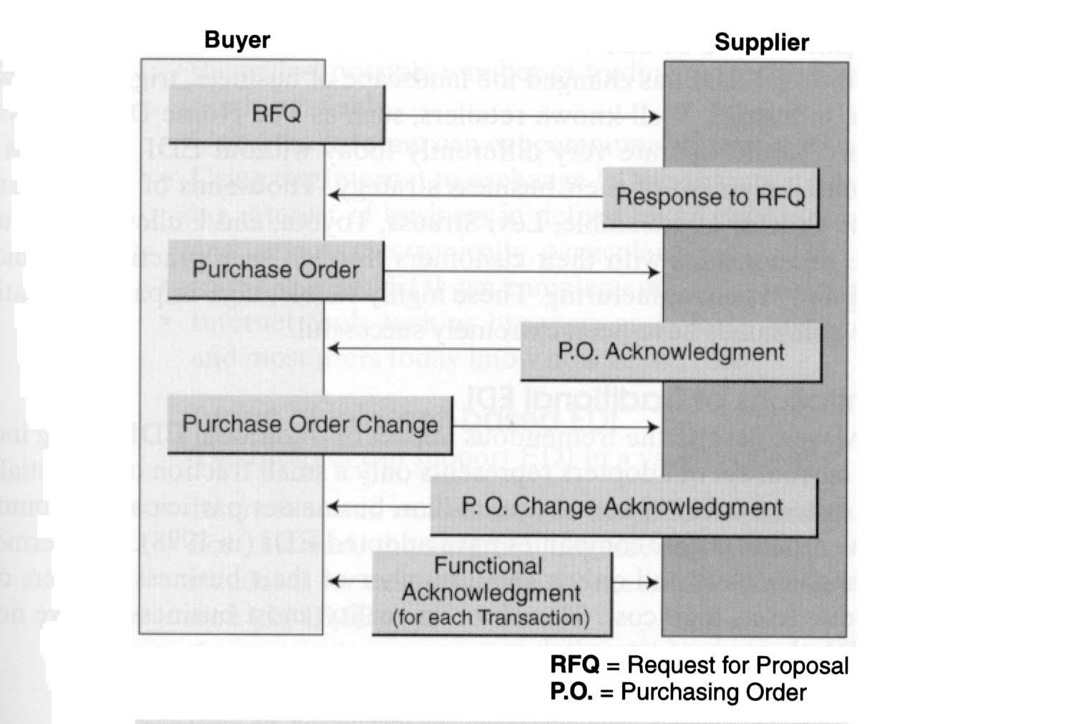
Figure 3.6 Typical Flow of EDI Messages (Source: Turban et al. (2000), p. 223)

Traditional EDI
EDI and standards
Electronic data interchange has been around for almost 30 years in the non-Internet environment. It is a system that standardize the process of trading and tracking routine business documents, such as purchase orders, invoices, payments, shipping manifest, and delivery schedules. EDI translates these documents into a globally understood business language and transmits them between trading partners using secure telecommunications links (see Figure 3.7). The most popular standard is United Nations EDI for Administration, Commerce, and Trade (EDIFACT). In the United States, the most popular standard is ANSI X.12. Traditional EDI users (most Fortune 1,00 or global 2,00 companies) used leased or dedicated telephone lines or a VAN, such as this run by IBM and AT&T, to carry these data exchanges. To distinguish it form Internet-based EDI, EDI on the non-Internet platform is traditional EDI.

Applications of EDI
Traditional EDI has changed the landscape of business, triggering new definitions of entire industries. Retailers such as The Home Depot, Toys R US, and Wal-Mart, would operate very differently today without EDI, since it is an integral and essential element of their business strategy. Thousands of global manufacturers, including Proctor and Gamble, Levi Straus, Toyota, and Unilever, have used DI to redefine relationships with their customers through such practices as quick response retailing and JIT manufacturing. These highly visible, high-impact applications of EDI by large companies have been extremely successful.

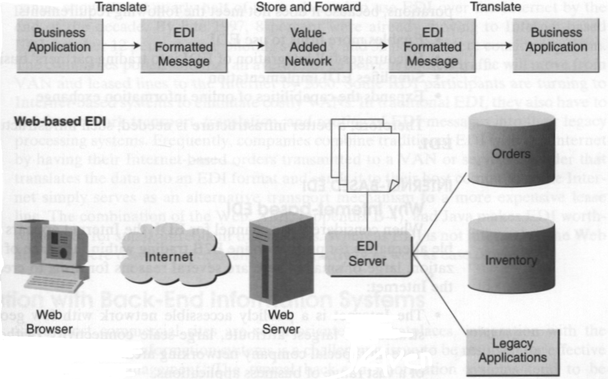
Figure 3.7 Traditional and Web-Based EDI (Source: Turban et al. (2000), p. 223)

Limitations of traditional EDI
However, despite the tremendous impact of traditional EDI among industry leaders, the current set op adopters represents only a small fraction of potential EDI users. In the United States, where several million businesses participate in commerce, every day, fewer than 100,000 companies have adopted EDI (in 1998). Furthermore, most of the companies have had only a small number of their business partners on the EDI, mainly due to its high cost. Therefore, in reality, most business have not benefited from EDI, the major factors being:
- Significant initial investment is needed
- Restructuring business process is necessary to fit EDI requirements
- Long start-up time is needed
- Use of expensive private VAN is necessary
- High EDI operating cost is needed
- There are multiple EDI standards
- The system is complex to use
- There is a need to use converter to translate business transactions to EDI standards

These factors suggest that traditional EDI⎯relying on formal transaction sets, translation software, and VANs⎯is not suitable as a long-term solution for most corporations, because it does not meet the following requirements:
- Enables more firm to use EDI
- Encourages full integration of EDI into trading partners’ business processes
- Simplifies EDI implementation
- Expands the capabilities of online information exchange

Therefore, a better infrastructure is needed; such infrastructure is Internet-based EDI.

Internet-based EDI
Why Internet-based EDI
When considered as a channel for EDI, the Internet appears to be the most feasible alternative for putting online B2B trading, within the reach of virtually any organization, large or small. There are several reasons for firms to create EDI ability over the Internet:
- The Internet is a publicly accessible network with few geographical constraints. It largest attribute, large-scale connectivity (without demand to have any special company networking architecture) is a seedbed for growth of a vast range of business applications.
- The Internet global internetwork connections offer the potential to reach the widest possible number of trading partners of any viable alternative currently available.
- Using the Internet can cut communication costs by over 50 percent.
- Using the Internet to exchange EDI transactions is consistent with the growing interest of business in delivering an ever-increasing variety of products and services electronically through the Web.
- Internet-based EDI can complement or replace current EDI applications.
- Internet tools such as browsers and search engines are very user-friendly and most users today know how to use them.
Types of Internet-based EDI
The Internet can support EDI in a variety of ways:
- Internet e-mail can be used as the EDI message transport in place of a VAN. For this end, the Internet Engineering Task Force (IEFT) is considering standards and encapsulating the messages within Secure Internet Mail Extension (S/MIME).
- A company can create an extranet that enables trading partners to enter information in Web from whose field correspond to the field in an EDI message or document.
- Companies can utilize the services of a Web-based EDI hosting service in much the same way that companies rely on third parties to host their commerce sites. Netscape Enterprise is illustrative of the type of Web-based EDI software that enables a company to provide their own EDI services over the Internet, while Harbing Express is illustrative of those companies that provide third-party hosting services.

Prospect of Internet-based EDI
Companies who currently possess traditional EDI have had a positive response to Internet-based EDI. A 1998 Forrester Research, Inc. survey of 50 Fortune 1,000 companies showed that nearly half of them planned to use EDI over the Internet by the end of the decade. By late 1997, 8 percent were already moving to Internet-based EDI, another 12 percent were piloting systems, and 32 percent were considering them. The companies polled said that n average of 16 percent of their traffic will move from VAN and leased lines to the Internet by 2000. Some EDI participants are turning to Internet-based systems to eliminate costly VANs. In traditional EDI, they also have to pay for network transport, translation, and routing of EDI messages into their legacy processing systems. Frequently, companies combine traditional EDI with the Internet by having Internet-based orders transmitted to a VAN or service provider that translate the data into an EDI format and sends it to their host computers. The Internet simply serves as an alternative transport mechanism to more expensive lease line. The combination of the Web, XML, and Java makes EDI worthwhile even for small, infrequent transactions. Whereas EDI is not interactive, the Web and java were designed specifically for interactivity as well as ease of use.

Business –to-consumer E-commerce
By using the Internet, manufacturers can directly contact customers without using intermediaries. The manufacturer’s direct marketing can be realized as long as they sell established brands and their home site is well known. If a manufacturer’s site does not have a high visibility, just opening a home page and passively waiting for customers’ access may not greatly contribute to sales. Therefor, it is necessary for companies to heavily advertise their Web sites’ address. Any cost-effective advertisement method can be employed for this purpose. One example is to link the site to well known electronic directories, and most manufacturers use the directory service or intermediaries. These intermediaries site are called electronic shopping malls (or e-malls). There are two types of electronic shopping malls: electronic distributors and electronic brokers (e-broker). If the e-mall takes responsibility for the order fulfillment, it is an electronic distributor. Electronic brokers only help the search process and the order is forwarded to a manufacturer or a distributor.

Business models of B2C
Direct versus Indirect Marketing
Direct marketing means that the manufacturer advertise and distribute their own products to the customers via the Internet-based electronic store (or other telemarketing media) without intervention of any intermediaries. Dell Computer belongs to this category. On the other hand, indirect marketing means that products are distributed through third party intermediaries such as e-malls.

Full Cybermarketing versus Partial Marketing
Full cybermarketing (or pure cybermarketing) means that companies like Amazon sell their products and service only through the Internet, whereas partial marketing means the companies like Barnes & ole sell not only through the Internet but also through traditional physical stores. Full cybermarketing companies are the new ones born in the e-businss era, whereas partial cybermarketing is a reactive response of existing companies who have done business through the physical distribution channel.

Electronic distributor versus Electronic Broker
Among electronic intermediaries, electronic distributors can be distinguished from and electronic brokers, depending upon whether an electronic intermediary is responsible for order fulfillment and guarantee. Electronic brokers only introduce suppliers who deal with the items that the customers are looking for.

Electronic Store versus Electronic Shopping Mall
It is not easy to define the difference between an electronic tore (e-store) and an electronic shopping mall (e-mall). In the physical world a shopping mall is a collection of stores, and the stores in the mall are independent distributors. In this sense, the role of electronic directory along with the associated e-stores matches with that of electronic mall. However, many online department stores, call their site shopping malls instead of electronic stores. The term electronic shopping mall is sometimes used as a wide umbrella term of electronic shops and stores as well as malls.
An electronic store will be defined as an electronic distributor whose dealing items are handled by a single store. An electronic shopping mall is an electronic distributor or broker whose dealing items are handled by more than a single electronic store.

Generalized E-malls/stores versus Specialized E-malls/stores
Generalized e-malls/stores deal with a various categories of items, so the supply items are very wide. Online department stores belong to this category. On the other hand, the specialized e-malls/stores focus only on special types of items. The cyberbookstores like Amazon belong to the generalized e-mall, and Dell, which focuses on its own computer products, belong to the specialized e-store.

Proactive versus Reactive Strategic Posture toward Cybermarketing
Proactive strategic posture toward cybermarketing means that a company’s main distribution channel is the Internet, and internal activities such as inventory and operations management are focussed to capitalize on the benefit of cybermarketing. In contrast, a reactive strategic posture toward cybermarketing means that the traditional physical distribution channels continues to be the main ones even though the company has opened an online distribution channel. So the traditional internal management style and activities are left unchanged.

Global versus Regional Marketing
Even though the Internet is connected to the entire wold, some products and services cannot be provided globally. For instance, perishable items like grocery cannot be delivered long distances. Delivery costs can limit the range of service to a certain region; legal boundaries limit range of service, as in the case of banking and insurance; and language can also limit business range. So the management must decide the geographical range of business considering these factors.

Sales versus Customer Service
The Web sites of some companies are used mainly or solely for customer service. All major computer hardware and software companies provide customer service sites, which can enhance customer satisfaction while reducing the cost of maintaining call center personnel.

Architecture of Internet, Intranet, and Extranet
The Internet, intranet, and extranet are the most popular platforms for e-commerce. In Internet is the most common platform for B2C e-commerce; the intranet is most the common for platform for corporate internal management; and the extranet is the most common platform for B2B e-commerce.

Network Type | Typical Users | Access | Type of information
The Internet | Any individual with dial-up access or LAN | Unlimited public; no restrictions | General public, and advertorial
Intranet | Authorized employees only | Private and restricted | Specific, corporate, and proprietary
Extranet | Authorized groups from collaborating companies | Private and authorized outside partners | Shared in authorized collaborating groups
Table 4-1 Characteristics of the Internet, Intranet, and Extranet (Source: Turban et al. (2000), p. 241)

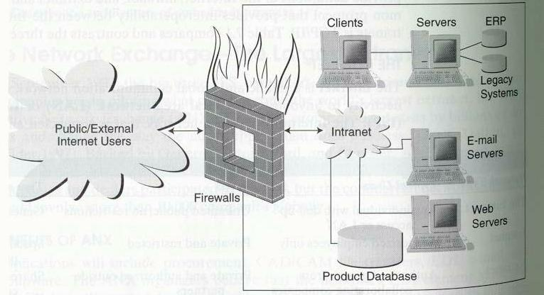
Figure 4.5 Architecture of Intranet (Source: Turban et al. (2000), p. 242)

The Internet
The Internet is a public and global communication network that provides direct connectivity to anyone over a local area network (LAN) or Internet Service Provider (ISP). The Internet is a public network that is connected and routed over gateways. End users are connected to local access providers (LANs or ISPs), who are connected to the Internet access providers, to network access providers, and eventually to the Internet backbone. Since access to the Internet is open to all, there is a lack of control that may result in an unruly proliferation of information.

The Intranet: An Intrabusiness Delivery System
An intranet is a corporate LAN or wide area network (WAN) that uses Internet technology and is secured behind company’s firewalls (see security and protection) as depicted in Figure 5.1. The intranet links various servers, clients, databases, and application programs like Enterprise Resource Planning (ERP). Although intranets are developed on the same TCP/IP protocol as the Internet, they operate as a private network with limited access. Only authorized employees are able to use it. Intranets are limited to information pertinent to the company and contain exclusive and often proprietary and sensitive information. The firewalls protect the intranets from unauthorized outside access; the intranet can be used to enhance the communications and collaboration among authorized employees, customers, suppliers, and other business partners. Since the intranet allows access through the Internet, it does not require any additional implementation of leased networks. This open and flexible connectivity is a major capability and advantage of intranet. Intranets provide the infrastructure for many intrabusiness commerce applications.

The Extranet
An extranet, or “extended intranet”, uses the TCP/IP protocol network of the Internet, to link intranets in different locations, see Figure 5.2. Extranet transmission are usually conducted over the Internet, which offers little privacy or transmission security. Therefore, when using an extranet, it is necessary to improve the security of connecting portions of he Internet. This can be done by creating tunnels (see paragraph on security and protection) of secured data flows, using cryptography and authorization algorithm. The Internet with tunneling technology is known as a virtually private network (VPN). Extranets provide secured connectivity between corporation’s intranets and the intranets of its business partners, material suppliers, financial services, government, and customers. Access to intranets is usually limited by agreements of the collaborating parties, is strictly controlled, and is only available to authorized personnel. The protected environment of the extranet allows groups to collaborate, sharing information exclusively, and exchanging it securely. Since an extranet allows connectivity between business through the Internet, it is an open and flexible platform suitable for supply chain management. To increase security, many companies replicate the database they are willing to share with their business partners and separate them physically from their regular intranets.

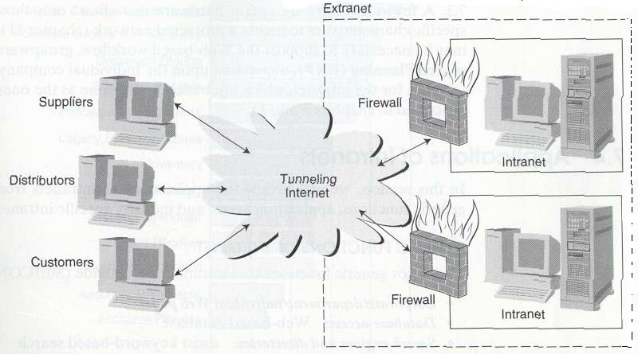
Figure 4.2 Diagrammatic Contrast of the Internet, Intranet, and Extranet (Source: Turban et al. (2000), p. 243)

Auction: From theory to practice

Auctions, an established method of commerce for generations, deal with products and services for which the conventional marketing channels are ineffective or inefficient. They can expedite the disposal of items that need liquidation or quick sale, they offer trading opportunities for both buyers and sellers that are not available in the convenient channels, and they assure prudent execution of contracts.
The Internet provides an infrastructure for executing auctions much cheaper, with many more involved sellers and buyers. Individual consumers and corporations alike can participate in this rapidly growing and very convenient form of E-commerce. The Internet auction industry is projected to reach $52 billion in sales by 2002.

Types of auctions
There are several types of auctions, each with its motives and procedures. Klein (1997) classified them into four major categories as shown in Table 6.1 Traditional auctions, regardless of their type, have several limitations. For example, they generally last only a few minutes or even seconds for each item sold. This rapid process may give potential buyers little time to make decisions, so they decide not to bid; therefore, sellers may not get the highest possible price, and bidders may not get what they really want, or they pay too much. Also, in many cases, the bidders do not have much time to examine the goods. Since bidders must usually come to the auction site, many potential bidders are excluded. Similarly, it may be complicated for sellers to move goods to the auction site. Commissions are fairly high, since a place needs to be rented, the auction needs to be advertised, and the auctioneer and other employees need to be paid. Electronic auctioning removes these deficiencies.

Electronic auctions
Electronic auctions have been in existence for several years. Notable are the auctioning of pigs in Taiwan and Singapore (Neo 1992), cars in Japan and the auctioning of flowers in Holland, which was computerized in 1995 (Kambil and van Heck 1998), but these were done on local area networks. Auction on the Internet started in 1995. They are similar to offline auctions, except that they are done on a computer. Host sites on the Internet at like a broker, offering services for sellers to post their goods for sale and allowing buyers to bid on those items. Most auctions open with a starting bid, which is the lowest price the seller is willing to accept. Detailed information on every item for sale is available online. For high-value items, additional information may be obtained by e-mail. Bidders look at the description and then start the bidding by sending an e-mail or filling out an electronic form. The bidding, which may last for a few days, are shown on a page at the host’s Web sites and updated continually to show the current highest bids. Names of bidders are kept coded to maintain privacy. Many sites have certain privacy etiquette rules tat must be adhered to in order to conduct fair business. Haggle online (http://www.hagle.com/), which allows private individuals to put up their merchandise for sale (free of charge, summer 1998), has a page dedicated to rules for users.

Auction Type | Coordination  Mechanism | Price discovery | Allocation mechanism | Distribution mechanism
Buyer role | Short-term acquisition of resources, e.g. for demand peaks, auction as a mechanism to achieve an equilibrium | Often experts/professional collectors trying to acquire rare items at a reasonable price | Bargain hunting, gambling motive | Bargain hunting, gambling motive; possible side motive: charity
Supplier role | Short-term allocation of resources, load balance | Exposing items for sale to a charity sufficient breadth of demand, hope for a high price | Clearance of inventory | Attention: direct sales channel, public relations; possible side motive: charity
Auctioneer/  Intermediary role | Often electronic auction without auctioneer | Active high breadth and depth of the auctions, high trading volume results in high returns, competitive advantage over other auctions | Active high breadth and depth of the auctions, high trading volume results in high returns, competitive advantage over other auctions | Limited role because supplier-buyer relation: possible function as service provider for the supplier side
Table 5.6 Motives of the Participants in Different Auction Types (Source: Turban et al. (2000), p. 180)

There are several auctioning methods (see http://www.onsale.com/). For example, some auctions use a “straight sales” method. The price for the good is listed and the first approved bidder gets the item at the listed price. In many cases the “Yankee method” is used in which sellers usually offer several identical items simultaneously. Bidding increase incrementally and the items are sold to the highest bidders. In the Dutch (or reversed) auction, prices decline until a buyer makes a bid (go to KlieKloc.com for gold and jewelry sales). Bid.Com International of Ontario Canada patented the Dutch (declining-price) auction technology.
Most auctions are open to public. Items auctioned frequently are computers and other electronic parts, artwork, antiques, rare coins, vacation packages, airline tickets, and may other products. The http://www.usaweb.com/ site provides a search engine, Bidfind, where a person type in the item he is looking for and the engine lets him know in what sites the item is auctioned. Some auctions are open only to dealers. These include used cars and foreclosed real estate sold by the U.S. government. There were about 500 companies doing auctions in 1999 on the Internet (a representative list is available at http://www.usaweb.com/auction.html). In 1999, Amazon.com and Dell Computers entered the auction business as well. Also, 3rd party companies, such as auction universe and itrack, monitor auction site for customers (for free).

E-commerce in the Netherlands

In 1998 the Ministry of Economic Affairs started the “Electronic Commerce Action Plan”. The objective of this action plan is to develop the Netherlands into one of the leading nations in the field of e-commerce. Since the Netherlands already fulfills as the gateway to Europe, the goal is to develop the Netherlands into an “Information Gateway to Europe”.

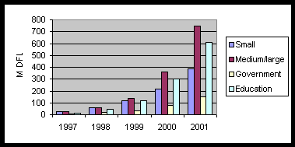
Figure 6.7 The expected development of E-commerce in the Netherlands for the period 1997 – 2001. (Source: Digitaal zaken doen: Bouwtekening voor een E-commerce monitor, p. 11)

The numbers in Figure 6.1 are calculated by IDC for small, medium and big enterprises, the government and education. These numbers are the realized and the expected revenue. The E-commerce types that are not based on the Internet such as EDI are left out the calculations. The revenue is expected to growth between 100 and 200 % annually and according to the prediction will reach DFL 3.1 billion in 2001.

Netherlands’ starting position
The Netherlands wants to be one of the leaders in the field of electronic commerce. Its starting position is potentially favorable:
- the market penetration of PCs and the number of subscription to the Internet is relatively high;
- the Netherlands is a nation that “pins” on a large scale (i.e. a system of cashpoint cards protected by a IN code is widely used) and is very familiar with the concept of telebanking;
- the use of EDI and the possession of chipcards (smart cards) is high compared with many Western countries;
- the Netherlands has some important providers, such as Philips, Baan, KPN, Ericsson and Alcatel, and has some European markets leaders in sectors that are important for electronic commerce, such as transport, business and financial services, trade and publishing;
- the Netherlands has a good underlying infrastructure and occupies a key position in the field of logistics and distribution;
- an international outlook, a high standard of education and good linguistics skills are also among the Netherlands’ key assets.

The extent to which electronic commerce is important to the Netherlands’s economy depends not so much on sales, however, but rather on the value that is added by Netherlands’ companies in generating these sales and the extra jobs that are created in the process. This added value depends on the following:
- at micro-level: the value that is added to a product or service by the supplier. A foreign CD that is sold over the Internet has, as product, no added value in itself;
- at national macro-level: the extent to which existing Netherlands’ (and other) products and services are replaced by electronic commerce. Electronic banking, for example, will to a large extend replace the traditional forms of banking and thus, form a macro-economic point of view, will, on balance, add little new value to the economy;
- at international macro-level: the extend to which the balance of trade is affected by electronic commerce transactions. This relates to the balance of Internet imports and exports.

Obstacles to electronic commerce in the Netherlands
Worldwide it is recognized that there are factors that hinder the rapid development of electronic commerce. These are mainly of an economic, legal and technical nature. This one of the reason why the Netherlands’ business sector is hesitant to push ahead with E-commerce. SMEs, in particular, are reluctant because the investment in people, hardware and software is high, while the return on investment is uncertain. There is also a shortage of skilled personnel to make the necessary adaptations to business processes. Furthermore, there are still many legal uncertainties, which, in view of the global character of E-commerce, demand internationally coordinated actions.

Role of the government
The introduction an implementation of E-commerce will primarily be market driven. The Netherlands’ government sees its task to ensure that market players are in a position to take advantage of the developments and new opportunities of E-commerce. It doe this by:
- creating a climate in which there is a scope for private-sector initiatives;
- increasing opportunities for research and developments;
- creating a clear and consistent legal framework;
- organizing its own position as a market player to enable it to have an encouraging and guiding role.

The governments’ aim is to speed up the desired developments and thereby strengthen and modernize the economic structure and improve competitiveness. Increasing awareness, promoting a transparent and accessible market, boosting confidence in and reliability of E-commerce, eliminating legal and infrastructure obstacles and promoting standardization and support facilities are key elements in this context. In this way the government wants to contribute to increasing ability of the Netherlands’ economy to absorb developments in the field of E-commerce. Analysis shows that this ability is still at low level, particularly among SMEs.

 | Demand | Supply
Economic factors | - cost of telecommunications and end-user equipment  - lack of (and lack of confidence) in electronic payments systems | - lack of knowledge and awereness  - uncertainty about return on investment  - lack of (and lack of confidence in) electronic commerce payments systems  - branding and marketing
Legal factors | - jurisdiction and liability  - electronic signatures/authentication  - consumer protection and privacy | - jurisdiction and liability electronic  - signatures/authentication  - intellectual property and copyright
Technical factors | - capacity of infrastructure  - complexity of software  - IT skills and knowledge of users | - capacity of infrastructure  - IT skills and knowledge of providers  - Standardisation & harmonisation  - Euro problems
Table 6.2 Supply and demand-type obstacles (Source: Electronic Commerce Action Plan, p. 21)

Some facts and figures of Dutch Internet Spending

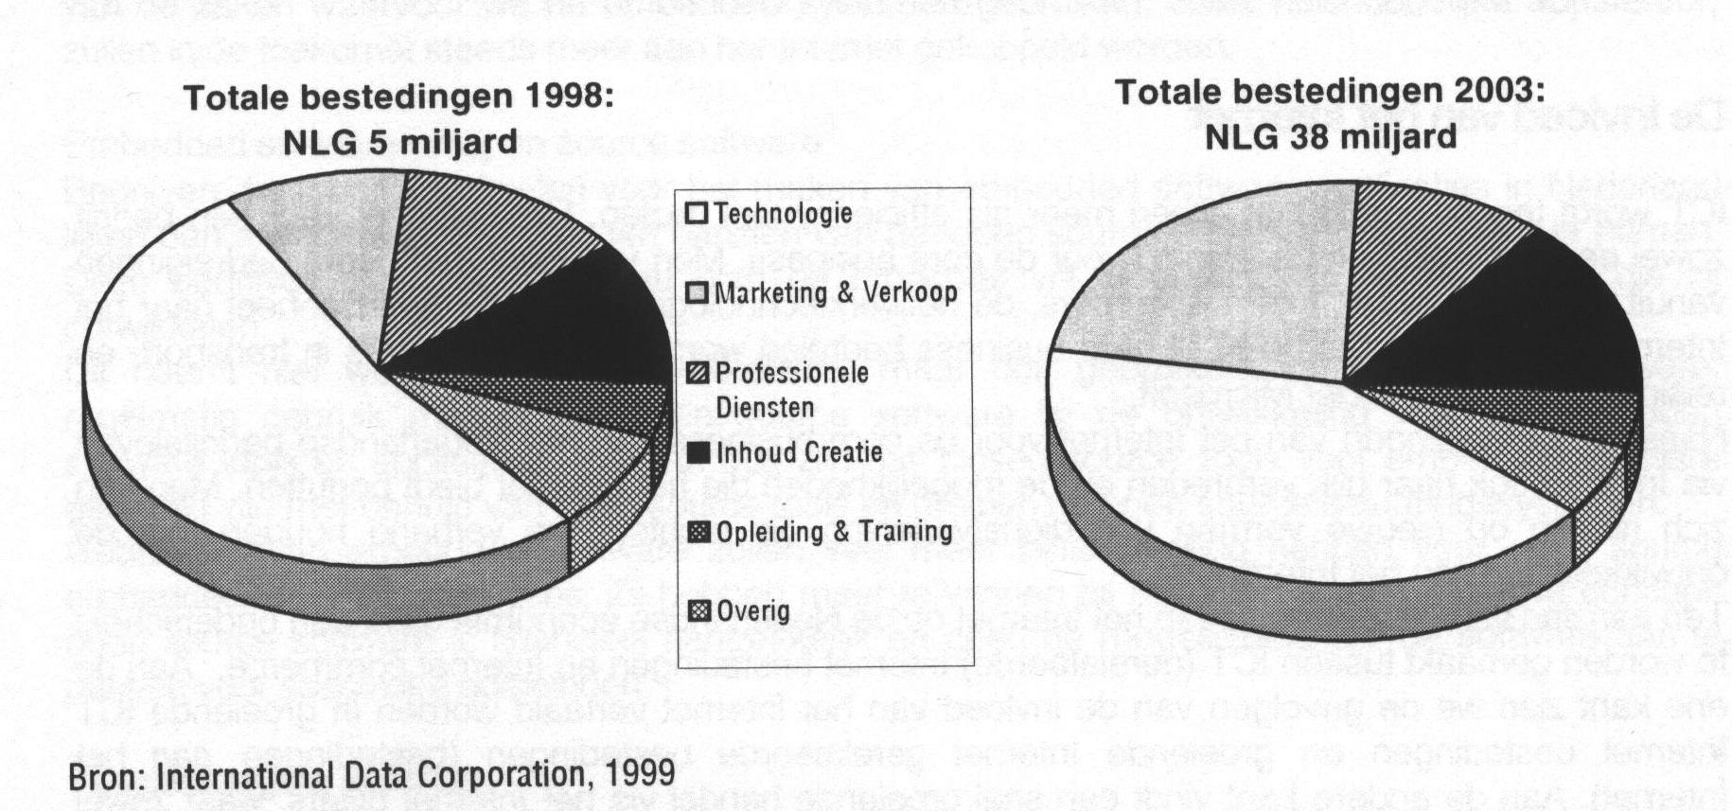
Figure 6.2 Nederlandse Internet bestedingen, 1998 en 2003 (Source: ICT en Nederland, Van Technologie tot Toepassing, p. 21)

In 1998 the Internet spending was NLG 5 billion (0.66 % of the GDP).
According to forecast the Internet spending will increase to NLG 38 billion (4.4%) in 2003.

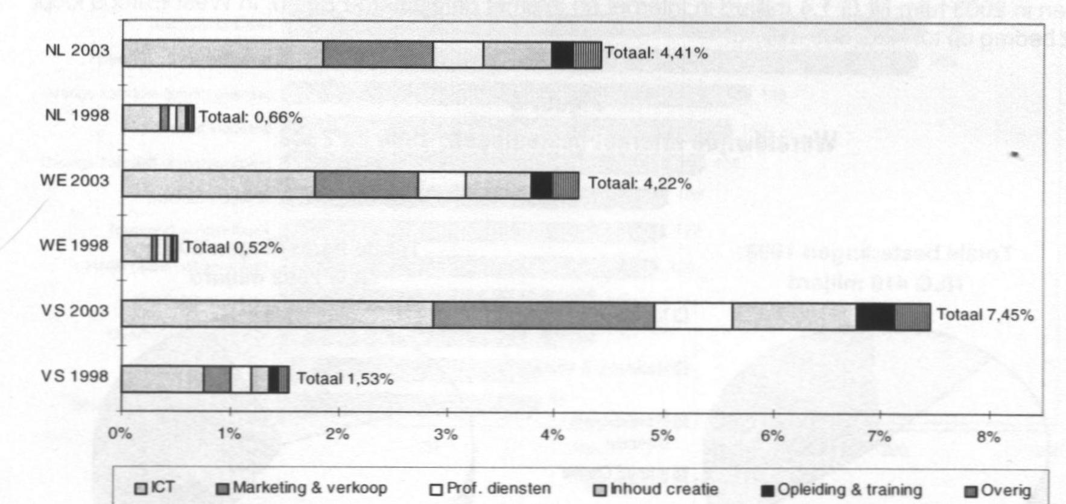
Figure 6.3 Internet bestedingen als percentage van het BNP voor Nederland, West Europa en de Verenigde Staten in 1998 en 2003 (Source: ICT en Nederland, Van Technologie tot Toepassing, p. 22)

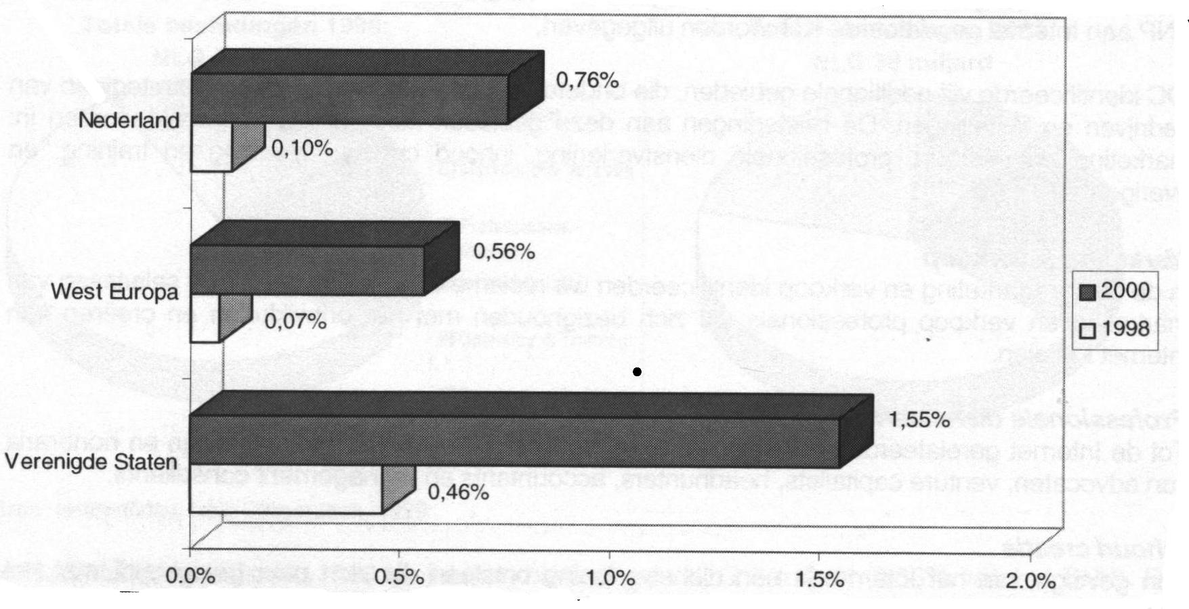
Figure 6.4 Internet commerce omzet als percentage van het BNP 1998 (Source: ICT en Nederland, Van Technologie tot Toepassing, p. 22)

In 1998 the e-commerce revenues in the Netherlands was about NLG 724 million (0.1% of the GDP). IDC expects that the revenues will grow to NLG 25 billions in 2002 (3% of GDP). This is a yearly grow of 143 % in the period 1998-2002. Most of the e-commerce revenues come from business-to-business transactions (67%). In 2002 for 80% of the e-commerce revenues will come form business-to-business transactions.

Bibliography
Boston Consulting Group, New BCG Research Re-evaluates Size, Growth and Importance of Business-to-Business E-commerce, Toronto/Boston, December 1999, http://www.bcg.com/

Bouman,Hein, e-commerce, http://www.antares.nl/

Efraim Turban, Jae Lee, David King and H. Micheal Chung, ELECTRONIC COMMERCE: A MANAGERIAL PERSPECTIVE, Prentice Hall, Inc., 1999, ISBN: 0-13-975285-4, pages 4-17, 24, 25, 199-209, 218-225
http://www.prenhall.com/turban

Electronic Commerce Platform Nederland/National Chipcard Platform, Leidschendam, Betalen op het Internet, Keuzemogelijkheden met de Nederlandse betaalsystemen, januari 2000, pagina 51-53, http://www.ecp.nl/

IBM e-business, http://www.ibm.com/e-business

http://www.whatis.com/

http://www.highlatitude.com/e-definitions/ (e-definitions)

ICT en Nederland, Van Technologie tot Toepassing, IDC, Februari 2000, http://www.minez.nl/

Laudon, Kenneth C. & Laudon, Jane P., International Edition, Management Information Systems, Organization and Technology in the Networked Enterprise, Prentice Hall, 2000, ISBN: 0-13-015682-5, page 25

Mesenbourg, Thomas L., Assistant Director for Economic Programs Bureau of the Census, U.S. Census Bureau, Measuring Electronic Business: Definitions, Underlying Concepts, and Measurement Plans 2000, http://www.census.gov/

Ministry of Economic Affairs (1999), Measuring E-commerce: Recommendation for a Dutch E-commerce monitor, Dialogic Innovatie & Interactie, March 2000, http://www.minez.nl/ecom

Ministerie van Economische Zaken, Digitaal zaken doen: Bouwtekening voor een E-commerce moitor, Dialogic Innovatie & Interactie, Utrecht, July 1999, http://www.minez.nl/ecom

Ministry of Economic Affairs (1998), Electronic Commerce Action Plan, The Hague, March 1998, pages 3, 4, 11, 21, 27, http://www.minez.nl/

Organisation for economic Co-operation and Development, Working Party on Indicators for the Iformation Society, Defining and Measuring E-Commerce: A Status Report (October 1999), page 8-9, http://www.oecd.org/

Organisation for economic Co-operation and Development, Working Party on Small and Medium-Sized Enterprises, SMEs and Electronic Commerce 1998, http://www.oecd.org/

PricewaterhousCoopers, What really is “e-business”?, http://www.e-business.pwcglobal.com/

Primau, C. PriceWaterhouseCoopers, E-business E-Xplosion, http://www.e-business.pwcglobal.com/

¹ Bell, S. et al., 1998, Resizing On-line Business Trade, Forrester Research BV, Amsterdam
Scharis, R., 1998, Electronic Commerce in the Netherlands, IDC, Amsterdam
Choi et al., The Economics of Electronic Commerce (Indianapolis: Macmillan Technical Publications, 1997)
Freeman, L. :Net Drives B-to-B to New Highs Worldwide”, Netmarketing, January 1998 (www.netb2b.com)
Retter, T. and Calyniuk,M. Technology Forecast: 1998 (Price Waterhouse, March 1998)
Handfield, R. and Nichols, E., Supply Chain Management(upper Saddle River, NJ: Prentice Hall, 1999)
Kalakota, R. and Whinston, B., Electronic Commerce: A Manager’s Guide (Reding MA: Addison Wesley, 1997)
Fickel, L. “Online Auctions: Bid Business” CIO Web Business Magazine (June 1, 1999)
Klein, S. “Introduction to Electronic Auctions,” Electronic Markets 7, (4:1997)
Neo, B.S., The Implementation of an Electronic Market for Pig Trading in Singapore,” Journal of Strategic Information Systems (December 1992)
Kambil, A. and van Heck, E., “Reengineering the Dutch Flowery Auctions: A Framewrok for Analyzing Exchange Organizations,” Information Systems Research (March, 1998)

